**Next.js Knowledge**

**To provide the most effective guidance, let's break down the understanding of Next.js into key areas:**

https://dev.to/vyan/mastering-nextjs-the-ultimate-guide-to-structuring-large-scale-projects-in-2024-h4e?context=digest

**Core Concepts**

* **File-based routing:** How familiar are you with Next.js's approach to routing based on file structure?
* **Data fetching:** Do you understand the different methods for fetching data in Next.js (SSR, SSG, ISR, client-side fetching)?
* **Component structure:** Are you comfortable with creating pages, layouts, and components in Next.js?
* **API routes:** Have you worked with API routes for server-side logic?

**Advanced Features**

* **Image optimization:** Are you familiar with Next.js's built-in image optimization features?
* **Static site generation (SSG):** Do you understand how to pre-render pages for SEO and performance?
* **Server-side rendering (SSR):** Have you worked with SSR to improve initial page load speed and SEO?
* **Incremental Static Regeneration (ISR):** Are you aware of ISR and its benefits for updating static pages?
* **Deployment:** Do you know how to deploy Next.js applications to different platforms (Vercel, Netlify, etc.)?

## Understanding Data Fetching Methods in Next.js

Next.js offers a variety of data fetching strategies to optimize performance, SEO, and user experience. Let's break down the key differences between them:

**Client-Side Rendering (CSR)**

* **Data fetching:** Occurs on the client-side after the initial page load.
* **How it works:** The browser downloads the HTML, and JavaScript executes to fetch data and update the DOM.
* **Best for:** Dynamic content that changes frequently or doesn't require SEO.

**Server-Side Rendering (SSR)**

* **Data fetching:** Occurs on the server before sending the HTML to the client.
* **How it works:** The server renders the page with data, and the fully rendered HTML is sent to the browser.
* **Best for:** SEO, initial page load performance, and sharing content on social media.

**Static Site Generation (SSG)**

* **Data fetching:** Occurs at build time, creating static HTML files.
* **How it works:** The pages are pre-rendered during the build process, and the generated HTML files are served to the client.
* **Best for:** Static websites or pages with content that rarely changes.

**Incremental Static Regeneration (ISR)**

* **Data fetching:** A hybrid of SSG and SSR, combining the benefits of both.
* **How it works:** Pages are pre-rendered at build time, but can be re-generated on demand or at a specified interval.
* **Best for:** Websites with frequently updated content but don't require real-time updates.

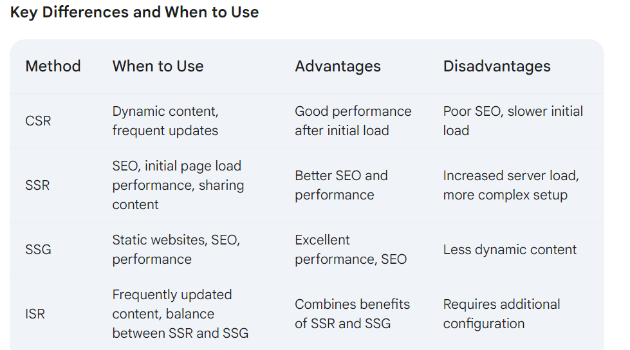

# Set UP -with Tailwind css

Node JS required

• **Next.js**:

* **Pages**: Files inside the pages directory become routes.
* **Components**: Reusable UI elements, stored inside the components directory.
* **Head Component**: Used to modify the <head> section of the page.

• **Tailwind CSS**:

* **Utility-First**: Tailwind provides low-level utility classes that can be composed to build custom designs.
* **Configuration**: The tailwind.config.js file allows customization of Tailwind's default configuration.

```

npx create-next-app@latest next-tailwind-app

cd next-tailwind-app

npm install tailwindcss postcss autoprefixer

initialize tailwind css - $npx tailwindcss init -p

```

**Configure Tailwind CSS**

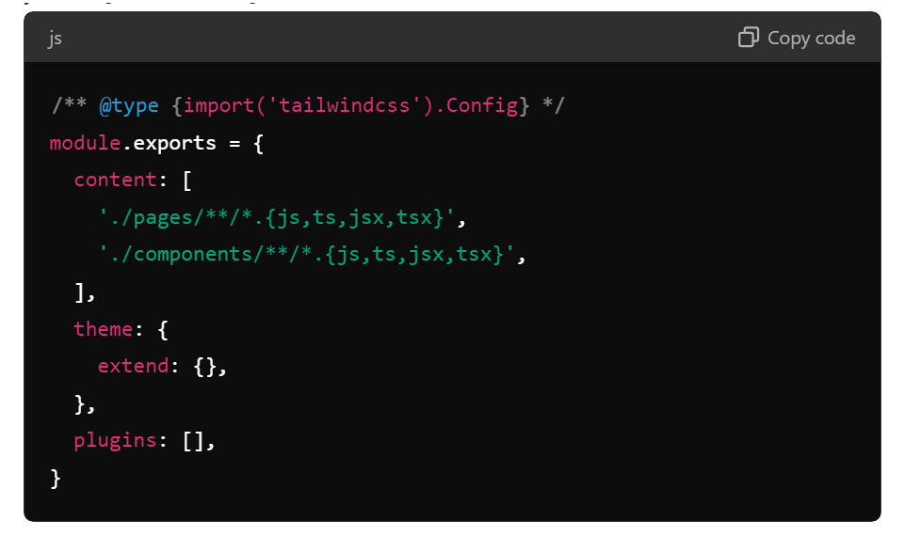

and **Configure Tailwind CSS – styles/global.css**

@tailwind base;

@tailwind components;

@tailwind utilities;

# Get start:

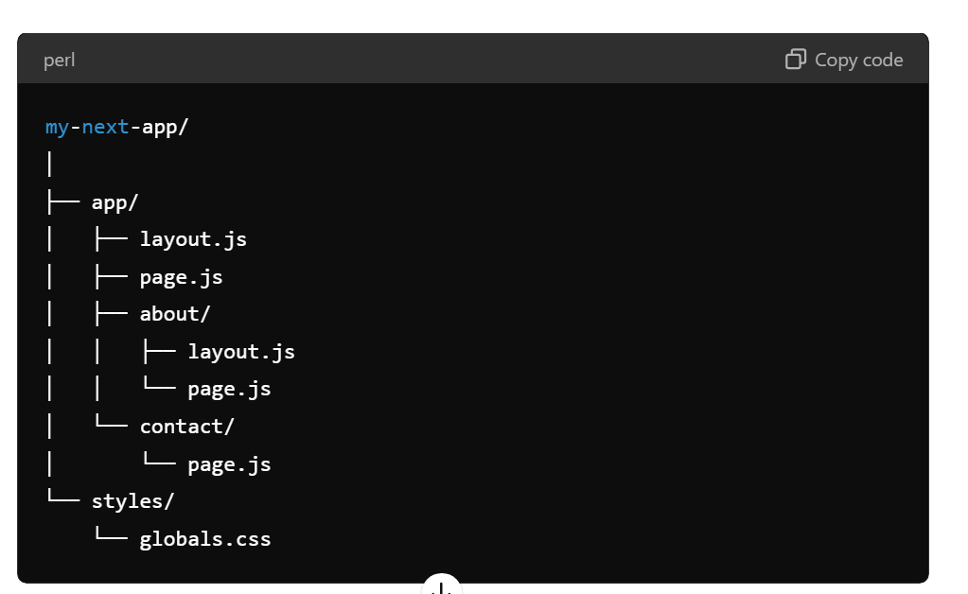

In Next.js, especially with the new app directory introduced in Next.js 13, the concept of layouts and pages has been streamlined to facilitate better structure and easier development. Here's an overview of how layouts and pages work together:

### Layouts

Layouts in Next.js are used to wrap around pages and provide a consistent structure (like headers, footers, or sidebars) across multiple pages. Layouts are defined in the app directory and apply to all pages nested under them.

#### How Layouts Work:

* **Root Layout**: This is the top-level layout that wraps the entire application. It is typically defined in app/layout.js or app/layout.tsx.
* **Nested Layouts**: You can also define nested layouts to apply to specific sections of your application.

• **Root Layout**: This is applied to all pages within the app directory.

• **Nested Layouts**: These are applied to pages within their specific subdirectory.

### Pages

Pages in Next.js represent individual routes of your application. Each file in the app directory (excluding special files like layout.js) corresponds to a route. The file structure inside the app directory maps directly to the URL structure.