FronEnd & API Integration Test

Version 1.0

Author: Sudhahar Vaithilingam

Please make sure back end Spring boot service is running with Port 11016

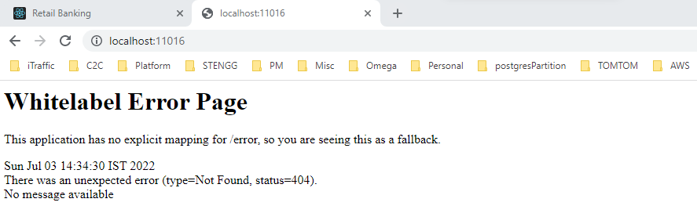

Swagger url:

<http://localhost:11016/swagger-ui/index.html?configUrl=/swagger19/swagger-config>

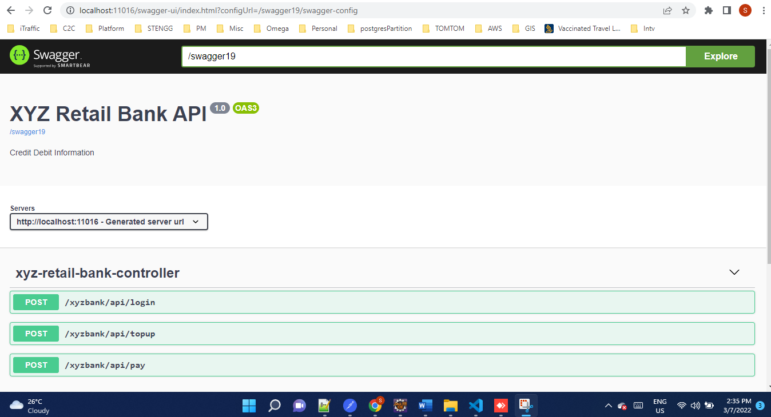

Start the front end application

URL: <http://localhost:3000/>

NodeJs version: node-v16.15.1

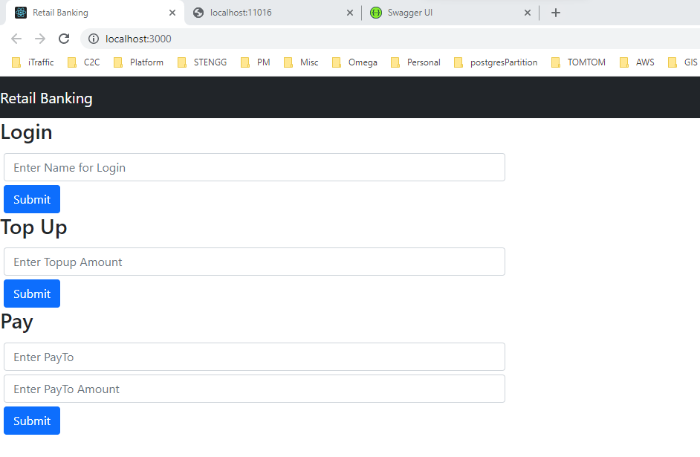

Case 1: Login Alice

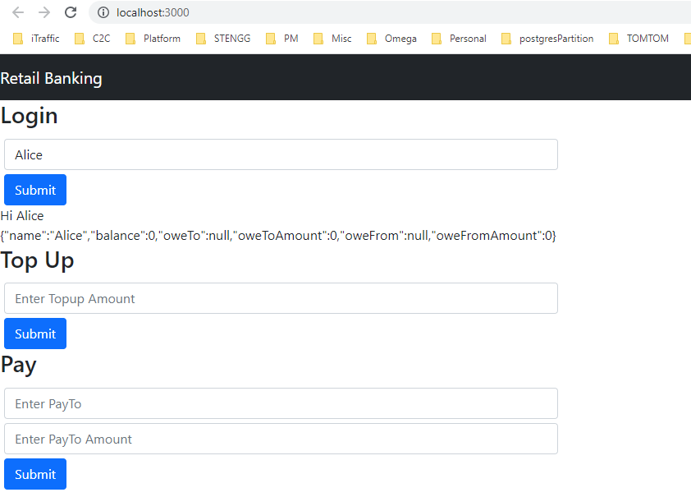

Case 2 : Top-up Alice to 100

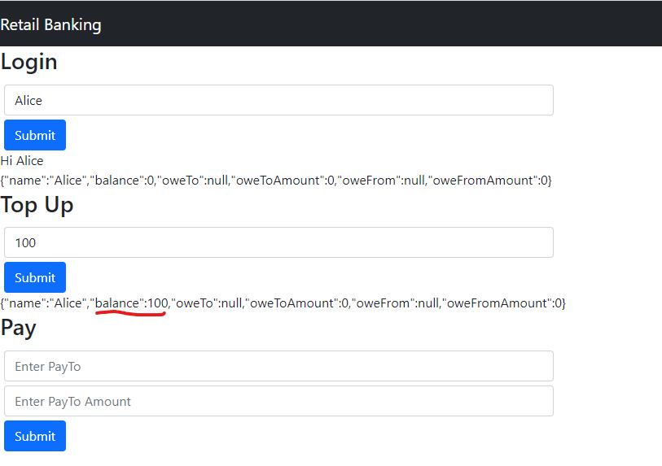

Case 3: Login Bob

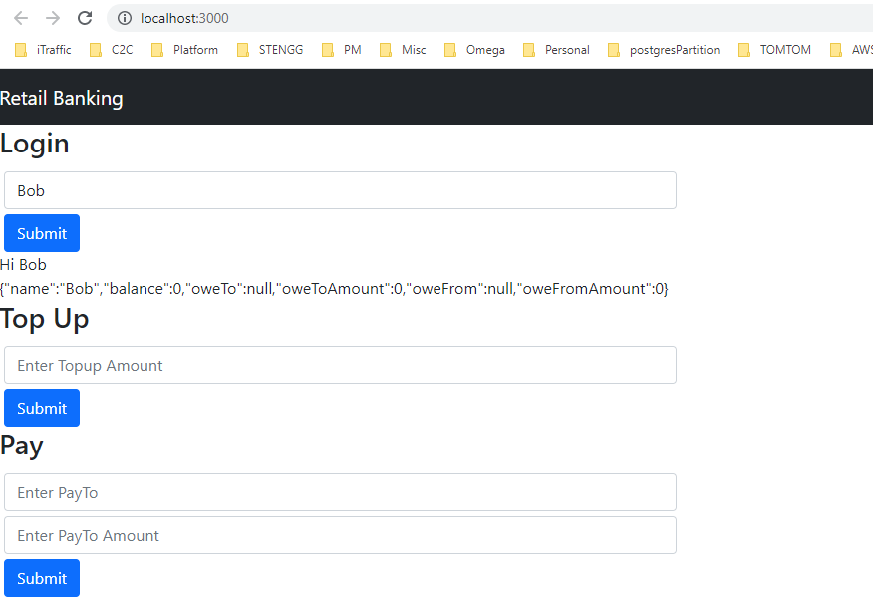

Case 4: Top-up Bob to 80

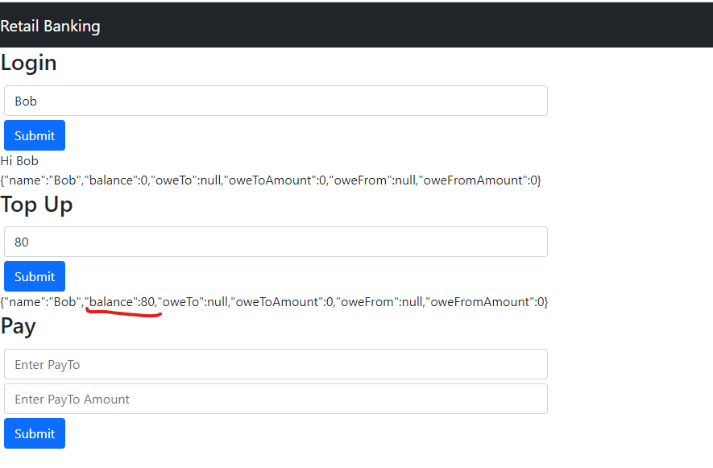

Case 5: Bob give Alice to 30

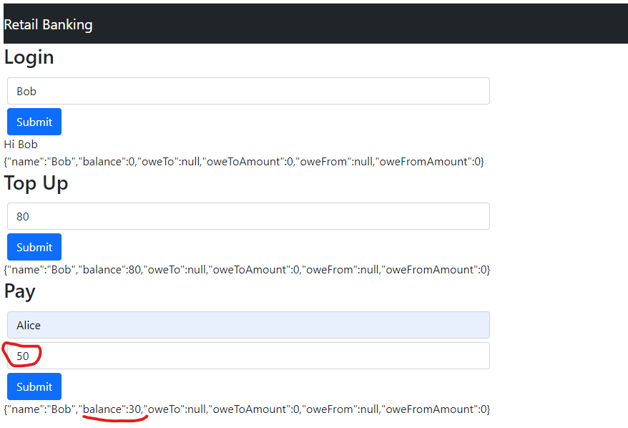

Case 6 : Alice got 50 with exisiting amount 100(100+50 =150)

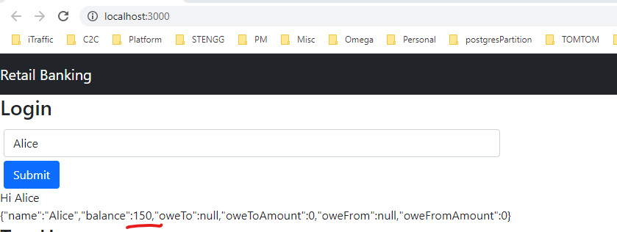

Case 7: Bob gives 100 to Alice

Bob balance is 0, oweto Alice, oweToAmount is 70

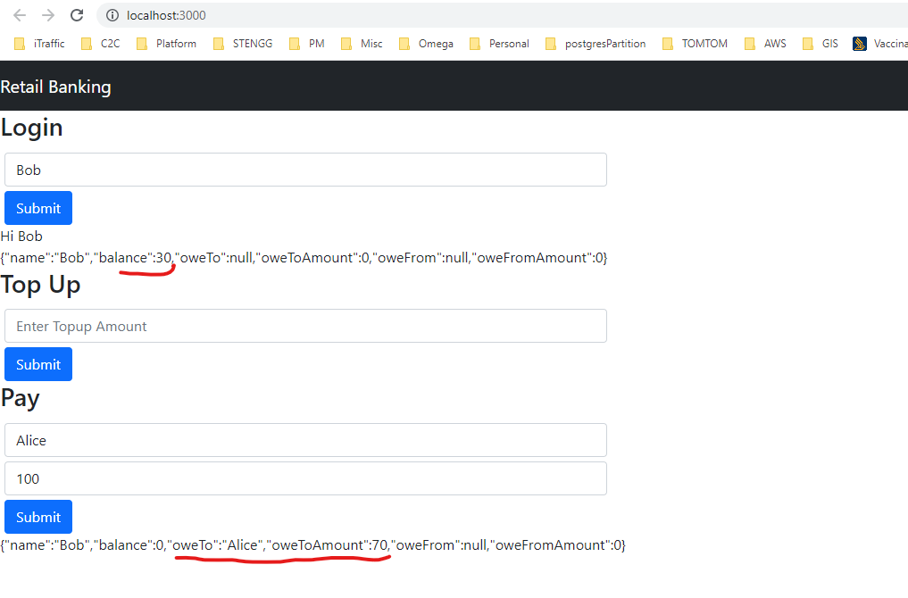

Alice got 30 with Owe from information

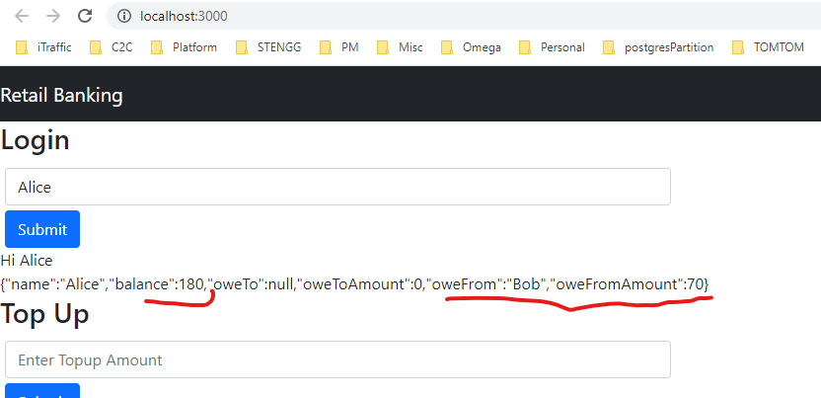

Case 7: Bob Top up 30

Bob balance still 30 and reduce oweTo amount 70 to 40

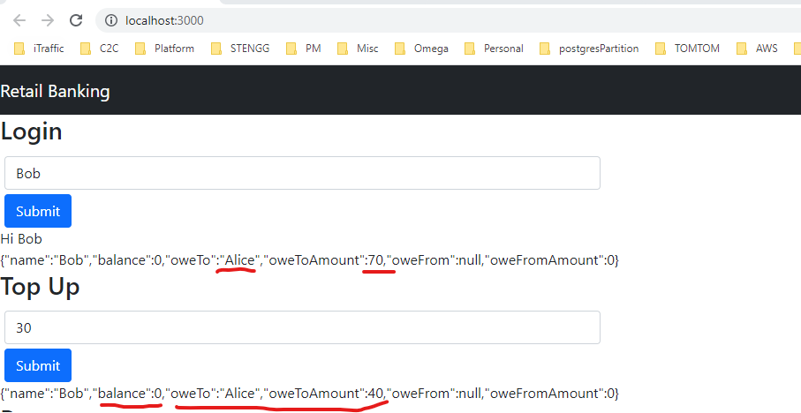

Alice balance now 210 changed to OweFrom information

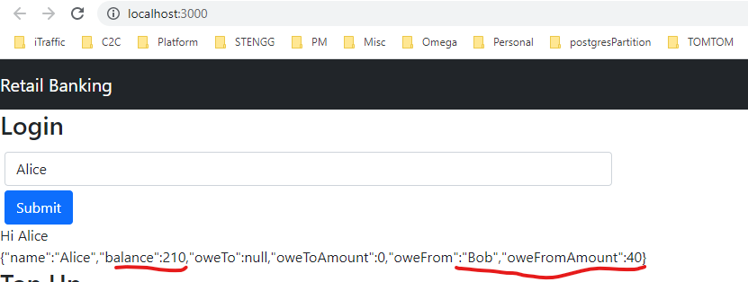

Case 8: Alice pays Bob t0 30

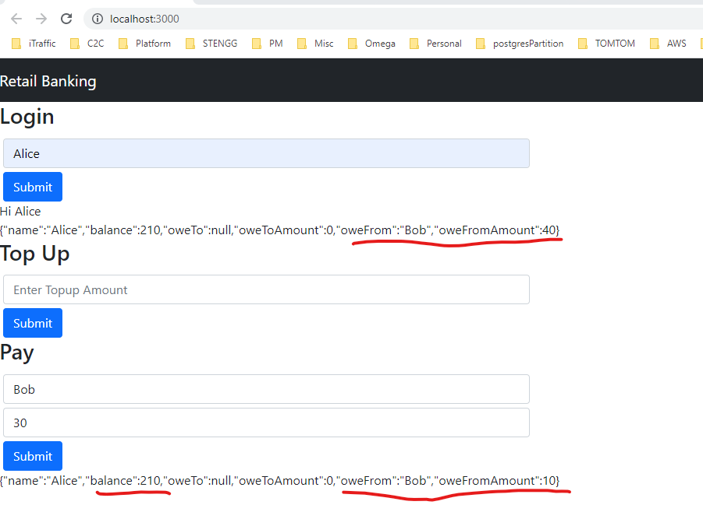

Case 9 : login Bob

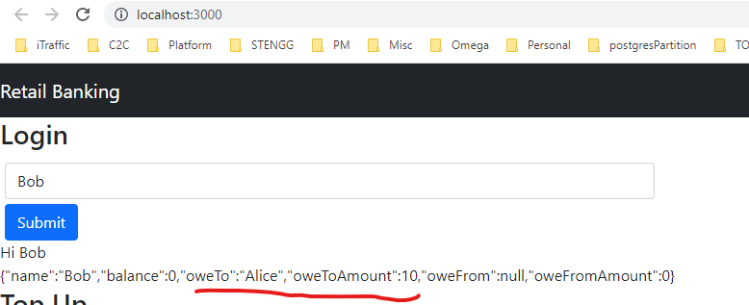

Still balance 0 and oweToAmount reduce 10

Case 10: Bob Top-up 100

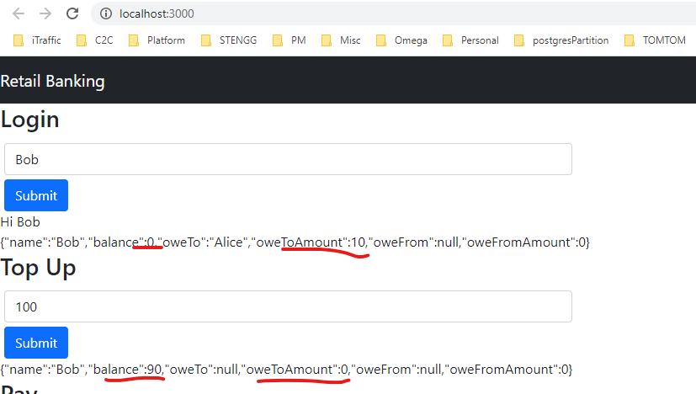

10 Transfer to Alice and update Balance