1. In the below given cell, shape of the boxes.eval() is (1783,4). Why are there 1783 boxes? Explain the reason for it. What is the maximum number and minimum number you can get for that? Write these answers in a word file.

The reason there are 1783 boxes in `boxes.eval()` is due to the way the YOLO (You Only Look Once) object detection model predicts bounding boxes. YOLO divides the input image into a grid, and for each grid cell, it predicts a certain number of bounding boxes with associated confidence scores and class probabilities.

**Maximum and Minimum Number of Boxes:**

* **Maximum Number:** The maximum number of boxes is the total number of boxes before filtering. In this case, it is 19 * 19 * 5 = 1805. This is because each grid cell has 5 anchor boxes.
* **Minimum Number:** The minimum number of boxes after filtering can be zero. This happens if all boxes have confidence scores or class probabilities below the threshold.

1. yolo_anchors.txt contains 10 values. They can be considered as height and width of 5 anchor boxes. What is the advantage of using such anchor boxes? What was the method used to determine the sizes of these anchor boxes? Give the answers to these questions in the word file.

By changing the mean and standard deviation (`stddev`) in the `tf.compat.v1.random_normal` function, as well as the threshold value, you can observe different values for `boxes.eval().shape`. Higher mean values and lower thresholds will generally result in more boxes passing the confidence filter, while lower mean values and higher thresholds will result in fewer boxes.

The values you provided represent the dimensions (width and height) of the 5 anchor boxes, typically formatted as pairs:

* **Anchor Box 1:** (0.57273, 0.677385)
* **Anchor Box 2:** (1.87446, 2.06253)
* **Anchor Box 3:** (3.33843, 5.47434)
* **Anchor Box 4:** (7.88282, 3.52778)
* **Anchor Box 5:** (9.77052, 9.16828)

**Interpretation:**

* **Smaller Anchors** (e.g., 0.57273, 0.677385): These anchors are useful for detecting small objects in the image.
* **Larger Anchors** (e.g., 9.77052, 9.16828): These anchors are more suitable for detecting larger objects.

These anchor boxes are carefully selected to represent a wide range of object sizes that the model is expected to detect in the dataset. By using these predefined anchor boxes, the model can predict objects more accurately, considering the typical aspect ratios and scales present in the dataset.

10. Download the output images zip file from the google drive and observe the bounding boxes in the autonomous driving dataset (i.e., 21 images from 0100.jpg to 0120.jpg). Select 2 images from these 21 images and,

* + Write what you observe regarding correctly detected objects, incorrectly detected objects, undetected objects and incorrect bounding boxes in the word file.
  + Include these output 2 images as well as the original 2 images in the word file.

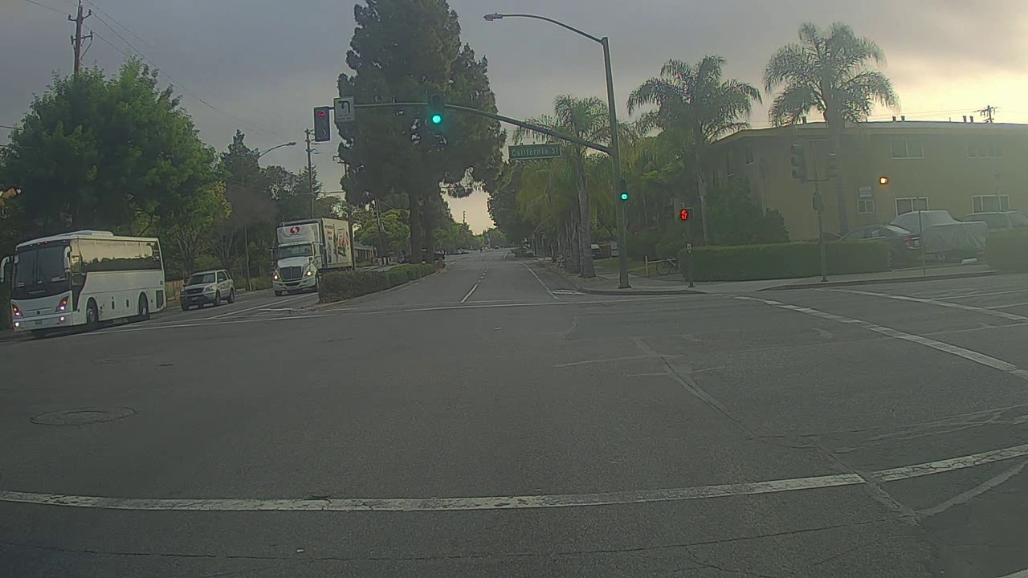

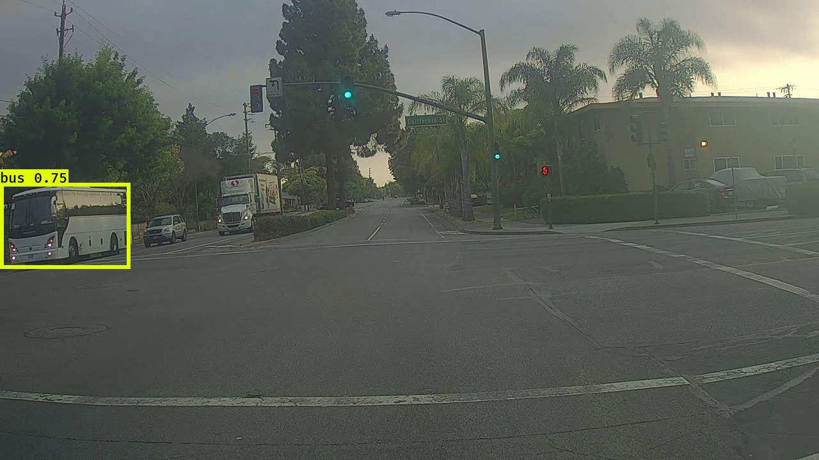

Original pic output pic

It’s correctly detected the bus but it didn’t detect the truck

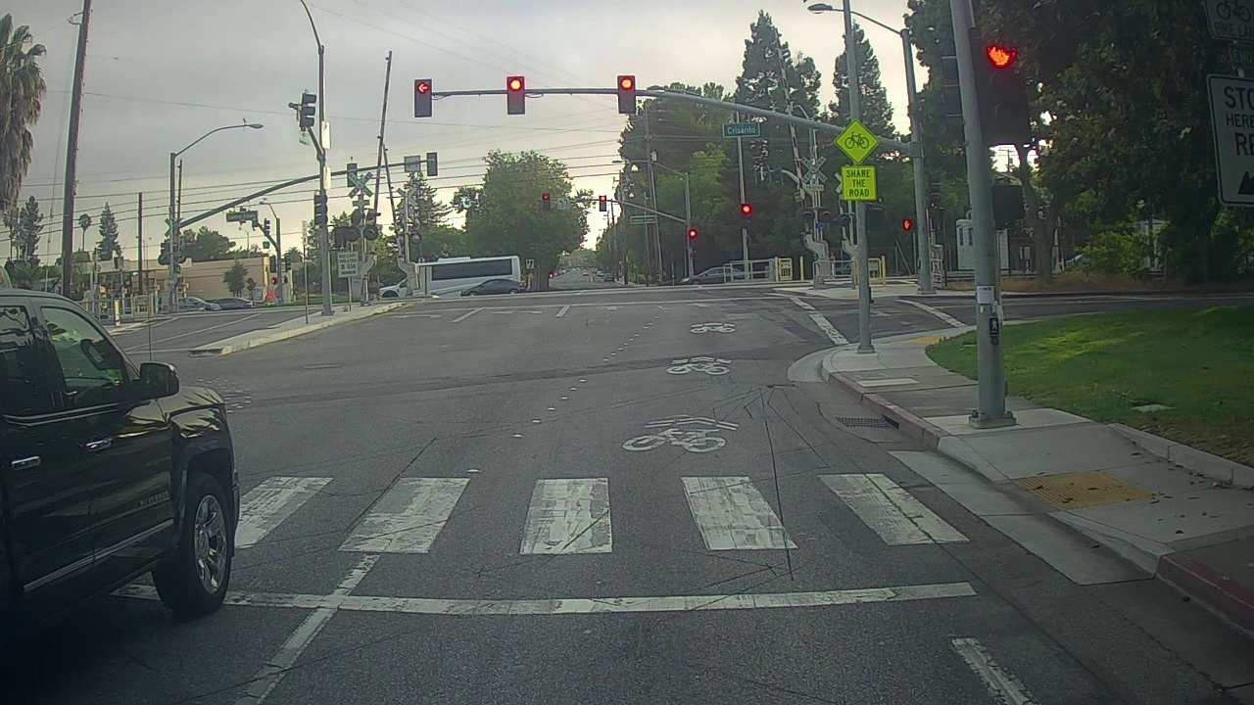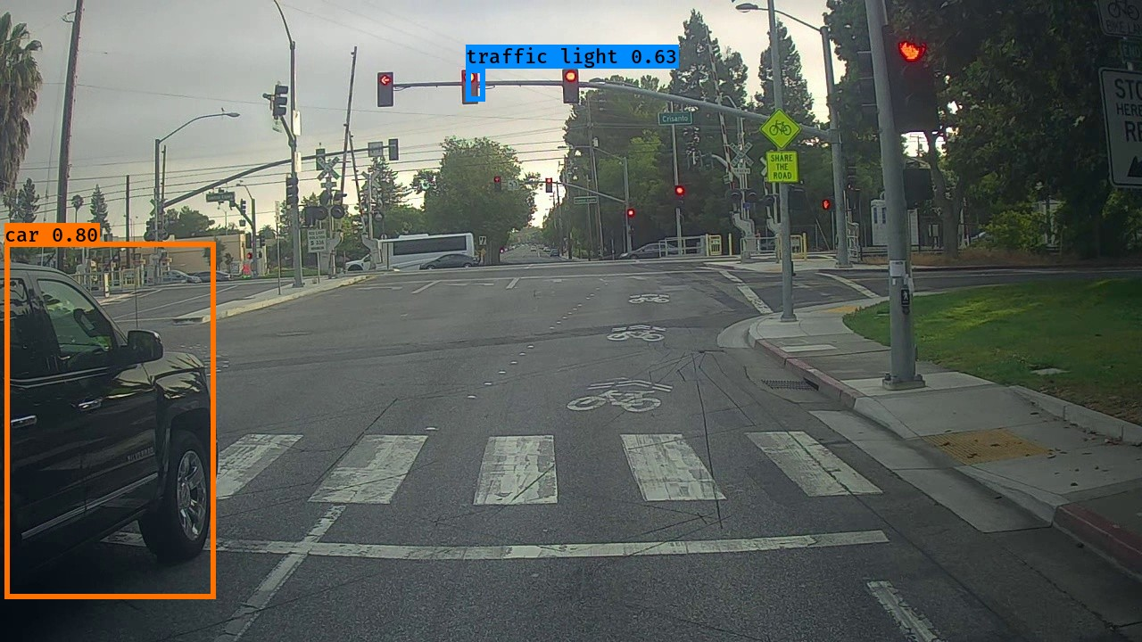 Original pic output pic

It’s incorrectly detected it’s not a car

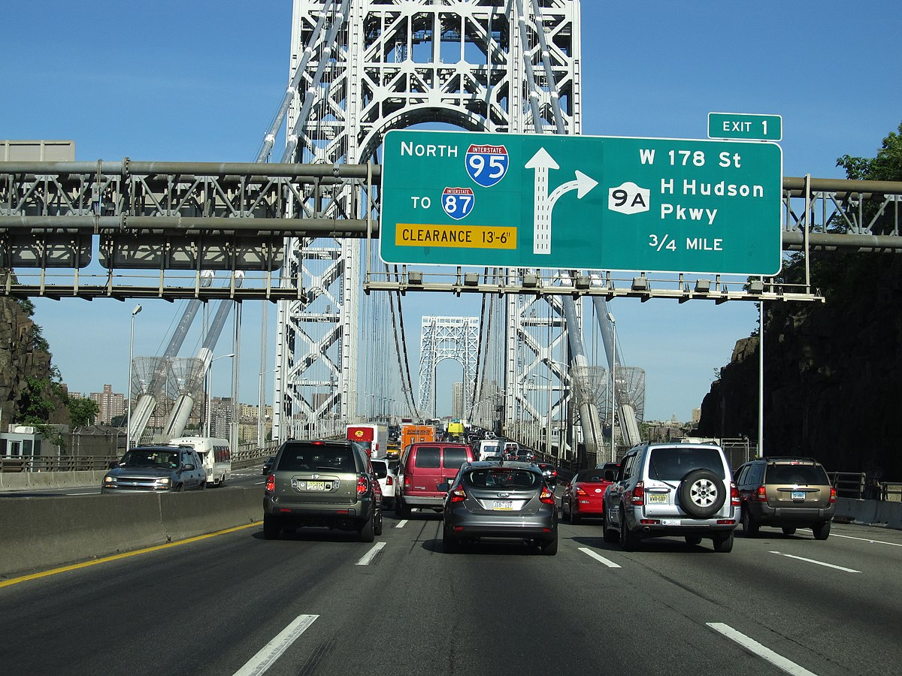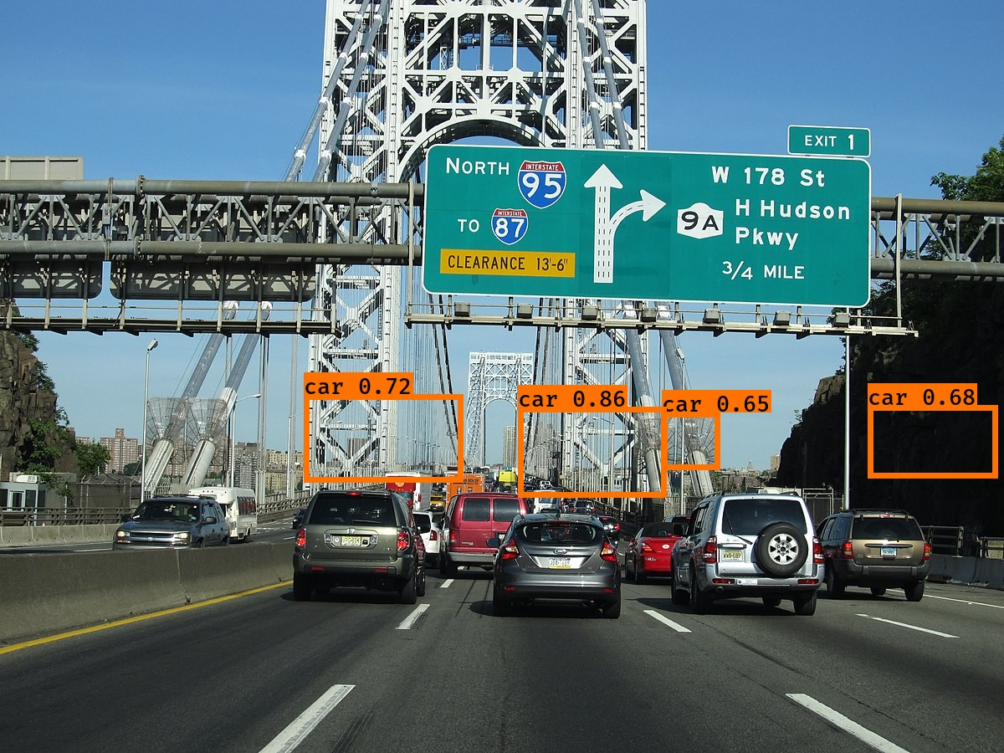

Original pic output pic

It’s incorrectly incorrect bounding boxes

11. Adjusting parameters like max_boxes, score_threshold, and iou_threshold of the yolo_eval function can potentially address the limitations you noticed in step 10.

* + Change the max_boxes [integer value] to a different value but use the original values for other 2 variables. Rerun the required cells to get the output images for the autonomous driving dataset. Observe if this result in improvement compared to step 10 for the same two images. If there are any improvements, write them in the word file. Include the new 2 output images in the word file.
  + Change the score_threshold [value between 0-1] to a different value but use the original values for other 2 variables. Rerun the required cells to get the output images for the autonomous driving dataset. Observe if this result in improvement compared to step 10 for the same two images. If there are any improvements, write them in the word file. Include the new 2 output images in the word file.

Change the iou_threshold [value between 0-1] to a different value but use the original values for other 2 variables. Rerun the required cells to get the output images for the autonomous driving dataset. Observe if this result in improvement compared to step 10 for the same two images. If there are any improvements, write them in the word file. Include the new 2 output images in the word file

Changing the max boxes it didn’t significantly changed the output

Decreasing the score_threshold it detect more objects

Before changing score_threshold after changing score_threshold

