**To achieve the TLS1.2 active, need to disable TLS 1.0 & 1.1, Enable TLS1.2 in the registry in the server**

[**https://docs.microsoft.com/en-us/previous-versions/windows/it-pro/windows-server-2012-R2-and-2012/dn786418(v=ws.11)?redirectedfrom=MSDN**](https://docs.microsoft.com/en-us/previous-versions/windows/it-pro/windows-server-2012-R2-and-2012/dn786418(v=ws.11)?redirectedfrom=MSDN)

**Step 1: Run command type “ regedit”**

**Go to the below mentioned path.**

**HKEY_LOCAL_MACHINE\SYSTEM\CurrentControlSet\Control\SecurityProviders\SCHANNEL\Protocols\**

1. **Create the TLS 1.0 , TLS 1.1 & TLS 1.2 as per the below screenshot.**
2. **Create the “server” under Each TLS 1.x path.**
3. **Create the DWORD** 
   1. **Name Enabled as per the below screenshot of TLS 1.0, TLS 1.1 & TLS 1.2 Create under each path ….\Protocols\TLS 1.X\server\**
   2. **Name DisabledByDefault as per the below screenshot of TLS 1.0 TLS 1.1 & TLS 1.2 Create under each path ….\Protocols\TLS 1.X\server\**

**Disable TLS 1.0 in server:**

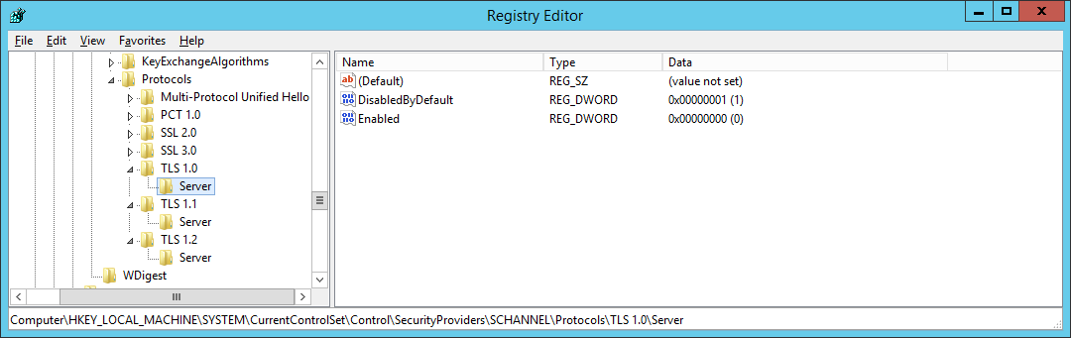

**Disable TLS 1.1 in server**

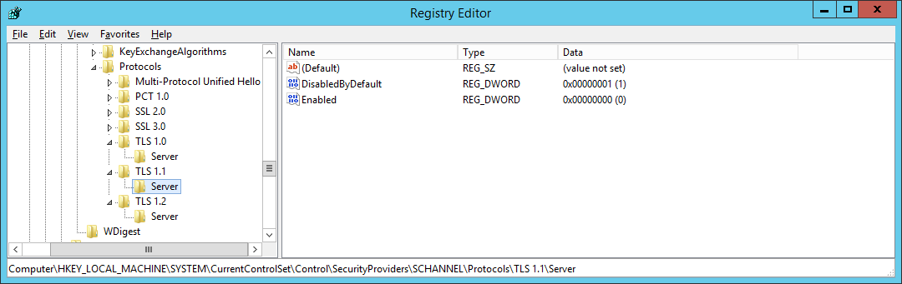

**Enable TLS 1.2 in server**

