**Redis IN BSIL0012**

**Set Password in Redis server in BSIL0012.**

1. Edit the file C:\Program Files\Redis\redis.windows-service.conf
2. Add this line in redis.windows-service.conf
   1. requirepass "**XXXXXXXXXXX**" (replace the with your password in **XXXXXXXXXXX**)

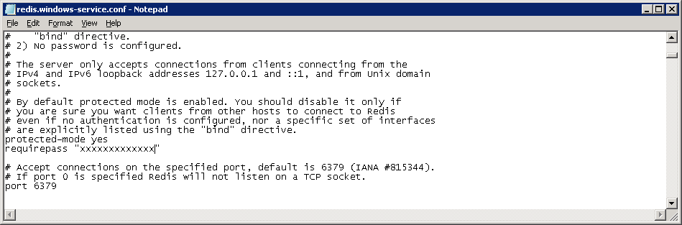

**The current password set in Redis server in BSIL0012**

**Botree@Redis#2019**