|  |  |
| --- | --- |
| A picture of a winding road and trees  Team FatArrow  Bala Sudhakar Gubbala | Great Things start from base zero  codewithbala@gmail.com  Minutes of Meetings |

Contents

06-Feb-2023 1

Team FatArrow

# 06-Feb-2023

## Spring

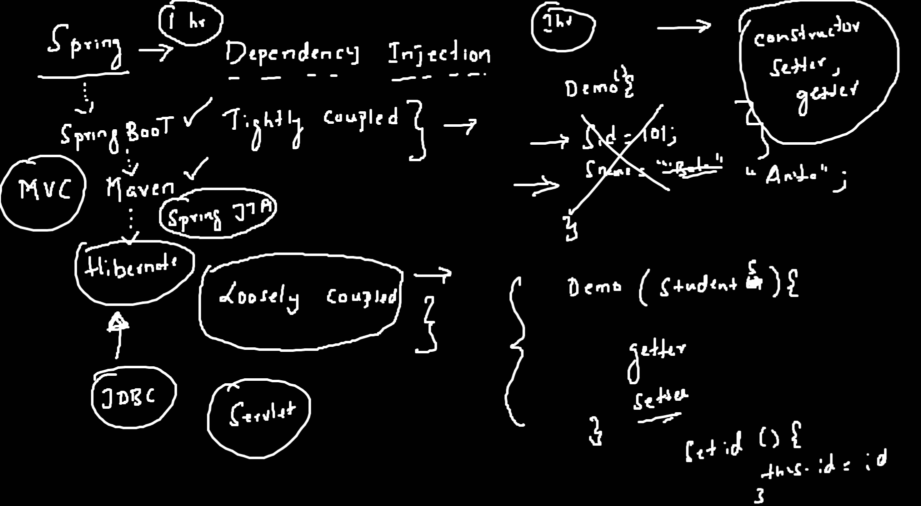

## C++

