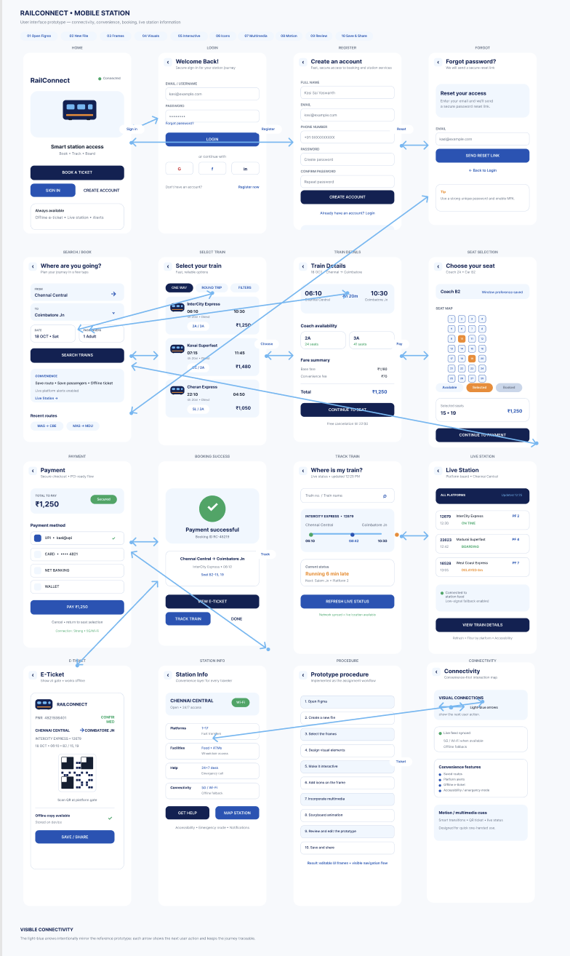

Figma Link: https://www.figma.com/design/YcZyTZcfnHx6GYzLGCLKXV/Mobile-Station-Ticket-Booking-Prototype?node-id=0-1&t=Jn7dOjpCRuylRQLG-1

