Data catalog system
Data model, rationale, Postgres/Supabase DDL, and UI wireframes
This document covers the three phases of the data catalog build: registering a data asset, cataloging and monitoring it, and profiling it for statistics and data quality. For each table it explains why the table exists and why each column is there, lists the relationships between tables, provides ready-to-run Postgres DDL for Supabase, and includes low-fidelity wireframes for the UI team to build from.

1. Entity relationship diagram
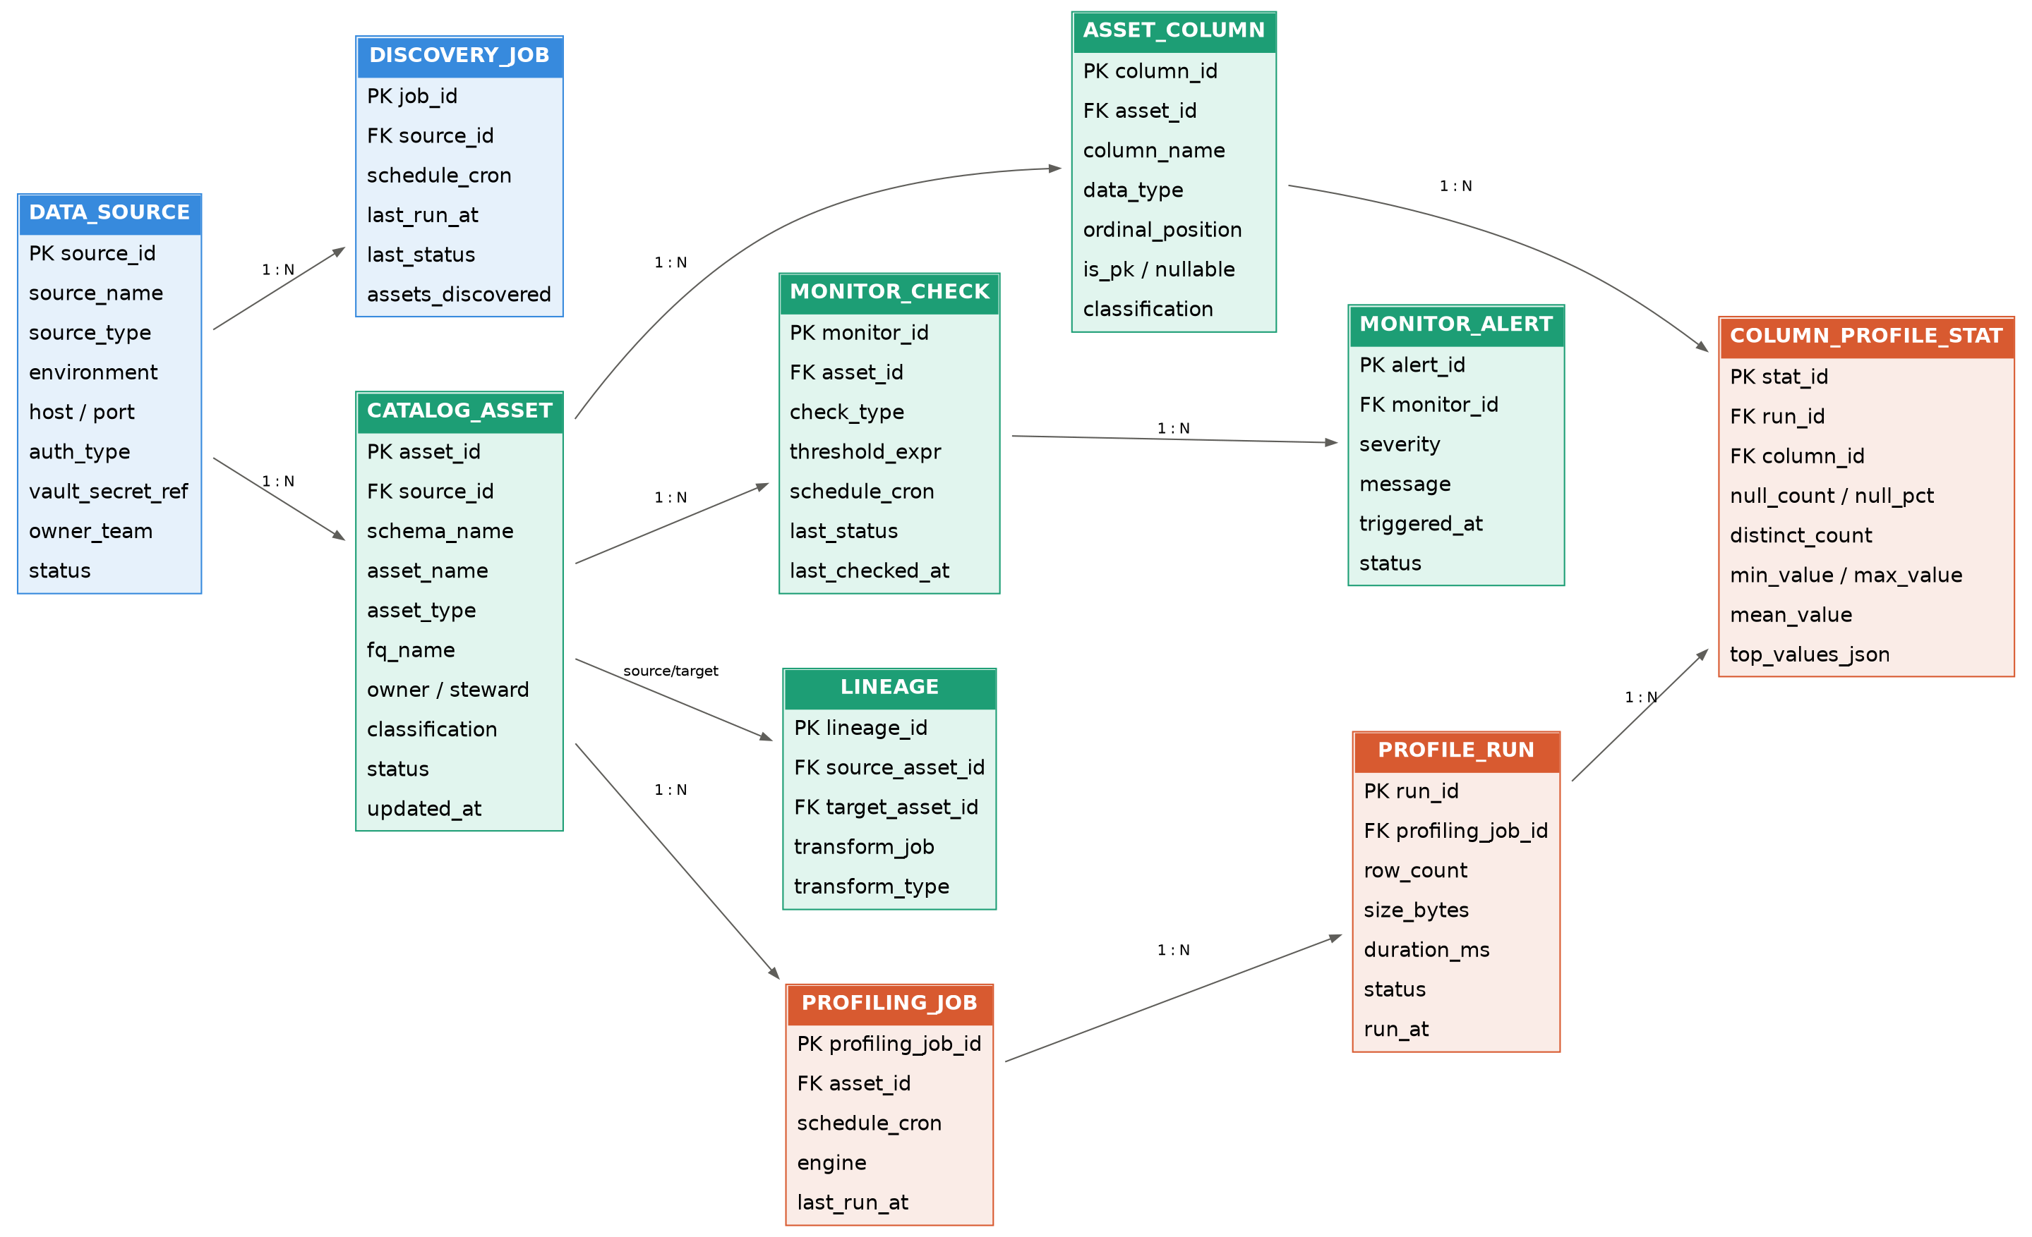
Figure 1. Full schema across registration (blue), catalog and monitoring (green), and profiling (orange).

2. Phase 1 — Register the asset
This phase captures a connection to a source system (Oracle, SQL Server, Postgres, a cloud warehouse, or object storage) and the job that crawls it. Nothing about catalog content lives here — only connection and crawl metadata.

2.1 DATA_SOURCE
Why this table exists: one row per connected system. This is the root of the whole model — every asset is scoped to a source, so deleting or disabling a source cascades sensibly to everything discovered under it.
Column | Type | Reason
source_id | uuid PK | Stable identifier other tables reference.
source_name | text | Human-readable label shown in the UI (e.g. prod-orders-db).
source_type | text (enum) | Drives which connector/driver logic to use — oracle, postgres, sqlserver, snowflake, s3, bigquery, etc. One polymorphic table instead of one table per DB type.
environment | text (enum) | Separates prod/staging/dev so monitoring thresholds and access rules can differ by environment.
host, port | text, int | Connection endpoint.
auth_type | text (enum) | basic / iam / oauth / service_account — tells the connector how to authenticate.
vault_secret_ref | text | Pointer to the secret in Vault/Secrets Manager. The actual credential is never stored in this table.
owner_team | text | Accountable team for this connection — used for access requests and incident routing.
status | text (enum) | active / inactive / pending — lets you register a source before it's live, or retire one without deleting history.

2.2 DISCOVERY_JOB
Why this table exists: the scheduled crawler that connects to a DATA_SOURCE and populates CATALOG_ASSET / ASSET_COLUMN. Kept separate from DATA_SOURCE because a source has one connection but can have its own discovery schedule and run history.
Column | Type | Reason
job_id | uuid PK | Identifies the job.
source_id | uuid FK | Which source this job crawls.
schedule_cron | text | When discovery runs automatically.
last_run_at, last_status | timestamptz, text | Lets the UI show crawl health without joining to a run-history table.
assets_discovered | int | Quick count for the registration confirmation screen ("247 tables found").

3. Phase 2 — Catalog and monitor
This phase is the catalog itself: what the asset is, who owns it, how sensitive it is, whether it's healthy, and how it connects to other assets.

3.1 CATALOG_ASSET
Why this table exists: the core catalog entry — one row per table, view, topic, or file discovered (or manually registered). This is what users search and browse.
Column | Type | Reason
asset_id | uuid PK | Referenced by columns, monitors, profiling jobs, and lineage.
source_id | uuid FK | Which DATA_SOURCE this asset came from.
schema_name, asset_name, fq_name | text | Fully qualified name for display and for joining back to the physical object.
asset_type | text (enum) | table / view / topic / file / api — the catalog isn't SQL-only, so this keeps it source-agnostic.
owner, steward | text | Owner is accountable for the data; steward is accountable for its quality and documentation — these are often different people.
classification | text (enum) | public / internal / confidential / pii / sensitive — drives access policy and highlights risk in the UI.
status | text (enum) | active / deprecated / archived — lets you flag an asset as being phased out without deleting its history.
updated_at | timestamptz | Last metadata refresh, shown in the asset list.

3.2 ASSET_COLUMN
Why this table exists: column-level metadata under each asset. Needed separately from CATALOG_ASSET because an asset has many columns, and classification/PII flags are often set at the column level, not the table level (a table can be mostly public with one PII column).
Column | Type | Reason
column_id | uuid PK | Referenced by profiling stats and data quality rules.
asset_id | uuid FK | Parent asset.
column_name, data_type, ordinal_position | text, text, int | Structural metadata from discovery.
is_pk, nullable | boolean | Used to validate data quality rules and to flag primary keys in the UI.
classification | text (enum) | Column-level sensitivity — the common real-world case for PII tagging.

3.3 MONITOR_CHECK and MONITOR_ALERT
Why these tables exist: ongoing health checks per asset (freshness, volume, schema drift, availability), and the alerts they raise. Split into two tables because a check definition is long-lived and recurring, while alerts are discrete events with their own lifecycle (open, acknowledged, resolved).
Column | Type | Reason
monitor_id | uuid PK | Identifies the check.
asset_id | uuid FK | Asset being monitored.
check_type | text (enum) | freshness / volume / schema_drift / availability.
threshold_expr | text | The rule being evaluated, e.g. max staleness 24h.
schedule_cron, last_status, last_checked_at | text, text, timestamptz | Run cadence and last outcome, shown in the asset list's monitor status column.
alert_id (FK monitor_id) | uuid PK/FK | One alert row per breach.
severity | text (enum) | low / medium / high / critical — drives notification routing.
message, triggered_at | text, timestamptz | What happened and when.
status | text (enum) | open / acknowledged / resolved — alert lifecycle, independent of the check's own schedule.

3.4 LINEAGE
Why this table exists: traces how data flows between assets so an impact-analysis view ("what breaks if I change this table") is a simple graph query. It's self-referencing — both source_asset_id and target_asset_id point back to CATALOG_ASSET — rather than a separate table per direction.
Column | Type | Reason
lineage_id | uuid PK | Identifies the edge.
source_asset_id, target_asset_id | uuid FK x2 | Both reference CATALOG_ASSET — this is what makes it a graph.
transform_job, transform_type | text, text (enum) | What produced the edge — an ETL job, a view definition, a stream — shown when a user asks "why are these connected".

4. Phase 3 — Profiling and stats
This phase runs statistical profiling on asset data and tracks results over time, plus optional explicit data quality rules.

4.1 PROFILING_JOB and PROFILE_RUN
Why split: PROFILING_JOB is the recurring configuration (schedule, engine); PROFILE_RUN is one row per execution. Keeping runs as their own append-only table is what gives you trend lines for free — row count growth, null-rate drift — instead of only ever seeing the latest snapshot.
Column | Type | Reason
profiling_job_id | uuid PK | Identifies the recurring job.
asset_id | uuid FK | Asset being profiled.
schedule_cron, engine | text, text (enum) | When it runs and which engine executes it (native_sql / spark / python) — larger assets often need Spark.
run_id (FK profiling_job_id) | uuid PK/FK | One row per execution.
row_count, size_bytes, duration_ms | bigint, bigint, int | Top-level run metrics shown as the summary stat cards.
status, run_at | text, timestamptz | Run outcome and timestamp — the x-axis for trend charts.

4.2 COLUMN_PROFILE_STAT
Why this table exists: the actual per-column statistics for a given run. This is deliberately one row per (run, column) rather than columns-as-fields on PROFILE_RUN, because the number of columns varies per asset and you want to query/chart a single column's history across runs easily.
Column | Type | Reason
stat_id | uuid PK | Identifies the stat row.
run_id, column_id | uuid FK x2 | Which run and which column this stat belongs to.
null_count, null_pct | bigint, numeric | Completeness — feeds the quality score.
distinct_count | bigint | Cardinality — flags potential keys or low-cardinality categoricals.
min_value, max_value, mean_value | text, text, numeric | Range and central tendency for numeric/date columns.
top_values_json | jsonb | Most frequent values with their share — drives the "top values" column in the UI without a separate table.

4.3 DATA_QUALITY_RULE and DATA_QUALITY_RESULT
Why these exist alongside profiling: profiling stats are automatic and descriptive; data quality rules are explicit assertions a steward defines ("email must never be null", "status must be one of 4 values") and are evaluated pass/fail against a run.
Column | Type | Reason
rule_id | uuid PK | Identifies the rule.
asset_id, column_id | uuid FK, uuid FK (nullable) | Rule can target a whole asset or a specific column.
rule_type | text (enum) | uniqueness / completeness / validity / consistency / accuracy / custom.
rule_expression, threshold | text, numeric | The actual check and its pass threshold.
severity | text (enum) | Drives whether a failure is a warning or blocks downstream consumption.
result_id (FK rule_id) | uuid PK/FK | One row per evaluation.
run_id | uuid FK (nullable) | Ties the result to a specific profiling run when evaluated alongside profiling; nullable so rules can also be evaluated standalone.
passed_count, failed_count, pass_rate | bigint, bigint, numeric | The actual outcome, charted as pass-rate history per rule.
status, evaluated_at | text, timestamptz | pass / fail / warn, and when.

5. Relationships summary
From | To | Relationship
DATA_SOURCE | DISCOVERY_JOB | 1 : N — a source has many discovery runs over time.
DATA_SOURCE | CATALOG_ASSET | 1 : N — a source contains many assets.
CATALOG_ASSET | ASSET_COLUMN | 1 : N — an asset has many columns.
CATALOG_ASSET | MONITOR_CHECK | 1 : N — an asset can have multiple health checks.
MONITOR_CHECK | MONITOR_ALERT | 1 : N — a check can fire many alerts over time.
CATALOG_ASSET | LINEAGE | 1 : N (x2) — an asset can be a source or target of many lineage edges.
CATALOG_ASSET | PROFILING_JOB | 1 : N — an asset can have one or more profiling configurations.
PROFILING_JOB | PROFILE_RUN | 1 : N — a job executes repeatedly.
PROFILE_RUN | COLUMN_PROFILE_STAT | 1 : N — each run produces stats for every profiled column.
ASSET_COLUMN | COLUMN_PROFILE_STAT | 1 : N — a column accumulates stat history across runs.
CATALOG_ASSET / ASSET_COLUMN | DATA_QUALITY_RULE | 1 : N — rules target an asset or a specific column.
DATA_QUALITY_RULE | DATA_QUALITY_RESULT | 1 : N — a rule is evaluated repeatedly over time.

6. SQL DDL — Postgres (Supabase)
Paste directly into the Supabase SQL editor. Creates all tables in dependency order, adds foreign keys inline, adds indexes on every FK, and enables Row Level Security with one example policy — extend the policies to match your auth model before going to production.
-- ============================================================
-- DATA CATALOG SCHEMA — Postgres / Supabase
-- Phase 1: Register | Phase 2: Catalog & Monitor | Phase 3: Profiling & Stats
-- ============================================================

create extension if not exists "pgcrypto";

-- ---------- PHASE 1: REGISTER THE ASSET ----------

create table data_source (
source_id uuid primary key default gen_random_uuid(),
source_name text not null,
source_type text not null check (source_type in
('oracle','postgres','sqlserver','mysql','snowflake','bigquery','s3','redshift')),
environment text check (environment in ('prod','staging','dev')),
host text,
port int,
auth_type text check (auth_type in ('basic','iam','oauth','service_account')),
vault_secret_ref text,
owner_team text,
status text not null default 'active' check (status in ('active','inactive','pending')),
created_at timestamptz not null default now()
);

create table discovery_job (
job_id uuid primary key default gen_random_uuid(),
source_id uuid not null references data_source(source_id) on delete cascade,
schedule_cron text,
last_run_at timestamptz,
last_status text check (last_status in ('success','failed','running')),
assets_discovered int default 0,
created_at timestamptz not null default now()
);

-- ---------- PHASE 2: CATALOG AND MONITOR ----------

create table catalog_asset (
asset_id uuid primary key default gen_random_uuid(),
source_id uuid not null references data_source(source_id) on delete cascade,
schema_name text,
asset_name text not null,
asset_type text check (asset_type in ('table','view','topic','file','api')),
fq_name text not null,
owner text,
steward text,
classification text check (classification in ('public','internal','confidential','pii','sensitive')),
status text not null default 'active' check (status in ('active','deprecated','archived')),
updated_at timestamptz not null default now(),
unique (source_id, fq_name)
);

create table asset_column (
column_id uuid primary key default gen_random_uuid(),
asset_id uuid not null references catalog_asset(asset_id) on delete cascade,
column_name text not null,
data_type text,
ordinal_position int,
is_pk boolean default false,
nullable boolean default true,
classification text check (classification in ('public','internal','confidential','pii','sensitive')),
unique (asset_id, column_name)
);

create table monitor_check (
monitor_id uuid primary key default gen_random_uuid(),
asset_id uuid not null references catalog_asset(asset_id) on delete cascade,
check_type text check (check_type in ('freshness','volume','schema_drift','availability')),
threshold_expr text,
schedule_cron text,
last_status text check (last_status in ('ok','warn','fail')),
last_checked_at timestamptz,
created_at timestamptz not null default now()
);

create table monitor_alert (
alert_id uuid primary key default gen_random_uuid(),
monitor_id uuid not null references monitor_check(monitor_id) on delete restrict,
severity text check (severity in ('low','medium','high','critical')),
message text,
triggered_at timestamptz not null default now(),
resolved_at timestamptz,
status text not null default 'open' check (status in ('open','acknowledged','resolved'))
);

create table lineage (
lineage_id uuid primary key default gen_random_uuid(),
source_asset_id uuid not null references catalog_asset(asset_id) on delete cascade,
target_asset_id uuid not null references catalog_asset(asset_id) on delete cascade,
transform_job text,
transform_type text check (transform_type in ('etl','elt','view','stream','manual')),
created_at timestamptz not null default now(),
check (source_asset_id <> target_asset_id)
);

-- ---------- PHASE 3: PROFILING AND STATS ----------

create table profiling_job (
profiling_job_id uuid primary key default gen_random_uuid(),
asset_id uuid not null references catalog_asset(asset_id) on delete cascade,
schedule_cron text,
engine text check (engine in ('native_sql','spark','python')),
last_run_at timestamptz,
created_at timestamptz not null default now()
);

create table profile_run (
run_id uuid primary key default gen_random_uuid(),
profiling_job_id uuid not null references profiling_job(profiling_job_id) on delete cascade,
row_count bigint,
size_bytes bigint,
duration_ms int,
status text check (status in ('success','failed','running')),
run_at timestamptz not null default now()
);

create table column_profile_stat (
stat_id uuid primary key default gen_random_uuid(),
run_id uuid not null references profile_run(run_id) on delete cascade,
column_id uuid not null references asset_column(column_id) on delete cascade,
null_count bigint,
null_pct numeric(5,2),
distinct_count bigint,
min_value text,
max_value text,
mean_value numeric,
top_values_json jsonb
);

create table data_quality_rule (
rule_id uuid primary key default gen_random_uuid(),
asset_id uuid not null references catalog_asset(asset_id) on delete cascade,
column_id uuid references asset_column(column_id) on delete cascade,
rule_type text check (rule_type in ('uniqueness','completeness','validity','consistency','accuracy','custom')),
rule_expression text,
threshold numeric,
severity text check (severity in ('low','medium','high','critical')),
created_at timestamptz not null default now()
);

create table data_quality_result (
result_id uuid primary key default gen_random_uuid(),
rule_id uuid not null references data_quality_rule(rule_id) on delete cascade,
run_id uuid references profile_run(run_id) on delete set null,
passed_count bigint,
failed_count bigint,
pass_rate numeric(5,2),
status text check (status in ('pass','fail','warn')),
evaluated_at timestamptz not null default now()
);

-- ---------- INDEXES ----------

create index idx_catalog_asset_source on catalog_asset(source_id);
create index idx_asset_column_asset on asset_column(asset_id);
create index idx_monitor_check_asset on monitor_check(asset_id);
create index idx_monitor_alert_monitor on monitor_alert(monitor_id);
create index idx_lineage_source on lineage(source_asset_id);
create index idx_lineage_target on lineage(target_asset_id);
create index idx_profile_run_job on profile_run(profiling_job_id);
create index idx_column_profile_stat_run on column_profile_stat(run_id);
create index idx_column_profile_stat_column on column_profile_stat(column_id);
create index idx_dq_rule_asset on data_quality_rule(asset_id);
create index idx_dq_result_rule on data_quality_result(rule_id);

-- ---------- ROW LEVEL SECURITY (Supabase stubs) ----------
-- Enable RLS on every table, then add policies matching your auth model.
-- Example shown for catalog_asset; repeat the pattern for the rest.

alter table data_source enable row level security;
alter table discovery_job enable row level security;
alter table catalog_asset enable row level security;
alter table asset_column enable row level security;
alter table monitor_check enable row level security;
alter table monitor_alert enable row level security;
alter table lineage enable row level security;
alter table profiling_job enable row level security;
alter table profile_run enable row level security;
alter table column_profile_stat enable row level security;
alter table data_quality_rule enable row level security;
alter table data_quality_result enable row level security;

create policy "Authenticated users can read catalog_asset"
on catalog_asset for select
using (auth.role() = 'authenticated');

-- Add insert/update/delete policies scoped to your team/role model, e.g.:
-- create policy "Owners can update their assets"
-- on catalog_asset for update
-- using (owner = auth.jwt() ->> 'email');

7. UI wireframes
Low-fidelity wireframes for the three core screens, matching the phases above. These are meant as a structural starting point for the design/frontend team, not a final visual design.

7.1 Register the asset
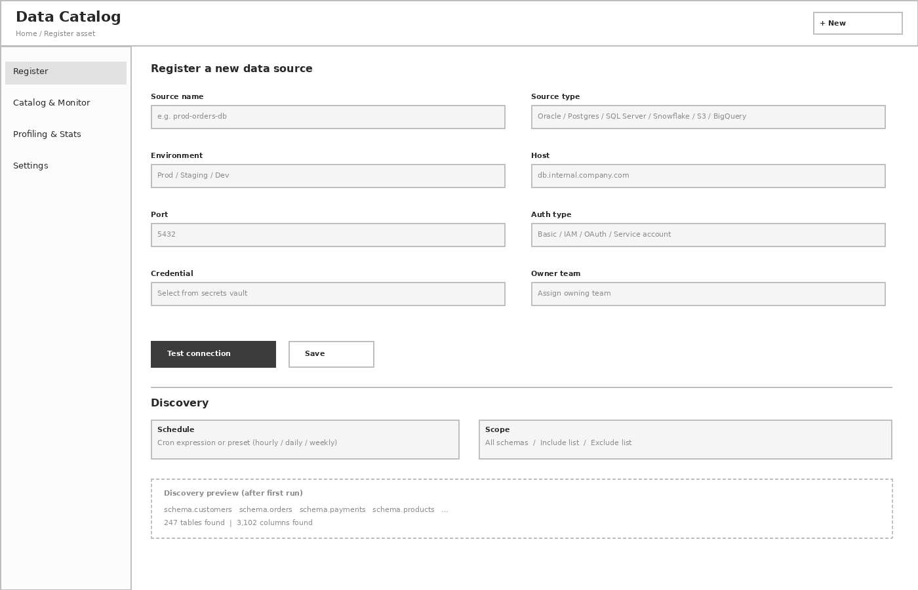
Figure 2. Connection form plus discovery scheduling and a preview of what discovery finds.

7.2 Catalog and monitor
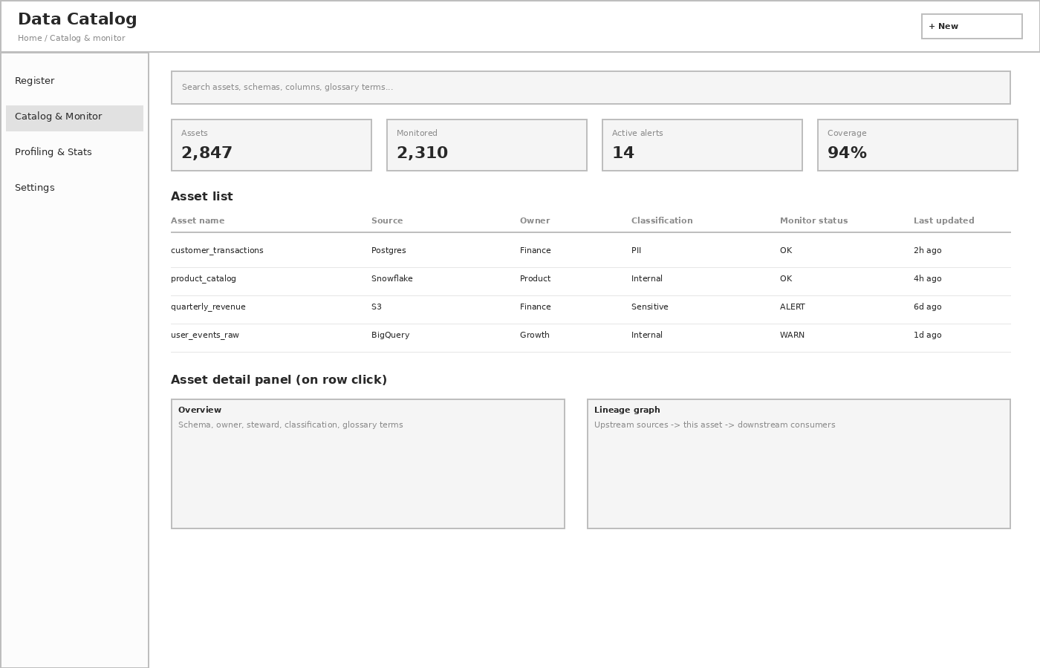
Figure 3. Searchable asset list with health status, plus an asset detail panel with overview and lineage.

7.3 Profiling and stats
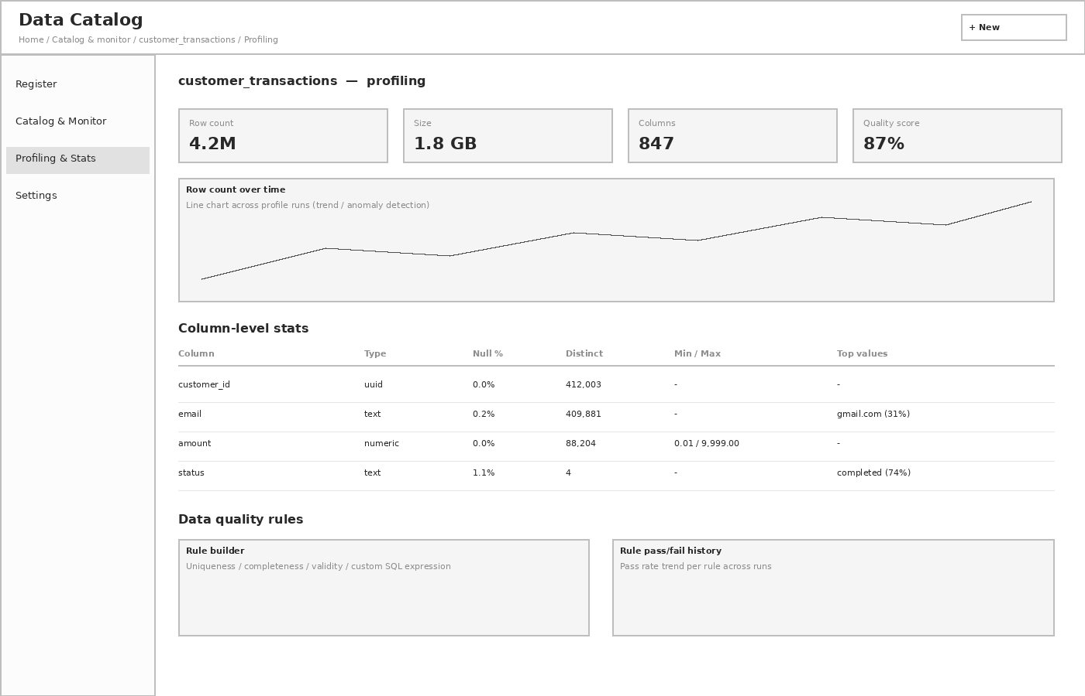
Figure 4. Per-asset profiling summary, row-count trend, column-level stats table, and data quality rules.

