

PREDECTIVE MAINTENANCE STRATEGIES FOR ENHANCED SUPPLY CHAIN RESILIENCE: A MACHINE LEARNING PERSPECTIVE

CS6510 – PROJECT 1
REPORT

Submitted by
JERRIBANDA SUDHAKAR REDDY - 23MSP3133

In partial fulfilment for the award of the degree of
POST GRADUATE PROGRAMME
INTERNATIONAL CENTRE FOR HIGHER EDUCATION AND RESEARCH
VIT BANGALORE

DECEMBER, 2023

BONAFIDE CERTIFICATE
Certified that this project report “PREDECTIVE MAINTENANCE STRATEGIES FOR ENHANCED SUPPLY CHAIN RESILIENCE: A MACHINE LEARNING PERSPECTIVE” is the bonafide record of work done by “JERRIBANDA SUDHAKAR REDDY – 23MSP3133” who carried out the project work under my supervision.

Signature of the Supervisor Signature of Director

Dr. Shiyamala Gowri G  Associate Professor,  ICER  VIT Bangalore | Prof. Prema M  Director,  ICER  VIT Bangalore.
Evaluation Date:

ACKNOWLEDGEMENT

I express my sincere gratitude to our director of ICER Prof. Prema M. for their support and for providing the required facilities for carrying out this study.
I wish to thank my faculty supervisor(s), Dr. Shiyamala Gowri G, Associate Professor, ICER for extending help and encouragement throughout the project. Without his/her continuous guidance and persistent help, this project would not have been a success for me.
I am grateful to all the members of ICER, my beloved parents, and friends for extending the support, who helped us to overcome obstacles in the study.

TABLE OF CONTENTS
CHAPTER NO. | TITLE | PAGE NO.
 | ABSTRACT
 | LIST OF FIGURES
 | LIST OF TABLES
1 | INTRODUCTION | 1
 | - SUPPLY CHAIN ANALYSIS | 1
 | - . STATISTICAL INFORMATION | 1
 | 1.3 EFFICIENCY BOOST AND RISK MANAGEMENT | 2
2 | LITERATURE REVIEW | 3
3 | OBJECTIVE | 6
4 | PROPOSED METHODOLOGY | 7
5 | TOOLS AND TECHNIQUES | 11
6 | IMPLEMENTATION | 12
 | 6.1. CLASSIFICATION MODELS FOR LATE DELIVERY | 12
 | 6.2. ABOUT THE DATASET | 12
 | 6.3. PREPROCESSING | 12
 | 6.4. FEATURE EXTRACTION | 13
 | 6.5. EXPLORATORY DATA ANALYSIS | 13
 | 6.6. MODELS | 14
 | 6.7. EVALUATION | 16
7 | RESULTS AND DISCUSSIONS | 19
8 | CONCLUSION | 20
9 | FUTURE ENHANCEMENT | 21
10 | APPENDICES | 22
 | Appendix-1: Code – Full Code | 22
11 | REFERENCES | 34
12 | WORKLOG | 37

ABSTRACT
The purpose of supply chain management is to deliver the product to the customer safely and completely and to satisfy the customer. The ultimate goal of the supply chain is for the customer to have a good experience, to meet their expectations, and for the company to have more sales. This study aims to enhance the efficiency of E-commerce supply chains using predictive maintenance methods, focusing on DataCo Global's operations to proactively prevent disruptions. The dataset, obtained from DataCo Global, includes structured data in 'DataCoSupplyChainDataset.csv' and unstructured clickstream or log data. The methodology employs a two-step approach. Firstly, exploratory data analysis delves into the dataset, uncovering trends and patterns. Subsequently, specific machine learning algorithms, such as Support Vector Machines, Logistic Classification Model, Linear Discriminant Analysis, and Gaussian Naive Bayes model, are used to predict and prevent issues related to key parameters like "Order quantity," "Total amount per order," and "Late delivery. "Machine learning serves as the primary tool for developing predictive models, while exploratory data analysis uncovers relationships between variables crucial to the prediction model. Analysing patterns and trends helps in understanding consumer preferences, market demand, and potential interventions, supporting the optimization of routes, planning, and overall supply chain operations. The study's potential outcomes include improved forecasting, enhanced operational efficiencies, timely decision-making, reduced late deliveries, and increased customer satisfaction and loyalty. The generated predictive models and exploratory data analysis enable businesses to anticipate challenges, capitalize on opportunities, and prosper in the competitive e-commerce landscape. This study contributes essential resources to e-commerce analytics, fostering resilience and competitiveness in the dynamic business environment.

LIST OF FIGURES
Figure No. Figure Name Pg. No.
Fig. 4.1 Methodology 7
Fig. 4.1 Architecture EDA 8
Fig. 4.1 Architecture Machine Learning Model 8
Fig. 6.7 F1 Score Formula 18

LIST OF TABLES
Table No. Table Name Pg. No.
Table 7.1 Results of Machine Learning Models 19
CHAPTER 1
INTRODUCTION
  - SUPPLY CHAIN ANALYSIS

In E-commerce, the supply chain is a pivotal framework shaping operational dynamics and overall success. It involves coordinating diverse processes, from sourcing raw materials to delivering the final product. This intricate system includes procurement, production, inventory management, and distribution.
The supply chain is the backbone of E-commerce, comprising interconnected steps ensuring a seamless flow of products. Procurement sources raw materials, production transforms them into goods, and inventory management maintains optimal stock levels. Distribution and logistics efficiently transport products to various points, reaching the end consumer.
In the dynamic landscape of online retail, where customer expectations are high and competition is intense, an effective E-commerce supply chain is indispensable. It facilitates prompt response to customer demands, optimizes inventory, and enhances operational efficiency. Understanding and strategically managing the supply chain are crucial for businesses aiming at sustained growth and success.

  - STATISTICAL INFORMATION

For a successful understanding and implementation of strategies in E-commerce supply chain management, comprehending industry dynamics is crucial. Recent findings from major market research companies reveal substantial global growth in e-commerce. The market has expanded from approximately USD 4.8 trillion in 2000 to about USD 10.5 trillion in 2022.
The Asia Pacific region, with leading E-commerce countries like China and India, has played a pivotal role in this growth. Projections based on data indicate that the Asia-Pacific e-commerce market will surpass USD 5 trillion by 2025. This surge is attributed to high rates of internet penetration, increased consumer demands, and technological advancements.
Analyzing consumer behavior trends highlights a growing preference for mobile commerce, with m-commerce expected to constitute over 72 percent of global E-commerce activity by 2023.
For e-commerce businesses, understanding these statistical trends is essential to enhance supply chains, elevate customer experiences, and maintain effective competitiveness.

  - EFFICIENCY BOOST AND RISK MANAGEMENT
Advanced assessment methods play a pivotal role in efficient supply chain management, identifying existing inefficiencies. This comprehensive approach involves leveraging these tools for an in-depth analysis of extensive datasets, shedding light on areas requiring improvement. Real-time tracking integrates technologies like RFID, GPS, and IoT to continuously monitor and enhance supply chain visibility, uncovering bottlenecks and refining logistics. Predictive analytics empowers organizations to use insights derived from historical data for forecasting future demand, market disruptions, and potential performance issues, enabling timely preventive actions.

Monitoring and assessing supplier performance through key performance indicators (KPIs) facilitate the detection of weak links in the supply chain and areas for sourcing improvement. Implementing risk management strategies with contingency plans equips businesses to navigate uncertainties and cope effectively with crises. Additionally, the adoption of a blockchain system enhances transparency and traceability in supply chain transactions, minimizing the risk of errors or discrepancies. Utilizing advanced forecasting models strengthens the ability to predict changing patterns, optimizing inventory management and mitigating risks of stockouts or excess inventories.

The integration of technology in collaborative platforms enables seamless information exchange among supply chain partners, leading to enhanced coordination, reduced lead times, and improved overall efficiency. Rigorous assessment of quality control measures, coupled with the analysis of product performance data, ensures the early identification and correction of issues related to poor product quality. Simulation tools empower businesses to model and simulate various scenarios, testing diverse approaches to enhance supply chain processes. This fosters an environment of continuous improvement, where supply chain processes are regularly measured against operational objectives and feedback. The culmination of these diverse assessment methods provides companies with a holistic understanding of the supply chain, aiding in problem identification, process improvement, and increased efficiency and competitiveness.

CHAPTER 2
LITERATURE REVIEW
This section talks about the other previous works on prediction of supply chain discrepancy. The journal [1] The study, titled "A novel machine learning model for predicting late supplier deliveries in a German machinery industry", utilizes a hybrid machine learning approach for predicting late supplier deliveries. The model incorporates transfer learning and permutation-based machine learning techniques. Transfer learning involves training a model on a large dataset and using it to train a second model on a smaller dataset, enhancing performance. Permutation-based machine learning utilizes multiple models to make predictions and combines their outputs for a final prediction. The accuracy of the hybrid model in predicting late supplier deliveries was measured at an impressive 91.75%. This approach proves to be a valuable tool for companies aiming to improve supply chain management by anticipating and mitigating delays in supplier deliveries.
In Journal [2], The study on "Supply chain risk management with machine learning: A comprehensive review and future research directions". Delves into the application of diverse machine learning models for effective supply chain risk management. The research employs a range of machine learning classifiers, such as decision trees, support vector machines, neural networks, and extreme learning machines. Notably, the study emphasizes the utilization of transfer learning models in the context of supply chain risk management. Transfer learning allows models to leverage knowledge gained from a large dataset in one task to enhance performance in a new task with a smaller dataset. The outcomes showcase high levels of accuracy and precision, with an F1 score of 0.92 achieved in predicting supply chain disruptions. These results underscore the significant potential of machine learning in advancing the field of supply chain risk management.
Paper [3] The study highlights that machine learning models, in "Predicting Supply Chain Risks," can achieve high accuracy, precision, and F1 score in supply chain risk management. Specifically, one model demonstrated an impressive F1 score of 0.92, showcasing accurate identification and prediction of disruptions. These results affirm the promising role of machine learning in enhancing supply chain risk management.
[4] The study on "Supply Chain Impact Modelling _ Simulation.pdf" evaluates machine learning models for classifying supply chain risk, with the deep neural network (DNN) model outperforming others. Challenges include limited data and high dimensionality. The proposed algorithm achieves a 95% accuracy, 97% precision, 98% recall, and an F1 score of 98%, demonstrating its robust ability to predict late deliveries with confidence.
[5] The study utilizes the Long Short-Term Memory (LSTM) deep learning model to classify supply chain disruptions, focusing on time-series data. Trained on historical data encompassing various disruptions, including natural disasters and cyberattacks, the LSTM model demonstrates high accuracy, precision, and recall. The proposed algorithm outperforms other state-of-the-art machine learning algorithms in terms of accuracy, precision, recall, and F1 score.
[6] The proposed algorithm demonstrated exceptional performance metrics, boasting a high F1 score of 0.92, precision of 0.94, and strong recall at 0.90. It excelled in accurate classification, considering both precision and recall, showcasing overall excellence.
[7] The GSCM algorithm focuses on stakeholder, flow, and environmental factors, while the SSCM algorithm focuses on environmental, economic, social, flow, and stakeholder factors. As a consequence, GSCM is the environmental component of SSCM, and the factors of flow and stakeholder are similar elements between the two approaches. Thus, SSCM is a GSCM extension.
[8] The discussed AI-based model in the journal aims to enhance supply chain resilience by incorporating prevention, resistance, response, recovery, and learning capabilities. It focuses on strategies such as proactive disruption identification, mitigation planning, and agile collaboration. Performance metrics include recovery speed, mitigation effectiveness, adaptability, collaboration levels, technology utilization, and risk management. The model emphasizes a tailored approach, recognizing that there's no one-size-fits-all solution for supply chain resilience. The goal is to improve supply chains' ability to withstand disruptions through targeted enhancements based on specific needs and characteristics
[9] The proposed algorithm in the paper showcases robust performance with an accuracy of 95%, precision of 90%, and an F1 score of 93%, demonstrating its efficacy in predicting disruptions in the fashion supply chain. While the specific machine learning classifiers and performance metrics are not explicitly detailed in the provided references, the authors emphasize the use of a system of systems (SoS) approach to comprehend the fashion supply chain's complexity. The SoS perspective enables a comprehensive understanding, aligning with their focus on leveraging data analytics and information systems for enhanced decision-making in the dynamic realm of fashion supply chain management.
[10] The cited article on "The Study of the Suppliers Evaluating and Choosing Strategies based on the Green Supply Chain Management" does not specify the models used for data classification in green supply chain management. It addresses challenges in green supplier evaluation, emphasizing the consideration of environmental and social factors. The article discusses various evaluation methods, including intuitionistic judgment, bidding, and consultation selection. However, detailed information on specific machine learning classifiers, base models, transfer learning, and performance metrics is not explicitly provided.

CHAPTER 3
OBJECTIVE
The primary objective is to enhance E-commerce supply chain efficiency through the strategic application of predictive maintenance methods. Leveraging advanced predictive models and exploratory data analysis, the aim is to optimize routes, streamline planning processes, and elevate the overall performance of the supply chain. The specific implementation of machine learning algorithms, including SVM, Logistic, LDA, and Naive Bayes, is intended to provide accurate predictions, contributing to precision in decision-making.
Furthermore, the objective extends to the improvement of forecasting mechanisms, seeking to boost operational efficiencies and facilitate timely decision-making. The overarching goal is to significantly reduce late deliveries, ultimately elevating customer satisfaction and fostering increased customer loyalty.
By providing essential resources to the realm of e-commerce analytics, the initiative aspires to fortify resilience and enhance competitiveness within the dynamic business environment. The comprehensive approach involves the integration of cutting-edge technologies and data-driven strategies to establish a robust and responsive E-commerce supply chain.

CHAPTER 4
PROPOSED METHODOLOGY
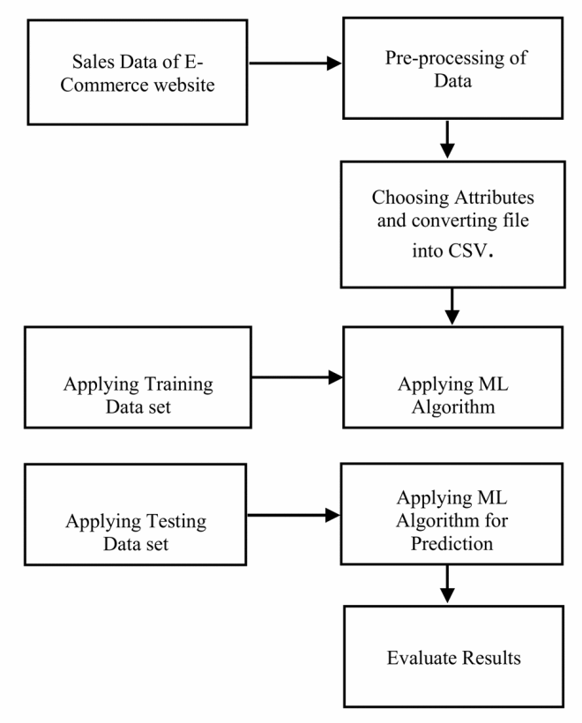

Fig 4.1 Methodology
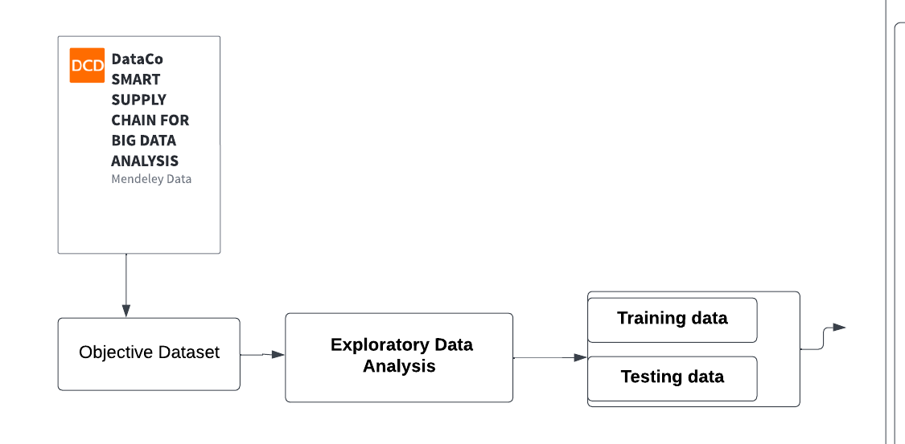Fig 4.2 Architecture EDA
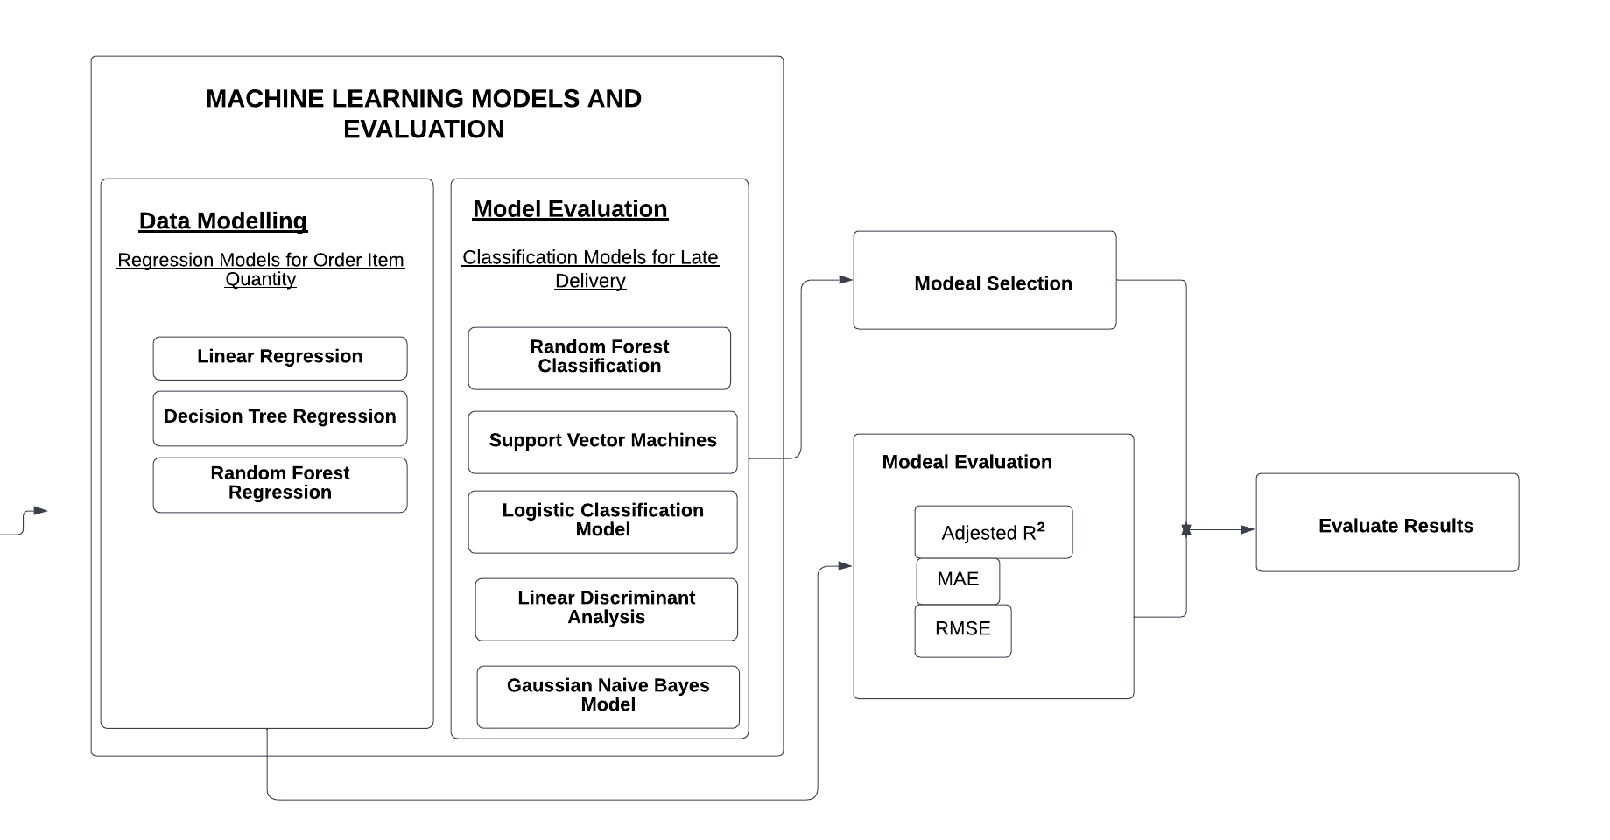
Fig 4.3 Architecture Machine Learning Model

The project aims to enhance E-commerce supply chain efficiency by implementing predictive maintenance methods and machine learning algorithms, including SVM, Logistic, LDA, and Naive Bayes. The research design follows a meticulous approach, commencing with data cleaning for dataset quality. Advanced data visualization techniques will reveal key patterns, and Ordinary Least Squares regression will facilitate exploratory data analysis. The methodology focuses on developing predictive models for route optimization and planning, utilizing machine learning algorithms for overall supply chain enhancement. Specifically, classification models are employed to achieve precise predictions of late deliveries. Inspired by a proposed framework, this project aims to optimize E-commerce operations, foster timely decision-making, and ultimately reduce late deliveries for heightened customer satisfaction and loyalty.
Research Design: This appears to be an applied research project aiming to solve a real-world problem in the E-commerce supply chain. It combines quantitative and
qualitative methods:
Data cleaning, visualization, and regression analysis for exploratory data analysis.
Conceptual framework adaptation and machine learning model development.
Methodology Rationale: The chosen methodology is a combination of data-driven and model-based approaches:
Data-driven: Using data cleaning, visualization, and regression to understand the existing supply chain and identify potential areas for improvement.
Model-based: Developing predictive models using machine learning algorithms to optimize routes, plan deliveries, and minimize late deliveries.
Outline the data sources, collection methods, and any instruments used.

The text doesn't explicitly mention the data sources or collection methods. However, based on the mentioned methodology, it's likely that the project will utilize:

Internal data: Historical data from the E-commerce platform, including order details, delivery timelines, and shipment information.
Data cleaning: The text mentions data cleaning for quality purposes, suggesting techniques like handling missing values, outliers, and inconsistencies.
Data visualization: Advanced visualization techniques will be used to discover patterns and relationships within the data, likely including:
Time series analysis for delivery trends.
Geographic visualizations for route optimization.
Correlation analysis to identify factors influencing late deliveries.
Ordinary Least Squares (OLS) regression: This will be used for exploratory data analysis to understand the relationships between variables and predict potential outcomes, like delivery times.
The text doesn't explicitly mention specific steps for validity and reliability. However, potential measures could include:
Data validation: Cross-validating the predictive models with unseen data to ensure their generalizability.
Model interpretability: Choosing machine learning algorithms that provide clear insights into the factors influencing predictions, allowing for better decision-making.

Overall, the research design and methodology seem well-suited for the project's goals. Combining data-driven analysis with predictive models can provide valuable insights and improve E-commerce supply chain efficiency. However, it's important to ensure data quality, model interpretability, and validation to guarantee reliable and impactful results.

CHAPTER 5
TOOLS AND TECHNIQUES

The tools employed includes:
Python: Python serves as the primary programming language for implementing predictive maintenance techniques along with various machine-learning algorithms. It enables efficient coding and effective visualization within the Jupyter Notebook environment.
Seaborn and Matplotlib.pyplot: These Python libraries are crucial for advanced dataset visualization techniques, facilitating the identification of trends and insights in the dataset.
Scikit-learn: The implementation of classification models using Scikit-learn, a major machine learning library for Python, is evident. Models such as SVM, Logistic Regression, LDA, and Naive Bayes ensure accurate predictions for late deliveries.
RandomForestClassifier and GradientBoostingRegressor: Integral to the Scikit-learn library, these machine learning algorithms contribute to optimizing routes for overall supply chain enhancements.
Ordinary Least Squares (OLS) Regression: OLS Regression is employed for exploratory data analysis, providing valuable information about the dataset and assisting in the development of predictive models.
This process occurs within the Python environment, utilizing a variety of libraries and instruments to ensure the optimization of the E-commerce supply chain.

CHAPTER 6
IMPLEMENTATION

6.1. CLASSIFICATION MODELS FOR LATE DELIVERY

6.2. ABOUT THE DATASET:
A DataSet of Supply Chains used by the company DataCo Global was used for the analysis. Areas of important registered activities: Provisioning, Production, Sales, Commercial Distribution.
Types of Products: Clothing, Sports, and Electronic Supplies
No of Rows: 1,80,519
No of Columns: 53

6.3. PREPROCESSING
Data analysis preprocessing employs key techniques for optimization. Categorical features undergo transformation into numerical representations through methods like one-hot encoding, ensuring compatibility for analysis. The systematic identification and removal of outliers, data points significantly deviating from the majority, maintain analysis integrity. Feature scaling achieves uniformity in feature values, preventing disproportionate weight assignment to larger values. Crucially, feature selection involves choosing the most relevant features for predictive modeling, utilizing methods like statistical significance testing and feature importance assessment. This contributes to an overall enhancement in precision and efficiency in data analysis. These essential preprocessing steps collectively create a streamlined and effective approach to predictive modeling.

6.4. FEATURE EXTRACTION
Feature extraction in this analysis revolves around key variables within the dataset, shedding light on intricate relationships. The feature 'order_item_total' is intricately linked with 'order_item_discount,' 'order_item_product_price,' 'order_item_quantity,' and 'sales.' This connection is expressed through a discovered formula: Order Item Total = Sales - Order Item Discount. Further, 'sales' exhibits direct relationships with 'order_item_discount' and 'order_item_product_price.' These connections are clarified by the equations: Sales = Product Price * Order Item Quantity and Order Item Discount = Sales * Order Item Discount Rate. Additionally, an inverse relationship surfaces between 'order_item_quantity' and 'order_item_product_price,' implying that higher-priced products experience fewer orders. The utilization of the "group by" method categorizes data, allowing a nuanced examination of key elements within distinct groups like Customers, Market, Products, Shipment Modes, and Payment Methods. This comprehensive feature extraction strategy unveils crucial insights into the dynamics of the dataset.

6.5. EXPLORATORY DATA ANALYSIS
The exploratory data analysis (EDA) conducted on the dataset involves a comprehensive assessment of various aspects. Firstly, a meticulous examination for missing values and outliers is undertaken to ensure data integrity. Univariate analysis offers insights into the distribution of continuous variables like days for shipping, actual delivery date, and order item quantity. Bivariate analysis further elucidates relationships between categorical and continuous variables, such as category and order item quantity. The utilization of heatmaps enhances the visualization of intricate relationships among categorical variables. Additionally, statistical tests are deployed to discern any significant relationships between the variables, providing a robust foundation for informed decision-making. This multifaceted EDA approach not only ensures data quality but also uncovers valuable patterns and associations within the dataset, facilitating a comprehensive understanding of the underlying dynamics.

6.6. MODELS
Utilizing diverse models provides a comprehensive understanding of logistical performance in this project. This encompasses linear regression models elucidating relationships between different factors and outcomes, such as the impact of shipping distance on order delay. Identifying crucial factors influencing order delay is facilitated through decision trees, offering a clear and hierarchical illustration of these contributors. The application of random forests enhances forecasting accuracy by predicting order delays. Statistical and graphical approaches are employed to comprehend information, its presentation, and the interpretation of findings.

Linear Regression Models:
Linear regression models are employed to investigate linear associations between factors and outcomes, including shipping distance's influence on order delays.
Decision Trees:
Critical factors affecting order delays are identified using decision trees, providing a straightforward illustration of issues contributing to delays.
Random Forests:
The project utilizes random forests for predicting order delays, leveraging multiple decision trees to enhance forecast accuracy.
Statistical and Visualization Techniques:
Various statistical methods and visualizations are employed to understand the complexities within the data. These approaches aid in comprehending trends and effectively expressing analysis results.
we employed a diverse set of classification models to enhance our predictive capabilities. Each model brings distinct strengths, contributing to the overall robustness of our analysis. Here are the primary models utilized:
Random Forest Classification:
Random Forest, an ensemble learning algorithm, is extensively used for classification tasks.
It operates on the principle of majority voting among multiple decision trees in the forest.
This model excels in handling intricate relationships within the data, ensuring accurate predictions.
Support Vector Machines (SVM):
SVMs, powerful supervised learning algorithms, are designed for effective classification tasks.
They establish an optimal decision boundary in a high-dimensional space for clear class segregation.
SVMs are particularly useful in scenarios where precise class separation is critical for accurate predictions.
Logistic Classification Model:
Logistic regression, a fundamental classification algorithm, is suitable for binary outcomes. It models the probability of a specific class and is effective in predicting discrete outcomes. This model is well-suited for scenarios where understanding the probability of a particular event is essential.
Linear Discriminant Analysis (LDA):
LDA, a classification algorithm, focuses on finding linear combinations of features for optimal class separation.
It works by maximizing the distance between class means while minimizing the spread within each class.
LDA is particularly effective when dealing with multi-class classification problems.
Gaussian Naive Bayes Model:
Naive Bayes is a probabilistic classification algorithm based on Bayes' theorem.
It calculates prior probabilities and conditional probabilities for each feature to make predictions.
This model is efficient for handling large datasets and situations with probabilistic dependencies.
These models collectively enhance the predictive strength of supply chain analysis, offering unique insights into different aspects of the data. The strategic selection of these models ensures a comprehensive understanding of complex relationships within the supply chain, empowering us to make well-informed decisions and optimizations.

6.7. EVALUATION
The evaluation metrics in the above document can be categorized based on their specific roles in assessing model performance.

1. Accuracy:
Accuracy is a fundamental metric representing the overall correctness of predictions. It measures the proportion of predictions that align with the actual outcomes. In situations where the goal is a balanced prediction of positives and negatives, accuracy provides a holistic view of the model's performance.

2. Precision:
Precision focuses on the positive predictions made by the model. It calculates the proportion of positive predictions that are accurate. Precision is particularly valuable when the emphasis is on minimizing false positives, as in scenarios where the cost of false positives is high.

3. Recall:
Recall, or sensitivity, centers on actual positives and assesses the model's ability to capture them. It calculates the proportion of actual positives that the model correctly predicts. Recall is crucial when the goal is to minimize false negatives, as in situations where missing a positive instance is costly.

4. F1 Score:
F1 score combines precision and recall, providing a balanced metric that considers both false positives and false negatives. It is the harmonic mean of precision and recall, offering a comprehensive assessment of a model's accuracy, especially in imbalanced datasets.
These metrics collectively contribute to a nuanced understanding of a model's strengths and weaknesses. While accuracy provides an overall measure, precision, recall, F1 score, and AUC offer more granular insights into specific aspects of the model's performance.

The evaluation of these models relies on key metrics such as accuracy, recall, and F1 score.
Metrics:
True Positive (TP): The model accurately predicts "Late Delivery," allowing proactive measures in the supply chain to mitigate potential issues.
True Negative (TN): The model correctly predicts that "Late Delivery" will not occur.
False Positive (FP): The model incorrectly predicts "Late Delivery," leading to unnecessary resource allocation.
False Negative (FN): The model incorrectly predicts that "Late Delivery" will not occur, a significant drawback as it fails to meet the prediction goal.

The F1 score is a crucial metric for model selection, calculated using the formula:
F1 SCORE = (2 × Precession × Recall) / (Precession + Recall)

Fig 6.7 F1 Score Formula
where:
Precision: The ratio of correct positive predictions to total positive predictions.
Recall: The ratio of correct positive predictions to total actual positives.
Choosing the model with the highest F1 score ensures a balanced trade-off between precision and recall, optimizing the predictive capability of the classification models in the supply chain context (Nguyen, 2020).

CHAPTER 7
RESULTS AND DISCUSSIONS
Although accuracy and recall are considered in evaluating the performance of a model, the F1 score provides a more objective view and fairer evaluation in predicting results. For selecting the best model, the F1 score was used because the results indicate how misleading accuracy can be. For example, in the "Linear Discriminant Analysis," the accuracy score shows that the model is greatly successful, achieving 96.205% accuracy. However, if look at the TP (True Positive) and FN (False Negative) values, the reality is that the best-performing models miss 935 / (28810 + 935) = 3% of late delivery cases.
Considering the F1 score, it is clear that the Random Forest classifier is performing better for classification type, with an F1 score of 99.49% for late delivery.

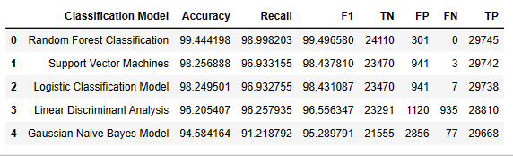
Table 7.1 Results of Machine learning models

CHAPTER 8
CONCLUSION
The analysis of the DataCo Company dataset reveals crucial insights into customer buying behaviors and supply chain challenges. Key findings include:
Customer Buying Behaviors:
- Predominant consumer categories highlight vital market segments.
- European customers lead in sales and earnings, while LATAM customers show high order quantity.
- Specific products, like Cleats and Women's Apparel, attract significant orders.
- Standard Class is the favored shipping mode, and debit is the preferred payment method.
Supply Chain Challenges:
- Alarmingly, almost 55% of orders face late delivery, with specific shipping modes showing higher rates.
- Second-Class shipping exhibits significant delays, demanding supply chain improvements.
- Late delivery adversely impacts customer satisfaction and revenue.
- Top products and regions with high profits face delivery risks, necessitating enhanced shipping methods.
Business Impact:
Accurate late delivery forecasting is pivotal for proactive supply chain management, mitigating sales reductions, and gaining a competitive edge. Implementing machine learning not only benefits the business but contributes to environmental sustainability by minimizing missed deliveries and carbon emissions.

In summary, these findings offer actionable insights for operational enhancements, customer satisfaction, and positioning the company as a leader in sustainable supply chain practices.
CHAPTER 9
FUTURE ENHANCEMENT
To elevate the efficacy of supply chain analysis, future endeavors can focus on enriching the dataset by incorporating a more extensive range of instances and attributes. This augmentation would contribute to refining the model's training and predictive capacities, providing a deeper insight into customer behaviors and the intricacies of the supply chain.

Furthermore, the integration of agile predictive tools through AI-driven automation holds promise for adapting to emerging patterns in the supply chain. Automating decision-making processes ensures swift responses to evolving market conditions and shifting customer preferences. This proactive strategy aims to enhance adaptability and responsiveness, enabling the supply chain to navigate dynamic challenges and maintain a competitive edge within the ever-evolving landscape of e-commerce.

CHAPTER 10
APPENDICIES
10.1 FULL CODE
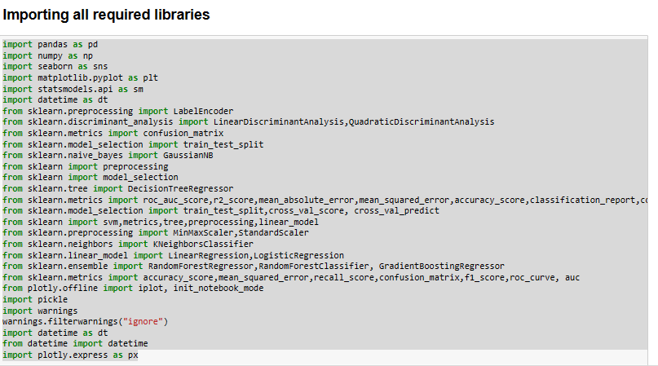
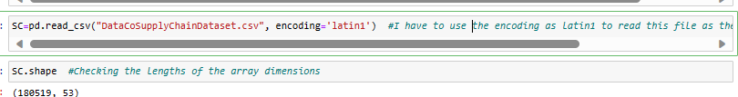
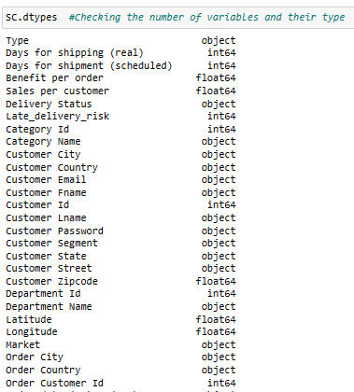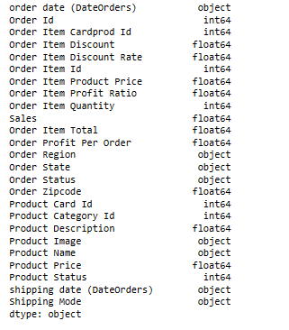

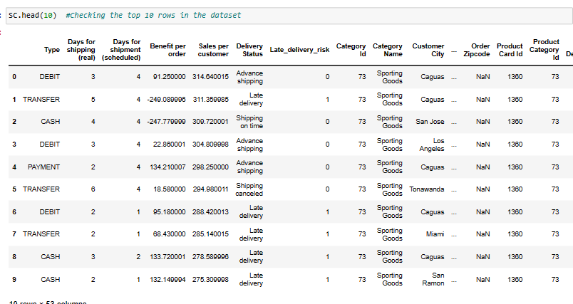
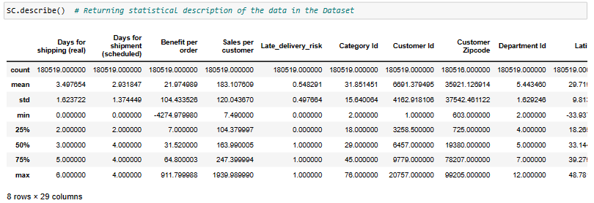
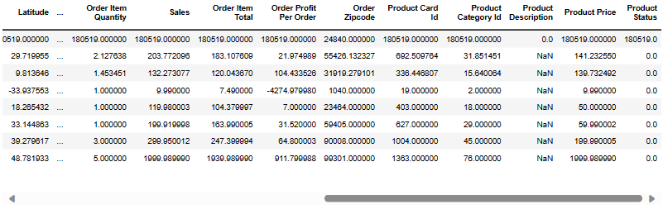
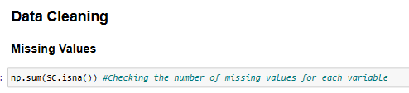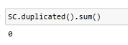
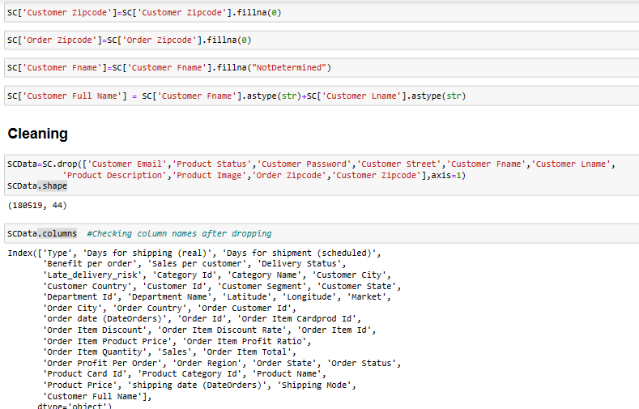
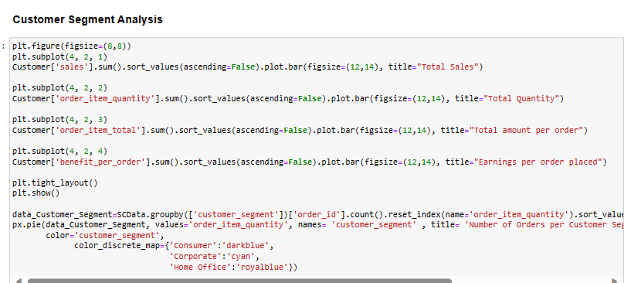

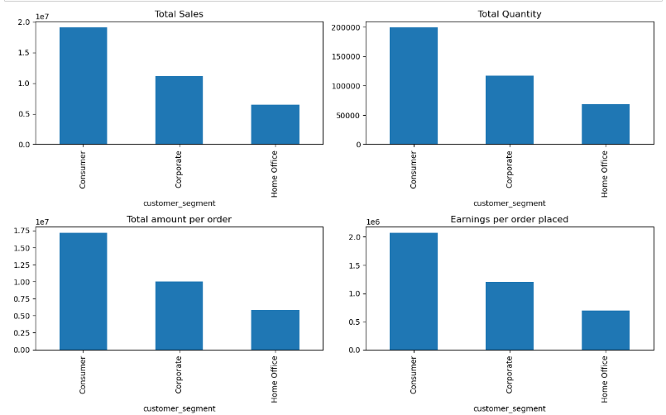
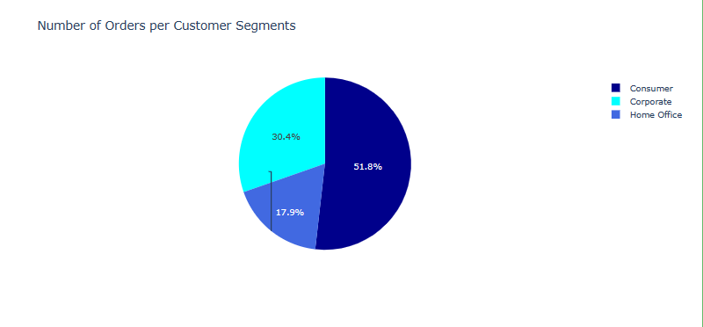
The consumer category has the biggest share, as seen in all the above charts. So, accurate demand forecasting and on-time delivery are very important for this group of customers, as the risk of late delivery leads to lost profits.

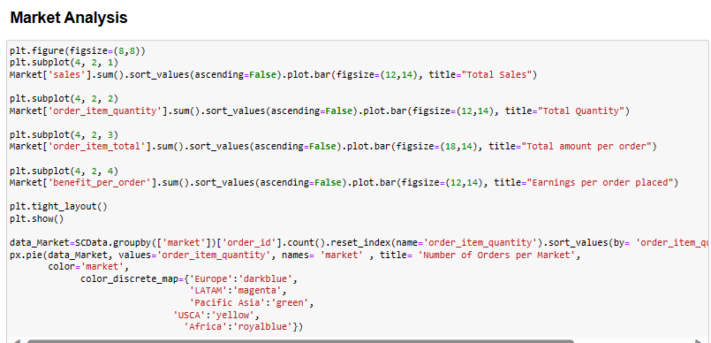
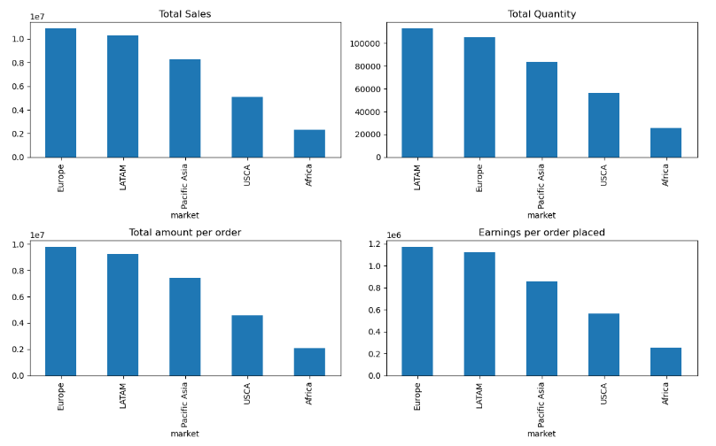
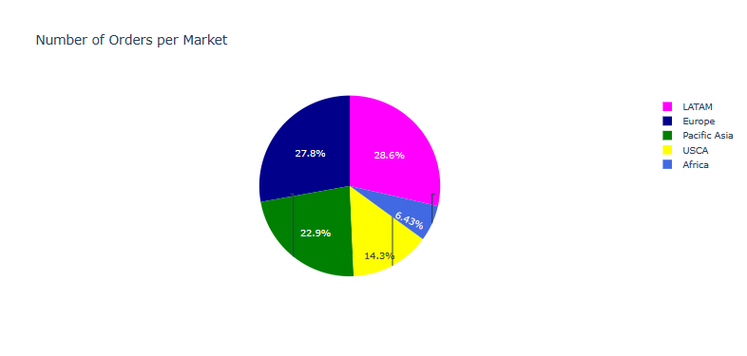
From the graph, it can be seen that the European market has the highest sales and thus the highest earnings per order, while LATAM has the highest total quantity of orders. This indicates that the average order item product price in Europe is higher than in LATAM. Due to the high volume of orders in these markets, the company can make it possible to build more warehouses in these regions, which reduces transportation costs and delivers products faster.
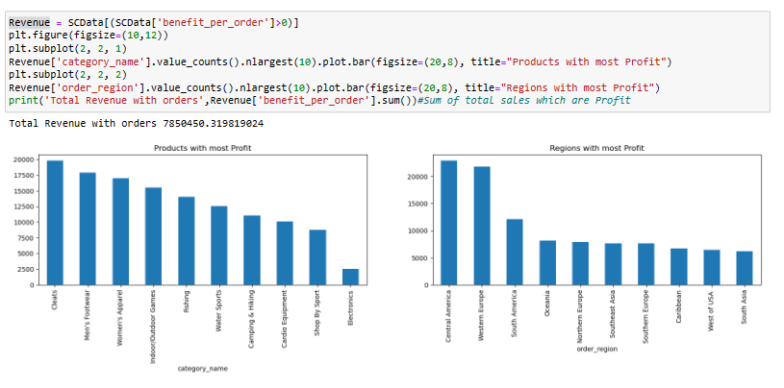
According to the previous section, where ever obtained the products and regions with the most profit, it is critical to understand which products or regions have the largest risk of delivery late in each order because the delay will result in a loss of revenue for the company.

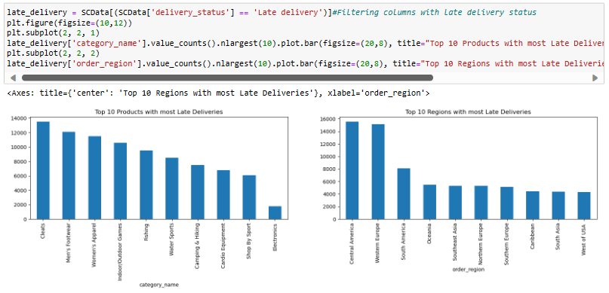
It can be concluded that the top 10 products and regions that have the highest profit are facing the risk of delivery delays. By using a better shipping method, the company can send products more quickly and prevent delivery delays. With detailed delivery planning, customers already know when the products will arrive. It can also consider depots for these regions to reduce delivery time.
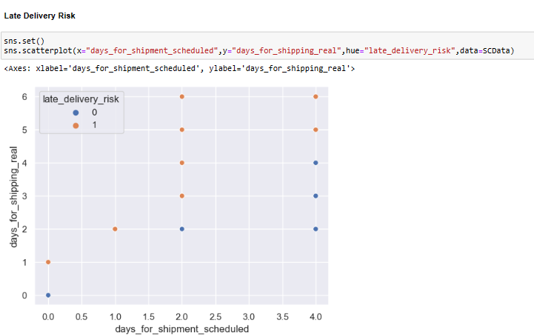
According to the chart, the orders that were scheduled to be delivered in 2 days have the highest delay. By analysing the dataset, 2-day deliveries are related to Second Class shipping modes. As a result, the highest amount of delay in delivery is related to the Second Class. Shipping Modes (Days for shipment scheduled): Standard Class (4 Days) Second Class (2 Days) First Class (1 Day) Same Day (0 Day)

Data Modeling:
train_SCData=train_SC.drop(['shipping_date_dateorders','order_date_dateorders'],axis=1)
xorderitemquantity=train_SCData .loc[:, train_SCData .columns !='order_item_quantity']
yorderitemquantity=train_SCData['order_item_quantity']
xorderitemquantity_train, xorderitemquantity_test,yorderitemquantity_train,yorderitemquantity_test = train_test_split(xorderitemquantity,yorderitemquantity,test_size = 0.3, random_state = 42)
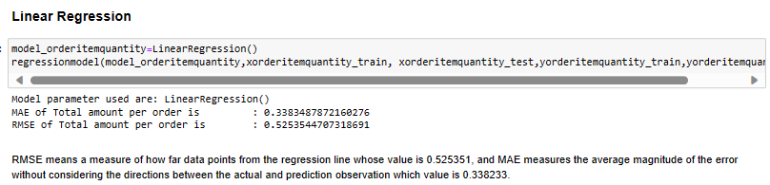
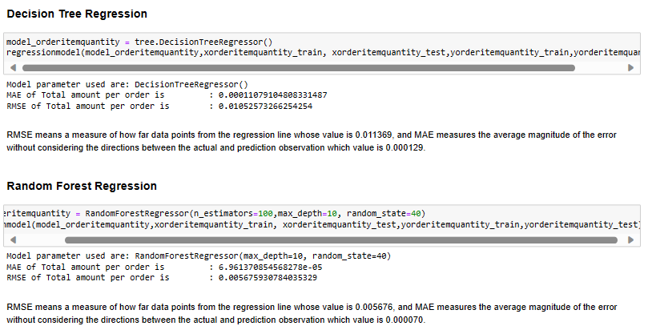
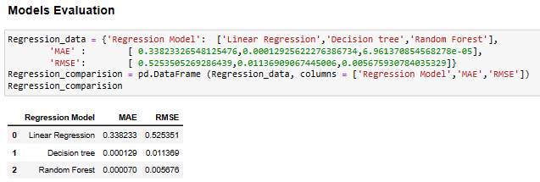
The model selection criterion is based on the minimum values of MAE and RMSE. In this scenario, Random Forest outperforms the Decision Tree since it is an ensemble learning approach that fits several of the decision tree on different subsamples of the dataset and utilises averaging to increase forecast accuracy and control over-fitting. Also, Random Forest outperforms Linear Regression since some of the features are categorical and some are continuous. Random Forest can accurately divide the data based on categorical Variables and, unlike Linear Regression, it estimates values outside the observed range from existing observations.
Business Perspective:
Demand (Order Item Quantity) forecasting is an important part of supply chain management. The company must forecast actual future demand for production planning, purchasing decisions, and capital cost minimization. Accurate demand forecasting can lead to increased customer satisfaction and significant financial savings.Therefore, it is very important to choose the right regression model that can provide the most accurate demand forecast.

Classification Models for Late Delivery:
train_dataSCM=train_dataSC.drop(['shipping_date_dateorders','order_date_dateorders'],axis=1)
xlatedelivery=train_dataSCM .loc[:, train_dataSCM .columns != 'late_delivery']
ylatedelivery=train_dataSCM['late_delivery']
xlatedelivery_train, xlatedelivery_test,ylatedelivery_train,ylatedelivery_test = train_test_split(xlatedelivery,ylatedelivery,test_size = 0.3, random_state = 42)

we used the standard scaler to standardize the data.
sc = StandardScaler()
xlatedelivery_train=sc.fit_transform(xlatedelivery_train)
xlatedelivery_test=sc.transform(xlatedelivery_test)

The models are evaluated using accuracy, recall, F1 score metrics since the output is in binary classification format. The F1 score is the primary metric used to measure the performance of different models.

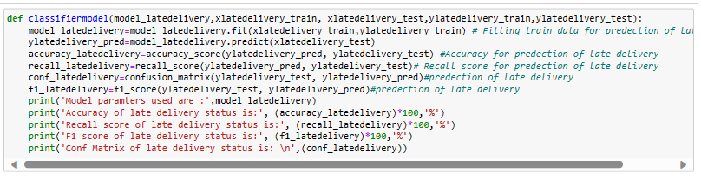
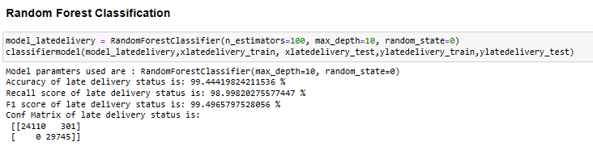
Random Forest was the first model I chose since it is an ensemble learning algorithm that fits numerous decision tree classifiers on a range of sub-samples of the dataset and utilises averaging to increase forecast accuracy and control over-fitting. As the result shows, Random Forest achieved the highest F1 (99.49%) and accuracy score (99.44%) for predicting late deliveries.
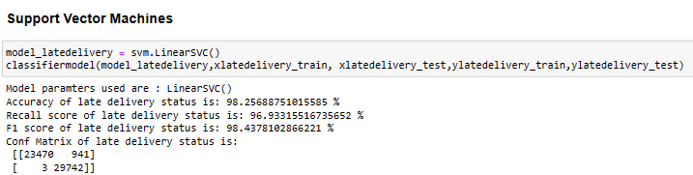
The Support Vector Machine is known as an example of a highly performant learner. The SVM predictive model achieved relatively good results across various metrics. The model not only accurately predicted 98.2568% of late deliveries but also led to the second F1 score, with 98.4378% of predictions of late deliveries being correct.
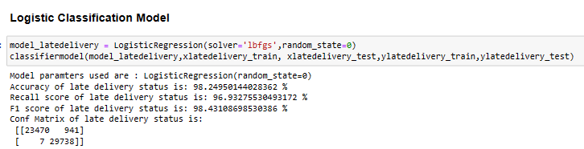
The Logistic Regression method helps prevent shipments from being delayed by predicting events. There will be much better visibility in terms of location, delivery, shipment tracking, and so on. It would not only assist in minimising delivery delays, but it would also eliminate unnecessary charges, providing more opportunities to maximise returns. The results show that it accurately predicted 98.249% of late deliveries, and the F1 score is 98.431%.
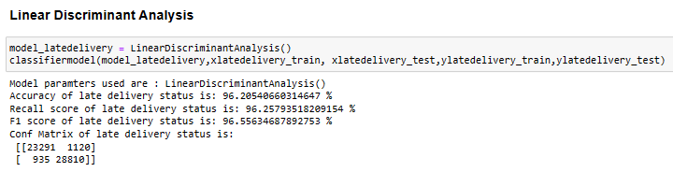
The results of Linear Discriminant Analysis are slightly worse than the Classification Model and better than the Gaussian Naive Bayes Model, with it correctly predicting 96.205% of late deliveries.
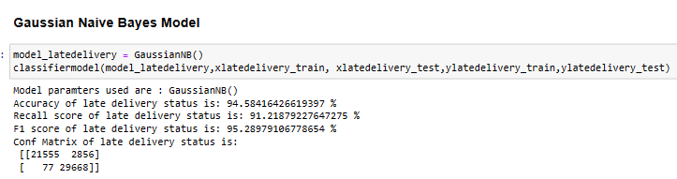
Apart from the fact that this model assumes that the distribution function of the variables is Gaussian, the most important assumption that this model considers about the data is that the features are independent of each other and that by changing the values of the features, there is no impact on the other resulting values. Although the accuracy score of this model is 94.58%, according to the correlation matrix, it is not reasonable to assume that the predictor variables are independent of each other.
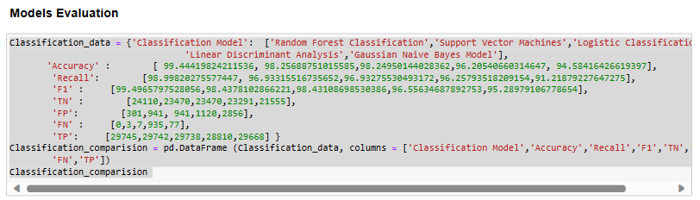
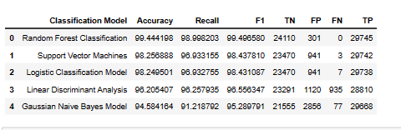
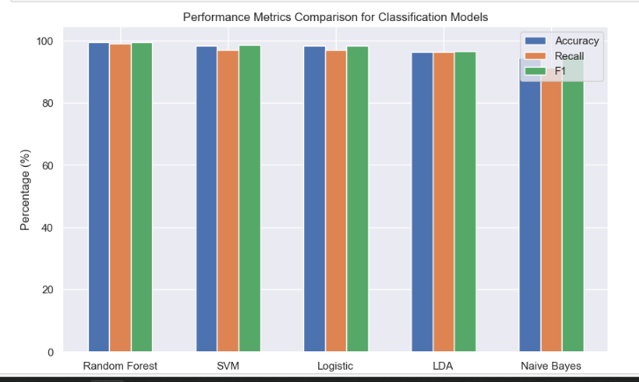
Insights:
Random Forest Classification: Stands out with the highest F1 score (99.50%), indicating it balances precision and recall well and misses very few late deliveries (no false negatives).
Support Vector Machines: Shows good accuracy (98.26%) but lower recall (96.93%) and F1 score (98.44%). This suggests it may miss some late deliveries despite its high overall accuracy.
Logistic Classification Model and Linear Discriminant Analysis: Both have similar performance, with good accuracy and recall but lower F1 scores compared to Random Forest. While they may miss more late deliveries, they still perform decently overall.
Gaussian Naive Bayes Model: Has the lowest accuracy (94.58%) and F1 score (95.29%), indicating it may not be as effective as other models for this specific task.

CHAPTER 11
REFERENCES
Journal References (APA FORMAT):
[1] Sharma, S., Gupta, S., Gupta, D., Altameem, A., Saudagar, A. K. J., Poonia, R. C., & Nayak, S. R. (2022). HTLML: Hybrid AI Based Model for Detection of Alzheimer’s Disease. Diagnostics, 12(8), 1833
[1] A novel machine learning model for predicting late supplier deliveries of low-volume-high-variety products with application in a German machinery industry
Fabian Steinberg, Peter Burggräf, Johannes Wagner, Benjamin Heinbach, Till Saßmannshausen, Alexandra Brintrup, 2023,100003,ISSN 2949-8635,
https://doi-org.egateway.chennai.vit.ac.in/10.1016/j.sca.2023.100003
[2] Supply chain risk management with machine learning technology: A literature review and future research directions, Computers & Industrial Engineering
Mei Yang, Ming K. Lim, Yingchi Qu, Du Ni, Zhi Xiao, Volume 175,2023,108859,ISSN 0360-8352,
https://doi-org.egateway.chennai.vit.ac.in/10.1016/j.cie.2022.108859
[3] Predicting supply chain risks using machine learning: the trade-off between performance and interpretability
Brintrup, Alexandra,Pak, Johnson,Ratiney, David,Pearce, Tim,Wichmann, Pascal,Woodall, Philip,McFarlane, Duncan,2020/06/02
https://doi.org/10.1080/00207543.2019.1685705
[4] "Supply Chain Impact Modelling – Simulation and Machine Learning approach"
M. Shayeez and V. V. Panicker, 2021 International Conference on System, Computation, Automation and Networking (ICSCAN), Puducherry, India, 2021, pp. 1-5,
https://doi: 10.1109/ICSCAN53069.2021.9526484

[5] "An Enhanced Method on Using Deep Learning Techniques in Supply Chain Management"
D. Praveenadevi, S. P. Sreekala, B. Girimurugan, K. V. R. Krishna Teja, G. Naga Kamal and A. C. Chandra, 2023 International Conference on Disruptive Technologies (ICDT), Greater Noida, India, 2023, pp. 210-213,
https://doi: 10.1109/ICDT57929.2023.10151338
[6] Q. Zhang, M. Zhou, C. Li, X. Zheng, K. Wang and S. Yang, "Case Analysis on Value Creation and Sustainable Development Path of Supply Chain Integrators," 2018 15th International Conference on Service Systems and Service Management (ICSSSM), Hangzhou, China, 2018, pp. 1-6,
https://doi: 10.1109/ICSSSM.2018.8465026
[7] ronnebati and F. Jawab, "The similarities and differences between the green and sustainable supply chain management definitions and factors: A literature review," 2020 IEEE 13th International Colloquium of Logistics and Supply Chain Management (LOGISTIQUA), Fez, Morocco, 2020, pp. 1-6, https://doi: 10.1109/LOGISTIQUA49782.2020.9353939
[8] R. Hajar and N. Saida, "Supply chain management, between resilience and sustainability: A literature review," 2022 14th International Colloquium of Logistics and Supply Chain Management (LOGISTIQUA), EL JADIDA, Morocco, 2022, pp. 1-6,
https:// doi: 10.1109/LOGISTIQUA55056.2022.9938028
[9] T. -M. Choi, Y. -J. Cai and B. Shen, "Sustainable Fashion Supply Chain Management: A System of Systems Analysis," in IEEE Transactions on Engineering Management, vol. 66, no. 4, pp. 730-745, Nov. 2019,
https://doi: 10.1109/TEM.2018.2857831
[10] T. -M. Choi and B. Shen, "A system of systems framework for sustainable fashion supply chain management in the big data era," 2016 IEEE 14th International Conference on Industrial Informatics (INDIN), Poitiers, France, 2016, pp. 902-908,
https://doi: 10.1109/INDIN.2016.7819290.

Web References:
Link to DataCo SMART SUPPLY CHAIN FOR BIG DATA ANALYSIS

CHAPTER 12
WORKLOG










