**Readme**

**Pre-Requisites:**

* JDK 22
* Maven
* Eclipse
  + Testng Plugin
  + Cucumber Plugin

**Framework Architecture Diagram:**

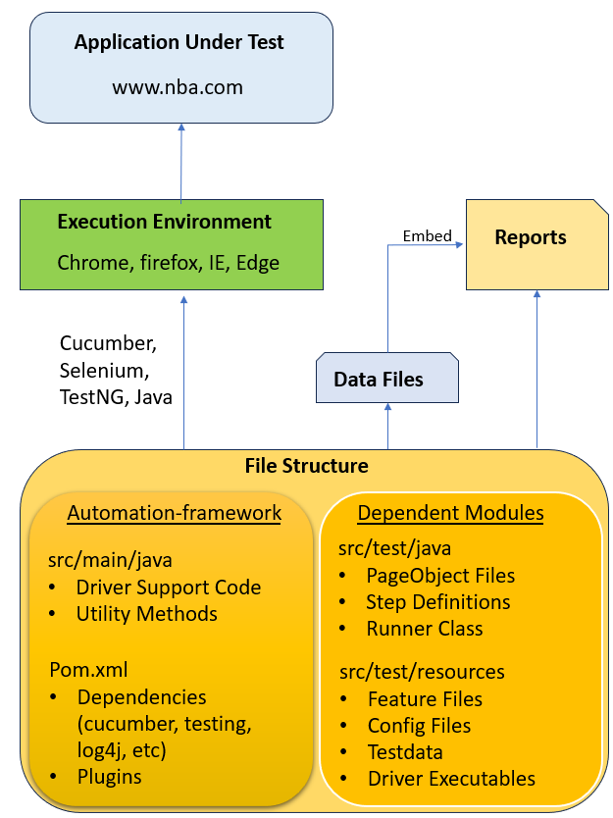

**Module Dependency:**

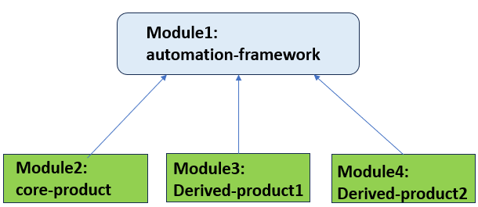

**Steps to Execute Testcases:**

* Executing testcases using mvn commands

Run any of the following commands to execute the testcases :

* mvn clean install (inside the folder SudhakarTestAssessment)
* mvn test
* mvn test -Dcucumber.filter.tags=”@Smoke”
* Execute using mvn from Eclipse
  + Right click on ‘SudhakarTestAssesment’ folder and click on ‘Run As’ followed by ‘Maven Build…”. Specify the goals as ‘clean install’.
* Execute tests using Cucumber Runner class + TestNG
  + In Eclipse, right click on the Runner class and click ‘Run As’, followed by TestNG
* Execute tests using feature file
  + In Eclipse, right click on feature file and click ‘Run As’, followed by ‘Cucumber Test’

**Features Used for Automation:**

* Testcase Automation for all 4 testcases
* Page Object Model
* Maven Multi Modules
  + Core-product, derived-product1 and derived-product2 modules have dependency only on automation-framework
  + Common functionality across modules, is only present in framework code
* Cucumber:
  + Feature Files, Step Definitions, Runner Class
  + Options
  + Hooks
  + Tags
* Reporting:
  + TestNG Reports
  + Cucumber Reports
* Execution on any browser (chrome, firefox, ie, edge)
* Usage of config files for identifying the browser, testurl, etc
* Usage of testdata files for data validation
* Usage of logger library (log4j) for efficient logging
* Usage of different waits:
  + Implicit, Explicit, FluentWait
* Usage of Java Regular expressions

**Screenshots:**

Config File:

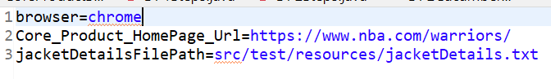

Testdata File:

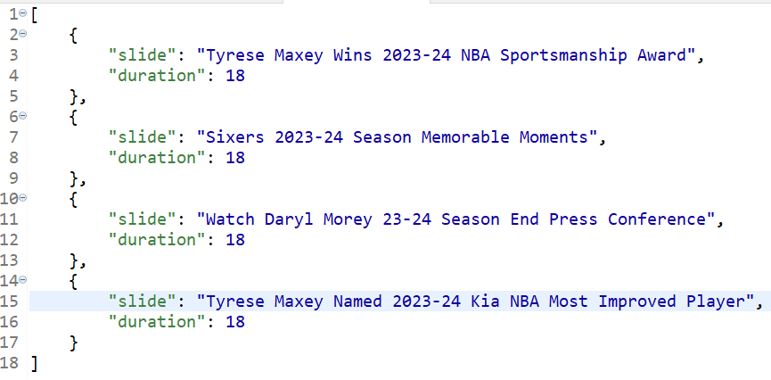

Reports:

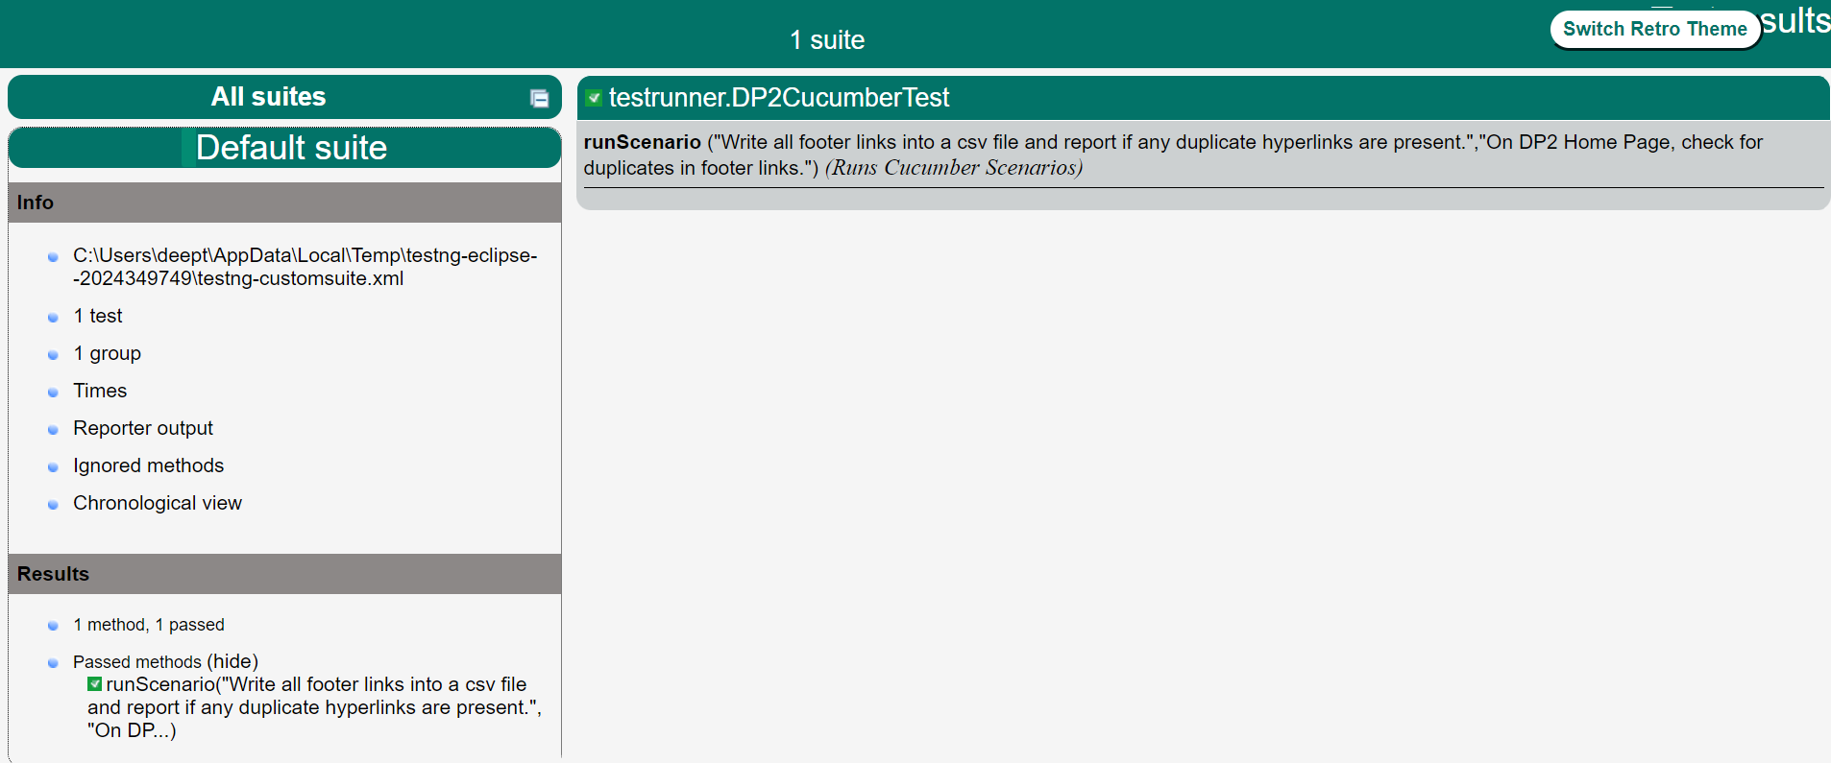

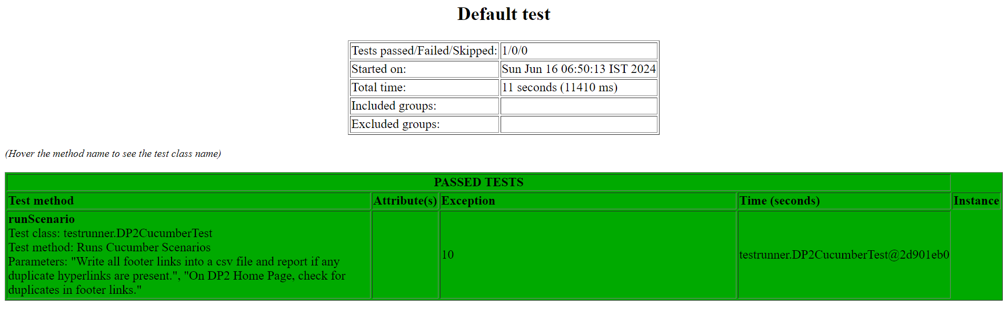

Folders and Files :

