**Exercise 1: Configuring a Basic Spring Application**

**Scenario:**

Your company is developing a web application for managing a library. You need to use the Spring Framework to handle the backend operations.

**Steps Performed:**

1. Created a Maven Project in Eclipse
2. Add Spring Dependencies
3. Create Spring Configuration File
4. Define Repository and Service Classes
5. Create Main Class to Run the Application

<dependencies>

<dependency>

<groupId>org.springframework</groupId>

<artifactId>spring-context</artifactId>

<version>5.3.30</version>

</dependency>

</dependencies>

<?xml version="1.0" encoding="UTF-8"?>

<beans xmlns="http://www.springframework.org/schema/beans"

xmlns:xsi="http://www.w3.org/2001/XMLSchema-instance"

xsi:schemaLocation="http://www.springframework.org/schema/beans http://www.springframework.org/schema/beans/spring-beans.xsd">

<bean id="bookRepository" class="com.library.repository.BookRepository" />

<bean id="bookService" class="com.library.service.BookService">

<property name="bookRepository" ref="bookRepository" />

</bean>

</beans>

package com.library.repository;

public class BookRepository {

public void display() {

System.***out***.println("BookRepository: Fetching book data...");

}

}

package com.library.service;

import com.library.repository.BookRepository;

public class BookService {

private BookRepository bookRepository;

public void setBookRepository(BookRepository bookRepository) {

this.bookRepository = bookRepository;

}

public void serve() {

System.***out***.println("BookService: Serving book request...");

bookRepository.display();

}

}

package com.library;

import org.springframework.context.ApplicationContext;

import org.springframework.context.support.ClassPathXmlApplicationContext;

import com.library.service.BookService;

public class MainApp {

public static void main(String[] args) {

ApplicationContext context = new ClassPathXmlApplicationContext("applicationContext.xml");

BookService service = (BookService) context.getBean("bookService");

service.serve();

}

}

**Output:**

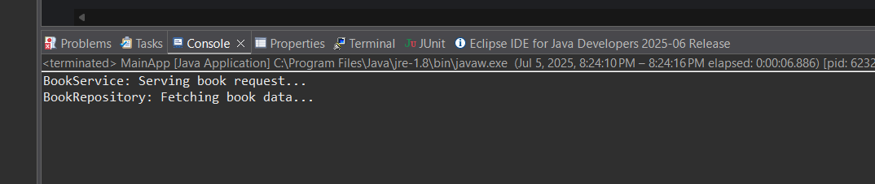

**Exercise 2: Implementing Dependency Injection**

**Scenario:**

In the library management application, you need to manage the dependencies between the BookService and BookRepository classes using Spring's IoC and DI.

**Steps Performed:**

1. Created a Maven Project in Eclipse
2. Added Spring Dependencies
3. Modified the Spring Configuration File (applicationContext.xml)
4. Updated the BookService class to include a setter for Dependency Injection
5. Tested the Dependency Injection using a main class

<dependencies>

<dependency>

<groupId>org.springframework</groupId>

<artifactId>spring-context</artifactId>

<version>5.3.30</version>

</dependency>

</dependencies>

<?xml version="1.0" encoding="UTF-8"?>

<beans xmlns="http://www.springframework.org/schema/beans"

xmlns:xsi="http://www.w3.org/2001/XMLSchema-instance"

xsi:schemaLocation="http://www.springframework.org/schema/beans http://www.springframework.org/schema/beans/spring-beans.xsd">

<bean id="bookRepository" class="com.library.repository.BookRepository" />

<bean id="bookService" class="com.library.service.BookService">

<property name="bookRepository" ref="bookRepository" />

</bean>

</beans>

package com.library.repository;

public class BookRepository {

public void display() {

System.out.println("BookRepository: Fetching book data...");

}

}

package com.library.service;

import com.library.repository.BookRepository;

public class BookService {

private BookRepository bookRepository;

public void setBookRepository(BookRepository bookRepository) {

this.bookRepository = bookRepository;

}

public void serve() {

System.out.println("BookService: Serving book request...");

bookRepository.display();

}

}

package com.library;

import org.springframework.context.ApplicationContext;

import org.springframework.context.support.ClassPathXmlApplicationContext;

import com.library.service.BookService;

public class MainApp {

public static void main(String[] args) {

ApplicationContext context = new ClassPathXmlApplicationContext("applicationContext.xml");

BookService service = (BookService) context.getBean("bookService");

service.serve();

}

}

**Output:**

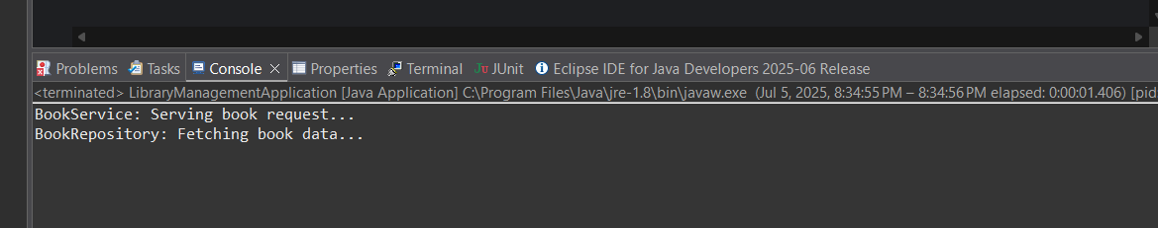

**Exercise 4: Creating and Configuring a Maven Project**

**Scenario:**

You need to set up a new Maven project for the library management application and add Spring dependencies.

### ****Steps Performed:****

1. Created a Maven Project in Eclipse named LibraryManagementCore
2. Added Spring Dependencies (spring-context, spring-aop, spring-webmvc) in pom.xml
3. Configured the Maven Compiler Plugin for Java version 1.8.
4. Created a MainApp class to load the Spring context and call the bean method

<project xmlns="http://maven.apache.org/POM/4.0.0"

xmlns:xsi="http://www.w3.org/2001/XMLSchema-instance"

xsi:schemaLocation="http://maven.apache.org/POM/4.0.0

https://maven.apache.org/xsd/maven-4.0.0.xsd">

<modelVersion>4.0.0</modelVersion>

<groupId>com.library</groupId>

<artifactId>LibraryManagementCore</artifactId>

<version>1.0-SNAPSHOT</version>

<packaging>jar</packaging>

<dependencies>

<dependency>

<groupId>org.springframework</groupId>

<artifactId>spring-context</artifactId>

<version>5.3.30</version>

</dependency>

<dependency>

<groupId>org.springframework</groupId>

<artifactId>spring-aop</artifactId>

<version>5.3.30</version>

</dependency>

<dependency>

<groupId>org.springframework</groupId>

<artifactId>spring-webmvc</artifactId>

<version>5.3.30</version>

</dependency>

</dependencies>

<build>

<plugins>

<plugin>

<groupId>org.apache.maven.plugins</groupId>

<artifactId>maven-compiler-plugin</artifactId>

<version>3.8.1</version>

<configuration>

<source>1.8</source>

<target>1.8</target>

</configuration>

</plugin>

</plugins>

</build>

</project>

<?xml version="1.0" encoding="UTF-8"?>

<beans xmlns="http://www.springframework.org/schema/beans"

xmlns:xsi="http://www.w3.org/2001/XMLSchema-instance"

xsi:schemaLocation="http://www.springframework.org/schema/beans

http://www.springframework.org/schema/beans/spring-beans.xsd">

<bean id="bookRepository" class="com.library.repository.BookRepository" />

<bean id="bookService" class="com.library.service.BookService">

<property name="bookRepository" ref="bookRepository" />

</bean>

</beans>

package com.library.repository;

public class BookRepository {

public void display() {

System.***out***.println("BookRepository: Fetching book data...") }

}

package com.library.service;

import com.library.repository.BookRepository;

public class BookService {

private BookRepository bookRepository;

public void setBookRepository(BookRepository bookRepository) {

this.bookRepository = bookRepository;

} public void serve() {

System.***out***.println("BookService: Serving book request...");

bookRepository.display();

}

}

package com.library;

import org.springframework.context.ApplicationContext;

import org.springframework.context.support.ClassPathXmlApplicationContext;

import com.library.service.BookService;

public class MainApp {

public static void main(String[] args) {

ApplicationContext context = new ClassPathXmlApplicationContext("applicationContext.xml");

BookService service = (BookService) context.getBean("bookService");

service.serve();}

}

**Output:**

