**1. Create a Spring Web Project using Maven**

Answer:

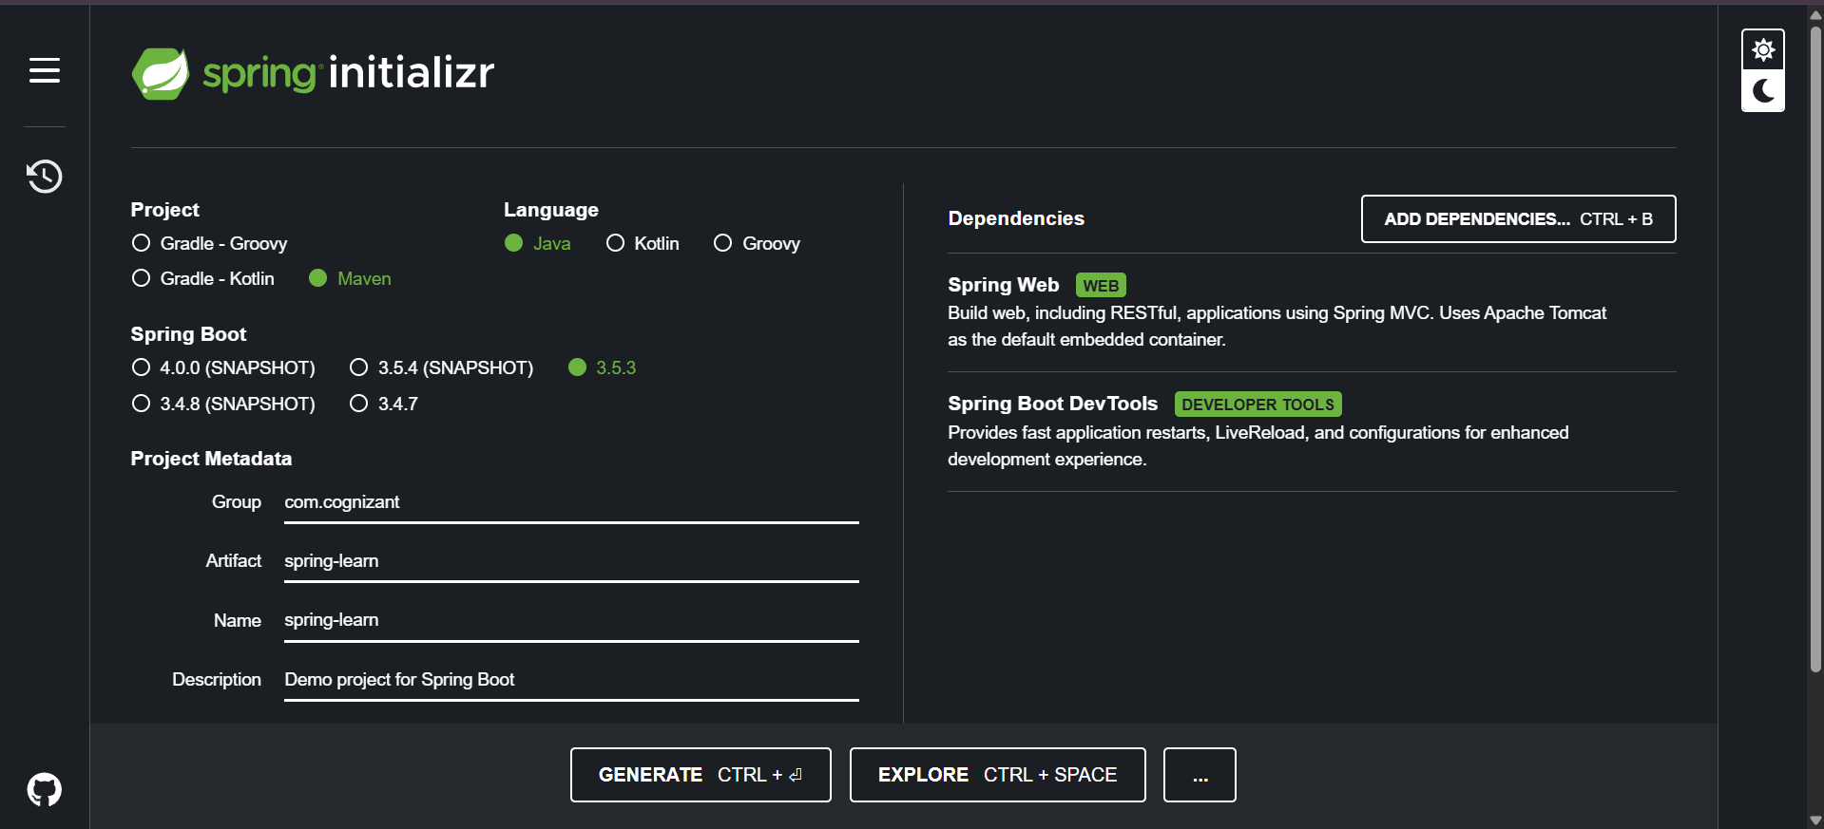

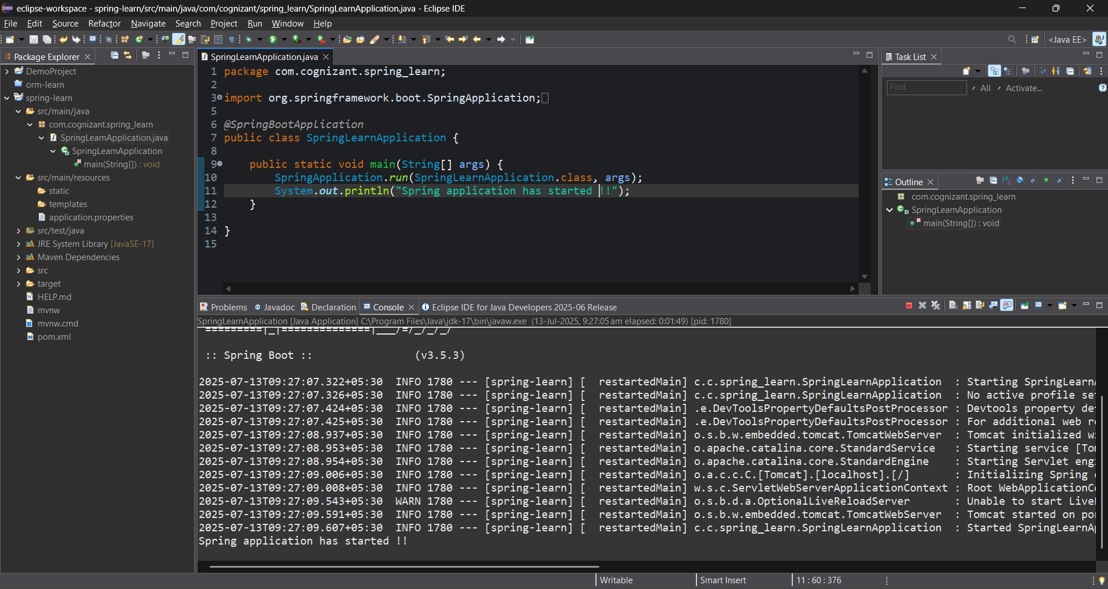

**2. Spring Core – Load Country from Spring Configuration XML** 

**Answer :**

PROGRAM :

//Country.java

package com.cognizant.spring_learn;

import org.slf4j.Logger;

import org.slf4j.LoggerFactory;

public class Country {

private static final Logger LOGGER = LoggerFactory.getLogger(Country.class);

private String code;

private String name;

public Country() {

LOGGER.debug("Inside Country Constructor.");

}

public String getCode() {

LOGGER.debug("Inside getCode()");

return code;

}

public void setCode(String code) {

LOGGER.debug("Inside setCode()");

this.code = code;

}

public String getName() {

LOGGER.debug("Inside getName()");

return name;

}

public void setName(String name) {

LOGGER.debug("Inside setName()");

this.name = name;

}

@Override

public String toString() {

return "Country [code=" + code + ", name=" + name + "]";

}

}

//country.xml

<?xml version="1.0" encoding="UTF-8"?>

<beans xmlns="http://www.springframework.org/schema/beans"

xmlns:xsi="http://www.w3.org/2001/XMLSchema-instance"

xsi:schemaLocation="

http://www.springframework.org/schema/beans

https://www.springframework.org/schema/beans/spring-beans.xsd">

<bean id="country" class="com.cognizant.spring_learn.Country">

<property name="code" value="IN" />

<property name="name" value="India" />

</bean>

</beans>

//SpringLearnApplication.java

package com.cognizant.spring_learn;

import org.slf4j.Logger;

import org.slf4j.LoggerFactory;

import org.springframework.context.ApplicationContext;

import org.springframework.context.support.ClassPathXmlApplicationContext;

import org.springframework.boot.SpringApplication;

import org.springframework.boot.autoconfigure.SpringBootApplication;

*@SpringBootApplication*

public class SpringLearnApplication {

private static final Logger ***LOGGER*** = LoggerFactory.*getLogger*(SpringLearnApplication.class);

public static void main(String[] args) {

SpringApplication.*run*(SpringLearnApplication.class, args);

*displayCountry*();

}

public static void displayCountry() {

ApplicationContext context = new ClassPathXmlApplicationContext("country.xml");

Country country = context.getBean("country", Country.class);

***LOGGER***.debug("Country : {}", country.toString());

}

}

OUTPUT:

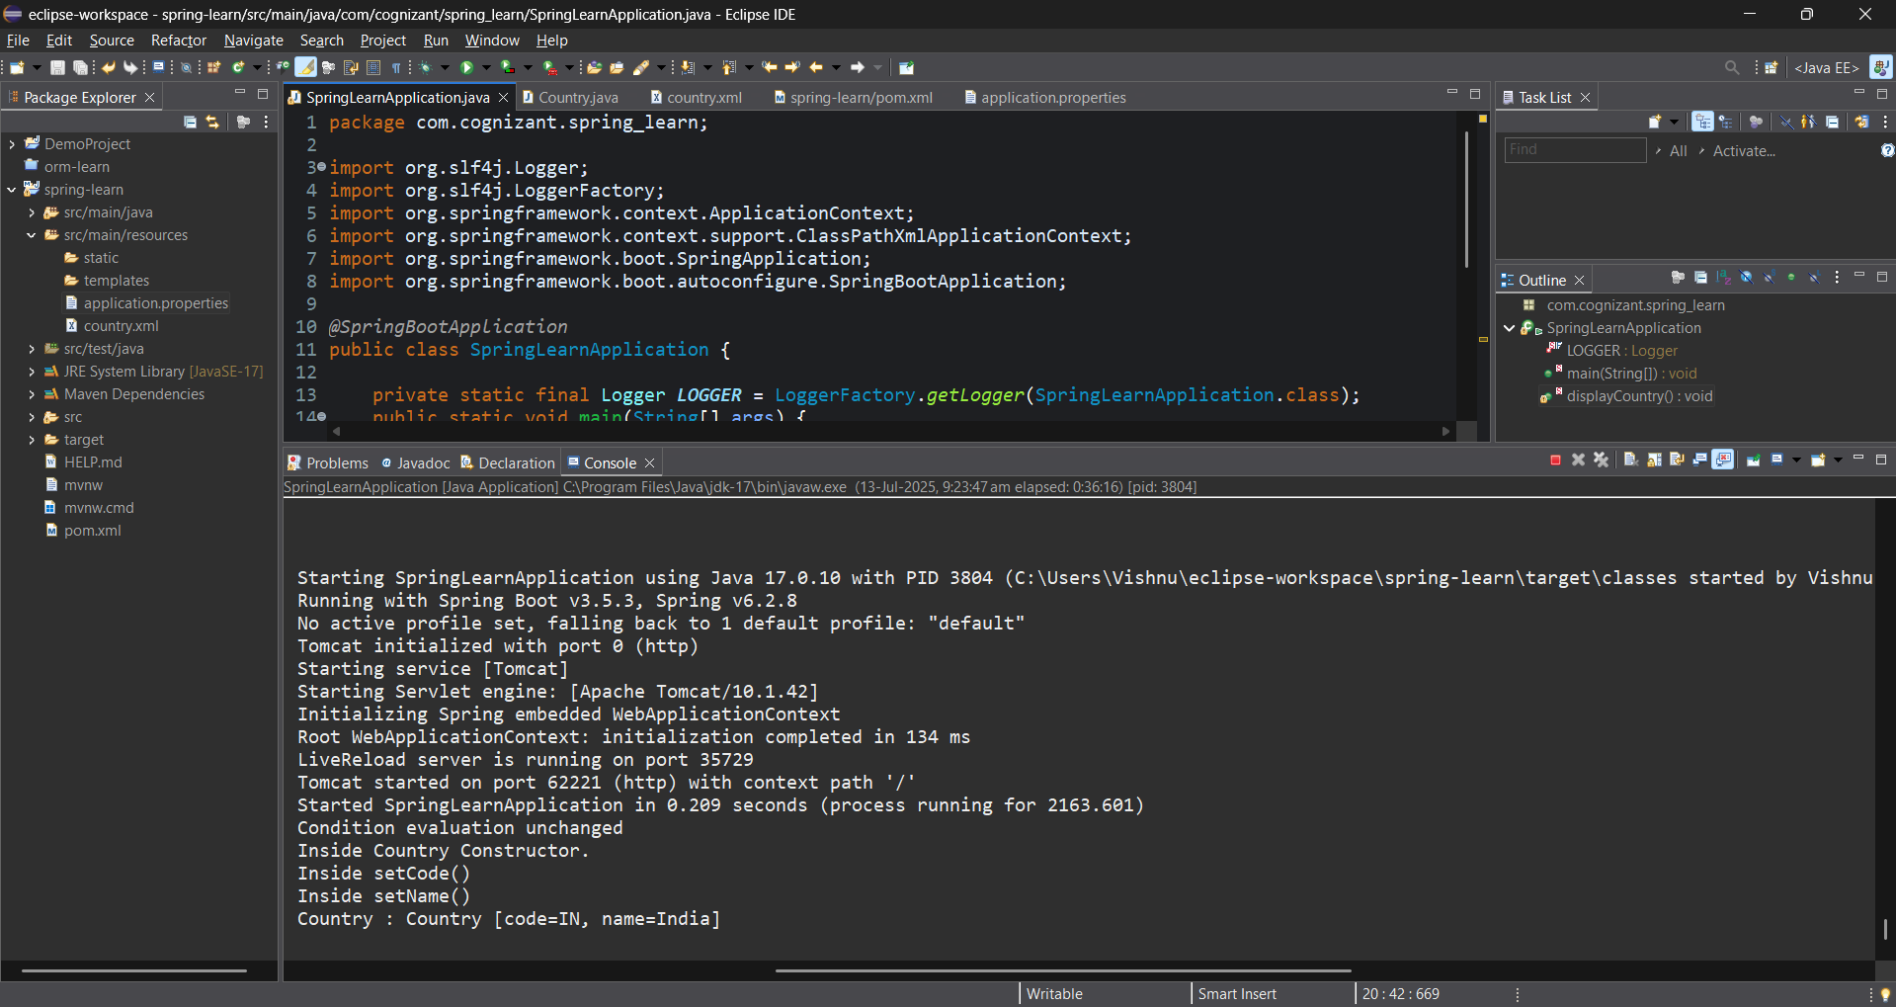

**3. Hello World RESTful Web Service**

**ANSWER:**

**PROGRAM:**

//HelloController.java

package com.cognizant.spring_learn.controller;

import org.slf4j.Logger;

import org.slf4j.LoggerFactory;

import org.springframework.web.bind.annotation.GetMapping;

import org.springframework.web.bind.annotation.RestController;

@RestController

public class HelloController {

private static final Logger LOGGER = LoggerFactory.getLogger(HelloController.class);

@GetMapping("/hello")

public String sayHello() {

LOGGER.debug("Start: sayHello()");

String response = "Hello World!!";

LOGGER.debug("End: sayHello()");

return response;

}

}

OUTPUT:

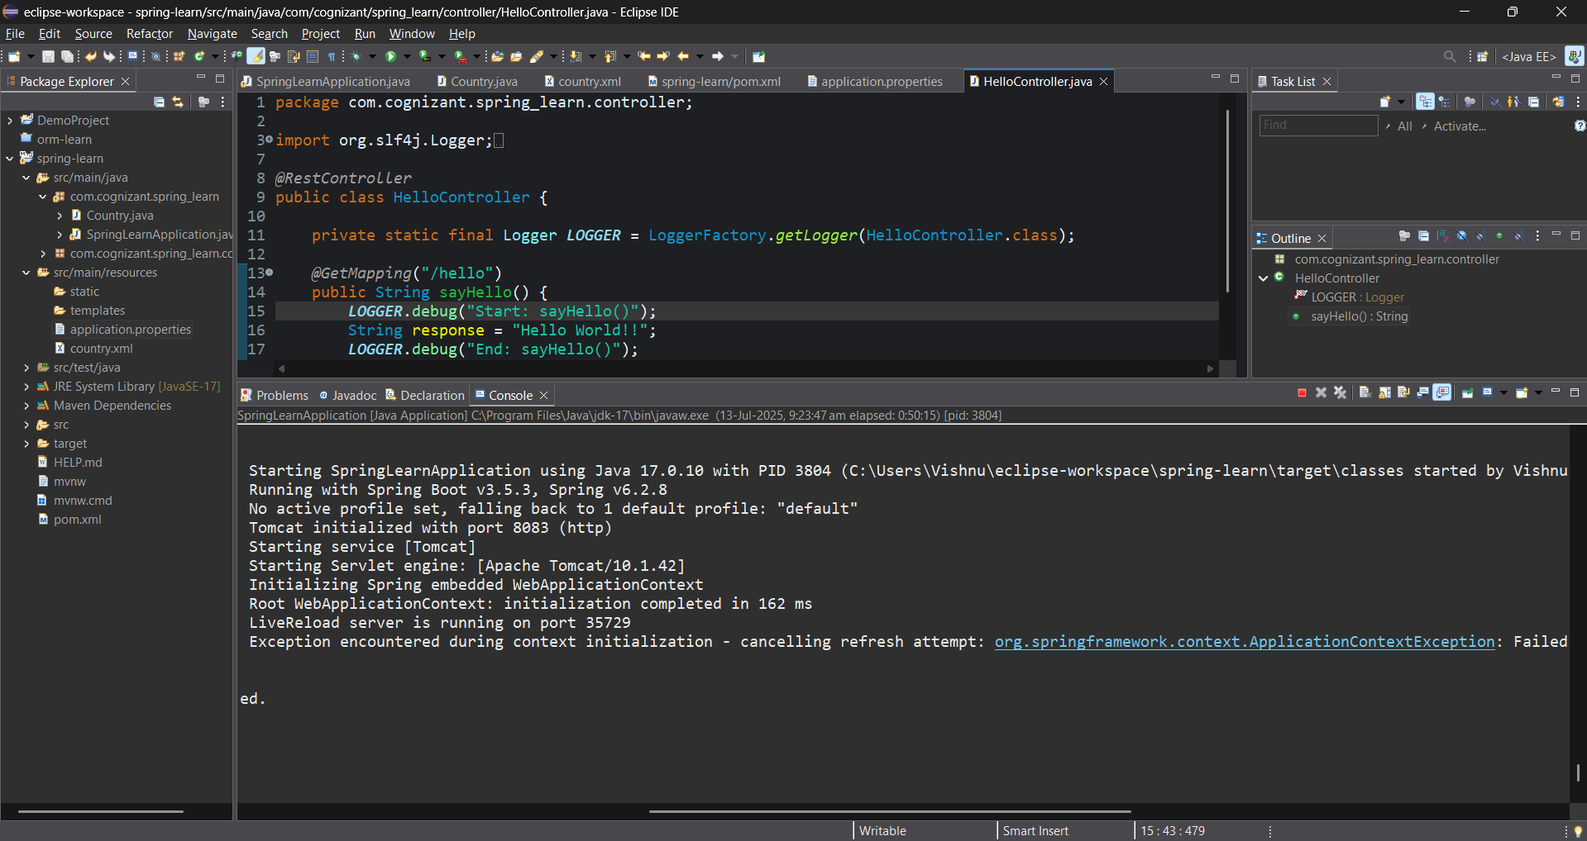

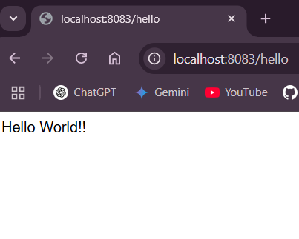

**4. REST - Country Web Service**

**ANSWER:**

**PROGRAM:**

//CountryController.java

package com.cognizant.spring_learn.controller;

import com.cognizant.spring_learn.Country;

import org.slf4j.Logger;

import org.slf4j.LoggerFactory;

import org.springframework.context.ApplicationContext;

import org.springframework.context.support.ClassPathXmlApplicationContext;

import org.springframework.web.bind.annotation.RequestMapping;

import org.springframework.web.bind.annotation.RestController;

*@RestController*

public class CountryController {

private static final Logger ***LOGGER*** = LoggerFactory.*getLogger*(CountryController.class);

*@RequestMapping*("/country")

public Country getCountryIndia() {

***LOGGER***.debug("Start: getCountryIndia()");

ApplicationContext context = new ClassPathXmlApplicationContext("country.xml");

Country country = context.getBean("country", Country.class);

***LOGGER***.debug("End: getCountryIndia()");

return country;

}

}

//country.xml

<?xml version="1.0" encoding="UTF-8"?>

<beans xmlns="http://www.springframework.org/schema/beans"

xmlns:xsi="http://www.w3.org/2001/XMLSchema-instance"

xsi:schemaLocation="

http://www.springframework.org/schema/beans

https://www.springframework.org/schema/beans/spring-beans.xsd">

<bean id="country" class="com.cognizant.spring_learn.Country">

<property name="code" value="IN" />

<property name="name" value="India" />

</bean>

</beans>

**OUTPUT:**

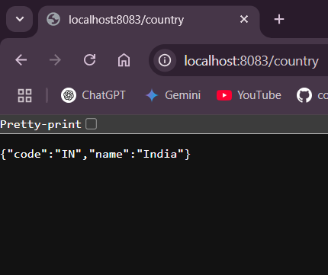

**5. REST - Get country based on country code**

ANSWER:  
PROGRAM:

//CountryController.java

package com.cognizant.spring_learn.controller;

import com.cognizant.spring_learn.Country;

import com.cognizant.spring_learn.service.CountryService;

import org.slf4j.Logger;

import org.slf4j.LoggerFactory;

import org.springframework.beans.factory.annotation.Autowired;

import org.springframework.web.bind.annotation.*;

*@RestController*

public class CountryController {

private static final Logger ***LOGGER*** = LoggerFactory.*getLogger*(CountryController.class);

*@Autowired*

private CountryService countryService;

*@GetMapping*("/countries/{code}")

public Country getCountry(*@PathVariable* String code) {

***LOGGER***.debug("Start: getCountry() with code {}", code);

Country country = countryService.getCountry(code);

***LOGGER***.debug("End: getCountry()");

return country;

}

}

//country.xml

<?xml version="1.0" encoding="UTF-8"?>

<beans xmlns="http://www.springframework.org/schema/beans"

xmlns:xsi="http://www.w3.org/2001/XMLSchema-instance"

xsi:schemaLocation="

http://www.springframework.org/schema/beans

https://www.springframework.org/schema/beans/spring-beans.xsd">

<bean id="countryList" class="java.util.ArrayList">

<constructor-arg>

<list>

<bean class="com.cognizant.spring_learn.Country">

<property name="code" value="IN"/>

<property name="name" value="India"/>

</bean>

<bean class="com.cognizant.spring_learn.Country">

<property name="code" value="US"/>

<property name="name" value="United States"/>

</bean>

<bean class="com.cognizant.spring_learn.Country">

<property name="code" value="JP"/>

<property name="name" value="Japan"/>

</bean>

<bean class="com.cognizant.spring_learn.Country">

<property name="code" value="DE"/>

<property name="name" value="Germany"/>

</bean>

</list>

</constructor-arg>

</bean>

<bean id="country" class="com.cognizant.spring_learn.Country">

<property name="code" value="IN"/>

<property name="name" value="India"/>

</bean>

</beans>

//SpringLearnApplication.java

package com.cognizant.spring_learn;

import org.slf4j.Logger;

import org.slf4j.LoggerFactory;

import org.springframework.context.ApplicationContext;

import org.springframework.context.support.ClassPathXmlApplicationContext;

import org.springframework.boot.SpringApplication;

import org.springframework.boot.autoconfigure.SpringBootApplication;

@SpringBootApplication

public class SpringLearnApplication {

private static final Logger LOGGER = LoggerFactory.getLogger(SpringLearnApplication.class);

public static void main(String[] args) {

SpringApplication.run(SpringLearnApplication.class, args);

displayCountry();

}

public static void displayCountry() {

ApplicationContext context = new ClassPathXmlApplicationContext("country.xml");

Country country = context.getBean("country", Country.class);

LOGGER.debug("Country : {}", country.toString());

}

}

OUTPUT:

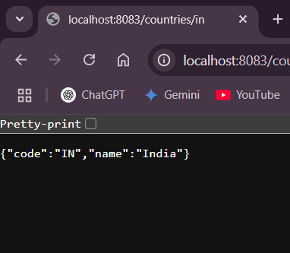

**6. Create authentication service that returns JWT**

**ANSWER:**

**PROGRAM:**

//AuthenticationController.java

package com.cognizant.spring_learn.controller;

import jakarta.servlet.http.HttpServletRequest;

import org.springframework.web.bind.annotation.*;

import org.springframework.http.ResponseEntity;

import org.springframework.beans.factory.annotation.Autowired;

import com.cognizant.spring_learn.security.JwtUtil;

import java.util.Base64;

*@RestController*

public class AuthenticationController {

*@Autowired*

private JwtUtil jwtUtil;

*@RequestMapping*("/authenticate")

public ResponseEntity<?> authenticate(HttpServletRequest request) {

System.***out***.println(">> Inside /authenticate"); // DEBUG LOG

String authHeader = request.getHeader("Authorization");

if (authHeader == null || !authHeader.startsWith("Basic ")) {

return ResponseEntity.*status*(401).body("Missing or invalid Authorization header.");

}

String base64Credentials = authHeader.substring("Basic ".length());

String credentials = new String(Base64.*getDecoder*().decode(base64Credentials));

String[] values = credentials.split(":", 2);

String username = values[0];

String password = values[1];

if ("user".equals(username) && "pwd".equals(password)) {

String token = jwtUtil.generateToken(username);

return ResponseEntity.*ok*("{\"token\":\"" + token + "\"}");

} else {

return ResponseEntity.*status*(403).body("Invalid credentials");

}

}

}

//SecurityConfig.java

package com.cognizant.spring_learn.config;

import org.springframework.context.annotation.Bean;

import org.springframework.context.annotation.Configuration;

import org.springframework.security.config.annotation.web.configuration.EnableWebSecurity;

import org.springframework.security.web.SecurityFilterChain;

import org.springframework.security.config.annotation.web.builders.HttpSecurity;

import org.springframework.security.config.Customizer;

import org.springframework.security.core.userdetails.User;

import org.springframework.security.core.userdetails.UserDetailsService;

import org.springframework.security.provisioning.InMemoryUserDetailsManager;

import org.springframework.security.crypto.password.PasswordEncoder;

import org.springframework.security.crypto.password.~~NoOpPasswordEncoder~~; // ⚠️ Deprecated

*@Configuration*

*@EnableWebSecurity*

public class SecurityConfig {

*@Bean*

public SecurityFilterChain securityFilterChain(HttpSecurity http) throws Exception {

http

.csrf(csrf -> csrf.disable())

.authorizeHttpRequests(auth -> auth

.requestMatchers("/authenticate").permitAll() // allow access

.anyRequest().authenticated()

)

.httpBasic(Customizer.*withDefaults*()); // Enable Basic Auth

return http.build();

}

*@Bean*

public UserDetailsService userDetailsService() {

// username: user, password: pwd

return new InMemoryUserDetailsManager(

User.*withUsername*("user")

.password("pwd") // stored in plain text (for testing only)

.roles("USER")

.build()

);

}

*@SuppressWarnings*("deprecation")

*@Bean*

public PasswordEncoder passwordEncoder() {

return ~~NoOpPasswordEncoder~~.~~getInstance~~(); // for development/testing only

}

}

//JwtUtil.java

package com.cognizant.spring_learn.security;

import io.jsonwebtoken.Jwts;

import io.jsonwebtoken.SignatureAlgorithm;

import io.jsonwebtoken.security.Keys;

import org.springframework.stereotype.Component;

import java.nio.charset.StandardCharsets;

import java.security.Key;

import java.util.Date;

*@Component*

public class JwtUtil {

private final Key key = Keys.*hmacShaKeyFor*("my-super-secret-key-my-super-secret-key".getBytes(StandardCharsets.***UTF_8***));

public String generateToken(String username) {

return Jwts.*builder*()

.setSubject(username)

.setIssuedAt(new Date())

.setExpiration(new Date(System.*currentTimeMillis*() + 1000 * 60 * 10))

.signWith(key, *SignatureAlgorithm*.***HS256***)

.compact();

}

}

**OUTPUT:**

