Redux:
=========
What is redux
Redux is a predictable state container for JavaScript apps. This means that Redux is a predictable state container for js applications.
Redux reduces the complexity of the code, by enforcing the restriction on how and when state update can happen. This way, managing updated states is easy.

Why Should I Use Redux?​
Redux helps you manage "global" state - state that is needed across many parts of your application. Redux helps you deal with shared state management.
Redux is more useful when:
- You have large amounts of application state that are needed in many places in the app
- The app state is updated frequently over time
- The logic to update that state may be complex
- The app has a medium or large-sized codebase, and might be worked on by many people

what is required (state, props)

Redux is a state management js library
A predictable State container for js apps
predictable==> able to be known
state container=> global state for entire app
javascript apps==> react, angular, vue etc

Mostly used in react
Redux is used for developing user interfaces(UI)
Local States: In each component we will maintain individual states, these are called local states
Global State:
For entire application we will use only one single state in redux (global state)
in redux 3 main things
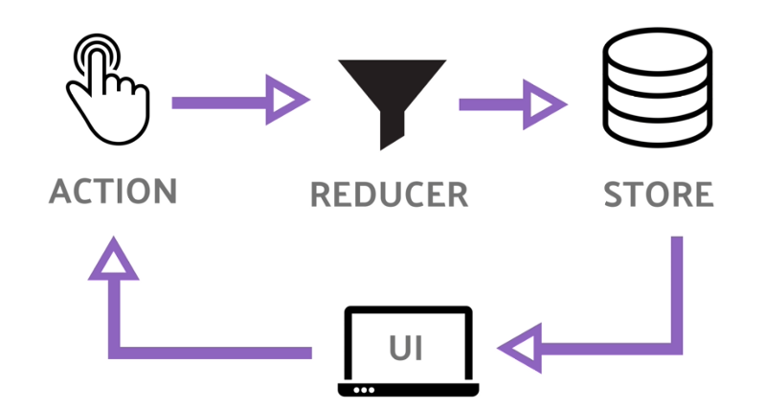

In the absence of Redux, if communication is required between two components (non-parent-child relationships), multiple intermediate components may be required to messaging for them, which wastes resources and complicates the code.
Redux proposed a single data source Store to store state data. All builds can modify the Store through Action s or get the latest state from the Store. Using Redux can solve the communication problem perfectly between the components.

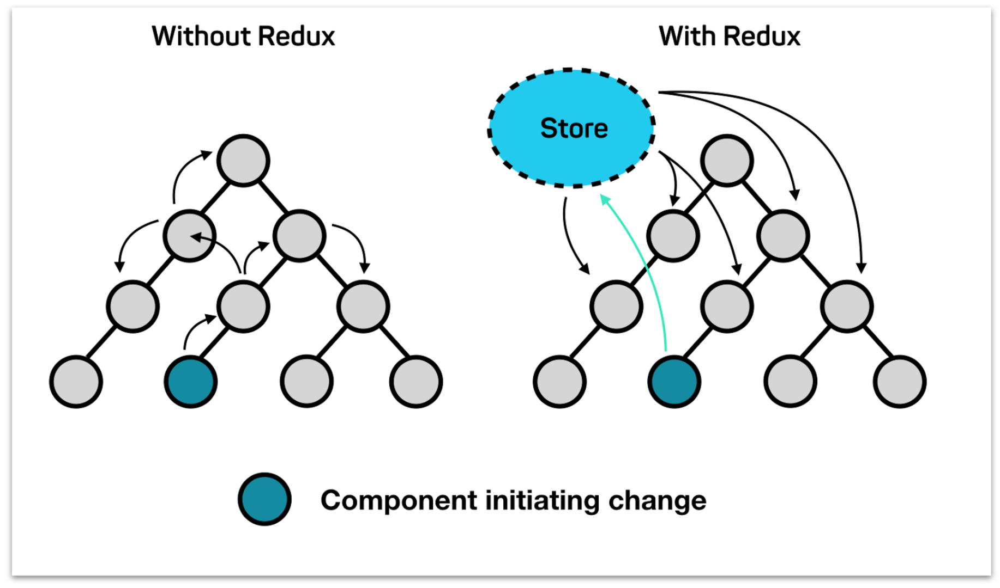Redux store:
The center of every Redux application is the store. A "store" is a container that holds your application's global state.
A store is an immutable object tree in Redux. A store is a state container which holds the application’s state. Redux can have only a single store in your application. Whenever a store is created in Redux, you need to specify the reducer.
create a store using the createStore method from Redux. One need to import the createStore package from the Redux library that supports the store creation process as shown below
import { createStore } from 'redux';
const store = createStore(reducer);

A createStore function can have three arguments.
createStore(reducer, [preloadedState], [enhancer])

ex:
import React from 'react';
import { legacy_createStore as createStore} from 'redux'
const initialState="Hello World"
const reducer=(state=initialState, action)=>{
return state
}
const store=createStore(reducer)
console.log(store.getState())
function App(){
return(
<div>
<h1> Redux is no nice {store.getState()}</h1>
</div>
)
}
export default App

Redux Terminology​
There's some important Redux terms that you'll need to be familiar with before we continue:

Actions​
An action is a plain JavaScript object that has a “type” field. You can think of an action as an event that describes something that happened in the application.
const addTodoAction = {
type: ‘deposit,
payload: 500
}

Reducers​
A reducer is a function that receives the current state and an action object, decides how to update the state if necessary, and returns the new state: (state, action) => newState. You can think of a reducer as an event listener which handles events based on the received action (event) type.

const initialState = { value: 0 }
function counterReducer(state = initialState, action) {
// Check to see if the reducer cares about this action
if (action.type === 'counter/incremented') {
// If so, make a copy of `state`
return {
...state,
// and update the copy with the new value
value: state.value + 1
}
}
// otherwise return the existing state unchanged
return state
}

Store​
The current Redux application state lives in an object called the store .
The store is created by passing in a reducer, and has a method called getState that returns the current state value:
import { configureStore } from '@reduxjs/toolkit'
const store = configureStore({ reducer: counterReducer })
console.log(store.getState())
// {value: 0}

Dispatch​
The Redux store has a method called dispatch. The only way to update the state is to call store.dispatch() and pass in an action object. The store will run its reducer function and save the new state value inside, and we can call getState() to retrieve the updated value
store.dispatch({ type: 'counter/incremented' })
console.log(store.getState())
// {value: 1}

Redux example with bank:
Let’s consider an event you’re likely familiar with — going to the bank to withdraw cash. Even if you don’t do this often, you’re likely aware of what the process looks like.
Young Joe heads to the bank.
You wake up one morning, and head to the bank as quickly as possible. While going to the bank there’s just one intention / action you’ve got in mind: to WITHDRAW_MONEY.
You want to withdraw money from the bank.
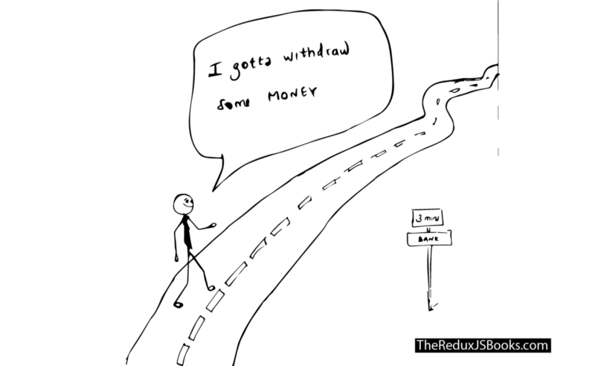
Young Joe heads to the bank with the intention to withdraw some money.
Here’s where things get interesting.
When you get into the bank, you then go straight to the Cashier to make your request known.
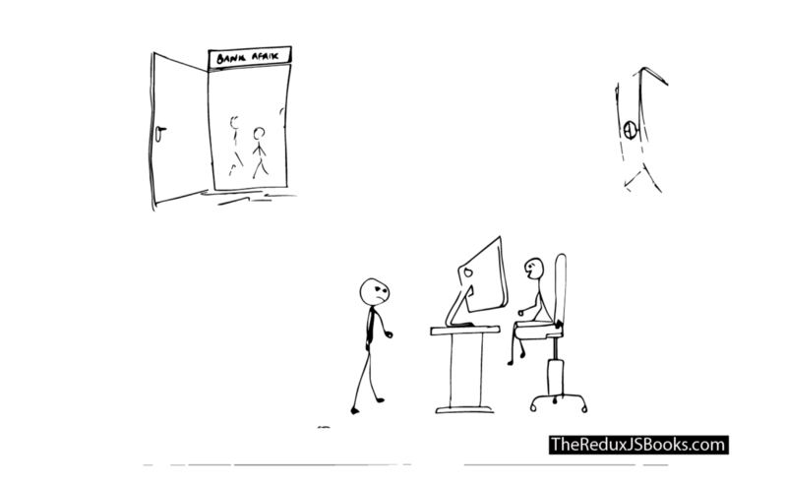
Young joe is at the bank! He goes straight to see the Cashier and makes his request known.

Wait, you went to the Cashier?
Why didn’t you just go into the bank vault to get your money?

If only Young Joe got into the Vault. He’ll cart away with as much as he finds.

After all, it’s your hard earned money.
Well, like you already know, things don’t work that way. Yes, the bank has money in the vault, but you have to talk to the Cashier to help you follow a due process for withdrawing your own money.
The Cashier, from their computer, then enters some commands and delivers your cash to you.
Here’s how you get money. Not from the Vault, sorry.
Now, how does Redux fit into this story?
We’ll get to more details soon, but first, the terminology.
1. The Bank Vault is to the bank what the Redux Store is to Redux.
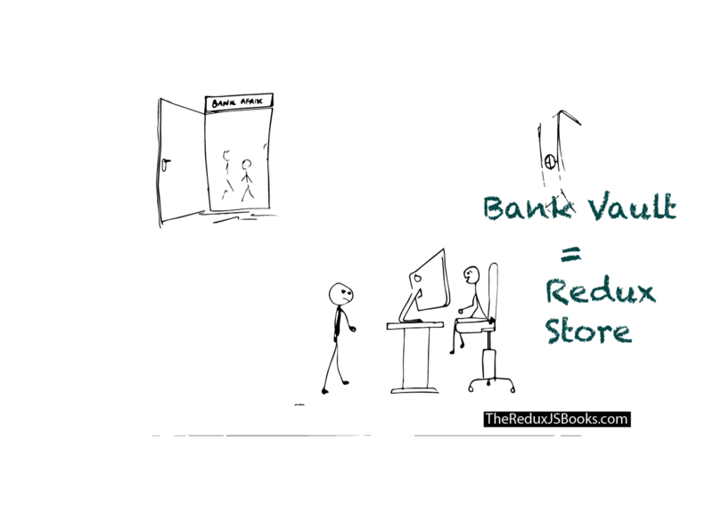
The bank vault keeps the money in the bank, right?
Well, within your application, you don’t spend money. Instead, the state of your application is like the money you spend. The entire user interface of your application is a function of your state.
Just like the bank vault keeps your money safe in the bank, the state of your application is kept safe by something called a store. So, the store keeps your “money” or state intact.

The Redux Store can be likened to the Bank Vault.
It holds the state of your application — and keeps it safe.
This leads to the first Redux principle:
Have a single source of truth: The state of your whole application is stored in an object tree within a single Redux store.
Don’t let the words confuse you.
In simple terms, with Redux, it is is advisable to store your application state in a single object managed by the Redux store. It’s like having one vault as opposed to littering money everywhere along the bank hall.
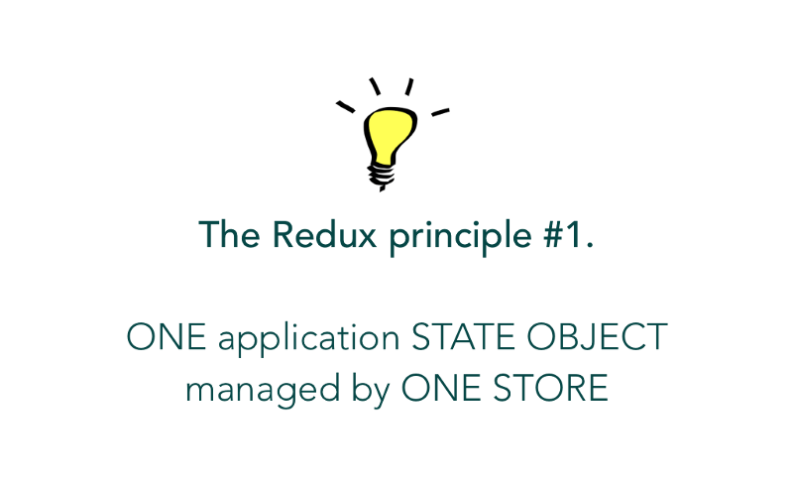The first Redux Princple
2. Go to the bank with an action in mind.
If you’re going to get any money from the bank, you’re going to have to go in with some intent or action to withdraw money.
If you just walk into the bank and roam about, no one’s going to just give you money. You may even end up been thrown out by the security. The same may be said for Redux.
Write as much code as you want, but if you want to update the state of your Redux application (like you do with setState in React), you need to let Redux know about that with an action.
In the same way you follow a due process to withdraw your own money from the bank, Redux also accounts for a due process to change/update the state of your application.
Now, this leads to Redux principle #2.
State is read-only:
The only way to change the state is to emit an action, an object describing what happened.
When you walk to the bank, you go there with a clear action in mind. In this example, you want to withdraw some money.
If we chose to represent that process in a simple Redux application, your action to the bank may be represented by an object.
One that looks like this:
{
type: "WITHDRAW_MONEY",
amount: "$10,000"
}
In the context of a Redux application, this object is called an action! It always has a type field that describes the action you want to perform. In this case, it is WITHDRAW_MONEY.
Whenever you need to change/update the state of your Redux application, you need to dispatch an action.
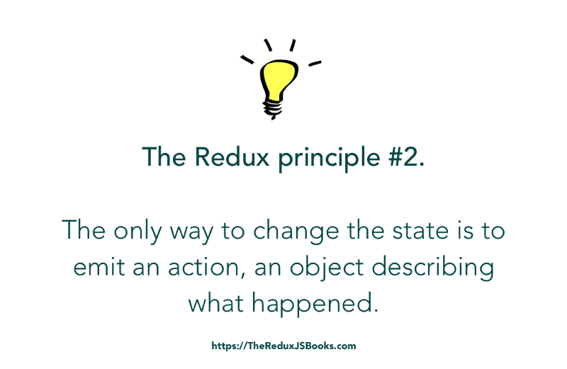
The Second Redux Principle.

3. The Cashier is to the bank what the reducer is to Redux.
Alright, take a step back.
Remember that in the story above, you couldn’t just go straight into the bank vault to retrieve your money from the bank. No. You had to see the Cashier first.
Well, you had an action in mind, but you had to convey that action to someone — the Cashier — who in turn communicated (in whatever way they did) with the vault that holds all of the bank’s money.
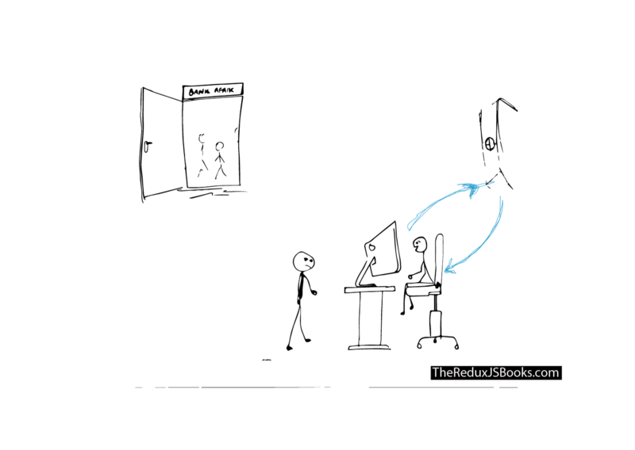The Cashier and Vault communication!
The same may be said for Redux.
Like you made your action known to the Cashier, you have to do the same in your Redux application. If you want to update the state of your application, you convey your action to the reducer — our own Cashier.
This process is mostly called dispatching an action.

Dispatch is just an English word. In this example, and in the Redux world, it is used to mean sending off the action to the reducers.
The reducer knows what to do. In this example, it will take your action to WITHDRAW_MONEY and ensure that you get your money.
In Redux terms, the money you spend is your state. So, your reducer knows what to do, and it always returns your new state.
And this leads to the last Redux principle:
To specify how the state tree is transformed by actions, you write pure reducers.
As we proceed, I’ll explain what a “pure” reducer means. For now, what’s important is to understand that, to update the state of your application (like you do with setState in React,) your actions must always be sent off (dispatched) to the reducers to get your new state.
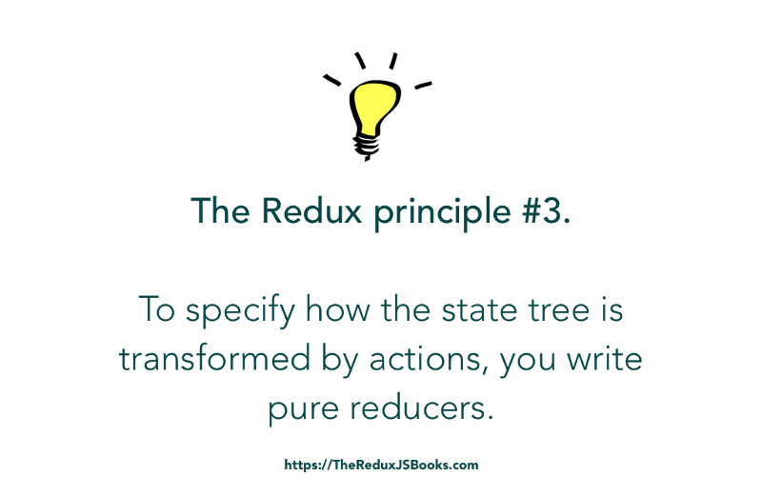The Third Redux Principle
With this analogy, you should now have an idea of what the most important Redux actors are: the store, the reducer and an action.
These three actors are pivotal to any Redux application. Once you understand how they work, the bulk of the deed is done.

Example:
Here’s what the App component looks like:

src/App.js

import React, { Component } from "react";
class App extends Component {
state = {
tech : "React"
}
render() {
return <h2>HelloWorld tech={this.state.tech}</h2>
}
}
export default App;

Have a good look at the state object.
There’s just one field, tech, in the state object and it is passed down as prop into the HelloWorld component as shown below:

So, here’s the challenge.
How do we refactor our App to use Redux ?
How do we take away the state object and have it entirely managed by Redux? Remember that Redux is the state manager for your app.

“Redux is a predictable state container for JavaScript apps.”
Technically, you want the state of your application to be managed by Redux.
This is what makes Redux a state container.
However, Redux will efficiently manage your overall application state. Like a bank vault, it’s got a store to do that.
For the simple <App/> component we’ve got here, the state object is simple.
Here it is:
{
tech: "React"
}
We need to take this out of the <App /> component state, and have it managed by Redux.
From my earlier explanation, you should remember the analogy between the Bank Vault and the Redux Store. The Bank Vault keeps money, the Redux store keeps the application state object.
So, what is the first step to refactoring the <App /> component to use Redux?
Remove the component state from within <App />.

The Redux store will be responsible for managing the App’s state. With that being said, we need to remove the current state object from App/>.

import React, { Component } from "react";
import HelloWorld from "./HelloWorld";

class App extends Component {
// the state object has been removed.
render() {
return <HelloWorld tech={this.state.tech}/>
}
}

export default App;

The solution above is incomplete, but right now, <App/> has no state.

Creating a Redux Store
If the <App /> won’t manage it’s state, then we have to create a Redux Store to manage our application state.

Here’s what the code to create a Redux store looks like:

import { createStore } from "redux"; //an import from the redux library
const store = createStore(); // an incomplete solution - for now.

First we import the createStore factory function from Redux. Then we invoke the function, createStore() to create the store.
Now, the createStore function takes in a few arguments. The first is a reducer.

So, a more complete store creation would be represented like this: createStore(reducer)

The Store and Reducer Relationship
Back to the bank analogy.
When you go to the bank to make a withdrawal, you meet with the Cashier. After you make your WITHDRAW_MONEY intent/action known to the Cashier, they do not just hand you the requested money.
No.
The Cashier first confirms that you have enough money in your account to perform the withdrawal transaction you seek.
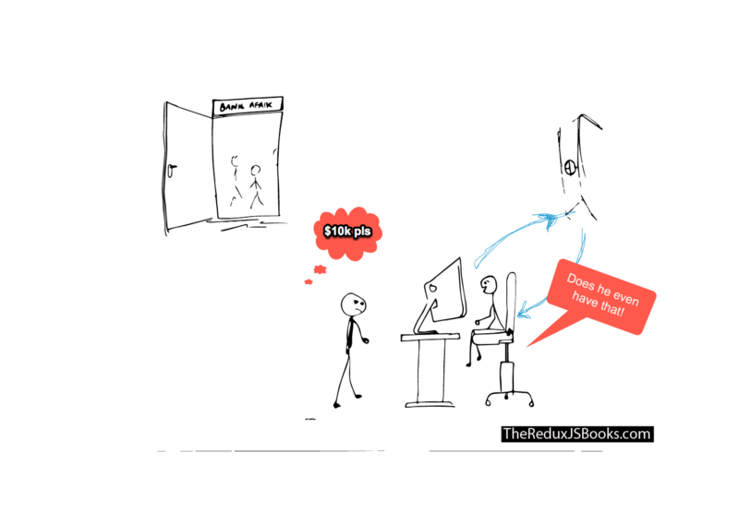
The Cashier first makes sure you have the money you say you do.
From the computer, they can see all that — kind of communicating with the Vault, since the Vault keeps all the money in the bank.
In a nutshell, the Cashier and Vault are always in sync. Great buddies!
The same may be said for a Redux STORE (our own Vault,) and the Redux REDUCER (our own Cashier)
The Store and the Reducer are great buddies. Always in sync.
Why?
The REDUCER always “talks” to the STORE. Just like the Cashier stays in sync with the Vault.
This explains why the creation of the store needs to be invoked with a Reducer, and that is mandatory. The Reducer is the only mandatory argument passed into createStore()

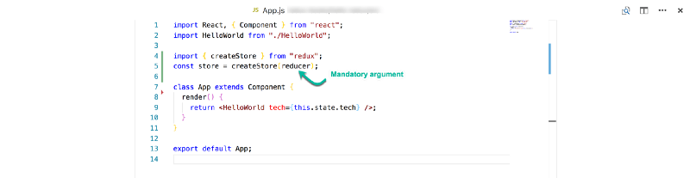
import { createStore } from "redux";
const store = createStore(reducer); //this has been updated to include the created reducer.

import React, { Component } from "react";
import HelloWorld from "./HelloWorld";

import { createStore } from "redux";
const store = createStore(reducer);

class App extends Component {
render() {
return <HelloWorld tech={this.state.tech}/>
}
}

export default App;
ou may have noticed a problem with this code. See Line 4.
The reducer function passed into createStore doesn’t exist yet.
Now we need to write one. The reducer is just a function, remember?
Create a new directory called reducers and create an index.js file in there. Essentially, our reducer function will be in the path src/reducers/index.js .
First export a simple function in this file:
export default () => {
}

Remember, that the reducer takes in two arguments — as established earlier. Right now, we’ll concern ourselves with the first argument, STATE

export default (state) => {
}

For a Redux reducer, you always return the new state of your application.

After you walk into the bank and make a successful withdrawal, the current amount of money held in the bank’s vault for you is no longer the same. Now, if you withdrew $200, you are now short $200. Your account balance is down $200.
Again, the Cashier and Vault remain in sync on how much you now have.
Just like the Cashier, this is exactly how the reducer works.
Like the Cashier, the reducer always returns the new state of your application. Just in case something has changed. We don’t want to issue the same bank balance even though a withdrawal action was performed.
Here’s the representation of this within the reducer:

export default (state) => {
return state
}

If you go to the bank without performing an action, your bank balance remains the same, right?
Since we aren’t performing any ACTION or even passing that into the reducer yet, we will just return the same state.

The Second createStore Argument
When you visit the Cashier in the bank, if you asked them for your account balance, they’ll look it up and tell it to you.
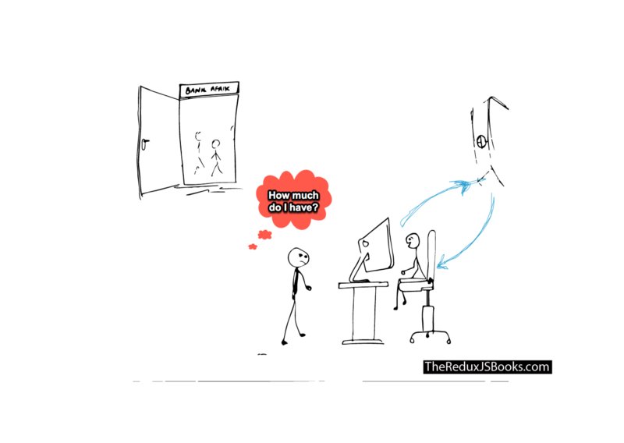
In the same way, when you create a redux STORE (our own money keeping Vault), there’s the option of doing so with an initial deposit.
In Redux terms, this is called the initialState of the app.
Thinking in code, initialState is the second argument passed into the createStore function call.
const store = createStore(reducer, initialState);
Before making any monetary action, if you requested your bank account balance, the Initial Deposit will always be returned to you.
Afterwards, anytime you perform any monetary action, this initial deposit will also be updated.
Now, the same goes for Redux.
The object passed in as initialState is like the initial deposit to the Vault. This initialState will always be returned as the state of the application unless you update the state by performing an action.
We will now update the application to pass in an initial state:
const initialState = { tech: "React " };
const store = createStore(reducer, initialState);
Note how initialState is just an object, and it is exactly what we had as the default state in the React App before we began refactoring.
Now, here’s all the code we have at this point — with the reducer also imported into App.
App.js
import React, { Component } from "react";
import HelloWorld from "./HelloWorld";
import reducer from "./reducers";
import { createStore } from "redux";

const initialState = { tech: "React " };
const store = createStore(reducer, initialState);

class App extends Component {
render() {
return <HelloWorld tech={this.state.tech}/>
}
}

export default App;
reducers/index.js
export default state => {
return state
}
If you’re coding along and try to run the app now, you’ll get an error. Why?
Have a look at the tech prop passed into <HelloWorld />. It still reads, this.state.tech.
There’s no longer a state object attached to <App />, so that will be undefined.
Let’s fix that.
The solution is quite simple. Since the store now manages the state of our application, this means the application STATEobject must be retrieved from the store. But how?
Whenever you create a store with createStore(), the created store has three exposed methods.
One of these is getState().
At any point in time, calling the getState method on the created store will return the current state of your application.
In our case, store.getState() will return the object { tech: "React"} since this is the INITIAL STATE we passed into the createStore() method when we created the STORE.
You see how all this comes together now?
Hence the tech prop will be passed into <HelloWorld /> as shown below:
App.js
import React, { Component } from "react";
import HelloWorld from "./HelloWorld";
import { createStore } from "redux";

const initialState = { tech: "React " };
const store = createStore(reducer, initialState);

class App extends Component {
render() {
return <HelloWorld tech={store.getState().tech}/>
}
}
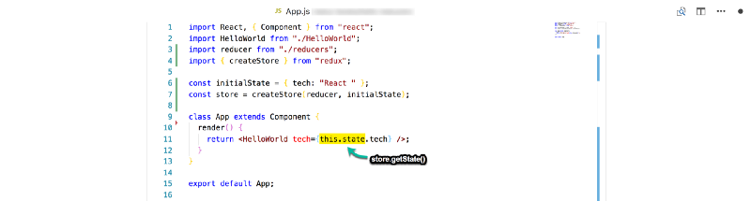Replace “this.state” with “store.getState()”
Reducers/Reducer.js
export default state => {
return state
}
And that is it! You just learned the Redux basics and successfully refactored a simple React app to use Redux.
The React application now has its state managed by Redux. Whatever needs to be gotten from the state object will be grabbed from the store as shown above.

