Git and GIt Hub is Source code repository:

Install git in windows 10(google it)-->git-scm.com (AN official webiste and download) and install .exe (Continue with Yes till successfull extension)

To check git is successfully installed/not ..Right click and then u can see GIT GUI and GIT BASH options and also GIT GUI in search option...

Login to https://github.com/

User Name: sudhaknv@gmail.com

pwd-->Sudha@1217

create new repository in abouve url (public and private)

In private for storing our data they will 4$ per each repository(in Interview we can say i am working on multiple projects and we have apprx 120 repositories..No need to expose our company repositories names)

Code in private can be viewed only who have access and public all over world can be viewed...

create directory like gitpractise and some files inside it in ur lappy and switch to dir in cmd prmpt..

We have 3 stages in GIT before pushing files to Central Repository: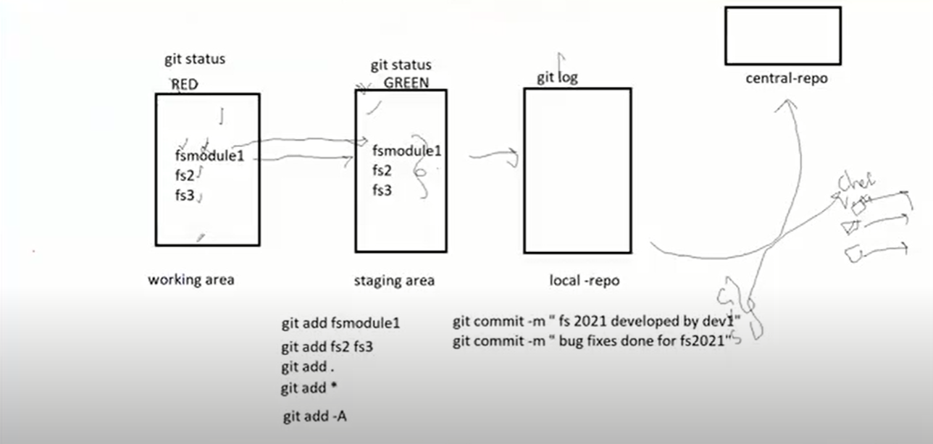

1)Working Area --->Once Git add file name is done it will deleted from working area and will be moved to Staging Area(Like MV)

2)Staging Area --->

3)Local-Rep0

finally to central Repository

--🡪

Select file and right click and select GIT BASH HERE.. It will directly open GIT BASH with that directory

And execute following commands