**18CS7IEIML-INTRODUCTION TO MACHINE LEARNING**

**Question Bank**

**UNIT-4**

1. Illustrate with appropriate reasons and motivation in the evolution of Aritificial Neural Network
2. Analyze the appropriate learning problem for neural network with its important characteristics
3. Design a single layer perceptron for AND function with perceptron training rule to determine a weight vector that causes the perceptron to produce the correct output with w0==-.8, w1=w2=0.5 with relevant diagram.
4. Analyze the dissimilarities between stochastic versus Non Stochastic gradient descent for neural network
5. Given a multilayer network with a fixed set of units and interconnections. Apply Back Propagation Algorithm that employs gradient descent to attempt to minimize the squared error between the network output values and the target values for these outputs.
6. Build the Neural Network representation for the ALVINN autonomus car driving vechicle.
7. Analyze the dissimilarities between stochastic versus Non Stochastic gradient descent for neural network
8. Explain the concept of perceptron with a neat diagram along with its learning rule
9. Write Stochastic Gradient Descent algorithm for training a linear unit.
10. Differentiate between Gradient Descent and Stochastic Gradient Descent

**UNIT-5**

1. Consider a medical diagnosis problem in which there are two hypothesis i-e having cancer

(+) and not having cancer(-).A patient takes a lab test and result comes back positive.

The test returns a correct positive result in only 98% of the cases in which the disease is

actually present ,and a correct negative result in only 97% of the cases in which the disease

is not present .Further more .008 of the entire population have this cancer. Determine

weather patient has cancer or not.

1. Explain Expectation Maximization Algorithm in detail and illustrate with its Applications in relevant domain with its advantages and disadvantages
2. Discuss Naïve Bayes classifier with appropriate notations
3. Apply Naïve Bayes Classifier for the car theft problem with attributes

Color, Type, Origin, and the target, Stolen can be either Yes or No.

Classify the unseen instance<color = RED,Type = SUV andOrigin= Domestic>

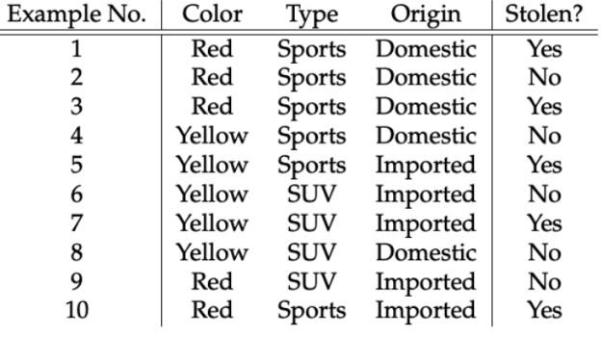

1. Apply Naïve Bayes Classifier for the Play tennis concept learning problem and

CALCULATE the probabilities and solve the novel instance <outlook = sunny ,Temperature = cool, Humidity = high,Wind = strong>

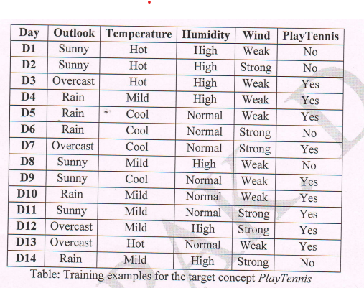

1. Explain Bayes Theorem with appropriate notations
2. Explain Baseian Belief Network and conditional Independence
3. Explain the practical difficulties of Bayesian Theorem.