**Regular Expressions in Javascript**

1. **Write the Regular Expression for Indian Mobile Number**
   1. **9988112233** 
      1. First Digit from 6-9 and rest of the digits will be 0-9
      2. Total number of digits will be 10

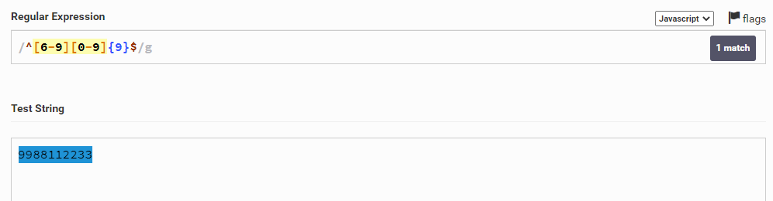

* 1. **09988776611**
     1. First digit will be 0
     2. Second digit will be anything from 6 to 9
     3. From third till last digit it will be 0 to 9
     4. Total count of the digits will be 11

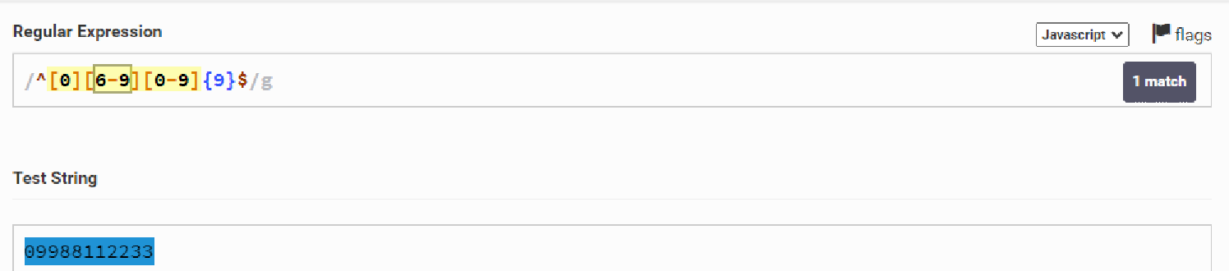

* 1. **+91-9988112233**
     1. Total count will be 14
     2. First digit or characters will be + sign
     3. Second digit will be 9
     4. Third digit will be 1
     5. Fourth character will be -(hyphen)
     6. Fifth digit will be anything from 6 - 9
     7. From sixth till the last character will be 0 - 9

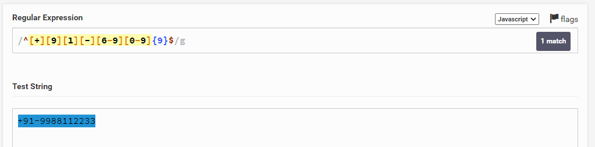

1. **Email Validation**
   1. **Username@DomainName.extension**
      1. **Username -**
      2. **DomainName - Gmail,hotmail,live,dhyanahita**
      3. **Extension - in,org,com**

**I. Define Parameters to Username**

I. It is combination of Lower,Upper and Digits

II. It also consists of some of the special characters like .(dot),_(Underscore) and -(hyphen)

III. It should contains minimum of 6 characters and maximum of 12 characters

**II. Define Parameters of Domain name**

1. It contains only lowercase characters
2. Len of characters will be from 3 to 15 characters
3. No spls characters are allowed here

**III. Define parameters of extension**

1. It contains only lowercase characters
2. Len of characters will be from 2 to 6
3. No characters are allowed

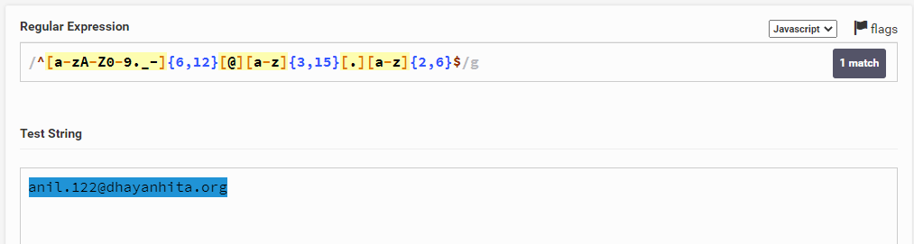

**3. Validate Your Roll numbers**

1. 221710309024
   1. You need to validate from 001 to 399

^[2][2][1][7][1][0][3][0-9]{2}[0-9]{3}$

^[2][2][1][7][1][0][3][0][9][0-3][0-9][1-9]$

^[2][2][1][7][1][0][3][0][9][0-9]{001,399}$

1. 198W1A0491
   1. Last three digits from 401 to 499

^[1][9][8][W][1][A][0][4][0-9]{2}$

**Validate the Mobile Number using Javascript Event:**

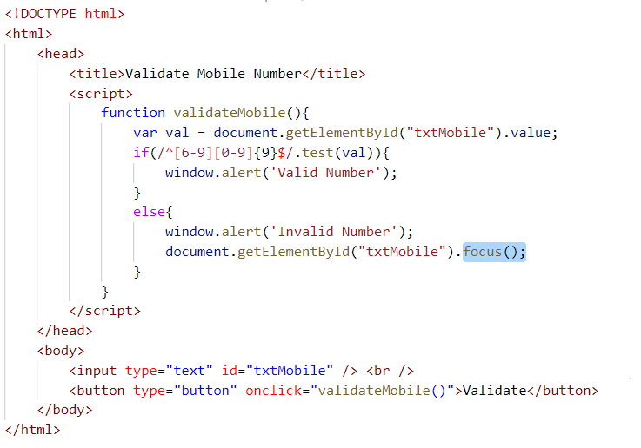

**Validate the EmailID using Javascript Event**

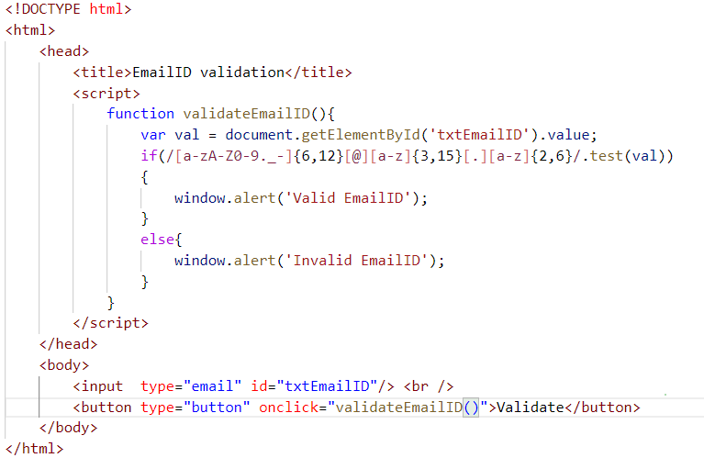

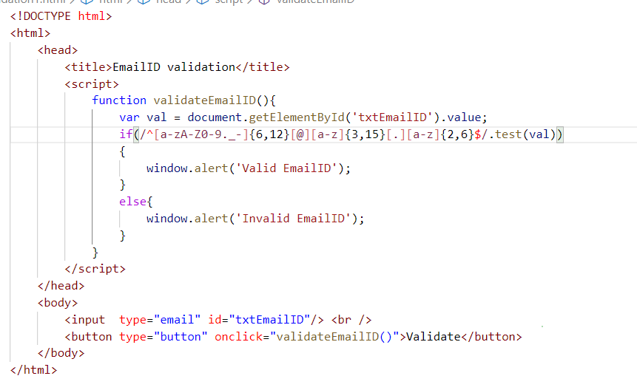

**Validate Your Roll numbers using Javascript Event**

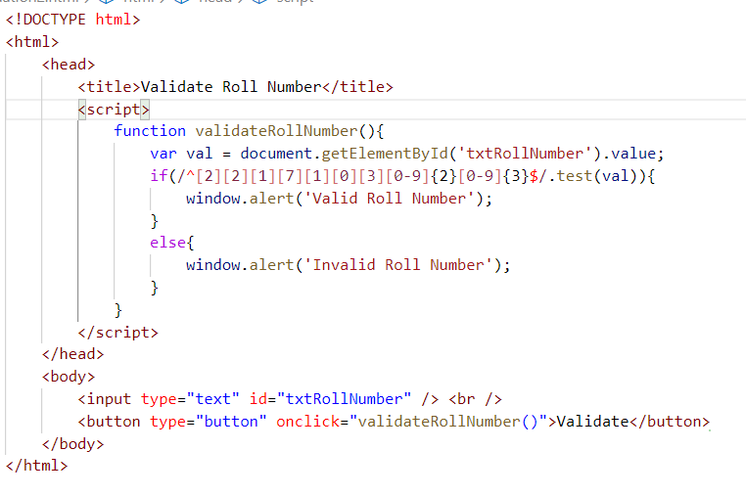

**Task**

