**ex1-main.html:**

<!DOCTYPE html>

<html>

<frameset rows="20%,80%">

<frame src="title.html">

<frameset cols="30%,70%">

<frame src="links.html">

<frame name="frame3" src="home.html">

</frameset>

</frameset>

</html>

**home.html:**

<html>

<head>

<title>Home</title>

</head>

<body>

<p>

The dog is a pet animal.<br>

A dog has sharp teeth so that it can eat flesh very easily, it has four legs, two ears, two eyes, a tail, a mouth, and a nose.<br>

It is a very clever animal and is very useful in catching thieves. It runs very fast, barks loudly and attacks the strangers.<br>

A dog saves the life of the master from danger. One can find dogs everywhere in the world. Dogs are a very faithful animals.<br>

It has a sharp mind and a strong sense of hearing smelling the things. It also has many qualities like swimming in the water, jumping from anywhere, good smelling sense.

</p>

</body>

</html>

**qualif.html:**

<!DOCTYPE html>

<html>

<head>

<title>Qualifications</title>

</head>

<body>

<p>

A dog has a strong power of smell.<br>

They are more liked by people because of their faithfulness. They are intelligent, they are watchful.<br> Dogs have many colors such as grey, white, black, brown and red. They are of many kinds such as bloodhound, greyhound, german shepherd, Labrador, Rottweiler, bulldog poodle, etc.<br>

Usually, the dog eats fish, meat, milk, rice, bread, etc. Dogs are sometimes called canines.<br>

Dogs are sometimes referred to as man’s best friend because they are kept as domestic pets and are usually loyal and like being around humans.<br>

They are also helpful in reducing stress, anxiety, and depression, loneliness, encourage exercise and playfulness and even improve your cardiovascular health.<br>

A dog also provides valuable companionship for older adults.

</p>

</body>

</html>

**contact.html:**

<!DOCTYPE html>

<html>

<head>

<title>Contact Us</title>

</head>

<body>

<p>

Blue Cross Of India<br><br>

Velachery Road, Guindy, Chennai, Tamil Nadu 600032<br><br>

Phone: +91-44-46274999 / +91-44-71819575<br><br>

Click to Rescue https://wa.me/919962998886 (WhatsApp)<br>

WhatsApp: +91919962998886 (No calls on WhatsApp, please!)<br><br><br>

Registered office:<br>

1 Eldams Road, Chennai - 600 018<br>

Tel : 91 - 44 - 22354959 / 22300666<br>

Fax: +91 44 2250 1801

</p>

</body>

</html>

**links.html:**

<html>

<body>

<a href="home.html" target="frame3">Home</a><br>

<a href="edu.html" target="frame3">Educational</a><br>

<a href="qualif.html" target="frame3">Qualification</a><br>

<a href="achievements.html" target="frame3">Achievements</a><br>

<a href="photogallery.html" target="frame3">Photo Gallery</a><br>

<a href="contact.html" target="frame3">Contact us</a><br>

</body>

</html>

**achievements.html:**

<html>

<head>

<title>Achievements</title>

</head>

<body>

<p>

Rupee is the first canine on record to travel for 10 days to Everest base camp with his owner, Joanne Lefson, taking him to the lofty altitude of 17,000 feet. Joanne found Rupee when he was a starving puppy on the streets of Ladakh, India and took him home to South Africa. They returned to India just months later for their challenge - a mountain trek up Everest

</p><br>

<p>

Laika was a true space dog and the first living creature launched into orbit around the Earth. Soviet Leader Nikita Krushchev wanted his engineers to follow up Sputnik 1 with a “space spectacular” - and they didn’t fail them.

</p><br>

<p>

Accompanying her owner on his Arctic expeditions, Titina was the first dog to reach the North Pole. The fierce little brown-and-white fox terrier was the inseparable companion of Umberto Nobile, an Italian inventor and airship pilot. His dog was his most loyal crew member - a faithful companion who stood only 10 inches high, weighed about 12 pounds and once barked down a polar bear.

</p><br>

<p>

In 1974, Ashley the whippet and his owner halted a nationally broadcast baseball game by dashing onto the field and performing frisbee stunts in front of an astonished audience. Both canine frisbee and Ashley became instant celebrities, and their disc-catching game turned into the annual Frisbee Disc Canine Championship.

</p><br>

<p>

American soldier Lee Duncan found the canine star of the silver screen on a French battlefield. Rin Tin Tin, who was famously cited in a divorce case and drank milk from a champagne glass, got his big break when he starred in the Warner Bros.’ film Where the North Begins, which is believed to have saved the studio from bankruptcy.

</p>

</body>

</html>

**dog.html:**

<html>

<body>

<p>YOU CLICKED A DOG</p>

</body>

</html>

**edu.html:**

<!DOCTYPE html>

<html>

<head>

<title>Educational</title>

</head>

<body>

<p>

The lifespan of a dog is very small however it can live around 12-15 years long which depend on their size such as smaller dogs lives a longer life.<br>

A female dog gives birth to a baby and feed milk that’s why dogs under the mammal category.<br>

The dog baby is called a puppy or pup and dog home is called kennel.<br>

Dogs are categorized according to their service to people such as guard dogs, herding dogs, hunting dogs, police dogs, guide dogs, sniffer dogs, etc.<br>

It has a strong power of smell with the assistance of police can arrest murderers, thieves, and dacoits.<br>

The Military trains the dogs to track and detect bombs.

</p>

</body>

</html>

**photogallery.html:**

<html>

<head>

<title>Gallery</title>

</head>

<body>

<p>Gallery of Dogs</p>

<img src="dog1.jpeg" usemap="#dogmap" width="400" height="379"><br><br>

<img src="dog2.jpg" ><br><br>

<map name="dogmap">

<area shape="rect" coords="120,70,290,300" href="dog.html">

</map>

</body>

</html>

**title.html:**

<html>

<head>

<title>FrameSet</title>

</head>

<body>

<h1 style="text-align:center;color:black;" >PERSONAL WEBSITE - DOGS</h1>

</body>

</html>

**Output:**

**Home:**

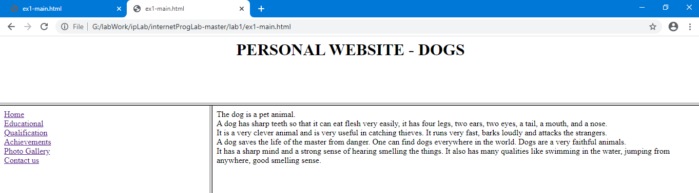

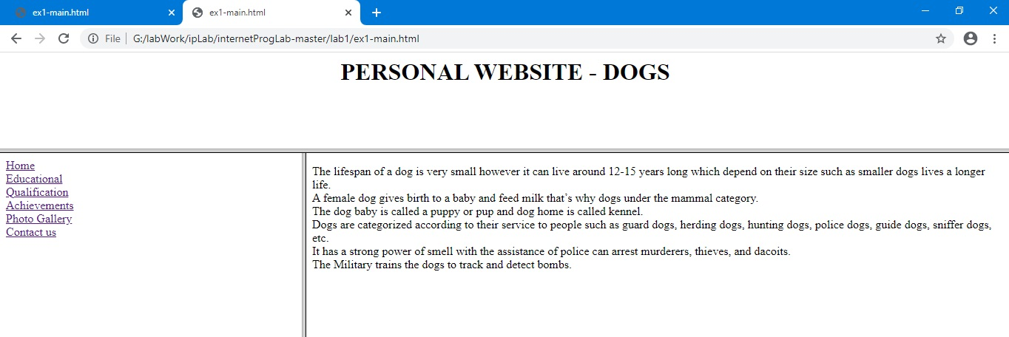**Educational:**

**Qualification:**

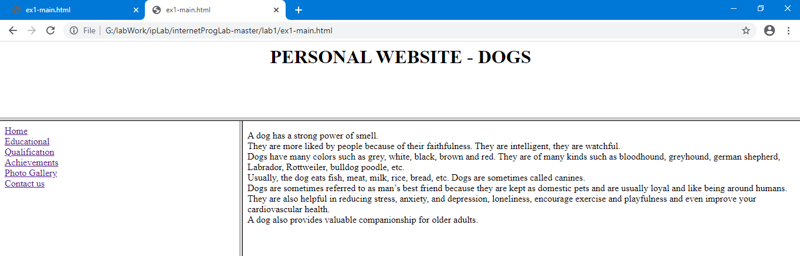

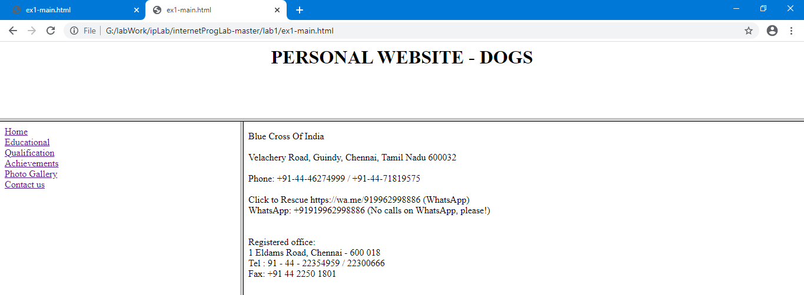**Contact Us**

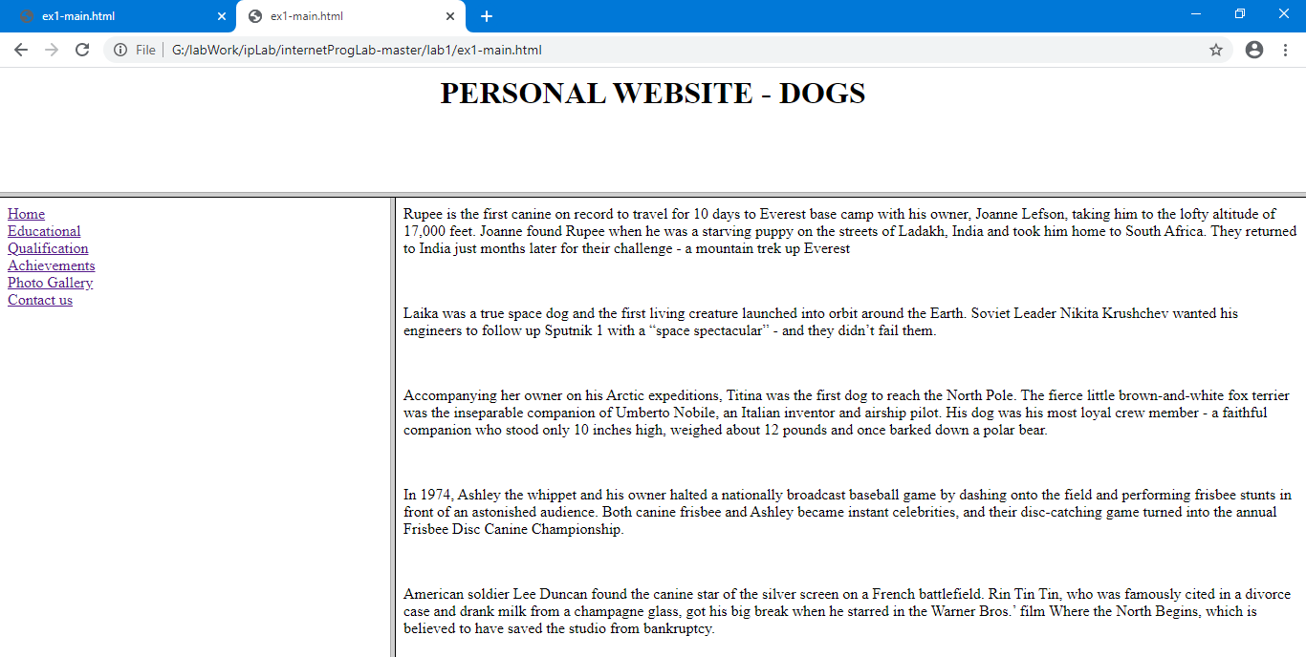**Achievements:**

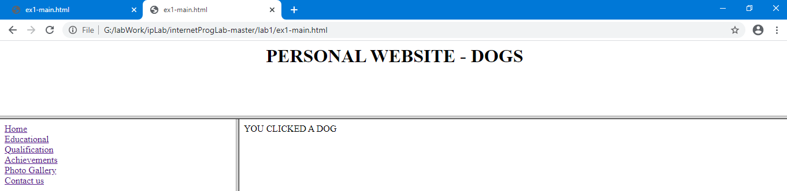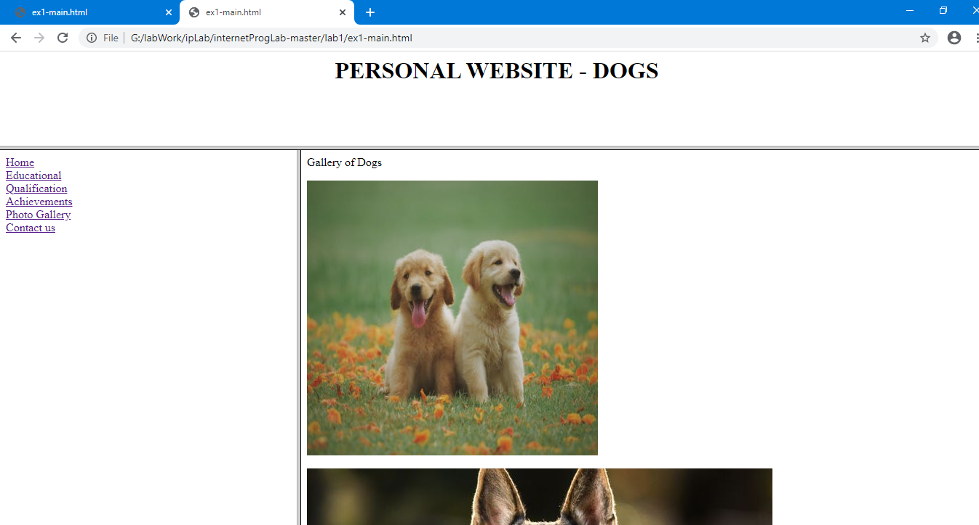**Photo Gallery: (With onClick mapping)**

**ex1_2.html:**

<!DOCTYPE html>

<html>

<head>

<title>Satcos-Tamil Web Pages</title>

<meta http-equiv="content-type" content="text/html; charset=utf-8" />

</head>

<body>

<p>கீதாசாரம்</p>

<p>எது நடந்ததோ அது நன்றாகவே நடந்தது</p>

</body>

</html>

**Output:**

