**q2_1.html:**

<!DOCTYPE html>

<html>

<head>

<style type="text/css">

p1{

margin-left:20px;

margin-right: 20px;

background:pink;

color: blue;

}

p2{

margin-left:30px;

margin-right: 30px;

background:black;

color: yellow;

}

p3{

text-indent: 1cm;

background: green;

color: white;

}

</style>

<title>Paragraph Question</title>

</head>

<body>

<p1>

Tamil Nadu, is the southern most state of India . It is the 11th largest state of India in terms of area. The language spoken here is Tamil and most people in the urban areas would be able to understand English. The capital of Tamil Nadu is Chennai (formerly known as Madras ). Tamil Nadu is divided into 32 districts.

</p1><br><br>

<p2>

Tamil Nadu has Pondicherry , Kerala, Karnataka and Andhra Pradesh as it neighbours. It also has one of the longest coastal lines in India and is very closely situated to Sri Lanka.

Climate in Tamil Nadu is generally hot. This is a highly monsoon dependent state and the monsoon seasons are from June to September (South West monsoons) and October to December (North East monsoons). The peak summer seasons, when the temperatures go as high as 43°C in the plains. The monsoon seasons are normally windy with intermittent rains.

</p2><br><br>

<p3>

The ancient, literary rich, classical Tamil is the official language in Tamil Nadu and people here attach a lot of respect and regard to Tamil, as their cultural identity. The spoken, colloquial Tamil has various dialects based on the region and they would sound quite differently. Hinduism is the majority religion along with a substantial population of Christians and Muslims.

</p3><br><br>

<p1>

People in Tamil Nadu have great taste for arts and culture. Carnatic music, Bharathanatyam dance form, folk music and rural dance forms are a fun to watch and a treat to the eyes and ears. They are colourful, vibrant and energetic with inspirational thoughts and about social issues. These art forms are performed during all occasions of celebrations, be it sorrow or joy

</p1><br><br>

<p2>

The staple food of people in Tamil Nadu is rice and its derivatives. Another important ingredient in the cuisine is tamarind. The basic food pattern of Tamil Nadu is breakfast, lunch and dinner, with a intermediate snack in the afternoon. Breakfast, primarily consists of what are called the tiffin items, viz., idly, dosai, pongal, upma etc., accompanied with various chutneys and sambar

</p2><br><br>

<p3>

The lunch(saappad) is of rice mixed with sambar or rasam or curd/buttermilk(yogurt) accompanied by curries (poriyal), gravies (kootus) ,appalams (papad) and pickles. Dinner is normally a light tiffin (as above) or in some places a full course meal(saappad).

</p3><br><br>

</body>

</html>

**Output:**

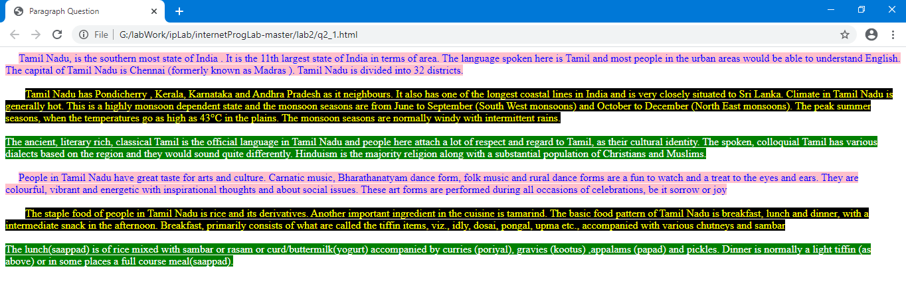

**q2_2.html:**

<!DOCTYPE html>

<html>

<head>

<title>Styles Question</title>

<link rel="stylesheet" type="text/css" title="style1" href="Style1.css">

<link rel="alternate stylesheet" type="text/css" title="style2" href="Style2.css">

</head>

<body>

<p> Create web page with the following contents. Use two style sheets. Style1.css displays the paragraph in pink background color with blue color font. Style2.css displays the paragraph in green background color, yellow color font with letters of the paragraph being spaced “2em” between each other. Demonstrate the rendering of web page with different styles using web browser. </p>

</body>

</html>

**Style1.css:**

p{ background:pink;

color:blue;

}

**Style2.css:**

p{ background:green;

color:yellow;

letter-spacing: 2em;

}

**Output:**

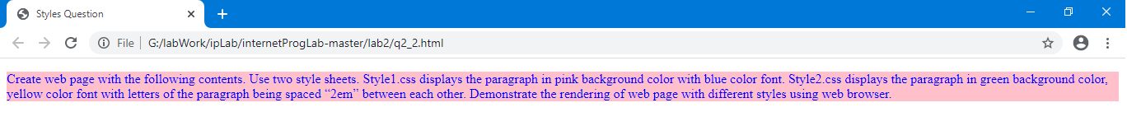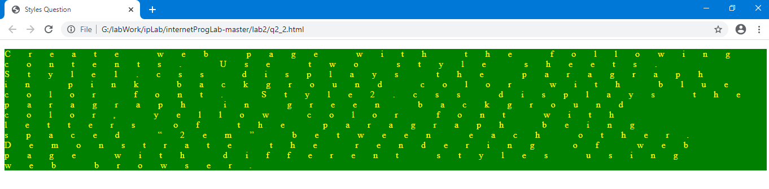

**q2_3.html:**

<!DOCTYPE html>

<html>

<head>

<title>Table Exercise</title>

<style type="text/css">

td{

font-size: 14pt;

font-family: sans-serif;

border:1px black solid;

}

th{

font-weight: normal;

font-style: italic;

border:1px solid black;

}

caption{

font-weight: bold;

}

a:active{

color: black;

}

a:link{

color: red;

}

a:hover{

color: green;

}

a:visited{

color: purple;

}

</style>

</head>

<body style="background:yellow">

<div>

<table>

<caption>A test table with merged cells</caption>

<tr>

<th rowspan="2"> </th> <th colspan="2">Average</th><th rowspan="2">Red<br>eyes</th>

</tr>

<tr>

<th>Height</th><th>Weight</th>

</tr>

<tr>

<th>Males</th><td>1.9</td><td>0.003</td><td>40%</td>

</tr>

<tr>

<th>Females</th><td>1.7</td><td>0.002</td><td>43%</td>

</tr>

</table>

</div>

<div>

<a href="https://www.gmail.com">Gmail</a><br>

<a href="https://www.google.com">Google</a><br>

<a href="https://www.yahoo.com">Yahoo</a><br>

<a href="https://www.ssn.net">SSN Intranet</a><br>

</div>

</body>

</html>

**Output:**

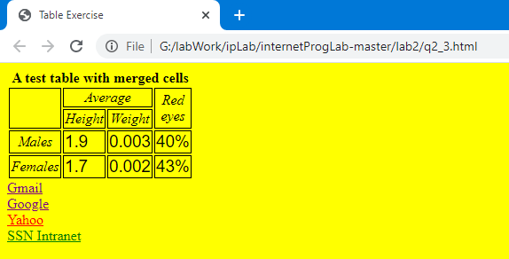

**q2_4.html:**

<!DOCTYPE html>

<html>

<head>

<title>Ps senior secondary school</title>

<link rel="stylesheet" type="text/css" href="ps.css">

</head>

<body>

<div id="maind">

<img src="logo1.jpg" height="75px" width="75px" id="fixed">

<div id="d1" >

<img src="logo1.jpg" height="130px" width="130px" id="i1">

<p id="p1"> P.S Senior Secondary School</p>

</div>

<div id ="d2">

<div id ="d21">

<a href="q2_4.html">Home</a><br><br>

<a href="fees.html">Fees</a><br><br>

<a href="ach.html">Achievements</a><br><br>

<a href="res.html">Results</a><br><br>

<a href="contact.html">Contact Us</a><br><br>

</div>

<div id="d22" >

<p ><span class="blue">The PS International Higher Secondary School is a recognized landmark in its pursuit of excellence in education, holistic development and human excellence, is deeply dedicated to the mission of building <span class="pink">"Global Citizens with Indian Values"</span class="pink"> , with an emphasis on value education, and respect for our rich cultural heritage.</span> <br><br>

PS International Higher Secondary School has been set up by the Learning Leadership Foundation (a public charitable trust) under the dynamic leadership of <span class="pink">Dr. PS, Director </span>. The PS International Higher Secondary School come directly under their purview and follow the tried and tested methodology of the teaching – learning process that has been the mainstay of academic excellence in over 50 years.<br><br>

The Learning Leadership Foundation comprises a group of enterprising people, who

have considerable experience in education, and are recognized for <span class="pink">'professional development initiatives'</span> for teachers. The School is backed by the combined strength of over a decade of <span class="pink">'thought leadership'</span> in best pedagogic practices of the Learning Leadership Foundation and more than five decades of academic excellence of PS International Higher Secondary School. The option of the School Transportation is provided for all the Campus, in all the locations, both in Chennai.

</p>

</div>

</div>

</div>

</body>

</html>

**ach.html:**

<!DOCTYPE html>

<html>

<head>

<title>Achievements</title>

<link rel="stylesheet" type="text/css" href="ach.css">

</head>

<body style="background: lightblue">

<img src="logo1.jpg" width="75px" height="75px" id="fixed">

<h1>Achievements</h1>

<div id="d1">

<ol id="ol1">

<li class="ol">

Hero Honda Inter Schools Athletics meet was held at Gems International School.

more than 40 schools of District Gurgaon participated in the meet. Director Hero

Honda was Chief Guest. Our participants brought many laurels to the school

<ul>

<li class="ul">

Deepak Yadav (Class X) bagged the Gold Medal in boys under 18years

</li>

<li class="ul">

Our Relay team Girls under 18 years got the Bronze Medal. The participants

were: Renu Yadav, Komal Yadav, Simral, Shereya

</li>

<li class="ul">

Student Simral (Class VII) won a Silver Medal in age group under 14 years

and Bronze Medal in age group under 18 years.

</li>

<li class="ul">

Nitesh Yadav (Class VIII) bagged the Gold Medal in age group Boys under

14 years

</li>

</ul>

</li>

<li class="ol">

Haryana State Roller Skating Championship was held at Faridabad from 17th Dec.

to 19th Dec. 2010. Our participants brought many laurels to the school. The results

are as follows:

</li>

<li class="ol">

Yuthika Khatri (Class VII) bagged Gold Medals and Bronze Medals in the

following events:

<ul>

<li class="ul">500 mtrs. Rink Race Gold Medal</li>

<li class="ul">5000 mtrs. Road Race Gold Medal</li>

<li class="ul">1000 mtrs. Rink Race Gold Medal</li>

</ul>

</li>

</ol>

</div>

</body>

</html>

**ach.css:**

#fixed{

position: fixed;

bottom: 0;

right: 0;

}

h1{

text-align: center;

}

#ol1{

margin-top: 50px;

}

.ul{

font-size: 15pt;

list-style-type: initial;

}

.ol{

margin-top: 30px;

font-size: 16pt;

}

**contact.html:**

<!DOCTYPE html>

<html>

<head>

<title>Contact Us</title>

<link rel="stylesheet" type="text/css" href="ps.css">

</head>

<body>

<h1>Contact Us</h1><br><br>

<img src="logo1.jpg" height="75px" width="75px" id="fixed">

<div style="background: yellow; font-size: 14px; text-align: center;">

<h2>PS Senior Secondary school</h2>

<h3>Contact:<br> +91 11 7564-6354</h3>

<h3>Mail:<br> contact@pssenior.com</h3>

<h3>Address:<br> Saana Niwas Road, Gurgoan, Haryana, India</h3>

</div>

</body>

</html>

**fees.html:**

<!DOCTYPE html>

<html>

<head>

<title>tables</title>

<link rel="stylesheet" type="text/css" href="fees.css">

</head>

<body>

<h1>Fee Structure</h1>

<img src="logo1.jpg" height="75px" width="75px" id="fixed">

<div id="d1" border="1">

<table border="1">

<caption>Fees Structure</caption>

<tr><td>Registration Fee</td> <td>25</td> <td></td> <td></td> </tr>

<tr id="r2"><td>School Dues</td> <td>LKG-V</td> <td>VI-X</td> <td>XI-XII</td></tr>

<tr><td>Admission Fees</td><td>200</td><td>200</td><td>200</td></tr>

<tr><td>Annual Charges</td><td>3745p.a</td><td>3745p.a</td><td>3745p.a</td></tr>

<tr><td>Development Charges</td> <td>275p.a</td> <td>295p.a</td> <td>315p.a</td> </tr>

<tr><td>Tution fee to be paid quarterly</td> <td>1840p.m</td> <td>1995p.m</td> <td>2115p.m</td></tr>

</table>

</body>

</div>

</html>

**fees.css:**

body{

background-color: whitesmoke;

}

td{

font-family: sans-serif;

font-size: 14pt;

}

th{

font-weight: normal;

font-style: italic;

}

#d1{

width: 400px;

height: 240px;

border: 1px solid black;

background-color: cornsilk;

margin: 200px auto;

}

a{

font-size: 12pt;

}

a:visited{

color: red;

}

a:hover{

color: black;

font-style: italic;

}

a:active{

color: green;

}

a:link{

color: blue;

}

#r2{

color: darkviolet;

font-weight: bold;

}

#fixed{

position: fixed;

bottom: 0;

right: 0;

}

h1{

text-align: center;

}

**ps.css:**

#maind{ position: absolute;

top: 0;

left: 0;

height:100%;

width:100%;

font-size: 14;

}

#d1{ height:20%;

width:100%;

border-bottom: 2px solid black;

background-color: yellow;

}

#p1{ position:absolute;

font-size: 20pt;

font-family: sans-serif;

font-weight: bold;

top:8%;

left:40%;

}

#d2{ margin-top:0px;

height: 80%;

width: 100%;

}

#d21{ height: 100%;

width: 20%;

border-right: 2px solid black;

}

#d22 { position: absolute;

top: 20%;

left: 20%;

width: 80%;

height: 100%;

}

a{ font-size:20pt;

text-align: center;

line-height:2cm;

}

a:link{

color: blue;

}

a:visited{

color: purple;

}

a:hover{

color: red;

}

a:active{

color: green;

}

p{ position: absolute;

top: 20%;

font-family: sans-serif;

}

.blue{ color: blue;

font-size: 13;

font-style: italic;

}

.pink{ color: violet;

font-weight: bold;

}

#fixed{ position: fixed;

bottom: 0;

right: 0;

}

**res.html:**

<!DOCTYPE html>

<html>

<head>

<title>Results</title>

<link rel="stylesheet" type="text/css" href="ach.css">

</head>

<body style="background: lightblue">

<img src="logo1.jpg" width="75px" height="75px" id="fixed">

<h1>Results</h1>

<div id="d1">

<ol id="ol1">

<li class="ol">

The class X and XII examinations were conducted recently (2019 session) and the results are as follows

<ul>

<li class="ul">

Deepak Yadav (Class X) got a CGPA 10.

</li>

<li class="ul">

Our girls from class XII got 98 Percentage in the Science Stream. The students

were: Renu Yadav, Komal Yadav, Simral, Sarayu

</li>

<li class="ul">

Student Simral (Class XII) got 96 percentage in commerce stream

</li>

<li class="ul">

(Misc) Nitesh Yadav (Class XII) bagged the Gold Medal in Cyber Olympiad

</li>

</ul>

</li>

</ol>

</div>

</body>

</html>

**Output:**

