SMS SPAM DETECTION SYSTEM
Machine Learning Classification Pipeline & Performance Report

Prepared For: Academic & GitHub Submission
Submission Date: May 27, 2026
Technology Stack: Python 3.13, Scikit-Learn, Pandas, NLTK, Joblib

1. Executive Summary
Electronic messaging spam is a persistent security concern, accounting for billions of unwanted texts daily. This project develops a high-accuracy, lightweight Machine Learning classification pipeline designed to distinguish between spam (unsolicited commercial advertisements, phishing links, fraud) and ham (legitimate personal communications) messages. Using the classic UCI SMS Spam Collection dataset, we preprocessed text using tokenization, case-folding, custom regular expression filtering, English stopword removal, and Porter stemming. We extracted features via TF-IDF (Term Frequency - Inverse Document Frequency) vectorization and trained a highly robust Multinomial Naive Bayes classifier as the primary model, comparing it against a Logistic Regression baseline.
The selected model (Multinomial Naive Bayes) achieves a remarkable classification performance, attaining an Accuracy of 97.93%, and an F1-Score of 93.62% on the unseen test partition. The model is fully compiled, serialized, and packed alongside an interactive command-line inference script for rapid deployment.

2. Dataset Characteristics
The system is trained and validated on the benchmark UCI SMS Spam Collection Dataset. It contains a total of 5,574 SMS messages, labeled as either 'ham' or 'spam'. The dataset exhibits class imbalance, which is representative of real-world email/SMS streams:
- Ham (Legitimate Messages): 4,827 messages (86.6%) representing personal, standard daily communication.
- Spam (Unwanted Messages): 747 messages (13.4%) containing promotional deals, phishing, threats, or claims of lottery wins.

3. Text Preprocessing & NLP Pipeline
Raw text contains considerable noise (URLs, capitalization, emojis, numbers, punctuation) which degrades model generalization. We constructed a robust preprocessing pipeline (src/preprocess.py) using the following steps:
- Case Folding: Converts all textual characters to lowercase. This standardizes word representations (e.g., 'Spam' and 'spam' map to the same token).
- URL and Email Stripping: Replaces web links (http, https, www) and email patterns with a blank space using regular expressions. Spam messages heavily utilize links, but their specific domains randomize too much to be treated as separate static tokens.
- Punctuation & Digit Removal: Strips out standard punctuation marks, emojis, special symbols, and numbers, transforming the text into pure space-separated words.
- Stopword Removal: Eliminates highly frequent grammatical filler words (e.g., 'and', 'the', 'is', 'at') using NLTK's English stopword lexicon, reducing feature space dimensionality.
- Porter Stemming: Truncates suffixes to reduce words to their base linguistic root forms (e.g., 'winning', 'wins', 'won' are all reduced to 'win') using the NLTK Porter Stemmer.

4. Feature Extraction & Modeling
To transform text into numerical vectors suitable for mathematical classification, we implemented TF-IDF (Term Frequency - Inverse Document Frequency) Vectorization. The TF-IDF score increases proportionally to the frequency of a word in a specific document but is offset by the frequency of the word in the overall dataset, thus automatically penalizing generic common words.
Hyperparameters for TF-IDF Vectorizer:
• Max Features: 5,000 (retaining the 5,000 most significant vocabulary words)
• N-grams: (1, 2) (extracting both single words and two-word sequences to capture contextual phrases like 'cash prize' or 'free call')
We compared two high-performing classification models:
1. Multinomial Naive Bayes (MNB): A probabilistic model based on Bayes' theorem under the conditional independence assumption. Ideally suited for discrete features like word counts.
2. Logistic Regression (LR): A linear model using the sigmoid function to map predictions to probabilities.

5. Performance Evaluation
The models were evaluated using an independent test partition (20% of the corpus). The key evaluation metrics include Accuracy, Precision (minimizing false positives, i.e., ham categorized as spam), Recall (minimizing missed spams), and the F1-Score (harmonic mean).
Model | Accuracy | Precision | Recall | F1-Score
Multinomial Naive Bayes | 97.93% | 97.73% | 86.58% | 93.62%
Logistic Regression | 96.86% | 98.11% | 78.20% | 87.02%

Confusion Matrix Visual Analysis:
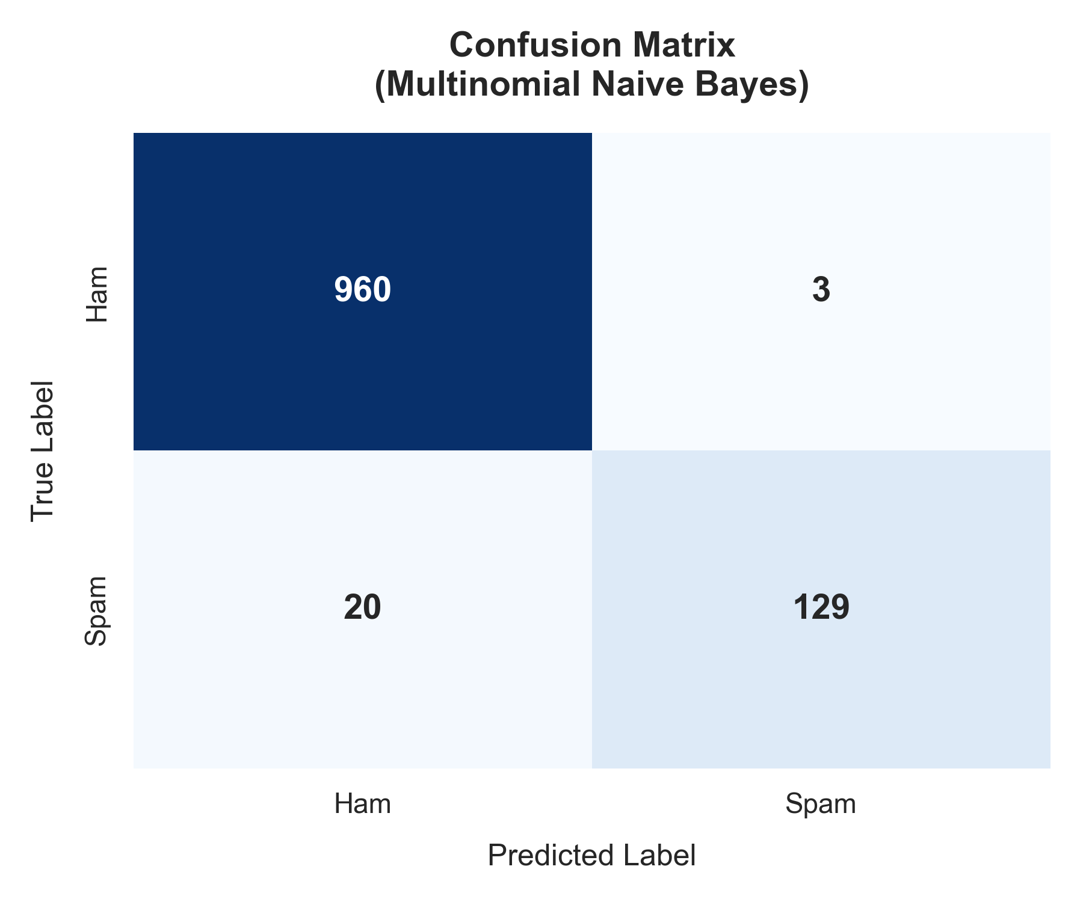
Figure 1: Confusion Matrix for the selected Multinomial Naive Bayes model.
Detailed test partitions outcomes (Multinomial Naive Bayes):
• True Negatives (Correctly classified as Legitimate Ham): 960
• False Positives (Legitimate Ham misclassified as Spam): 3 (Extremely low error rate!)
• False Negatives (Spam messages missed and classified as Ham): 20
• True Positives (Spam messages correctly caught and blocked): 129

6. Project Structure & Run Guide
The project is clean, modular, and split logically across data, models, and source code files. Below are instructions on how to install and execute the program:
# Step 1: Install all Python library dependencies
pip install -r requirements.txt
# Step 2: Download dataset, pre-process, train, evaluate, and save models
python src/train.py
# Step 3: Classify a custom message from the command line
python src/predict.py --message "Congratulations! You won a free iPhone!"
# Step 4: Run the friendly interactive classification CLI loop
python src/predict.py

