**Crime Dataset:**

The columns in Crime.csv are Area_Name,Year,Group_Name,Sub_Group_Name, Cases_Property_Recovered,Cases_Property_Stolen,Value_of_Property_Recovered,Value_of_Property_Stolen

1.Remove the headers

2.Copy the local file in hdfs

#hadoop dfs -put 'file' /

**LOAD Dataset:**

crime_record = LOAD '/Crime.csv' using PigStorage(',') as (area:chararray,year:int,groups:chararray,subgroups:chararray,casesrecovered:int,casesstolen:int,valuerecovered:int,valuestolen:int);

**View Dataset:**

dump crime_record;

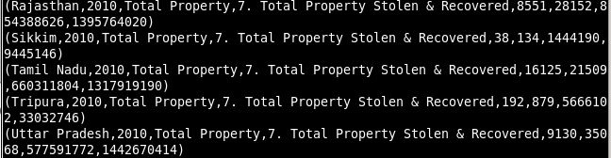

**Analysing Dataset:**

**1)Crimes accured in TamilNadu:**

filter_data = FILTER crime_record by area == 'Tamil Nadu';

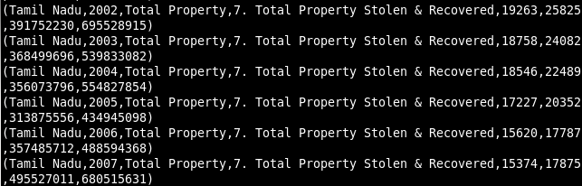 dump filter_data;

**2)Crimes in TamilNadu at 2010:**

filter_data = FILTER crime_record by area == 'Tamil Nadu' and year==2010;

dump filter_data;

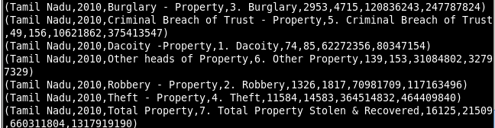

**3)Crimes Average Value Stolen by Area:**

GroupByArea = GROUP crime_record by area;

dump GroupByArea;

area_avg_value = foreach GroupByArea GENERATE group,AVG(crime_record.valuestolen);

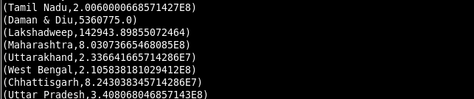 dump area_avg_value;

**4)Maximum Value Recovered by year:**

GroupByyear = GROUP crime_record by year;

dump GroupByyear;

max_val_rec = FOREACH GroupByyear GENERATE group,MAX(crime_record.valuerecovered);

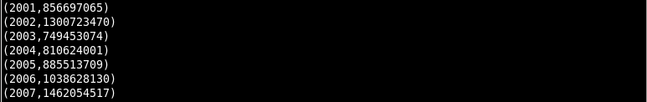 dump max_val_rec;

**5)Average ValueStolen of cases by area and year:**

GroupByareayear = GROUP crime_record by (area,year);

dump GroupByareayear;

avg_area_year = FOREACH GroupByareayear GENERATE group, AVG(crime_record.valuestolen);

dump avg_area_year;

