MUSICPLAYLIST MANAGEMENT SYSTEM

CODING:

import java.sql.*;

import java.util.Scanner;

public class MusicPlaylistManager {

    // Database connection details

    private static final String URL = "jdbc:mysql://localhost:3306/music_db";

    private static final String USER = "root";

    private static final String PASSWORD = "";

    // Method to establish database connection

    private static Connection getConnection() throws SQLException {

        return DriverManager.getConnection(URL, USER, PASSWORD);

    }

    // Add a song to the database

    private static void addSong(String title, String artist, String genre) {

        String query = "INSERT INTO songs (title, artist, genre) VALUES (?, ?, ?)";

        try (Connection conn = getConnection();

             PreparedStatement stmt = conn.prepareStatement(query)) {

            stmt.setString(1, title);

            stmt.setString(2, artist);

            stmt.setString(3, genre);

            stmt.executeUpdate();

            System.out.println("Song added successfully.");

        } catch (SQLException e) {

            System.out.println("Error adding song: " + e.getMessage());

        }

    }

    // View all songs in the database

    private static void viewSongs() {

        String query = "SELECT * FROM songs";

        try (Connection conn = getConnection();

             PreparedStatement stmt = conn.prepareStatement(query);

             ResultSet rs = stmt.executeQuery()) {

            System.out.println("Songs:");

            while (rs.next()) {

                System.out.println("ID: " + rs.getInt("song_id") +

                                   ", Title: " + rs.getString("title") +

                                   ", Artist: " + rs.getString("artist") +

                                   ", Genre: " + rs.getString("genre"));

            }

        } catch (SQLException e) {

            System.out.println("Error fetching songs: " + e.getMessage());

        }

    }

    // Create a new playlist

    private static void createPlaylist(String name) {

        String query = "INSERT INTO playlists (name) VALUES (?)";

        try (Connection conn = getConnection();

             PreparedStatement stmt = conn.prepareStatement(query)) {

            stmt.setString(1, name);

            stmt.executeUpdate();

            System.out.println("Playlist created successfully.");

        } catch (SQLException e) {

            System.out.println("Error creating playlist: " + e.getMessage());

        }

    }

    // Add a song to a playlist

    private static void addSongToPlaylist(int playlistId, int songId) {

        String query = "INSERT INTO playlist_songs (playlist_id, song_id) VALUES (?, ?)";

        try (Connection conn = getConnection();

             PreparedStatement stmt = conn.prepareStatement(query)) {

            stmt.setInt(1, playlistId);

            stmt.setInt(2, songId);

            stmt.executeUpdate();

            System.out.println("Song added to playlist successfully.");

        } catch (SQLException e) {

            System.out.println("Error adding song to playlist: " + e.getMessage());

        }

    }

    // View all songs in a playlist

    private static void viewPlaylist(int playlistId) {

        String query = "SELECT s.title, s.artist, s.genre " +

                       "FROM songs s " +

                       "JOIN playlist_songs ps ON s.song_id = ps.song_id " +

                       "WHERE ps.playlist_id = ?";

        try (Connection conn = getConnection();

             PreparedStatement stmt = conn.prepareStatement(query)) {

            stmt.setInt(1, playlistId);

            try (ResultSet rs = stmt.executeQuery()) {

                System.out.println("Playlist Songs:");

                while (rs.next()) {

                    System.out.println("Title: " + rs.getString("title") +

                                       ", Artist: " + rs.getString("artist") +

                                       ", Genre: " + rs.getString("genre"));

                }

            }

        } catch (SQLException e) {

            System.out.println("Error viewing playlist: " + e.getMessage());

        }

    }

    // Main method for user interaction

    public static void main(String[] args) {

        Scanner scanner = new Scanner(System.in);

        while (true) {

            System.out.println("\nMusic Playlist Management System");

            System.out.println("1. Add Song");

            System.out.println("2. View Songs");

            System.out.println("3. Create Playlist");

            System.out.println("4. Add Song to Playlist");

            System.out.println("5. View Playlist");

            System.out.println("6. Exit");

            System.out.print("Choose an option: ");

            int choice = scanner.nextInt();

            scanner.nextLine(); // Consume newline

            switch (choice) {

                case 1:

                    System.out.print("Enter song title: ");

                    String title = scanner.nextLine();

                    System.out.print("Enter artist: ");

                    String artist = scanner.nextLine();

                    System.out.print("Enter genre: ");

                    String genre = scanner.nextLine();

                    addSong(title, artist, genre);

                    break;

                case 2:

                    viewSongs();

                    break;

                case 3:

                    System.out.print("Enter playlist name: ");

                    String playlistName = scanner.nextLine();

                    createPlaylist(playlistName);

                    break;

                case 4:

                    System.out.print("Enter playlist ID: ");

                    int playlistId = scanner.nextInt();

                    System.out.print("Enter song ID: ");

                    int songId = scanner.nextInt();

                    addSongToPlaylist(playlistId, songId);

                    break;

                case 5:

                    System.out.print("Enter playlist ID: ");

                    int plId = scanner.nextInt();

                    viewPlaylist(plId);

                    break;

                case 6:

                    System.out.println("Exiting...");

                    return;

                default:

                    System.out.println("Invalid option. Please try again.");

            }

        }

    }

}

**OUTPUT:**

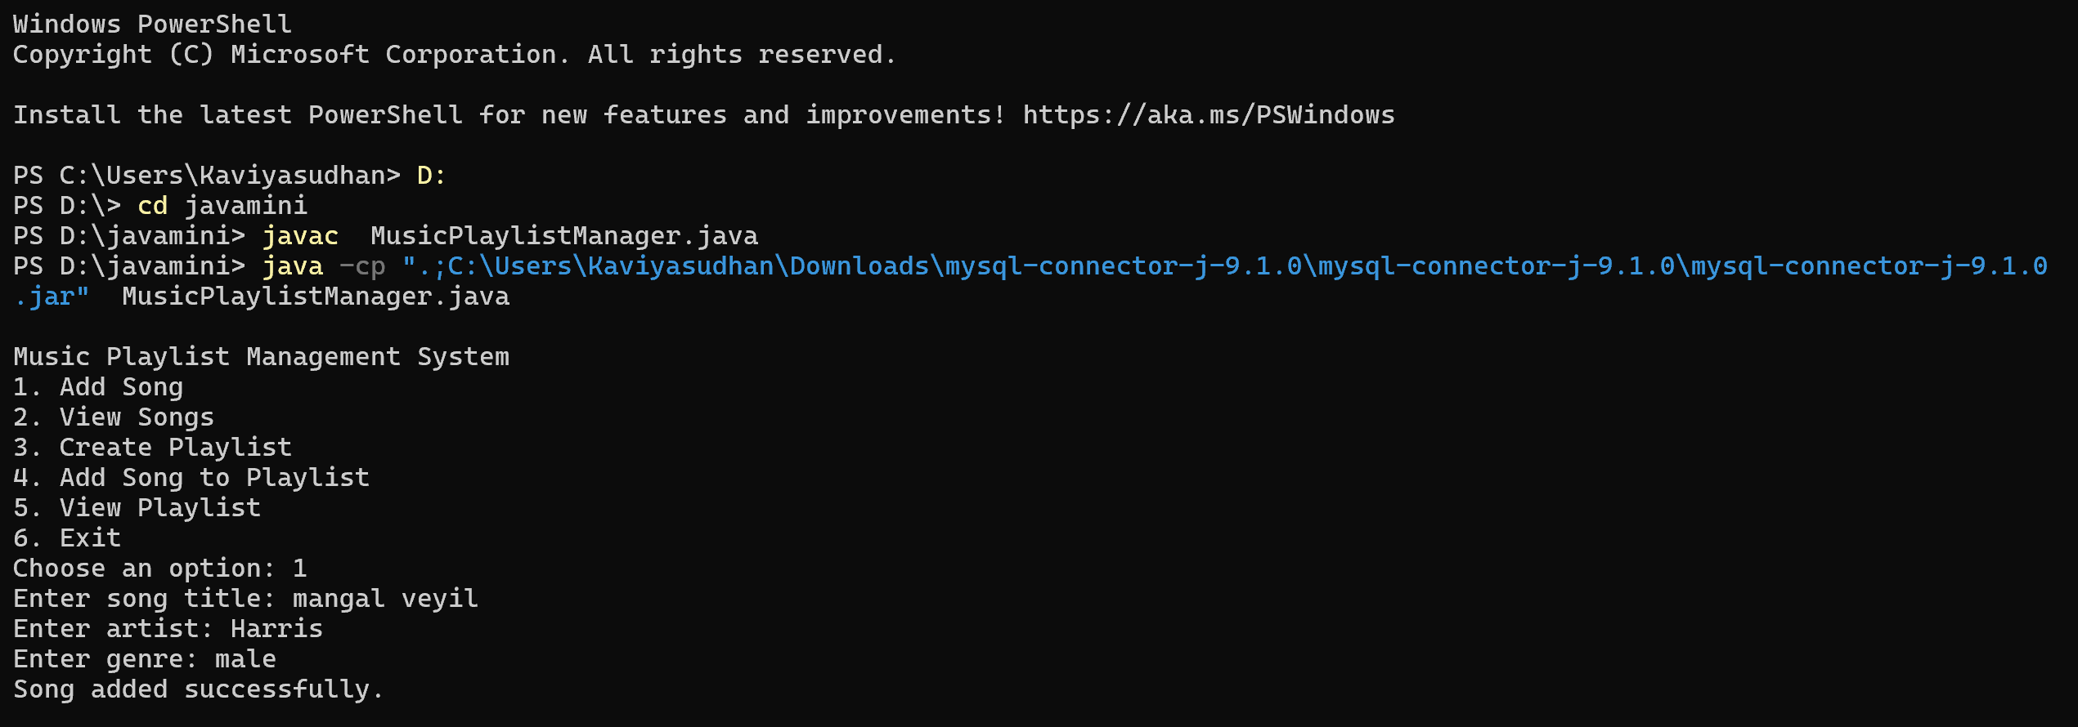

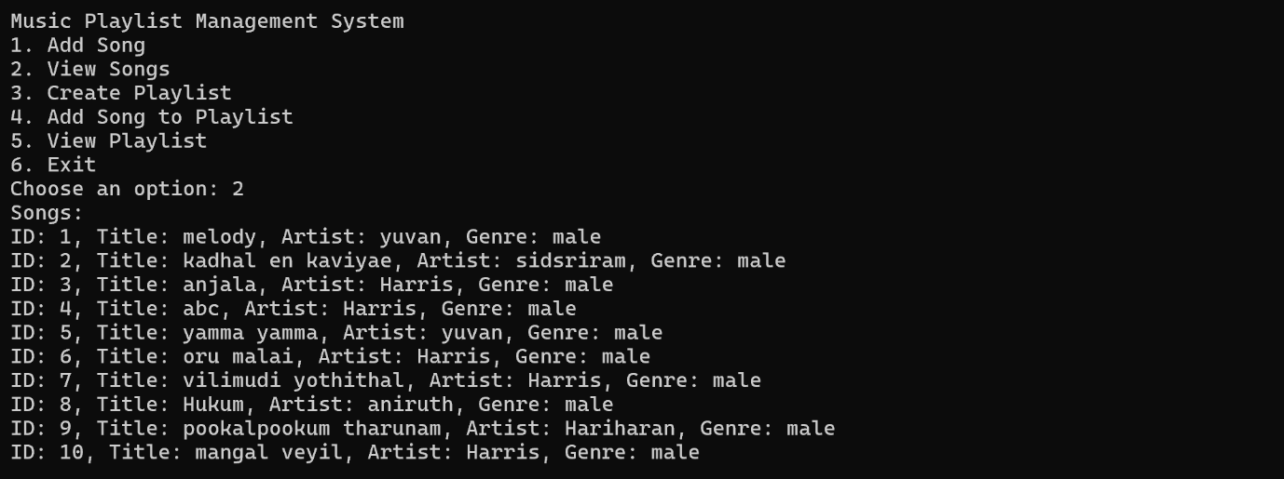

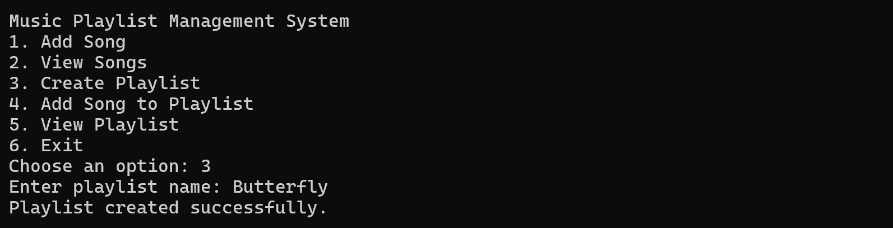

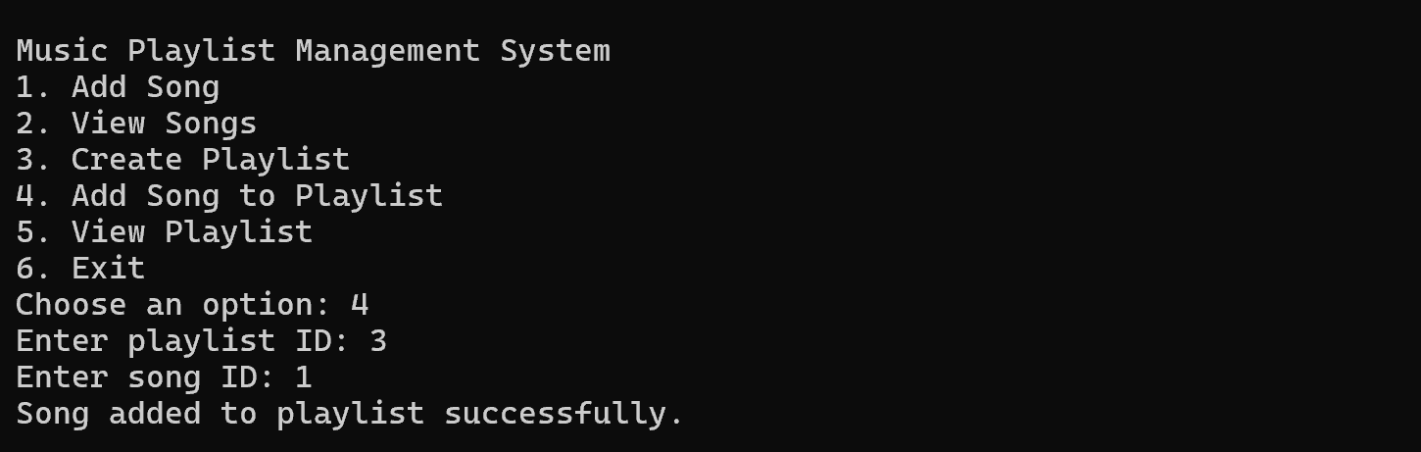

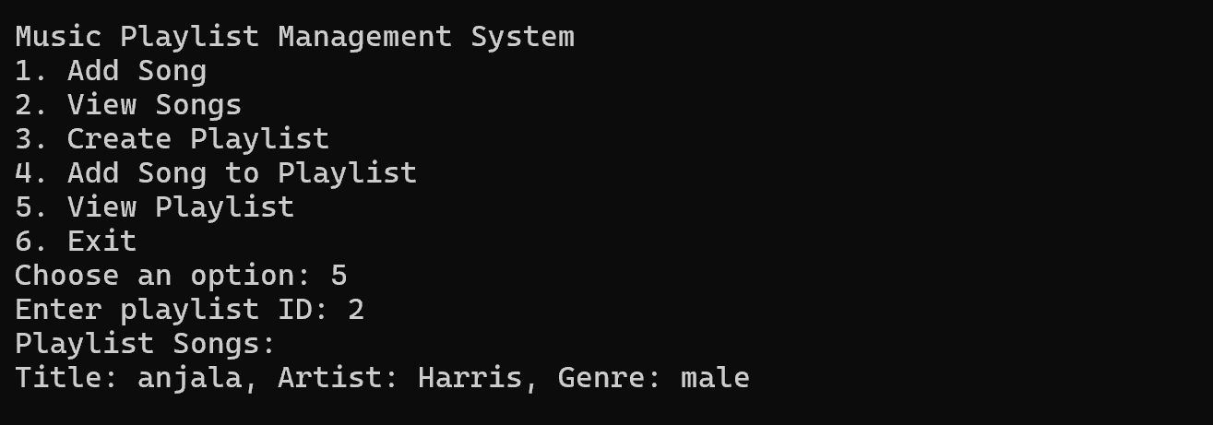

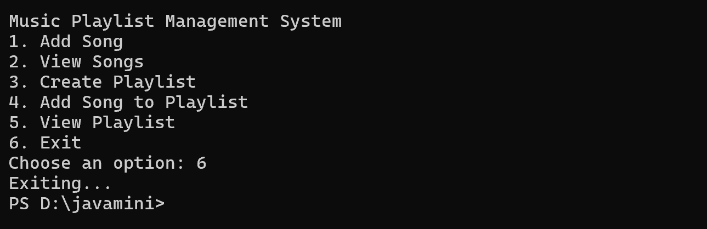

**DATAbase connection output:**

