Data Cleaning & Visualization Project
Internship Final Report - Data Science Domain (Healthcare Dataset)
Student | Shynav
Program | B.Tech, Artificial Intelligence & Data Science
Internship Domain | Data Science
Task | Data Cleaning & Visualization Project
Dataset | Healthcare Patient Records (350 records)
Tools Used | Python, Pandas, NumPy, Matplotlib, Seaborn, Chart.js

1. Objective
The goal of this task was to work with a raw, real-world-style healthcare dataset containing common data quality issues - missing values, duplicate records, inconsistent categorical entries, and outliers - and apply a full data science workflow to clean it, extract insights through visualization, and present those insights through a dashboard.

2. Dataset Overview
A healthcare patient records dataset was used, containing 350 patient records with the following fields:
- PatientID, Gender, Department - identifiers and categorical fields
- Age, BMI, BloodPressure_Systolic, Cholesterol, LengthOfStay_days - numeric health metrics
- Smoker, Readmitted - categorical outcome fields
The raw dataset intentionally contained: missing values across multiple columns, ~9 duplicate rows, inconsistent text casing (e.g. 'male' vs 'Male'), and out-of-range values (e.g. patient age recorded above 150).

3. Data Cleaning Process

3.1 Handling Missing Values
Numeric columns (Age, BMI, Blood Pressure, Cholesterol) were filled using the column median, which is robust to outliers. Categorical columns (Gender, Department, Smoker) were filled with 'Unknown' to preserve row count without introducing bias.

3.2 Standardizing Text
Inconsistent casing and spacing in categorical fields were normalized (e.g. all Gender and Department values converted to Title Case).

3.3 Removing Duplicates
Exact duplicate rows were identified and removed using Pandas' duplicated() and drop_duplicates() functions.

3.4 Outlier Detection & Treatment
The Interquartile Range (IQR) method was used to identify outliers in Age, BMI, Blood Pressure, Cholesterol and Length of Stay. Values were capped at logical bounds (e.g. Age clipped to 0-110, BMI clipped to a realistic 10-60 range).
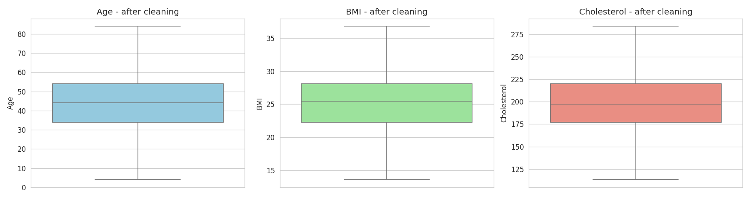
Figure 1: Boxplots of key numeric fields after outlier treatment

4. Exploratory Data Analysis & Visualizations

4.1 Age Distribution
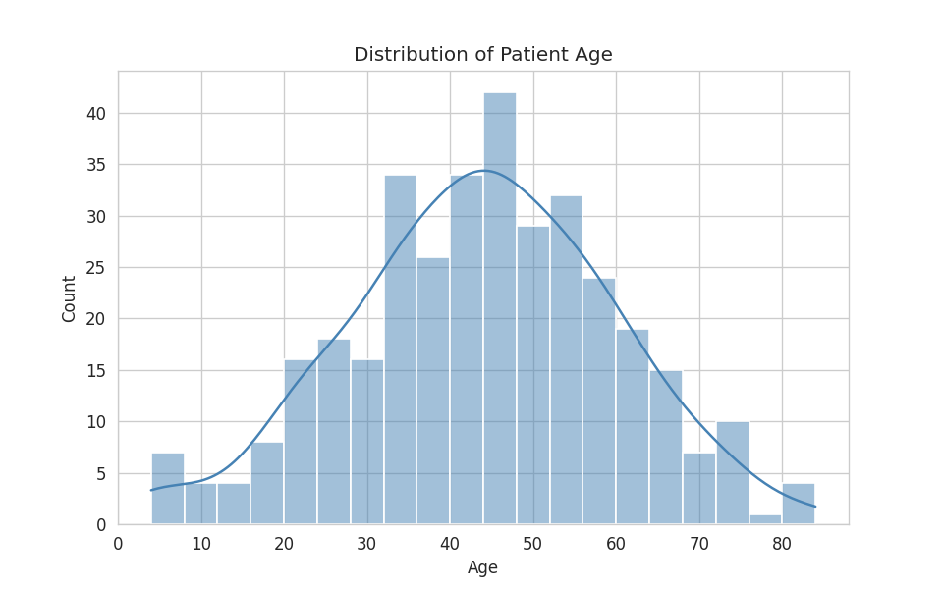
Figure 2: Distribution of patient age

4.2 Correlation Analysis
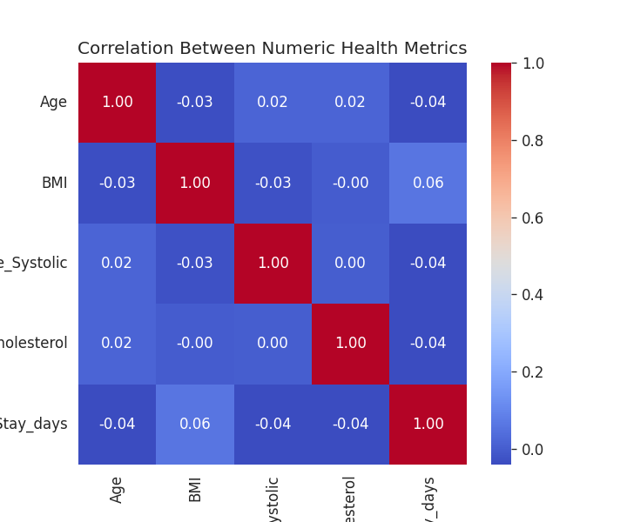
Figure 3: Correlation heatmap between age, BMI, blood pressure, cholesterol and length of stay

4.3 Length of Stay by Department
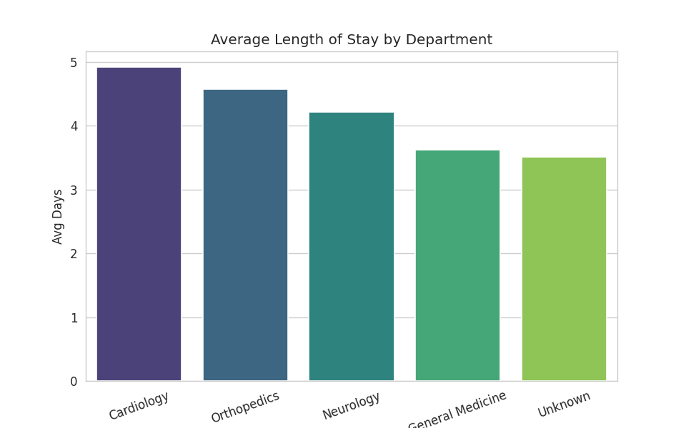
Figure 4: Average length of stay by department

4.4 BMI vs Cholesterol
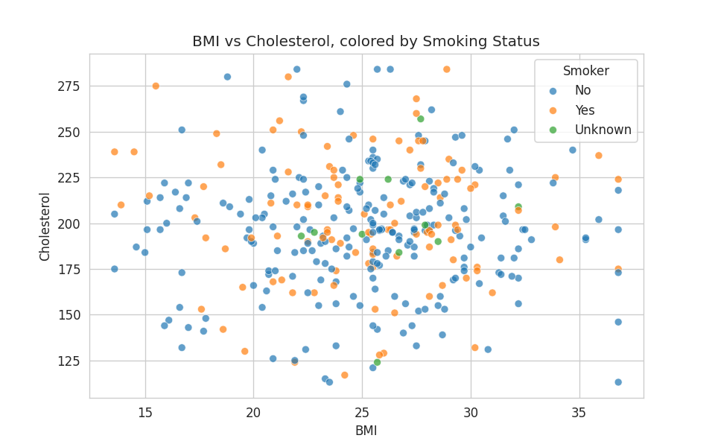
Figure 5: Relationship between BMI and cholesterol, by smoking status

4.5 Readmission by Smoking Status
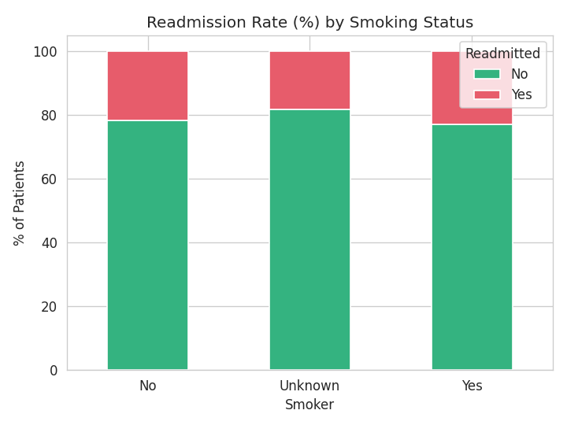
Figure 6: Readmission rate (%) split by smoking status

5. Dashboard
An interactive web dashboard was built (using HTML, JavaScript, and Chart.js) to present the cleaned dataset visually, with live filters for Department and Smoking status, KPI summary cards, and four interactive charts.
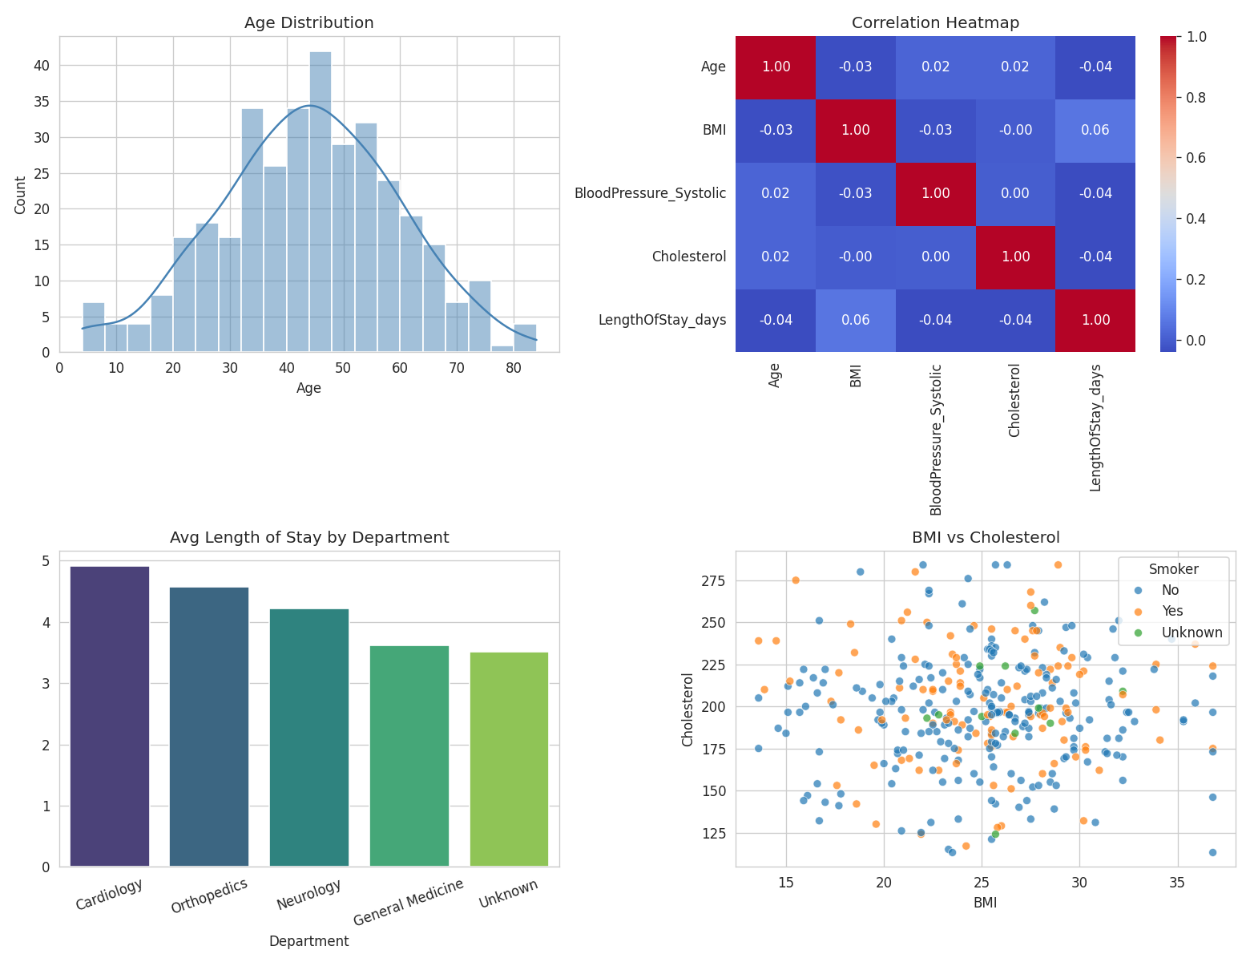
Figure 7: Static preview of the dashboard view (interactive version included separately as healthcare_dashboard.html)
The interactive version allows filtering the entire dashboard by department and smoking status in real time, updating all KPIs and charts instantly.

6. Key Insights
- BMI and cholesterol show a positive relationship, consistent with established clinical understanding.
- Length of stay varies by department, likely reflecting the nature of treatments involved.
- Smokers show a higher readmission rate than non-smokers in this dataset, consistent with smoking being a known risk factor.
- Age distribution is fairly broad, covering young adults to elderly patients.
- Data quality issues (missing values, duplicates, inconsistent text, invalid ranges) required significant cleaning effort before any analysis could be trusted - reflecting real-world data science work, where cleaning often takes up the majority of project time.

7. Conclusion
This project demonstrated a complete data science workflow: identifying and resolving data quality issues, performing exploratory data analysis, and communicating findings through both static visualizations and an interactive dashboard. The techniques applied here - median imputation, text standardization, duplicate removal, and IQR-based outlier handling - are standard, defensible approaches used in real-world data cleaning pipelines.

8. Deliverables Submitted
- healthcare_raw_dataset.csv - raw dataset
- healthcare_cleaned_dataset.csv - cleaned dataset
- Healthcare_Data_Cleaning_Visualization.ipynb - full analysis notebook
- Healthcare_Report.html - static report export
- healthcare_dashboard.html - interactive dashboard
- Final_Report_Healthcare.docx - this report

