Predictive Modeling Using Machine Learning
Internship Task 2 - Final Report - Data Science Domain (Titanic Dataset)
Item | Details
Student | Shynav
Program | B.Tech, Artificial Intelligence & Data Science
Task | Predictive Modeling Using Machine Learning
Dataset | Titanic Passenger Data (891 passengers, seaborn built-in)
Algorithms | Logistic Regression, Decision Tree, Random Forest
Tools | Python, Pandas, scikit-learn, Matplotlib, Seaborn

1. Objective
Build machine learning models that predict an outcome from data, train and test them for accuracy, and visualize performance using confusion matrices and ROC curves.

2. Problem and Dataset
The task is binary classification: predict whether a Titanic passenger survived, using passenger class, sex, age, number of siblings/spouses and parents/children aboard, fare paid, and port of embarkation. The dataset has 891 passengers; about 38% survived. Age (about 20% missing) and embarked (2 missing) were imputed; the deck column was dropped as it was missing in about 77% of rows, and the alive column was dropped to avoid leaking the target.
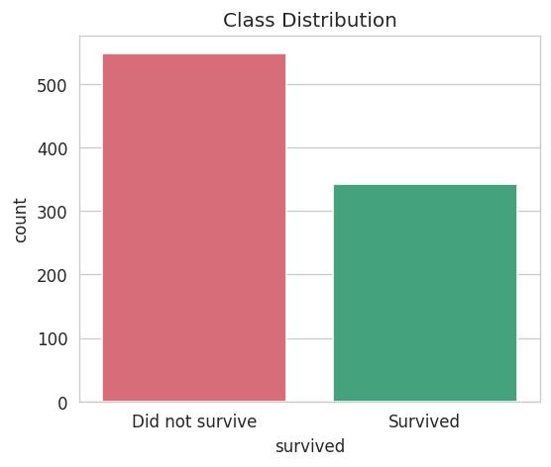
Figure 1: Survival class distribution

3. Exploratory Data Analysis
Survival rate is visibly higher for first-class passengers and for women, and age shows different survival patterns at the extremes (children) versus working-age adults.
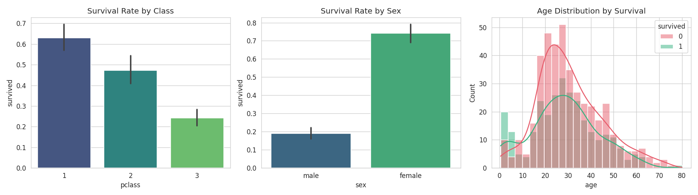
Figure 2: Survival rate by passenger class, sex, and age distribution

4. Methodology
- Split the data 80/20 into train and test sets (stratified, random_state=42).
- Built a preprocessing pipeline: median imputation + scaling for numeric features (age, fare, sibsp, parch); most-frequent imputation + one-hot encoding for categorical features (pclass, sex, embarked).
- Trained Logistic Regression, Decision Tree (max_depth=5) and Random Forest (200 trees), each wrapped with the same preprocessing pipeline.
- Evaluated on the test set using accuracy, precision, recall, F1 and ROC-AUC.
- Checked stability with 5-fold cross-validation.
- Tuned the Random Forest with GridSearchCV.

5. Results

5.1 Test Set Performance
Model | Accuracy | Precision | Recall | F1 | ROC-AUC
Logistic Regression | 0.8045 | 0.7931 | 0.6667 | 0.7244 | 0.8427
Decision Tree | 0.7765 | 0.7544 | 0.6232 | 0.6825 | 0.7927
Random Forest | 0.8156 | 0.8000 | 0.6957 | 0.7442 | 0.8345

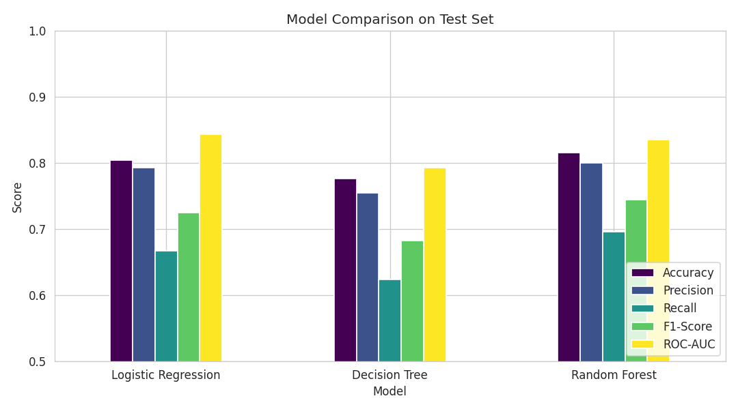
Figure 3: Model comparison on the test set

5.2 Cross-Validation (5-fold accuracy)
Model | Mean Accuracy | Std Dev
Logistic Regression | 0.7901 | 0.0216
Decision Tree | 0.8137 | 0.0289
Random Forest | 0.8059 | 0.0310

5.3 Confusion Matrices
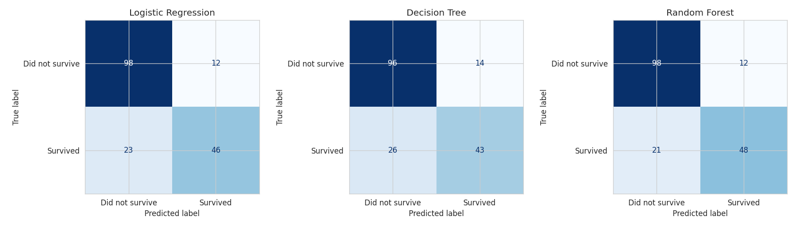
Figure 4: Confusion matrices (test set, 179 passengers)

5.4 ROC Curves
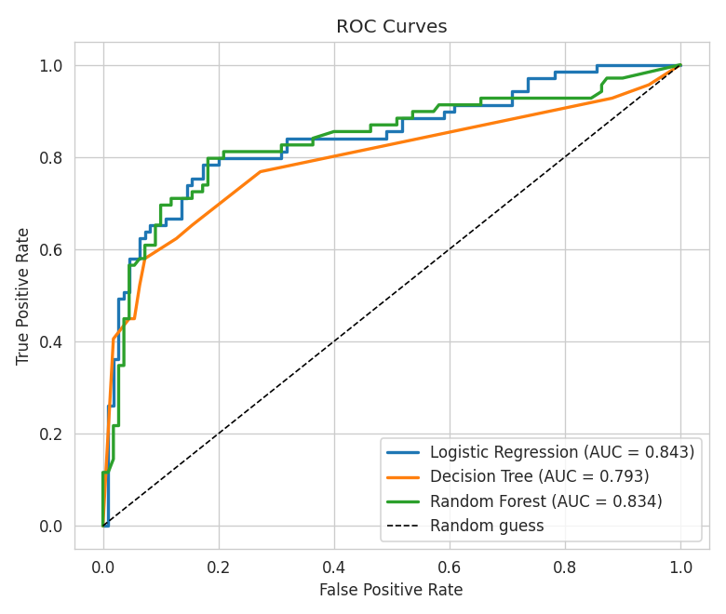
Figure 5: ROC curves for all three models

5.5 Hyperparameter Tuning and Feature Importance
GridSearchCV on the Random Forest selected max_depth=10, min_samples_split=5, n_estimators=200, with a best cross-validated F1 of about 0.758. Fare, sex and age were the strongest predictors of survival.
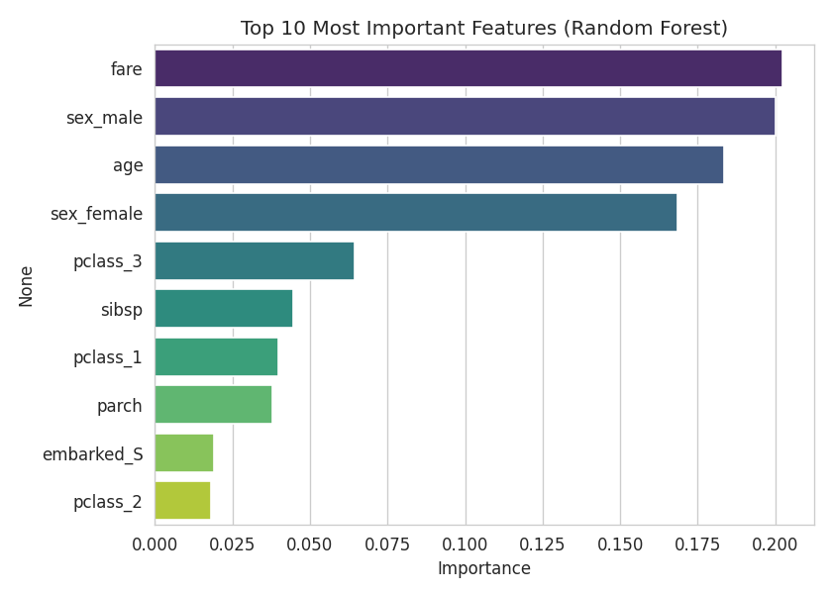
Figure 6: Top 10 features by Random Forest importance

6. Conclusion
- Random Forest gave the best test accuracy (81.56%) and F1 (0.744); Logistic Regression had the highest ROC-AUC (0.843).
- Cross-validation shows the three models performing closely (79-81%), so results are stable rather than a lucky split.
- Fare, sex, and age are the strongest predictors, consistent with the historical 'women and children first' policy and better lifeboat access for higher-fare passengers.
- All models are noticeably better at identifying passengers who did not survive (recall ~0.90 for the tuned model) than those who did (recall ~0.65), a common pattern with an imbalanced positive class.
Limitations: age was about 20% missing and median-imputed, which can soften true age-related effects; deck was dropped due to being missing in about 77% of rows.

7. Deliverables
- Predictive_Modeling_Titanic.ipynb - executed notebook
- Predictive_Modeling_Titanic_Report.html - static export of the notebook
- model_results.csv - metrics table
- charts/ - all figures used in this report
- Final_Report_Titanic.docx - this report

