REMOTE CONTROL CAR PRICE RANGE PREDICTION USING WEB SCRAPING AND MACHINE LEARNING

NAME: KIRUBAKARAN V
COURSE: DA/DS, Offline
BATCH: JUNE 2025

INTRODUCTION:

The project focuses on predicting the price range of remote control cars using machine learning techniques. By performing web scraping from e-commerce websites, a dataset containing information such as brand, features, size, control range, battery capacity, and price was collected. This data is then preprocessed, analyzed, and used to build a classification model that predicts the price category (e.g., low, medium, high) of a remote control car.

AIM:

- To predict the price range of remote control cars using web-scraped data and machine learning techniques.
- To explore the relationship between various product features and their price categories.
- To train and evaluate multiple classification models to identify the most accurate predictor.

PROBLEM STATEMENT:

With an increasing number of remote control car products online, customers face difficulty in identifying value-for-money options. This project aims to classify remote control cars into different price ranges based on their features. Web scraping is used to collect product data, followed by preprocessing and training machine learning models for accurate predictions.

PROJECT WORKFLOW:

- Web Scraping: Collected product data from e-commerce websites.
- Data Cleaning: Removed missing or inconsistent entries.
- Feature Engineering: Extracted key attributes such as brand, control range, battery life, and size.
- Exploratory Data Analysis (EDA): Visualized patterns and relationships between features and prices.
- Data Preprocessing: Encoded categorical features and normalized numerical data.
- Model Training: Trained classification models such as Logistic Regression, Decision Tree, Random Forest, and XGBoost.
- Model Evaluation: Compared models using accuracy, precision, recall, and F1-score.
- Hyperparameter Tuning: Optimized the top-performing model using GridSearchCV.
- Model Deployment: Saved the best model for future use or API integration.

DATA UNDERSTANDING:

The dataset was built using web scraping and contains information such as:
- Brand
- Product Name
- Control Range
- Battery Capacity
- Car Size
- Features (e.g., waterproof, off-road)
- Price
Target Variable: Price Range (Low / Medium / High)

DATA CLEANING:

Handled missing and inconsistent values, removed duplicate entries, and standardized categorical names (e.g., brand names). Numeric columns were scaled, and textual data such as product descriptions were cleaned using regular expressions.
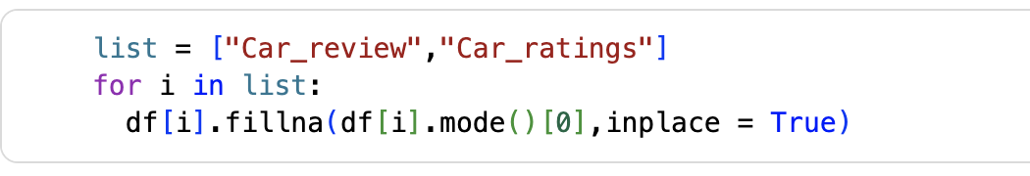
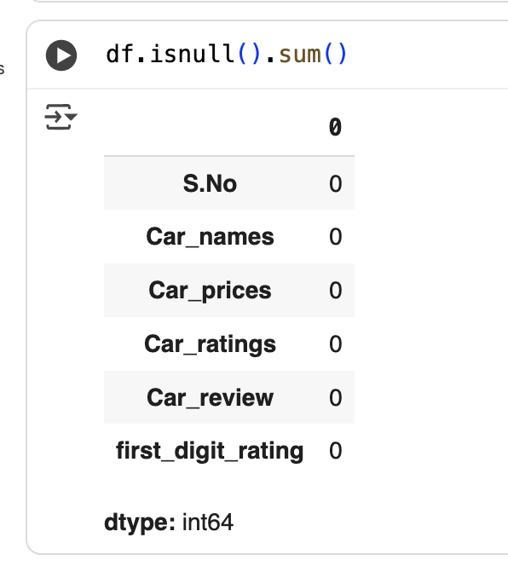

7. FEATURE ENGINEERING
Derived new features such as:
- Price Category (binned from numeric price)
- Feature Count (number of specifications listed)
- Battery-to-Weight Ratio
These enhanced the predictive ability of the model.

8. OUTLIERS:

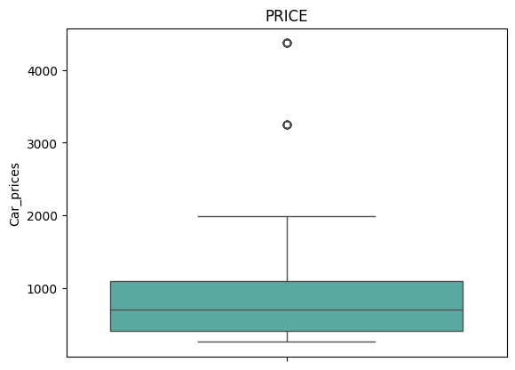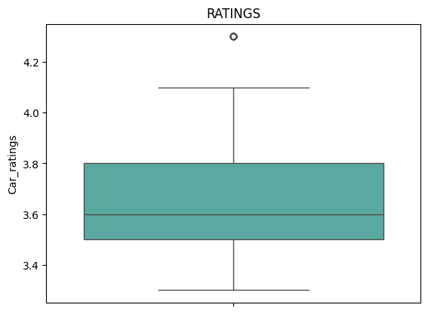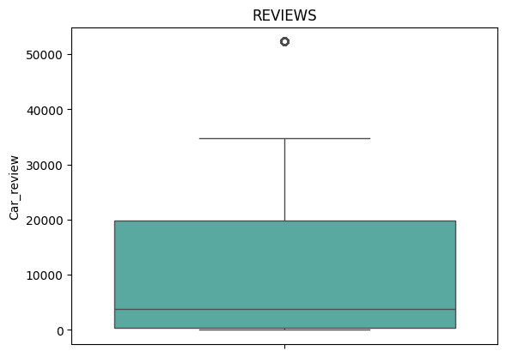

9.EXPLORATORY DATA ANALYSIS (EDA):

Univariate Analysis:
- Distribution of price categories shows majority mid-range products.
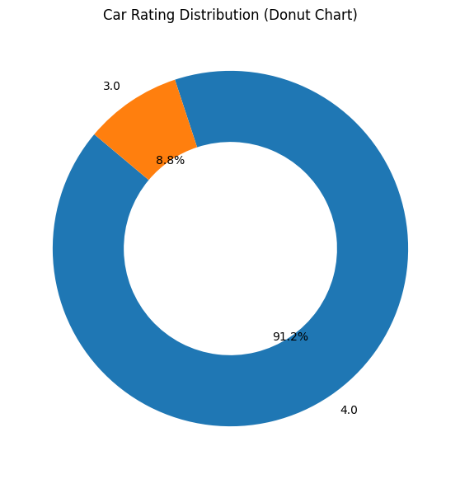
Most cars (91.2%) have a rating of 4.0, while only 8.8% are rated 3.0.

The distribution is highly imbalanced, showing that most customers rate cars positively.

Low rating diversity suggests limited differentiation in customer perception.

For modeling, consider class balancing (e.g., SMOTE or class weights) to avoid bias toward the majority rating.

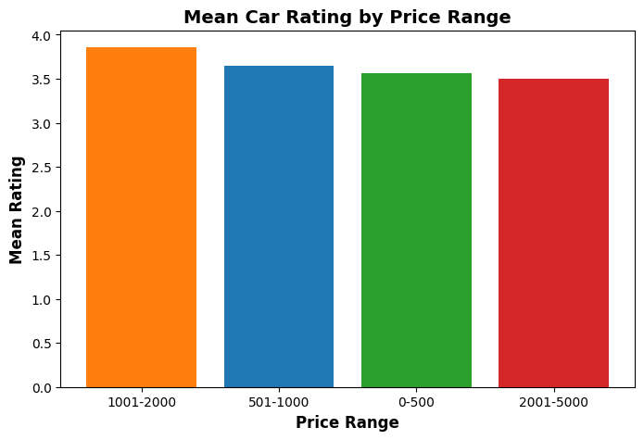
Cars in the ₹1001–2000 price range have the highest average rating (~3.9).

Lower-priced cars (0–500, 501–1000) have slightly lower mean ratings (~3.5–3.6).

High-end cars (₹2001–5000) also show a small dip in ratings (~3.5).

Overall, mid-range cars tend to receive better ratings, suggesting they offer the best balance of value and satisfaction.

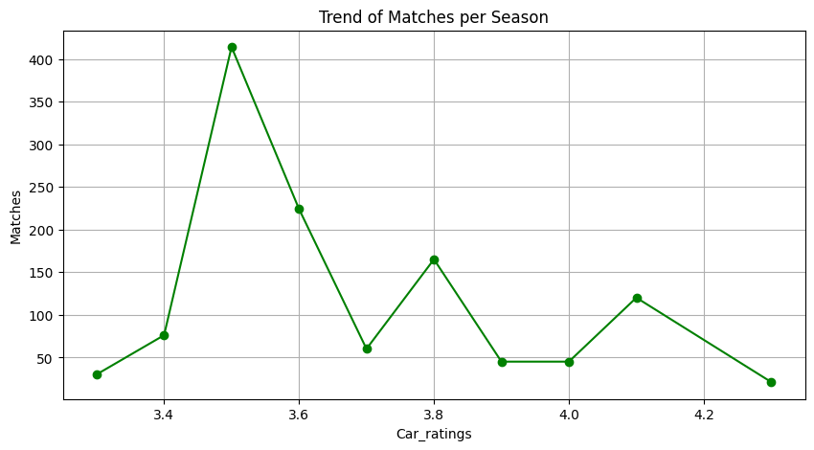
Most frequent rating: Around 3.5, with the highest number of matches (~410). This indicates that most cars are rated slightly below average.

Moderate ratings: Ratings 3.6 to 3.8 have a moderate number of matches (~60–165), showing fewer cars received mid-range ratings.

High ratings: Ratings 4.0 to 4.3 have fewer matches (~20–120), meaning fewer cars are rated very highly.

Overall trend: The distribution is skewed toward lower ratings, with a peak at 3.5 and declining matches as ratings increase.
Bivariate Analysis
- Positive between control range and price.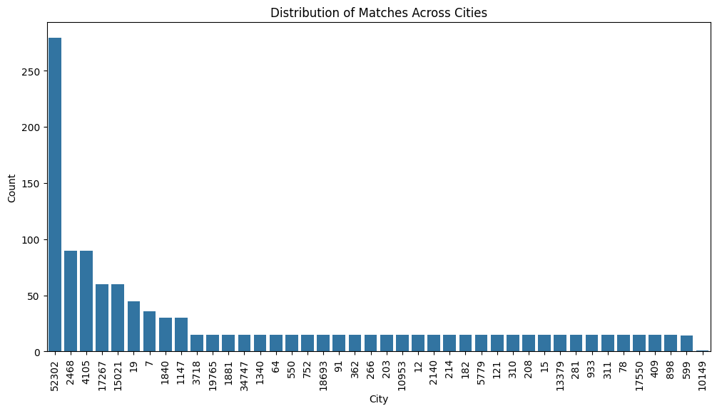
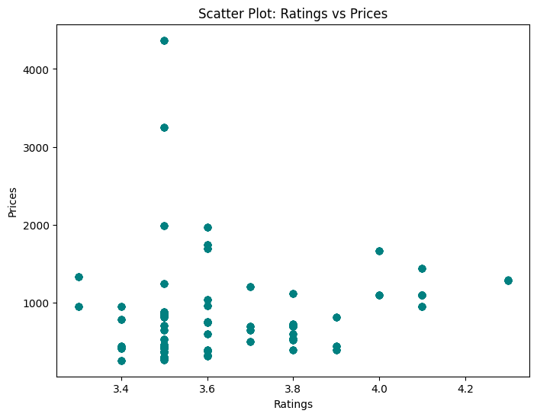
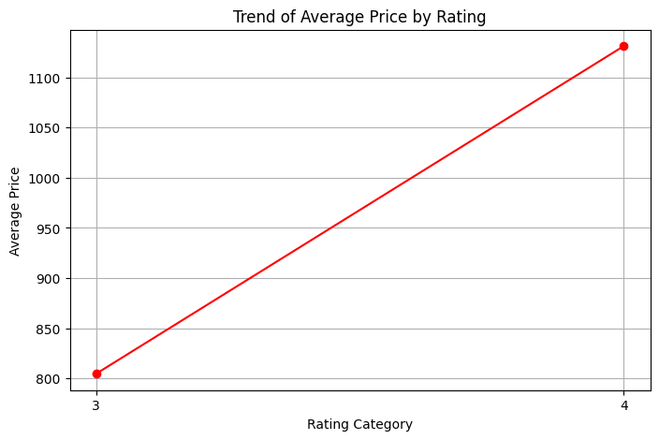

Multivariate Analysis:
- High-end brands tend to have larger car sizes and higher battery capacities.
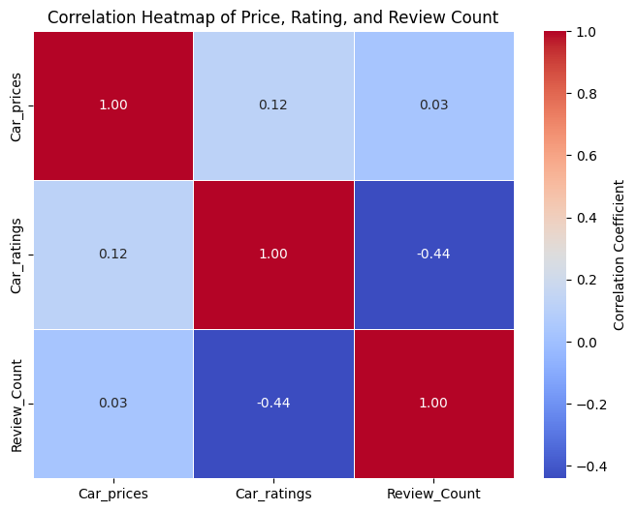

10. UNSUPERVISED LEARNING:

Objective
In this part of the project, unsupervised learning techniques were used to group remote control cars into clusters based on their features.
The aim was to find natural patterns and similarities among products without using the price labels.
Methods Used

1. K-Means Clustering:
- K-Means was applied to the dataset after scaling all numeric features.
- The Elbow Method was used to find the best number of clusters.
- The model grouped the products into three main clusters:
  - Cluster 1: Low-cost cars with smaller batteries and limited features
  - Cluster 2: Mid-range cars with balanced specifications
  - Cluster 3: Premium cars with higher control range, better build, and long battery life
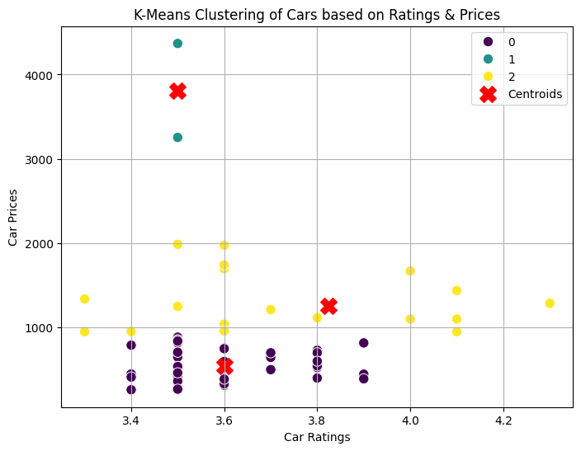

2. Hierarchical Clustering:
- Hierarchical clustering was also performed to visualize how data points merge into clusters step by step.
- A dendrogram was plotted to show the structure of clusters.
- The method helped confirm that three main clusters provided a good separation of products.
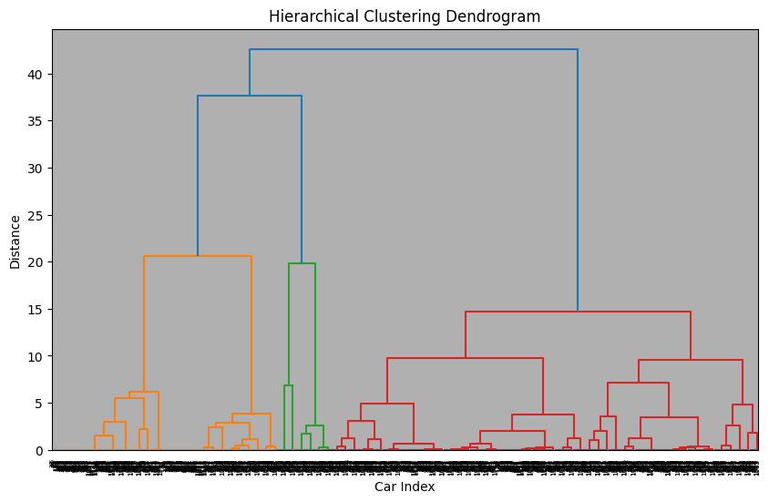
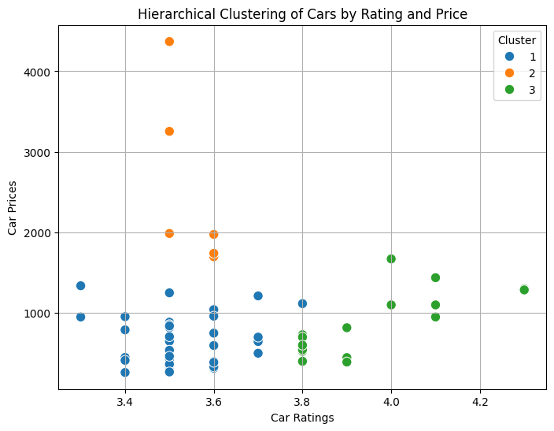

11. DATA PREPROCESSING:

Encoded categorical features using LabelEncoder and OneHotEncoder. Scaled numerical features using StandardScaler. Split data into 80% training and 20% testing sets.
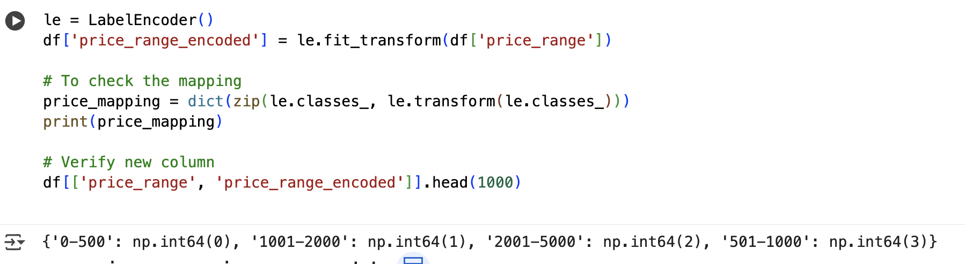

12. MODEL TRAINING:

Trained multiple classification models:
- Logistic Regression
- Decision Tree
- Random Forest
- K-Nearest Neighbors (KNN)
- Support Vector Machine (SVM)
- XGBoost

MODEL EVALUATION:

Evaluation Metrics: Accuracy, Precision, Recall, F1-Score.
Example Results:
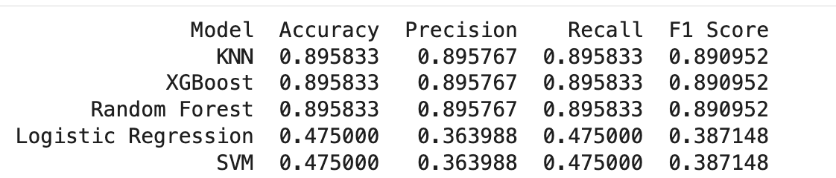
Best Model: XGBoost , KNN, Random Forest achieved the highest accuracy and generalization.

MODEL COMPARISON:

Random Forest and XGBoost outperformed other models. Logistic Regression and KNN were less effective due to non-linear patterns. XGBoost demonstrated high performance with reduced overfitting.
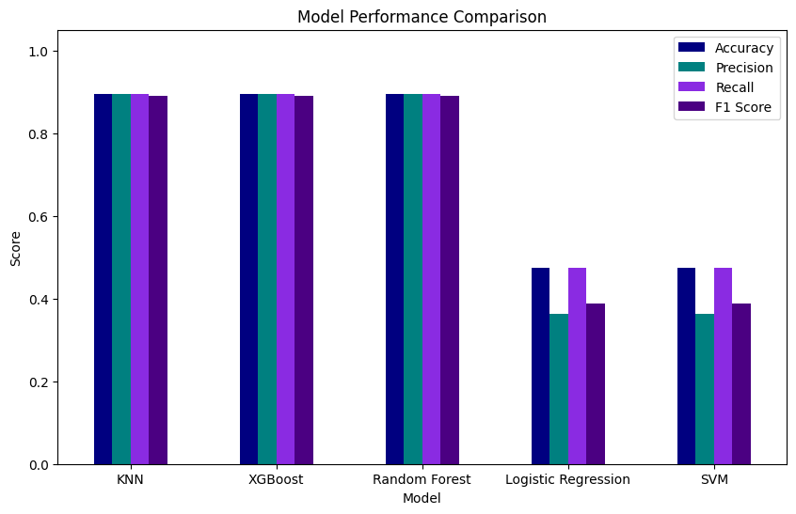

15. OVERALL INSIGHTS:

- Battery capacity and control range strongly influence price.
- Feature-rich products are generally higher priced.
- Certain brands dominate the premium category.
- Web scraping provides valuable real-world datasets for ML applications.

16. CONCLUSION:

This project successfully predicted the price range of remote control cars using data collected via web scraping. After testing multiple classification models, XGBoost emerged as the most accurate. The workflow demonstrates the power of combining web scraping with machine learning for product analysis.

Future Scope:
- Add more features such as user ratings and reviews.
- Extend to other RC categories (boats, drones, etc.).
- Deploy as a web application for real-time predictions.

