AI Case Study: Social Support Application Workflow Automation

This document provides a detailed summary of how the prototype solution was developed to address the problem statement of automating social support application workflows. The solution replicates the real-world case study scenario using synthetic data, locally hosted models, and an orchestrated pipeline with validation, decisioning, and explanations.

1. Problem Statement & Challenges
The social support department faces several operational challenges in manually processing applications. Below are the key problems and how our solution addressed them:
• Manual Data Gathering: Applicants submit forms, ID scans, and financial statements manually, leading to errors. In our solution, we automated ingestion of CSVs, PDFs, IDs, and JSON credit reports into MongoDB using GridFS for file storage. This eliminates manual errors and ensures consistent structured input.
• Semi-Automated Validations: Previously only basic form validation existed. We introduced strict schema validation using Pydantic v2 models (CanonicalProfile), which automatically coerces types, validates ranges (e.g., credit score 0–1000), and ensures consistency before storing into MongoDB.
• Inconsistent Information: Conflicting declared income, bank statements, and credit reports were a major bottleneck. Our canonical profile consolidates all information into a single profile with mismatch detection (e.g., declared income vs. bank salary estimate). We flag mismatch percentages and set a mismatch_flag for downstream review.
• Time-Consuming Reviews: Manual reviews required multiple rounds. We automated this by running validation, exporting structured training datasets, and applying ML + rules to generate instant approve/reject/needs_review outcomes.
• Subjective Decision-Making: Decisions previously depended on human interpretation. Our pipeline applies deterministic rules (hard reject, soft decline, needs review, approve) and augments with an XGBoost classifier. This ensures fairness, transparency, and consistency.

2. Architecture Overview
The following diagram illustrates the architecture of the solution, showing hraw data flows through ingestion, canonicalization, validation, ML training, and explanation layers.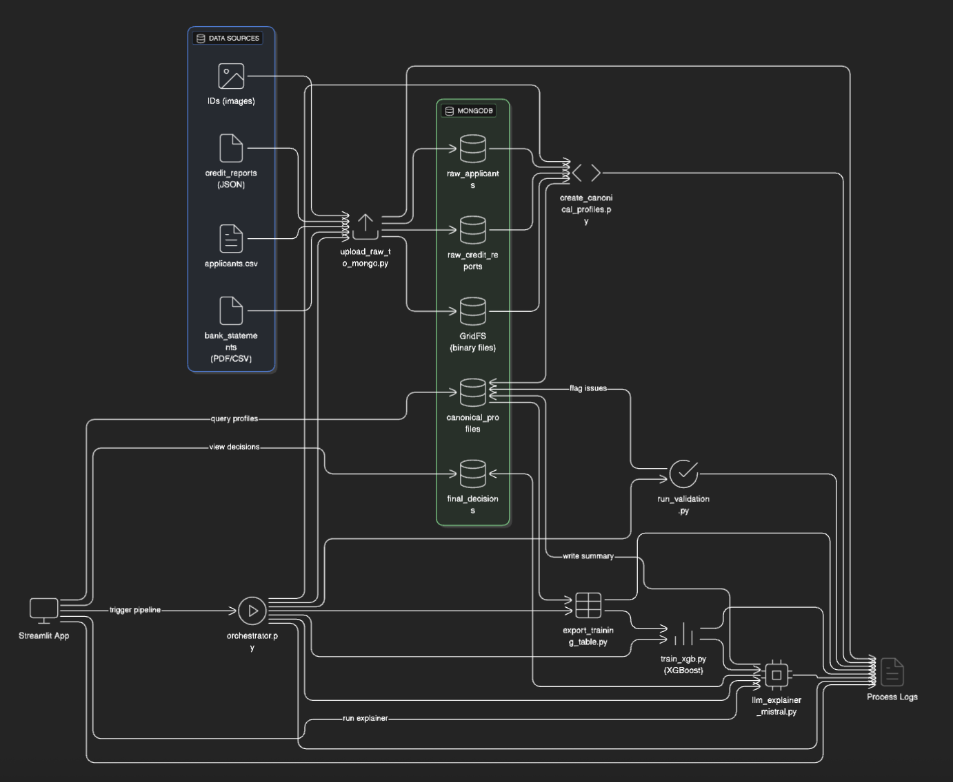

Current Architecture (Prototype)

Our current solution is designed as a lightweight orchestration pipeline built on Python scripts, MongoDB, and XGBoost.
- Data Sources: Inputs include applicant CSV files, scanned IDs, credit reports (JSON), and bank statements (PDF/CSV).
- Upload & Storage: Data is ingested via upload_raw_to_mongo.py and stored in MongoDB collections (raw_applicants, raw_credit_reports) and binary files in GridFS.
- Canonicalization: create_canonical_profiles.py processes raw data into structured canonical profiles.
- Validation: Pydantic v2 schema validation (run_validation.py) ensures data consistency and type correctness.
- Training & Prediction: Data is exported (export_training_table.py) and used to train an XGBoost model (train_xgb.py) for eligibility scoring.
- LLM Explainer: llm_explainer_mistral.py uses rule-based logic + Mistral LLM to generate applicant-level decision summaries.
- UI & Orchestration: A Streamlit App triggers the orchestrator.py pipeline and displays logs, canonical profiles, and decision outputs.
- Process Logs: Each stage records logs for traceability.

Transition to Ideal Solution

In the ideal Azure-native, agentic solution:
- MongoDB & GridFS → Replaced with Azure Data Lake (for raw data) and Cosmos DB (for canonical profiles + decisions).
- Python Orchestration → Replaced with Semantic Kernel Orchestrator that manages all agents.
- XGBoost model → Removed. Eligibility moves to few-shot/fine-tuned GPT-4 agents combined with explicit rules.
- Pydantic Validation → Extended by a dedicated Validation Agent powered by GPT-4 + schema enforcement.
- LLM Explainer (Mistral) → Replaced with Decision Explainer Agent using GPT-4/Claude for richer justifications.
- Streamlit App → Retained but extended with richer web UI + officer interaction.
- Logs → Monitored by LangFuse / Azure Monitor for observability, drift detection, and audit trails.

2. Dataset and Canonical Profile
We created a synthetic dataset simulating real applicants. Each applicant includes:
- applicant_id, demographic info (name, dob, gender, family_size)
- financial info (declared_income, bank_salary_estimate, normalized_income, liabilities, assets)
- credit reports (JSON files with credit_score, total_debt, loan_count)
- identity proofs (ID images)
- bank statements (PDF/CSV)
These heterogeneous inputs are unified into a CanonicalProfile using LLM-assisted extraction and Pydantic validation. The canonical schema ensures that missing values are marked as null, numbers are coerced properly, and evidence sources are attached.

Example Candidate Profile
Below is an example canonical profile for applicant Saanvi Mehta (APP100041):
{
"applicant_id": "APP100041",
"name": "Saanvi Mehta",
"dob": "1990-12-09",
"declared_income": null,
"credit_score": 329,
"total_liabilities": 8845,
"default_flag": true,
"confidence_score": 0.15,
"risk_band": "high"
}
This example shows how missing incomes, low credit score, and defaults were consolidated. The profile_summary field gives a one-line human-readable description.

3. Validation Rules and Approval Logic
We designed deterministic policy rules to classify applicants before considering ML probability. These rules ensure conservative decisioning and fairness. Example rules applied:
- Hard Reject: If default_flag == True OR credit_score < 450 OR debt_to_income_ratio > 0.7
Example: Saanvi Mehta defaulted and has a credit score of 329 → hard_reject.
- Soft Decline: If credit_score < 600 AND debt_to_income_ratio > 0.35
Example: An applicant with score 550 and DTI 0.45 would be soft_decline.
- Needs Review: If mismatch_flag == True OR confidence_score < 0.7 OR ML probability is borderline (0.4–0.6).
Example: If bank salary evidence mismatches declared income by >15%, mark needs_review.
- Approve: If normalized_income is available, confidence_score >= 0.7, mismatch_flag == False, and credit_score >= 600.
Example: An applicant with normalized_income 35,000, credit_score 720, no mismatches → approve.
Final Decision: Rules dominate. The ML model (XGBoost) probability is only used as supporting evidence. If rules suggest approve but ML probability < 0.6, we conservatively reject.

4. Orchestration Pipeline
The orchestrator (src/orchestrator.py) automates the full pipeline in 5 steps:
1. Upload: Reads applicants.csv and attachments, uploads into MongoDB (raw_applicants, raw_credit_reports).
2. Canonicalization: Builds canonical profiles via LLM extraction and schema validation.
3. Validation: Applies Pydantic validation + rules to assign validation_status.
4. Export: Creates training/test CSVs for ML.
5. Train: Fits an XGBoost pipeline, computes metrics, stores model + feature importances.
Each step logs outputs into Mongo collections (orchestrator_runs, orchestrator_summary), ensuring traceability.

5. LLM Explainer and Streamlit App
We built llm_explainer_mistral.py which merges rule decisions with ML outputs and generates structured JSON + human explanation. It highlights key evidence, reasoning bullets, and recommended actions.
The Streamlit app integrates the orchestrator and explainer, allowing evaluators to run end-to-end from data ingestion to decision explanation. Users can input applicant_id, fetch canonical profile, and view the LLM explanation alongside metrics.

6. Candidate Case Study: Saanvi Mehta
Below is the human summary generated for applicant Saanvi Mehta, illustrating how rules + ML produce explanations:
Decision Summary: The applicant, Saanvi Mehta (APP100041), is at high risk due to the lack of income evidence, a credit score of 329, liabilities of 8845, and a history of defaults. Final decision = REJECTED.
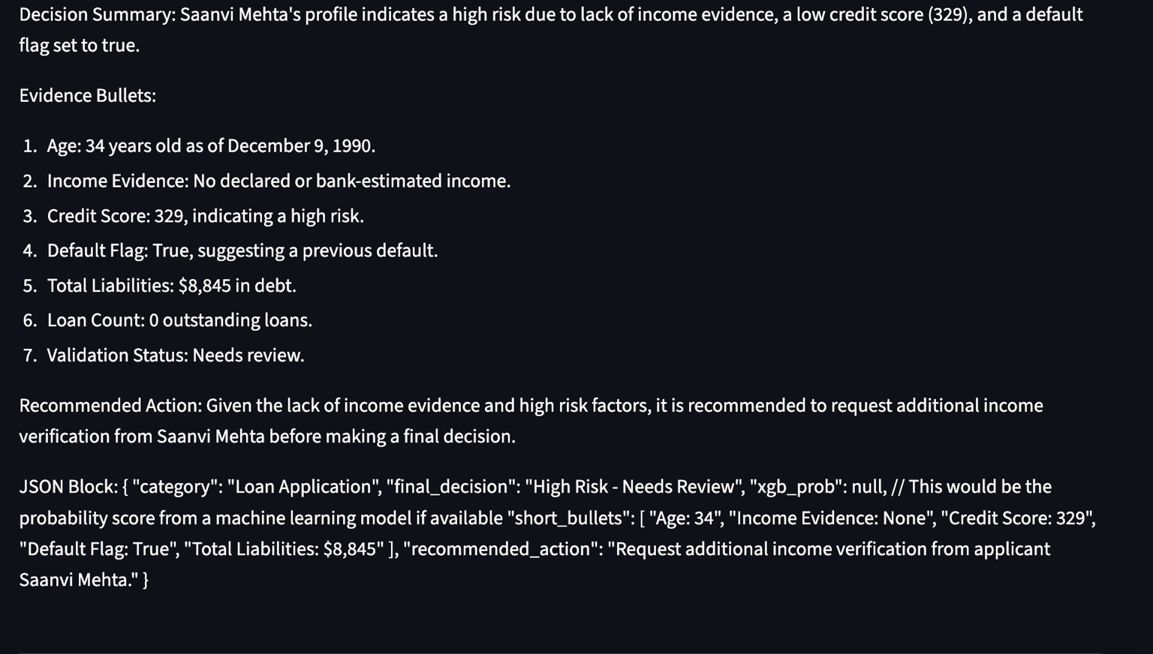

7. Architecture Overview
The following diagram illustrates the high-level architecture of the solution, showing how raw data flows through ingestion, canonicalization, validation, ML training, and explanation layers.
[Insert architecture diagram here]

8. Conclusion
Our prototype demonstrates how manual pain points were solved through automated data ingestion, schema validation, deterministic rules, ML classification, and explainable decisions. This solution reduces turnaround from days to minutes, ensures consistency, and provides transparent justifications. Future enhancements may include real-time streaming data pipelines, LangGraph-based orchestration, and integration with government APIs.

