AI Case Study: Social Support Application Workflow Automation (Ideal Solution)

1. Introduction
The social support application process in government departments is traditionally slow, manual, and error-prone, taking between 5 and 20 working days for applicants to receive decisions. The key pain points include manual data entry, inconsistent validations, subjective decision-making, and time-consuming reviews. This document presents a detailed ideal solution built entirely on an agentic architecture, leveraging Azure Cloud, Data Lake storage, Azure Document Intelligence, OpenAI GPT-4 and Claude models, and Semantic Kernel orchestration. The goal is to demonstrate how end-to-end automation can reduce decision times to minutes while ensuring transparency, fairness, and scalability.

2. Problem Context
The government social security department must ingest applicant forms (PDFs, scanned images, IDs, bank statements), validate and reconcile inconsistencies, and decide whether to approve financial or enablement support. Key problems are as follows:
• Manual data gathering from multiple unstructured documents.
• Semi-automated validations requiring manual correction.
• Inconsistent information between sources.
• Long review cycles across multiple departments.
• Subjective and inconsistent decision-making.
The ideal solution addresses these issues with an intelligent, agentic, cloud-native architecture.

3. Solution Architecture
The solution architecture is fully agentic. Data ingestion begins with an Azure Data Lake that stores raw applicant submissions (forms, PDFs, scanned IDs, credit reports). Azure Document Intelligence extracts structured data, which is stored in Cosmos DB as canonical applicant profiles. Semantic Kernel orchestrates multiple specialized processing agents, each assigned to a distinct responsibility. Observability is provided through LangFuse or Azure Monitor, ensuring complete audit trails. Streamlit provides the user-facing interface.
The following diagram illustrates the architecture:
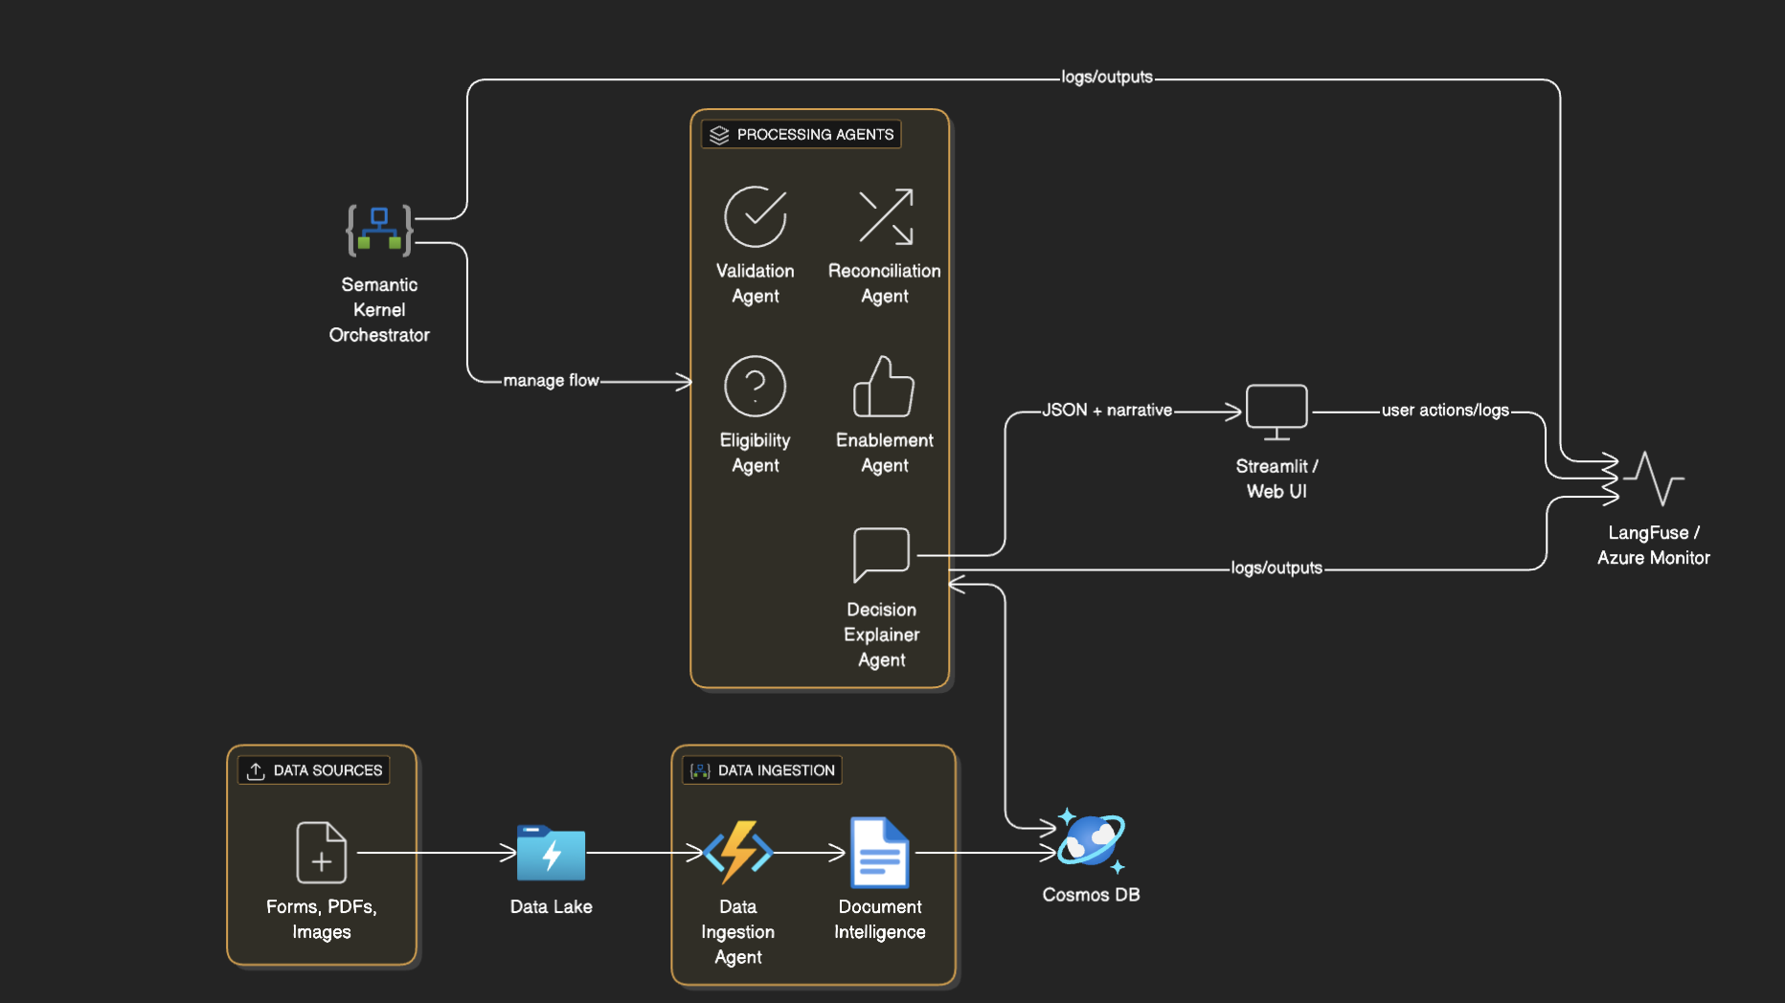

4. Processing Agents

4.1 Validation Agent
The Validation Agent is responsible for ensuring that all applicant submissions contain the required fields and supporting documents. It leverages Document Intelligence outputs and applies schema rules to check for completeness, format accuracy, and potential fraud signals (such as mismatched IDs or missing bank details). This agent flags errors early to prevent invalid applications from entering the pipeline.

4.2 Reconciliation Agent
The Reconciliation Agent compares values across multiple sources. For example, it reconciles declared income with bank salary credits and credit bureau reports. It uses GPT-4 for natural language reasoning when handling ambiguous discrepancies. If mismatches exceed policy thresholds, the application is flagged for review. This agent ensures data consistency across documents.

4.3 Eligibility Agent
The Eligibility Agent applies eligibility policies using few-shot learning with GPT-4. It determines whether applicants meet thresholds for income, debt-to-income ratio, family size, or risk bands. Unlike fixed ML models, GPT-4 can reason flexibly about nuanced cases. The agent outputs a binary decision (approve/reject) along with confidence scores and justification. Rules are combined with policy-driven thresholds to enforce fairness.

4.4 Enablement Agent
Not all applicants qualify for direct financial support. The Enablement Agent identifies candidates for economic enablement programs such as upskilling, job matching, or career counseling. It leverages Claude’s summarization and GPT-4 reasoning to recommend tailored non-financial support options, turning rejections into opportunities for citizen empowerment.

4.5 Decision Explainer Agent
Transparency is critical in public sector AI. The Decision Explainer Agent converts structured outputs from other agents into clear JSON blocks and human-readable narratives. It ensures that applicants and officers understand why a decision was made. This agent uses GPT-4 to draft explanations, constrained by rules and evidence so that no hallucinations occur. The explanations include evidence bullets (e.g., income, credit score) and a recommended action.

4.6 Semantic Kernel Orchestrator
The Semantic Kernel Orchestrator manages the flow between all agents. It uses a planner pattern to dynamically decide which agents to invoke based on intermediate outputs. For example, if validation fails, the orchestrator retries ingestion or prompts for missing documents. If eligibility passes but reconciliation flags a mismatch, the orchestrator prioritizes human review. The orchestrator also ensures that logs and agent interactions are recorded in LangFuse for observability.

5. Data Flow and Storage
1. Data Sources: Applicants upload forms, PDFs, images, and credit reports.
2. Data Lake: Raw documents are securely stored in Azure Data Lake with encryption at rest.
3. Data Ingestion: The Data Ingestion Agent coordinates uploads and invokes Azure Document Intelligence for OCR and extraction.
4. Cosmos DB: Extracted data is stored as canonical JSON profiles.
5. Processing Agents: Validation, Reconciliation, Eligibility, Enablement, and Explainer Agents process canonical profiles.
6. Streamlit UI: Final results, JSON outputs, and narrative explanations are presented to officers.
7. Observability: LangFuse and Azure Monitor log every step for compliance and traceability.

6. End-to-End Example
An applicant uploads their ID and credit report. The Data Ingestion Agent processes these documents, invoking Document Intelligence for structured extraction. Cosmos DB stores the canonical profile. The Validation Agent confirms all required fields are present. The Reconciliation Agent identifies that declared income is missing, but credit score is low. The Eligibility Agent determines the applicant does not qualify for financial support. The Enablement Agent suggests job training opportunities. Finally, the Decision Explainer Agent generates a JSON block and a human-readable summary explaining the rejection and alternative support recommendations. The full flow is logged in LangFuse for transparency.

7. Conclusion
This ideal solution leverages modern agentic AI and cloud-native infrastructure to transform the social support application process. By combining Azure Data Lake, Document Intelligence, Cosmos DB, and Semantic Kernel orchestration with GPT-4 and Claude, the system provides fast, transparent, and fair decisions. The multi-agent architecture ensures modularity, scalability, and extensibility, positioning it as a future-ready approach for government digital transformation.

