Sudhanshu Ranjan - Car Price Prediction Report
Analysis of the 2021 car specification dataset and a Random Forest price predictor.

Dataset and preparation
Source file: cars_ds_final_2021.csv. After selecting the modeling fields and converting units embedded in text, the analysis contains 1,267 usable rows and 26 input features.
Dataset source: Indian Cars Dataset on Kaggle - https://www.kaggle.com/datasets/medhekarabhinav5/indian-cars-dataset?select=cars_ds_final_2021.csv
Missing numeric values are imputed with medians and categorical values with the most frequent category. Categorical specifications are one-hot encoded and unknown categories are accepted at prediction time.

Model results
The original exploratory notebook compared Random Forest with a Linear Regression baseline using the same train/test split and processed features. Its reported results are shown below.
Metric | Notebook comparison
Random Forest MAE | 149,663.3237
Random Forest RMSE | 320,467.4241
Random Forest MAPE (%) | 8.4870
Random Forest R2 | 0.9788
Linear Regression MAE | 238,985.0604
Linear Regression RMSE | 388,509.8840
Linear Regression MAPE (%) | 12.3905
Linear Regression R2 | 0.9688
The notebook results round to R2 = 0.97 for Random Forest and R2 = 0.96 for Linear Regression. The saved API model is trained by the reusable pipeline and may produce different metrics because its preprocessing configuration is separate from the original notebook experiment.
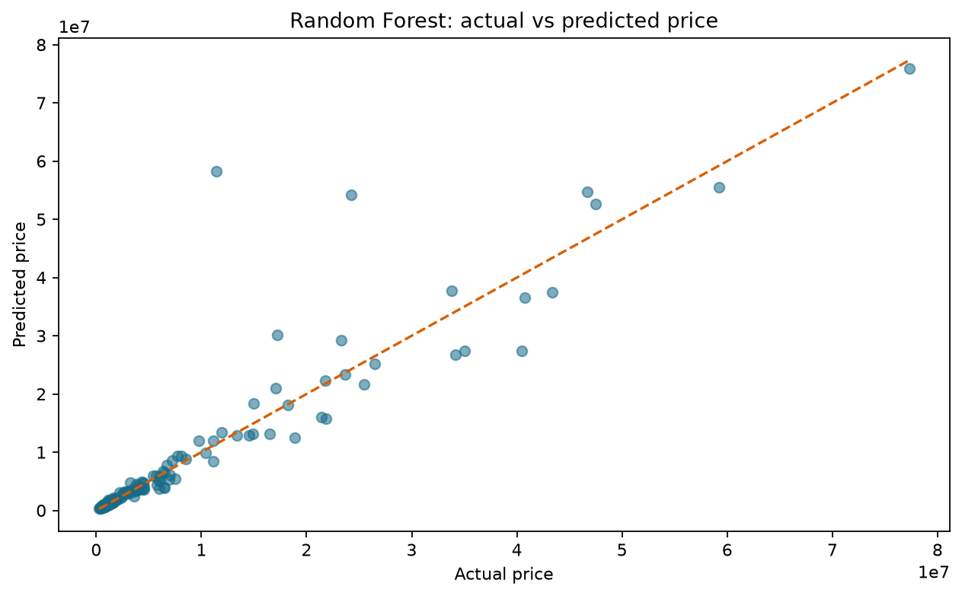

Interpretation
The model is intended as an estimate, not a valuation guarantee. Errors can be larger for rare luxury vehicles because the target price spans a wide range. A future version could compare gradient boosting, logarithmic target transformation, and cross-validation.

Application dashboard
The project includes a Streamlit dashboard named Indian Cars Intelligence. It presents the analysis as an interactive application instead of requiring the user to inspect notebook cells manually.

Application screenshots
The following screenshots show the live dashboard interface used for the project.

Live dashboard overview
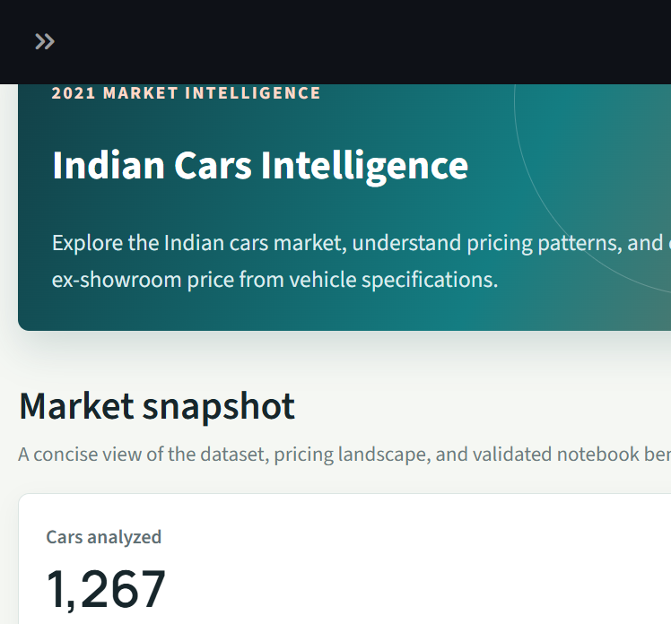

Live market explorer
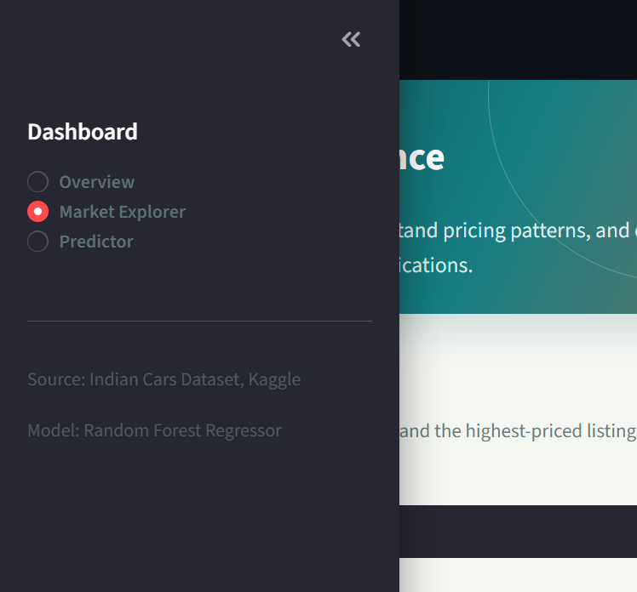

Live price predictor
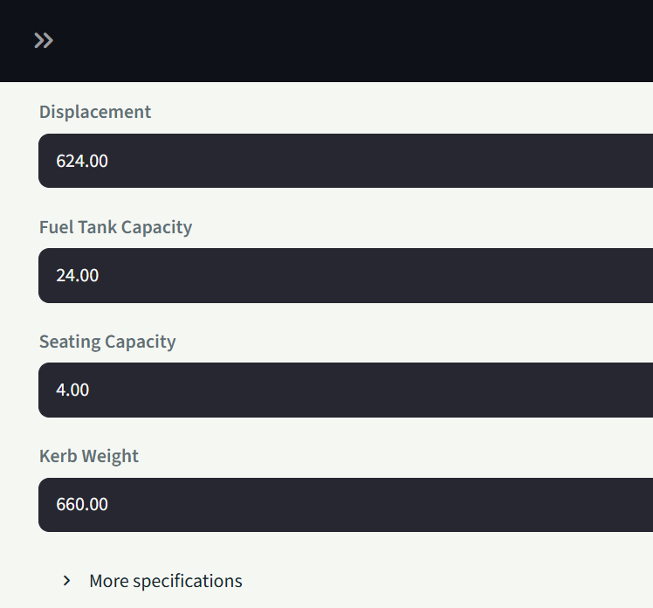

Overview screen
The Overview screen gives a quick market snapshot: 1,267 cars analyzed, brand coverage, median ex-showroom price, the official notebook Random Forest R2 score, price distribution, leading brands by number of listings, and model-quality metrics.

Dashboard overview: price distribution
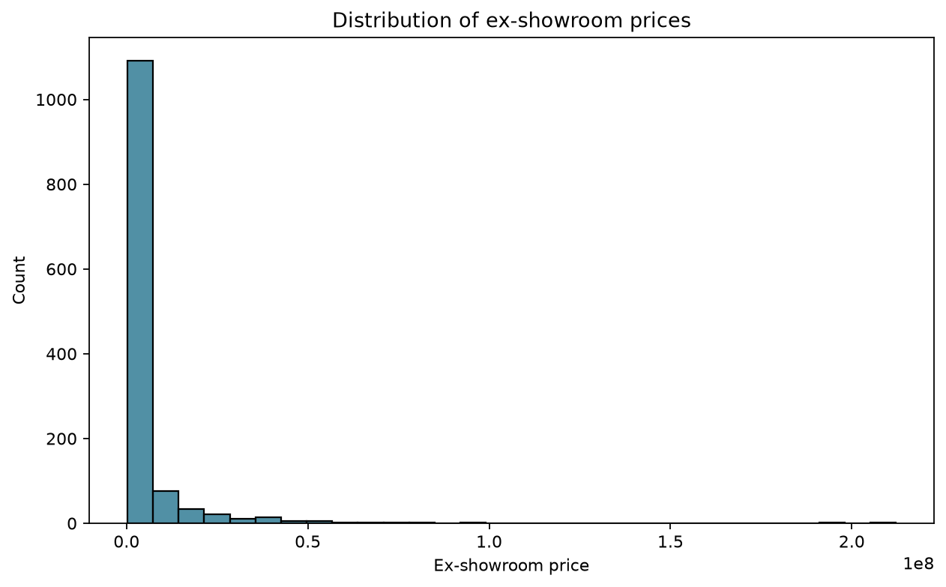

Dashboard overview: model comparison
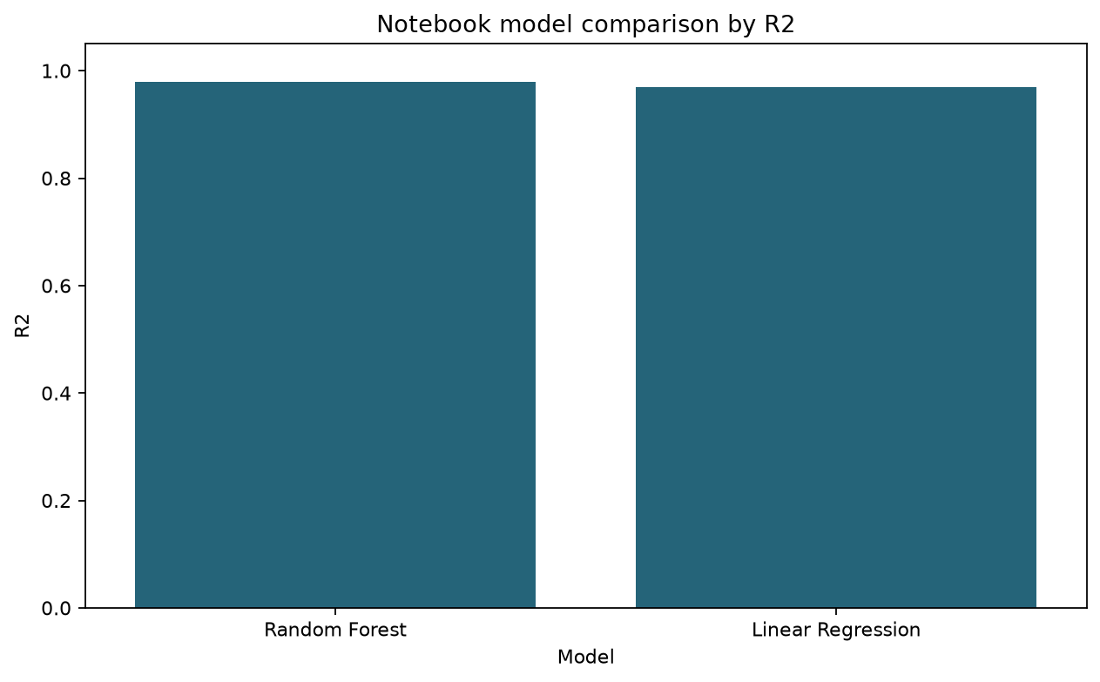

Market Explorer screen
The Market Explorer screen provides filters for brand, body type, and fuel type. It shows median price by body type, the relationship between engine displacement and price, and a table of the highest-priced listings in the selected segment. Missing brand values are shown as Not specified rather than None.

Market Explorer evidence: feature relationships
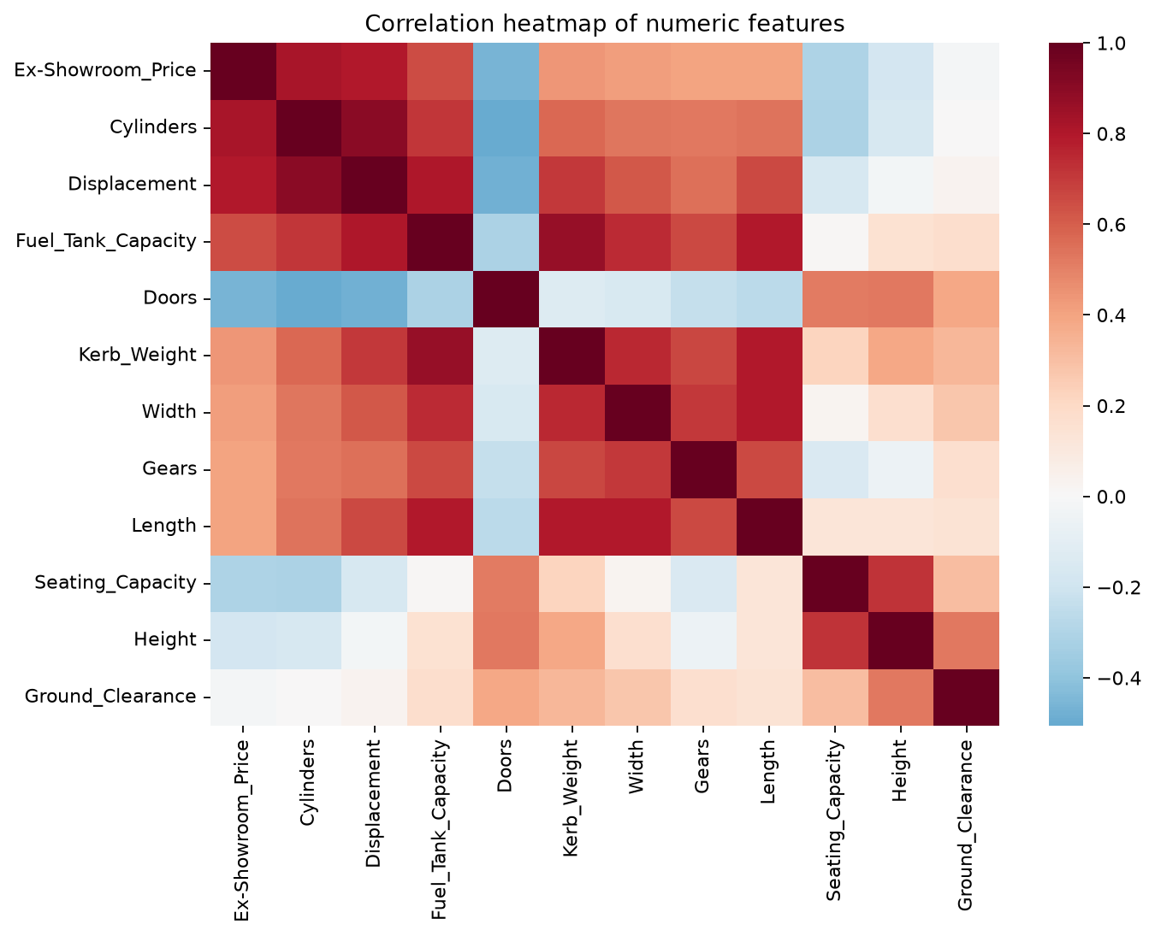

Predictor screen
The Predictor screen accepts vehicle identity and specification values such as make, model, variant, displacement, seating capacity, kerb weight, fuel information, power, and torque. When the user submits the form, the saved Random Forest deployment pipeline returns an estimated ex-showroom price.

Predictor evidence: actual versus predicted price

Application services
Streamlit dashboard: http://localhost:8503
Flask backend health check: http://127.0.0.1:5000/health
Flask prediction endpoint: POST http://127.0.0.1:5000/predict

Analysis diagrams

Price distribution

Missing-value review
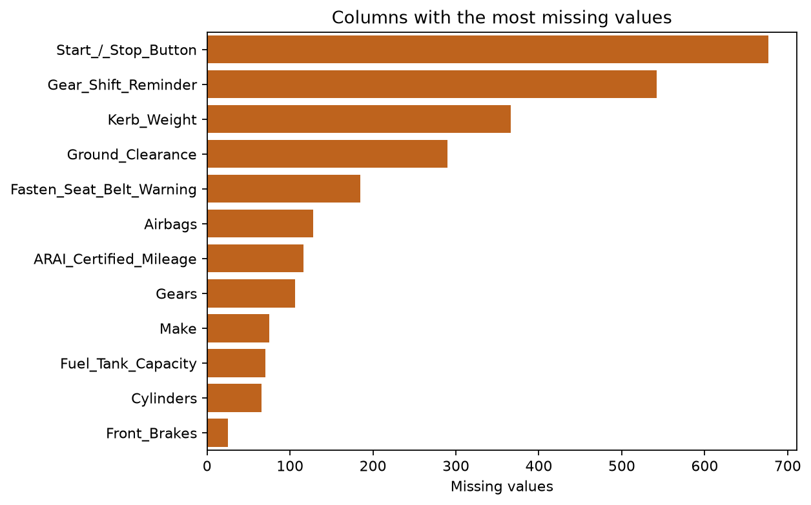

Correlation heatmap

Outlier review
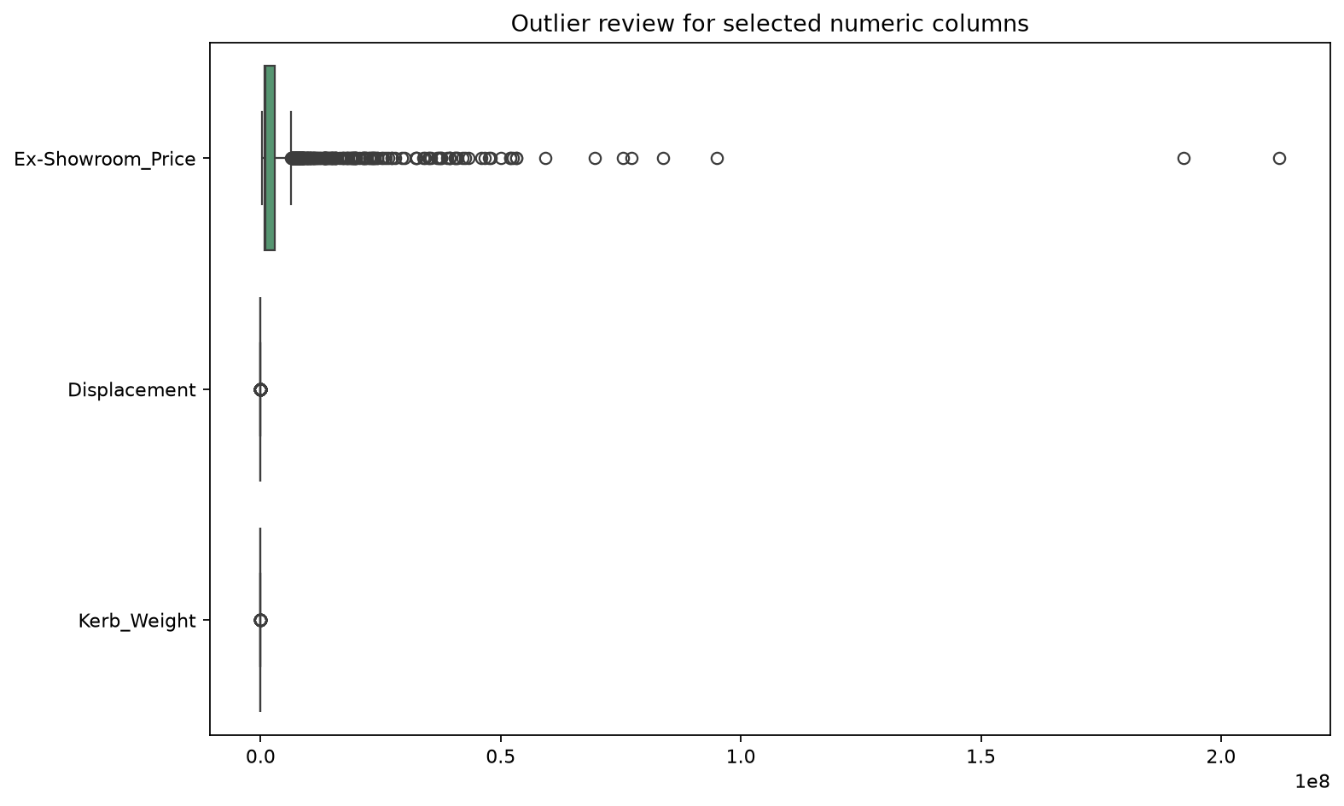

Notebook model comparison

Actual versus predicted price

Residual analysis
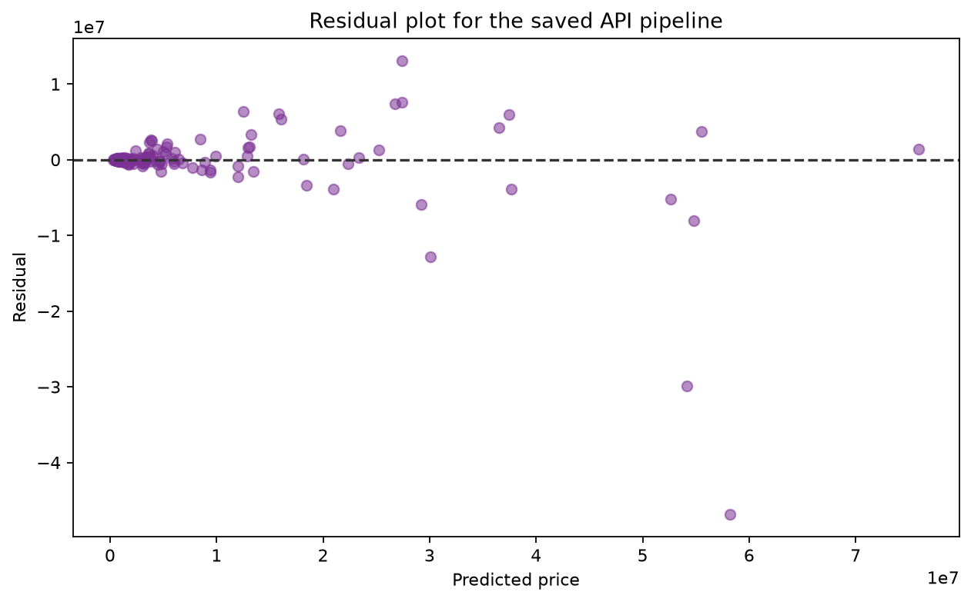

Feature importance
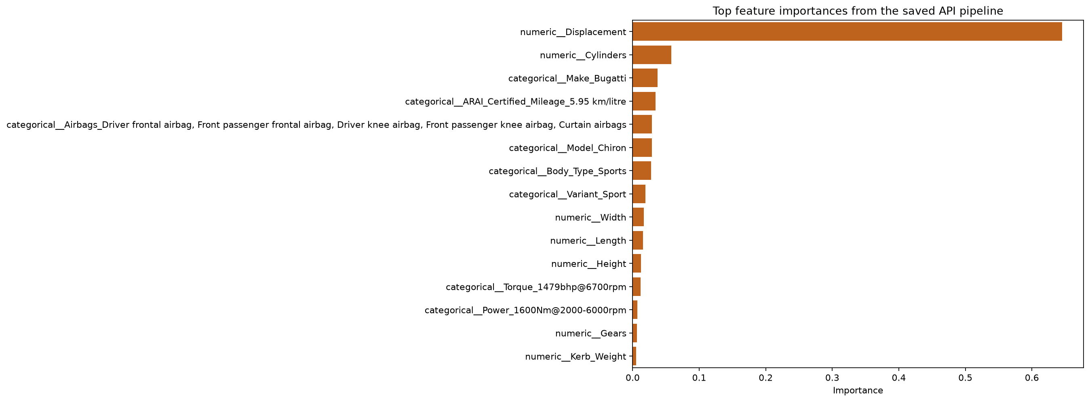

How to use the project
Run `py model_pipeline.py` to train and save the model, `py app.py` to start the Flask API, or `streamlit run streamlit_app.py` for the interactive interface.

