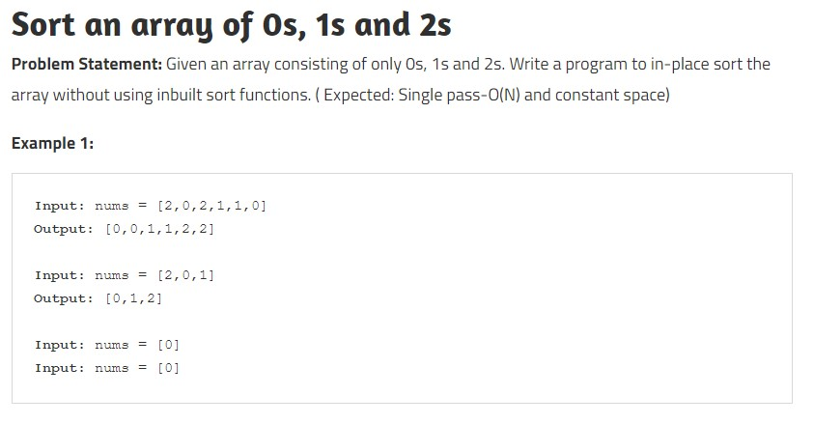

**Disclaimer**: Don’t jump directly to the solution, try it out yourself first.