**IPL Dashboard Project Description**

The IPL Dashboard is a comprehensive data visualization project designed to provide actionable insights into the Indian Premier League (IPL) for the 2008-2022 season. Developed using Power BI, the dashboard integrates various datasets to deliver an interactive and visually appealing analysis of IPL statistics, performance metrics, and team outcomes.

**Key Features(for season 2022):**

1. **Tournament Highlights:**
   * Displays the title winner (Gujarat Titans), Orange Cap (highest run-scorer: Jos Buttler), and Purple Cap (highest wicket-taker: Yuzvendra Chahal).
   * Overall season statistics, including the total number of sixes (1,062) and fours (2,017).
2. **Player Performance Metrics:**
   * Batting stats for selected players, including runs scored, boundaries hit, and strike rate.
   * Bowling stats for top performers, including wickets, economy rate, and bowling average.
3. **Match Insights:**
   * Breakdown of wins based on toss decisions (field vs. bat) and result types (wins by runs or wickets).
   * Analysis of matches won at different venues, highlighting team performance across stadiums.
4. **Team Performance Analysis:**
   * Total wins by each team, showcasing the dominance of Gujarat Titans and Rajasthan Royals.
   * Performance comparison of teams like Lucknow Super Giants, Royal Challengers Bangalore, and others.

**Tools and Technologies Used:**

* Power BI: For creating interactive visualizations and designing an intuitive user interface.
* Data Analysis Expressions (DAX): For deriving calculated metrics and insights.
* Microsoft Excel/SQL: For data cleaning, preprocessing, and preparation.

**Outcomes:**

* Offers stakeholders (coaches, analysts, and fans) an in-depth understanding of team strategies and player performance.
* Facilitates decision-making by highlighting critical trends, such as the effectiveness of toss decisions and venue-specific performances.

This project demonstrates expertise in data visualization, statistical analysis, and the ability to derive insights from complex datasets, making it a valuable asset for any data analytics portfolio.

**Overview of the Dashboard**

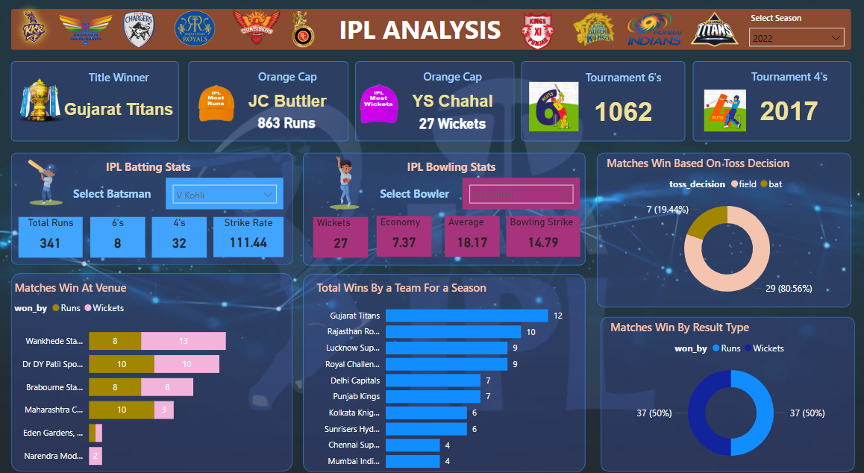

**Insights and Observations**

**1. Key Highlights**

* **Title Winner**: The Gujarat Titans were crowned champions of the IPL season 2022.
* **Orange Cap Holder**: Jos Buttler scored the most runs in the season, amassing 863 runs.
* **Purple Cap Holder**: Yuzvendra Chahal took the most wickets, with a total of 27 in the season 2022.

**2. Tournament Statistics**

* **Total Boundaries**:
  + Sixes: 1,062 were hit during the season, showcasing power-hitting.
  + Fours: 2,017 were scored, indicating a balance between strike placement and power.
* **Strike Performance**:
  + For the selected batsman, Virat Kohli, the season's stats include:
    - Total Runs: 341.
    - Sixes: 8.
    - Fours: 32.
    - Strike Rate: 111.44.

**3. Bowling Performance**

* **Yuzvendra Chahal’s Stats**:
  + Wickets: 27.
  + Economy: 7.37.
  + Average: 18.17 runs per wicket.
  + Bowling Strike Rate: 14.79.

**4. Venue Analysis**

* **Matches Won by Venue**:
  + At **Wankhede Stadium**, 13 matches were won by wickets, the highest across venues.
  + At **Dr. DY Patil Sports Stadium**, victories were evenly split between wins by runs and wickets (10 each).
  + **Narendra Modi Stadium** recorded the fewest wins by runs (2).

**5. Toss Decision and Match Outcomes**

* **Based on Toss**:
  + Teams choosing to field after winning the toss saw more success, with 80.56% of matches won this way.
  + Only 19.44% of matches were won when opting to bat first.
* **Result Type**:
  + Wins were evenly distributed between runs (50%) and wickets (50%).

**6. Team Performance**

* **Top Performers**:
  + Gujarat Titans led the season with 12 wins.
  + Rajasthan Royals followed with 10 wins.
* **Other Teams**:
  + Lucknow Super Giants and Royal Challengers Bangalore secured 9 wins each.
  + Chennai Super Kings and Mumbai Indians had the least success, with 4 wins each.

**Suggestions for Improvement**

1. **Focus on Batting Powerplay**:
   * Analyze strategies to improve the consistency of batsmen like Virat Kohli, focusing on powerplay overs to increase strike rates and boundary counts.
2. **Fielding First Strategy**:
   * Teams should prioritize fielding first when winning the toss, as data highlights an 80.56% success rate with this approach.
3. **Venue-Specific Strategies**:
   * Utilize past performance insights to create specific plans for venues like Narendra Modi Stadium, where run-based wins are challenging.
4. **Bowling Efficiency**:
   * Promote players with low economy and strike rates, like Yuzvendra Chahal, to maintain pressure in crucial matches.

**Dataset link :**

<https://drive.google.com/file/d/1DWWkMCr_bAgXxYCjzTZK-x-NHVQ5-Yxm/view?usp=drive_link>

<https://drive.google.com/file/d/1denUSsr8sj-GJp3Hi3fEmeiBjue7pxUV/view?usp=drive_link>