**Job Recruitment Assistant**

**System Domain** - The system focuses on making the hiring procedure at organizations automated and reliable using an expert system. The system is designed to recommend whether a candidate would be a good fit for the job.

The hiring process consists of several steps during the hiring process. Here, a baseline process of hiring candidates has been considered.

* The initial phase of the procedure consists of an aptitude test which determines the cognitive strength of the employee. These tests generally consist of two major sections – Quantitative and Verbal.
* The second phase is the personal interview with the organization. The interview is probably the most critical part of the selection process considering it’s the only real chance a candidate gets to impress the people of authority at the firm and to showcase his job-related and interpersonal skills at the same time.
* Other things to be considered are the age and years of relevant experience they have in that field.

Together all these factors influence the final decision. All the factors might not carry the same importance in the decision, but they should be a part of it. A system that can take all these factors into account and give a result/rating for each candidate competing for the job and recommend if they would be a good fit or not would not only save the Human Resources department of an organization a lot of time and manual work but can also enable the firms to hire the best talent. After all, the workforce is the most important part of an organization and getting the right people onboard would tremendously increase the productivity of a firm.

**Structure of the system** – This is an interactive system that has completely been implemented using the Jess Rule Engine. The system is designed to interact with the user by making the user enter scores for several attributes, it then computes the final rating of the candidate and recommends if he/she should be hired for the job. Following is the list of attributes-

* Age of the candidate (18-65)
* Total Years of Experience (1-40)
* Years of relevant experience pertaining to the required field of the job (for example, for a Python developer post, high relevant experience in python coding is desired) (1-40)
* Score in terms of having good interpersonal skills (1-10)
* Score in terms of having the qualities of being a good team player (1-10)
* Score on the numerical test (1-10)
* Score on the verbal test (1-10)
* Score on the interview (1-10)

Taking these factors into account the system runs the rule engine and figures out the final rating for the candidate. The rating ranges between 1-10 (1 being the lowest and 10 being the highest). The system recommends a candidate for the job if they have a rating of more than 7.

The different weights given to the factors:

* Fuzzy value for (Age + Experience + Relevant Experience) – 35%
* Interview Rating – 20%
* Numerical Score – 15%
* Verbal Score – 15%
* Interpersonal skills – 10%
* Team Player qualities – 5%

A relative value for each of the attributes for the final score is considered giving each of them a fair share depending on the importance of the attributes for the job at hand and for the company.

**Knowledge Base** – The knowledge base being used by the system consists of:

Global Variables and their Fuzzy values ->

Candidate’s Age:

*Range of Numerical Input*: 18 to 65

*Fuzzy Values*: low, medium, high

Candidate’s Experience:

*Range of Numerical Input*: 1 to 40

*Fuzzy Values*: low, medium, high

Candidate’s Relevant Experience:

*Range of Numerical Input*: 1 to 40

*Fuzzy Values*: low, medium, high

Candidate’s Rating:

*Range of Values*: 3.0(very low or low) to 10.0(high or very high)

*Fuzzy Values*: low, medium, high

***Facts*** –

*Questions*: The user is asked to input values based on the questions asked, each pertaining to an attribute.

* *Age* - What is the candidate's age?
* *Experience* - How many years of total experience does the candidate have?
* *Relevant Experience* - How many years of relevant work experience does the candidate have in the required professional field?
* *Interpersonal skills* - How much would you rate the candidate in terms of interpersonal skills?
* *Team Player* - How much would you rate the candidate as a team player?
* *Quantitative-score* - How much did the candidate score on the quantitative exam?
* *Verbal-score* - How much did the candidate score on the verbal exam?
* *Interview-score* - How much did the candidate score on the interview?

**Test Cases** – Few of the test cases for the system are illustrated below –

**Case1**: Very good candidate with all good attribute values

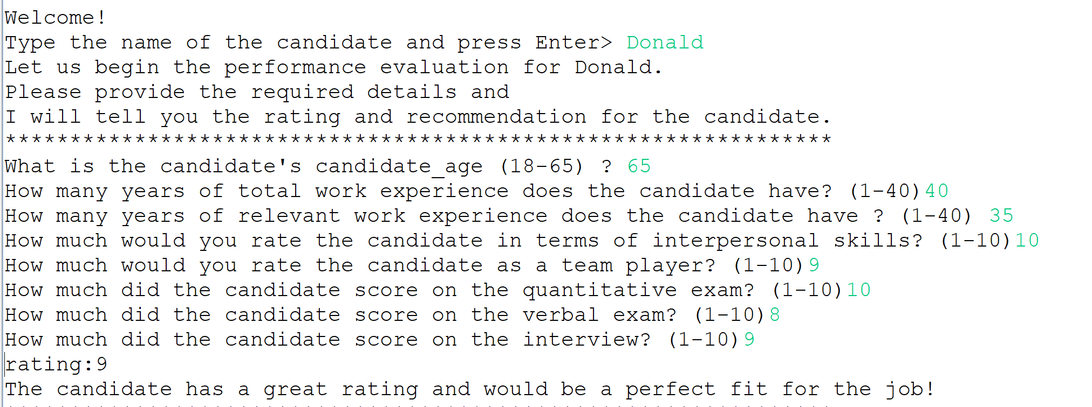

**Case2**: Mediocre candidate with average attributes

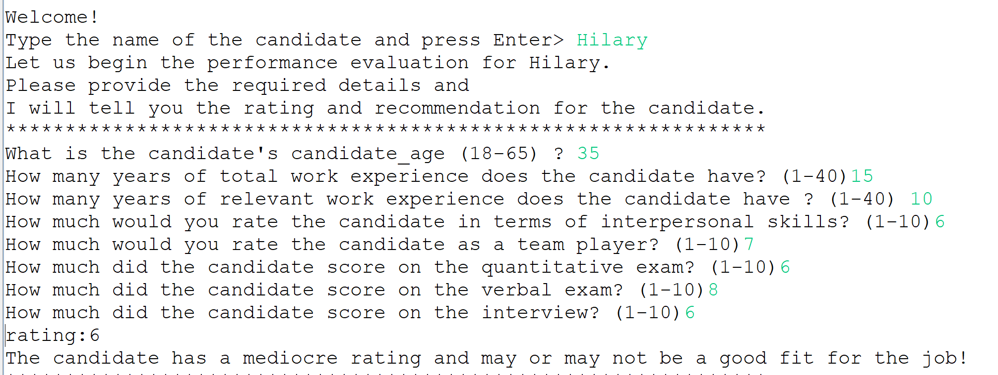

**Case3:**

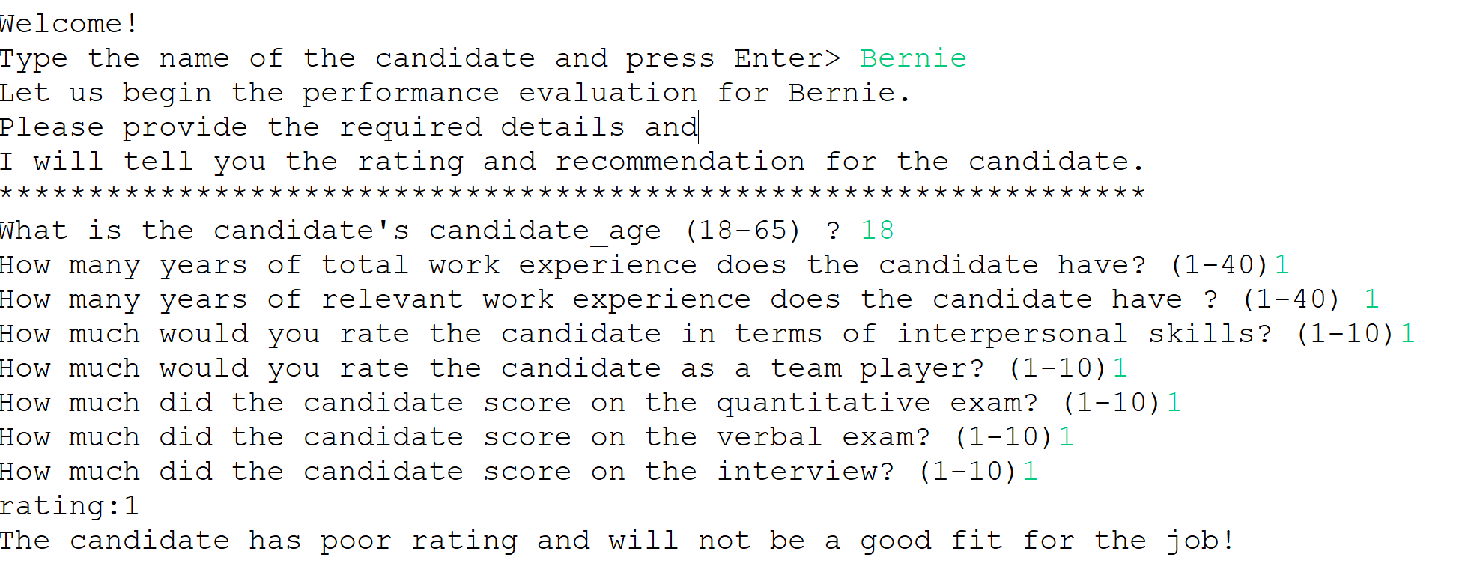

**Case4**: Candidate who is very senior but has low experience and lacks other attributes.

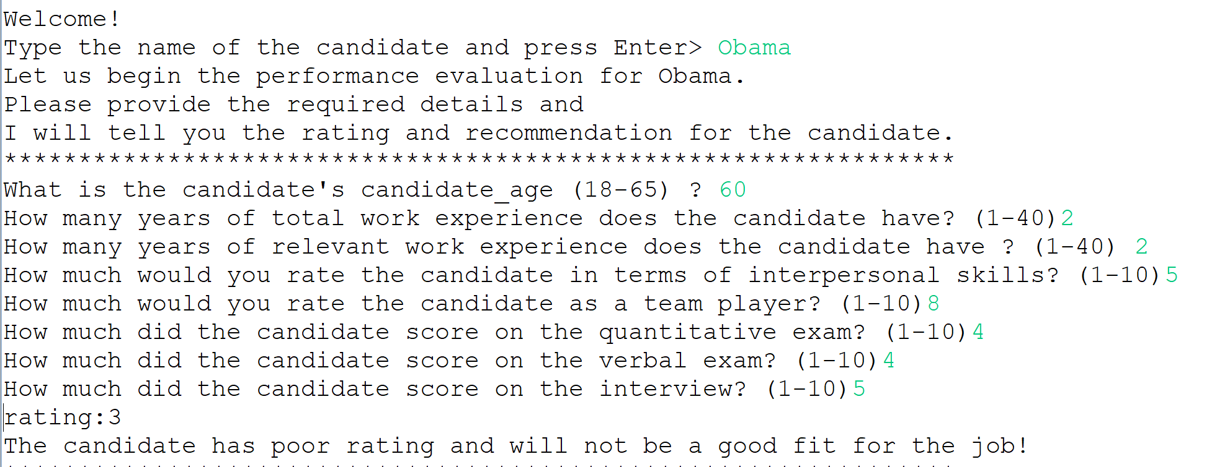

**Possible Test Cases**-

1. You can try out any test case with interpersonal, team player, interview, numerical and verbal scores between 1 – 10.
2. Any age suitable for working in a corporate world (18-65).
3. Total years of experience in the corporate world and relevant years of experience for the job which should obviously be logical with respect to the age of the candidate (for example, a candidate can’t be 25 years old and have 20 or 30 years of experience).

**Expected Output** –

The expert system would give you a rating for the candidate and a recommendation whether the candidate would be a good fit for the job. The ratings range from 1-10, considering the immense amount of competition for jobs in today’s world the system recommends only the candidates who have a rating of 7 and above to give a real sense of competition.

Note:- This is a baseline system and can be adjusted to a company’s own recruitment process, thus would provide much accurate results for a scenario.

**Instructions to run the system** -

Run file Hitman_Project2.clp