# DOM CREATELEMENT

Jan 24 2025

**By document.createElement(‘h1’) we create element**

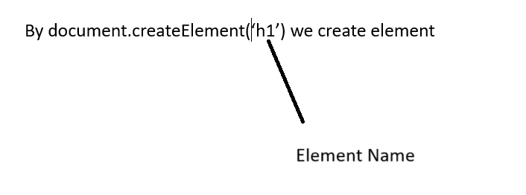

Append used for merging two element

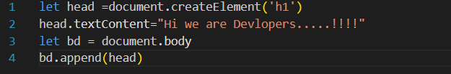

**document.setAttribute(‘align ’, ‘center’)**

It give attribute through Java Script

It takes two argument first is attribute name and second is attribute value

**document.setAttribute(‘align ’, ‘center’).removeAttribute(‘Align’)**

It removes the attribute