# Events

Jan 6 2025

Event call the function

If we click the button the event Fires every time(onclick)

If we click the button twice the event Fires (ondblclick)

If we hover the button the event Fires (onmouseenter)

If we hover the button and when we leaves the button then event Fires (onmouseleave)

If we want to click the button by right mouse click then for event Fires we use (oncontextmenu)

Classlist

It add the class or apply the class

Arrow Function

Arrow function are used for the code conciseness.

Various representation of arrow Function

()=>{return }

()

FEB 05-25

Callback Function

Callback function is used for calling function in another function argument.

Map Function

This function is used for assigning data by fetching to an array

Map function accept function in argument

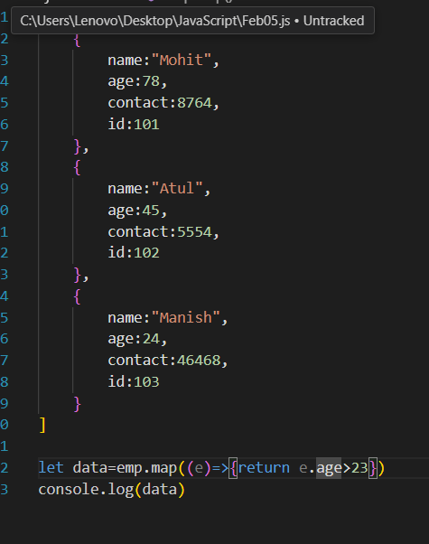

Filter Function

It is use to filter out to the data on any specific condition

Map function accept function in argument

It return data if we give condition in return not like map function

Set Interval

It is the function which accept function and time out in its argument

Feb 13 2025

npm install latest – npm install -g npm@latest

//node package manager

.node js - run time environment

Json - JavaScript object notation

Json runs on server

we have install server for successful functioning

npm install -g Json-server

json file runs on json server only

json file

Json-server –watch feb13.json