**React(JS Library)**

Jordan walke Developed the react library of JavaScript

He was developer at Facebook

It is developed for fastening website

It is closed in 2013 but it is open sourced after

It open sourced in 2013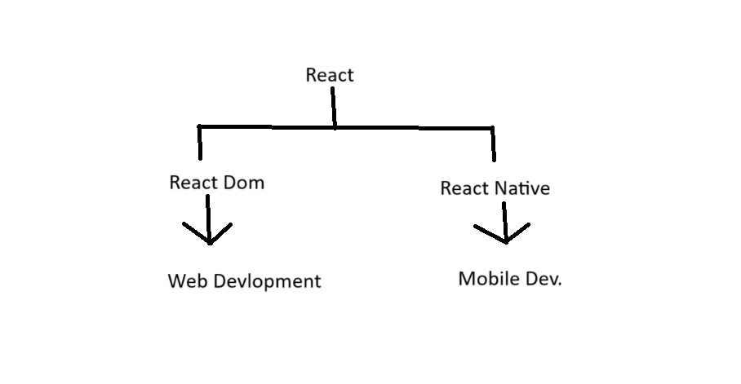

React architecture works on SPA

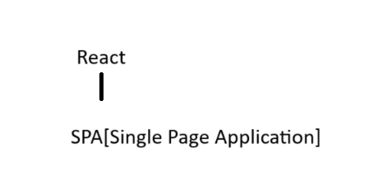

React Only have single page

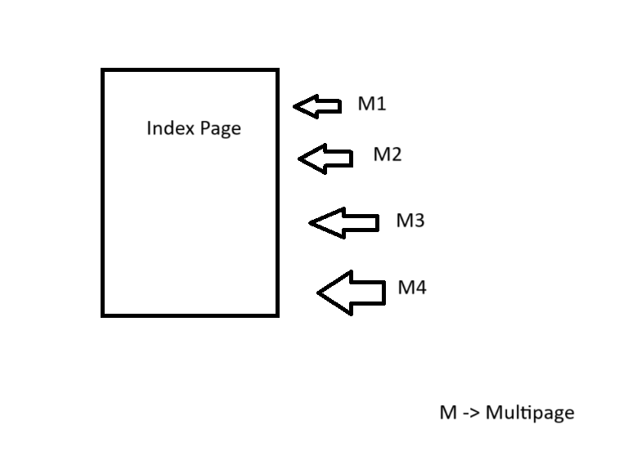

It works on Component Based Architecture

It is faster because of both CBA and SPA

Developer can do change in library but not in Framework

npm create-react-app <app-name>( Approx app size => 350Mb)

Bundler(Approx app size => 50-60Mb)

Bundler decrease dependency to open app

Bundler we will use -> vite,parcel

npm create vite@latest 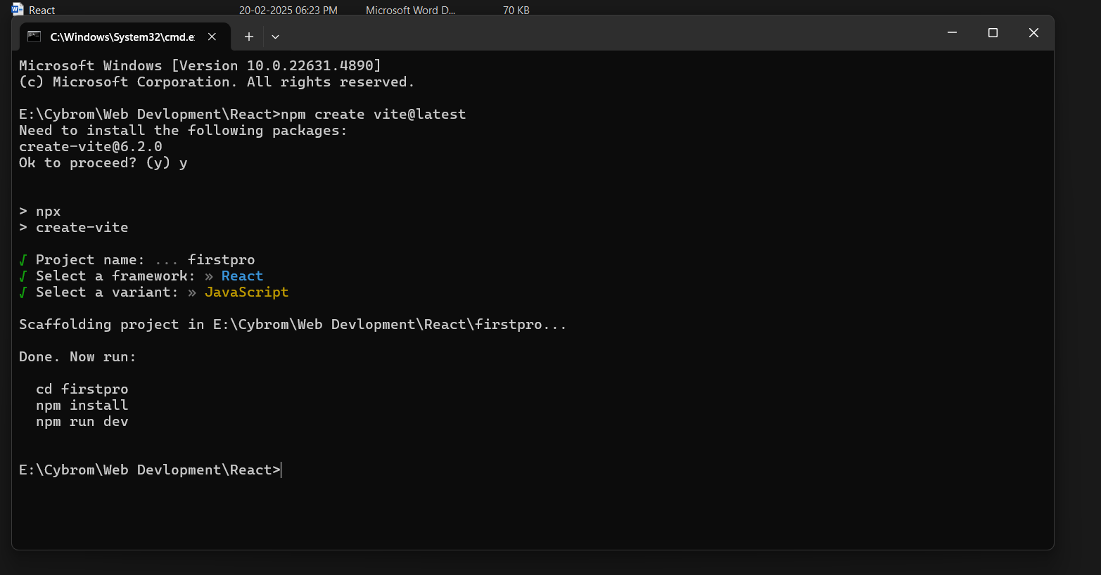

Weble is the compiler of JavaScript

Feb 21 2025

Node Module



package and library dependency

public folder consist of static files

SRC folder is a source folder. It is main folder all we do is in source folder

Package.json file 🡪 if we import any library or library we use in react project firstly install in it

Package-lock.json file 🡪 Library detail stored in

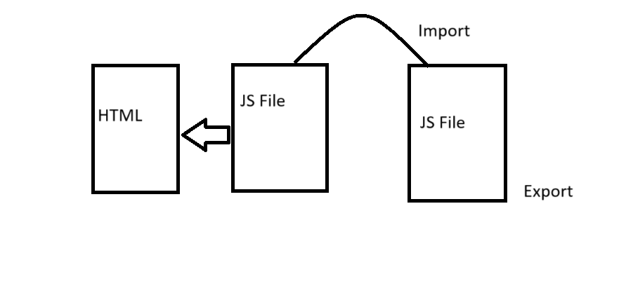

2 type of import and export

* Default (In case we used to import single)
* Named (In case of many)

Jsx is JavaScript XML(Extensible markup language)

Jsx rules

Only one element can be return one time in jsx you can easily just resolve by creating an div like : 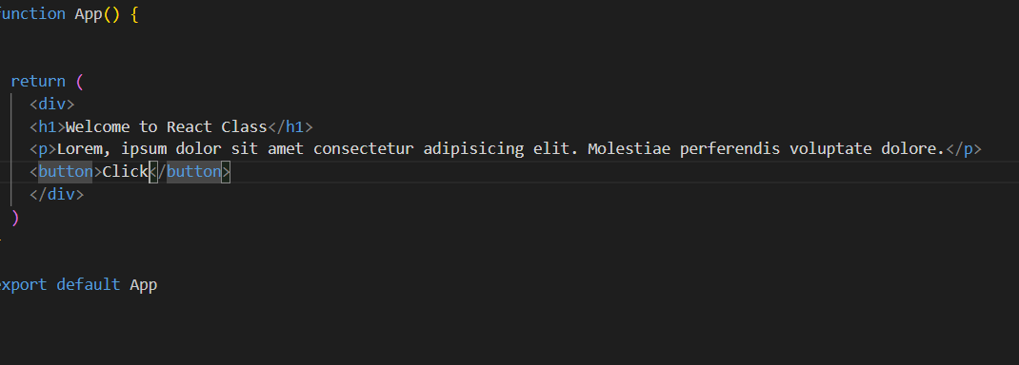

Or by creating fragment

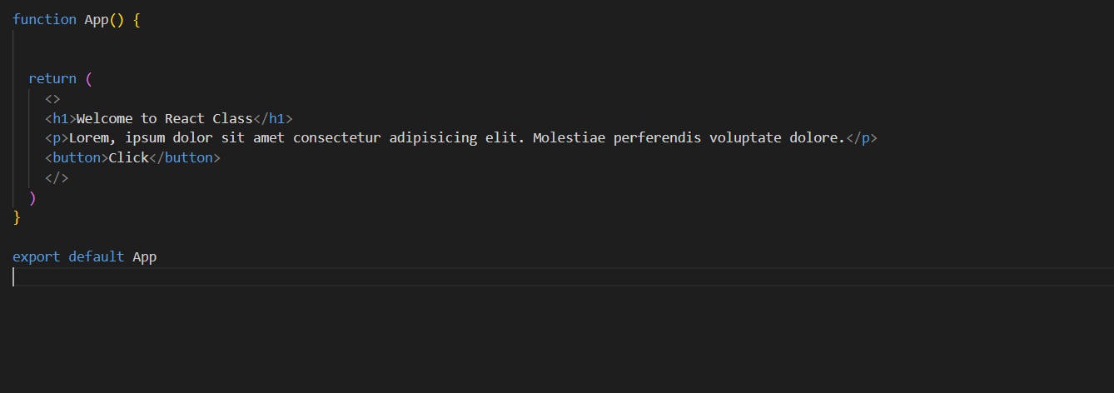

What is fragment?

There are two type of component in react :

* Functional Component
* Class Component

Diff b/w npm and npx