# Database Lab Assignment

# Code repository for IIT Guwahati

Group 2 | CS345 | 13th April 2013

Aditya Sharma 10010106

Samarth Tripathi 10010156

Shrinivas Acharya 10010164

Sudhanshu Mittal 10010166

# Table of Contents

1. System requirements
2. Installation instructions
3. About

# System Requirements

* Windows 7,8 (64-bit)
* Wamp 2.1 (64-bit) or above

# Installation Instructions

* Extract iitgCodeRepository.zip anywhere in your computer.
* Run setup.bat
* It will install Wamp server.
* Set system environment variable for C:\wamp\bin\mysql\mysql5.1.53\bin as shown below.

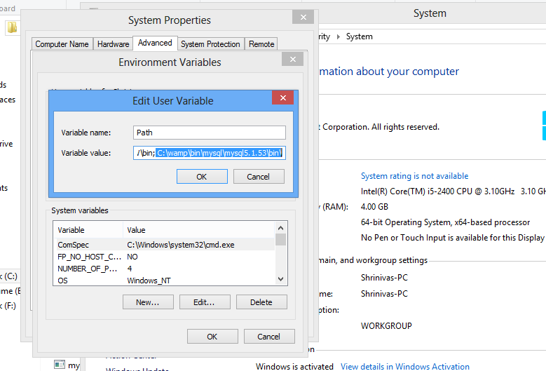

* Run createDB.sh.
* This will create the database required by the website.
* The website can be found on localhost/iitgCodeRepository.

# About

The database: 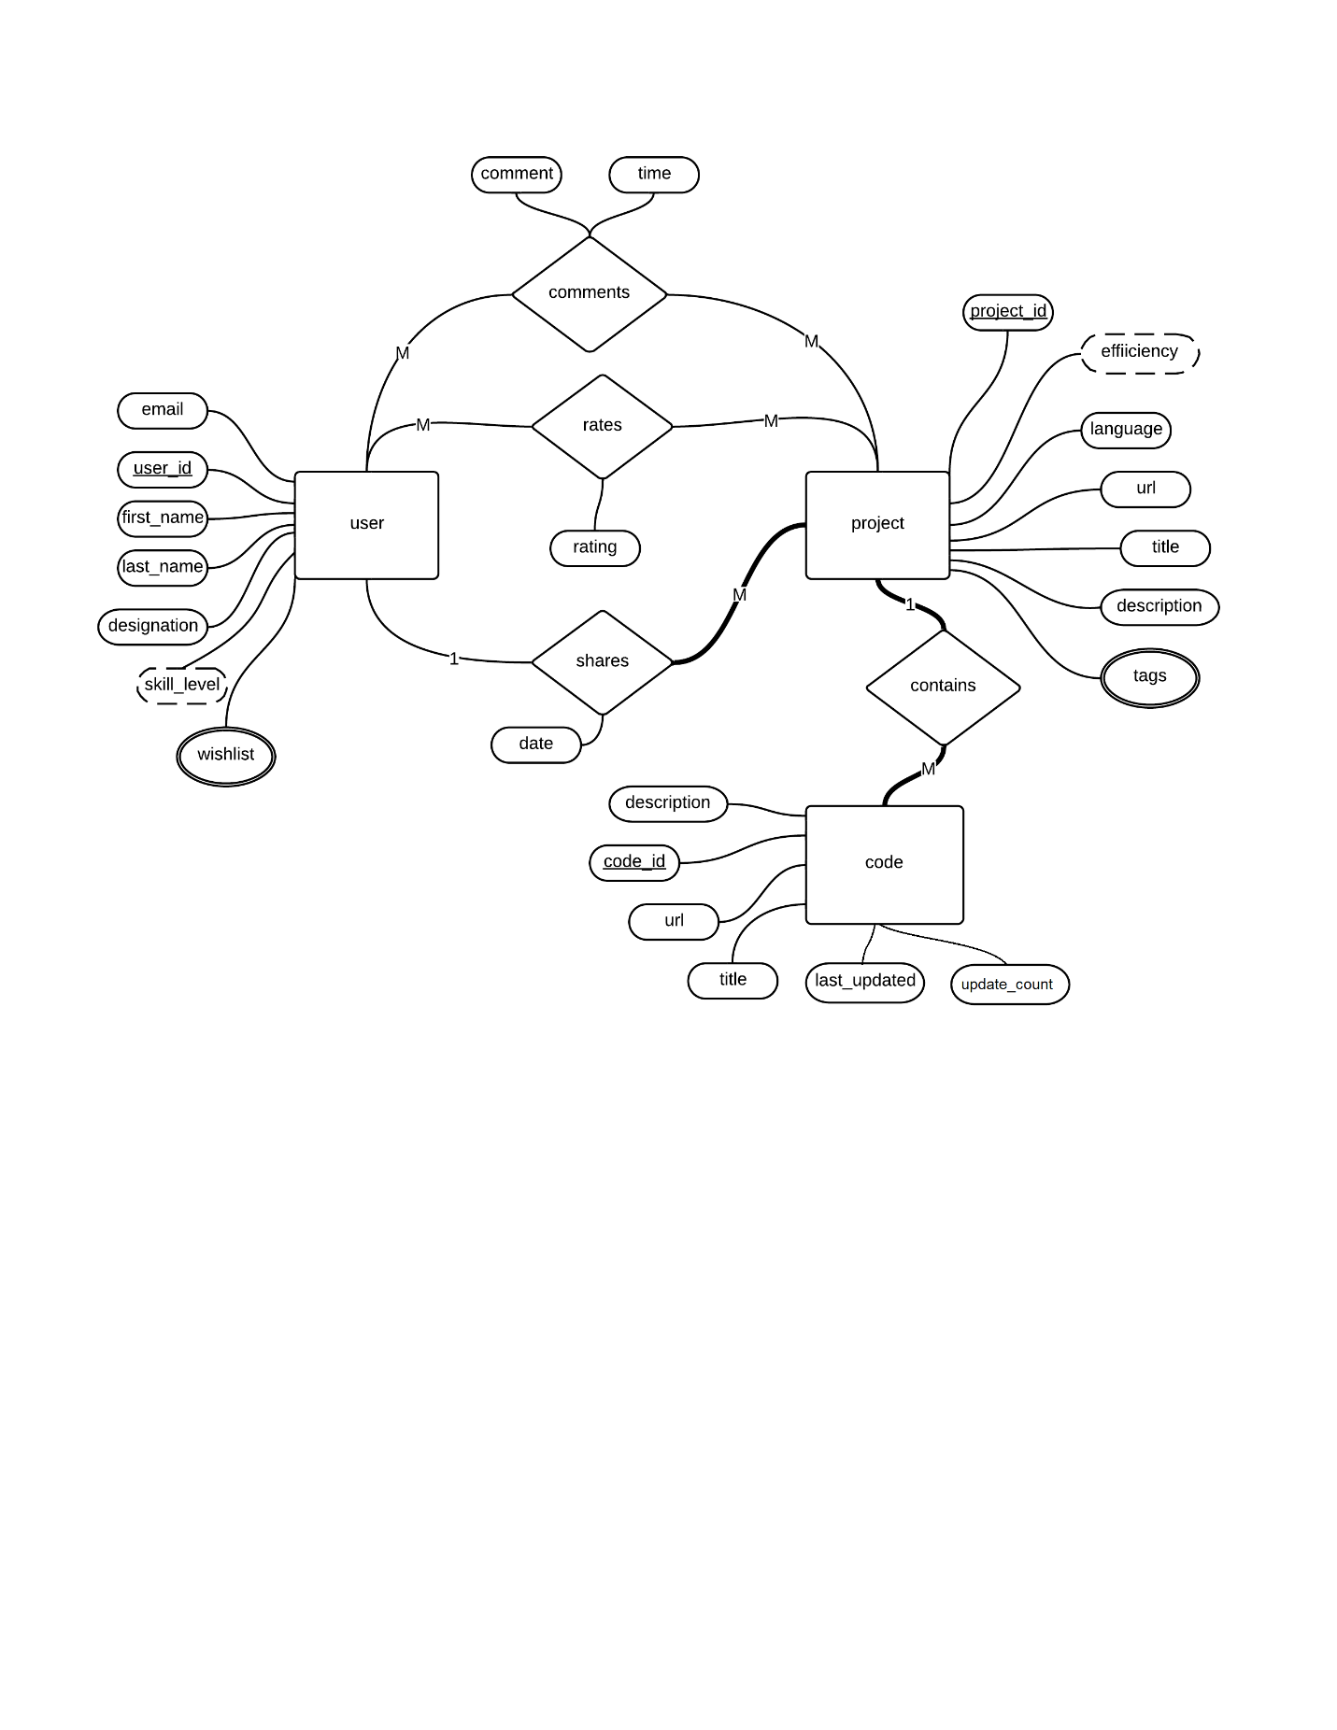

Project Rationale:

Over the few years that we've been at IITG, we've observed that every year a lot of good and laborious projects and programs are written in numerous languages but are ultimately scrapped. Through this project we wish to keep a better track of the efforts and programming mastership of IIT junta. Not only will this repository help us to save our precious time and efforts by recycling of already implemented programs and algorithms but also encourage our instructors to come up with different project topics every year instead of repetition. Along with this, the repository will help inculcate an environment of awareness and curiosity among the programmers of our college.

Project Description:

* The repository will maintain a database of submitted programming projects along with all the information about the creator, programming language, bugs and description, date etc.
* While uploading the user would put certain tags and description for efficient searching.
* Along with this we maintain a separate user database which enlists one's interests (pertaining to s/w development), his personal info and his rating as a programmer (devised from the responses to his submitted codes).
* The repository will support an active discussion forum for doubts and queries.
* The database will maintain a record of the changes inflicted on a given code.
* If a user does not find a code, he may request to receive a notification in case such a code is uploaded.
* If time permits, we hope to implement memcached on top of this project.
* Optionally, we wish to introduce online compiler facility for limited number of languages, and thus provide a platform to organize programming events.