**Automatic Homework Grading**

1. Prof. creates editable PDF’s using Emacs/latex with either empty fields to fill numeric answer or radio box for multiple choice questions
2. Student will download their homework from server and fill the answers on their machine in any PDF editor and save it
3. Student then Upload their saved PDF in their respective folder on server using login id and password
4. Once the deadline is over for submission, then Prof. will run this python code in Jupyter Notebook on server
5. Python code on the server runs on every student’s solution PDF and checks each question and generates feedback PDF in student’s folder
6. Feedback file for each student contains question wise comments and marks obtained for each question and total marks obtained
7. In the Jupyter Notebook, question wise student’s performance graph is also generated.
8. Requirement of Python code:
   1. The server setup looks like this: 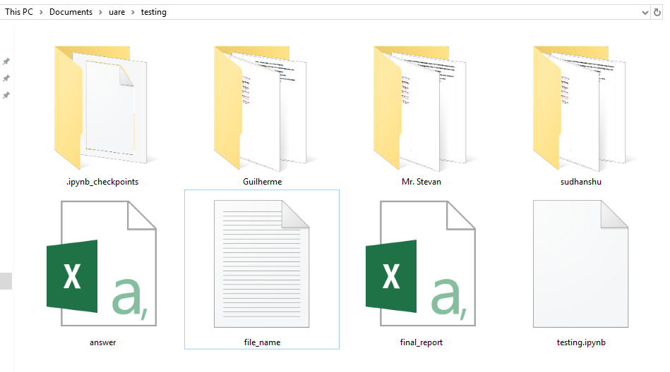
   2. All students have separate folder with their name and each folder contains a homework PDF with same name (can be different content)
   3. Name of homework PDF is stored in a text file named ‘file_name.txt’
   4. Answer CSV file should be like this: 