Name : Sudhanshu Wadhwani

Task : DB-01 Assessment

I’ve created three tables : users, income and expense

Users :

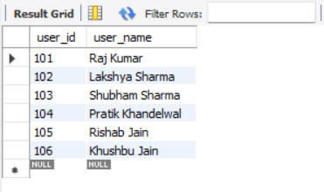

Income :

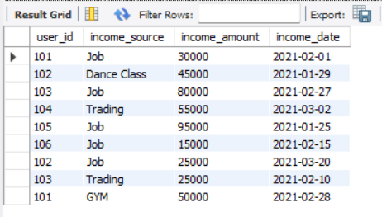

Expense :

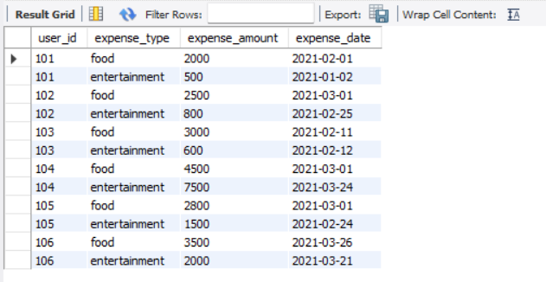

Queries :

1. We should be able to find aggregate of all the income for a particular category.

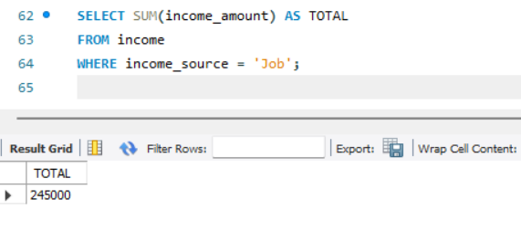

2. We should be able to find aggregate of all the income for a particular category for specific duration.

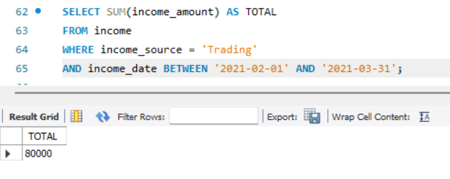

3. We should be able to find aggregate of all the income for a particular category for specific duration for specific user.

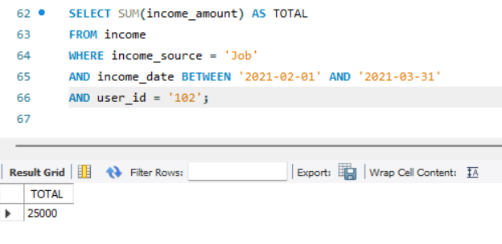

4. We should be able to find income and expense of particular user for specific duration.

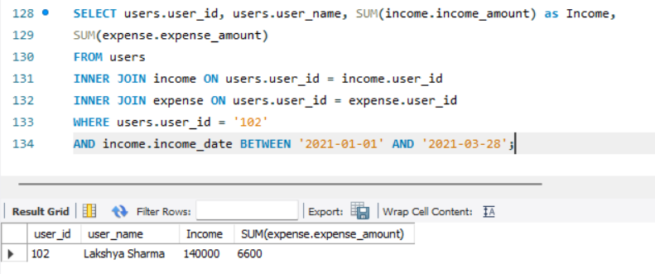

5. We should be able to find average income or average expense of user of specific duration

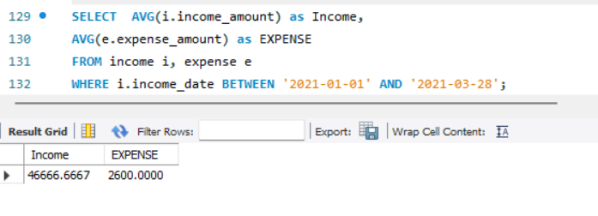

6. We should be able to find overall remaining balance (maybe negative or positive based on income and expenses) for a particular user.

WITH temp_income

AS (

SELECT u.user_id

,u.user_name

,coalesce(SUM(i.income_amount), 0) AS INCOME

FROM users u

LEFT JOIN income i ON u.user_id = i.user_id

GROUP BY u.user_id

,u.user_name

)

,temp_expense

AS (

SELECT u.user_id

,u.user_name

,coalesce(SUM(e.expense_amount), 0) AS EXPENSE

FROM users u

LEFT JOIN fact_expense e ON u.user_id = e.user_id

GROUP BY u.user_id

,u.user_name

)

SELECT c1.user_id

,c1.user_name

,c1.INCOME - c2.EXPENSE AS Balance

FROM temp_income c1

INNER JOIN temp_expense c2 ON c1.user_id = c2.user_id

WHERE c1.user_id = '102';

