Topic : Hospital Management Queries

Queries :

Q1. Count the no. of in and out patient who booked an appointment with a particular doctor on current date.

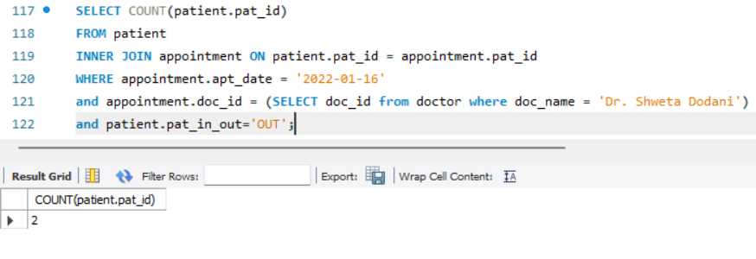

Q2. Count the no. of patients who booked an appointment with atleast one doctor for current date.

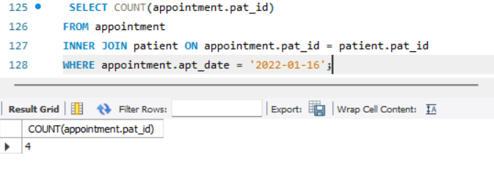

Q3. Count the no. of available beds in a ward.

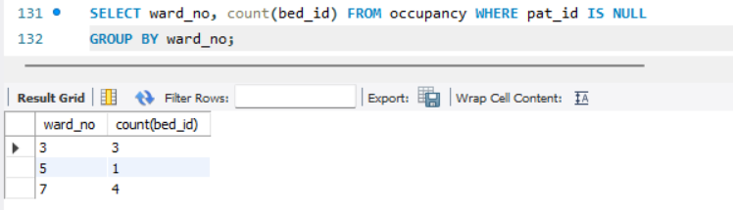

Q4. No. of appointment taken by a patient.

