KOTAk LIFE
SOP (Standard Operating Procedures)
For
PRIME360 de-dupe application


URL: http://www.posidex.com
E-mail: support@posidex.com

Copyright ©2019 – POSIDEX TECHNOLOGIES PRIVATE LIMITED

This document is the property of POSIDEX Technologies, Hyderabad, India. The copying or reproducing of any contents of this document in any form (manual, electronic or otherwise) is strictly prohibited and can be done only with specific written permission from the duly authorized signatories of the organization.

1.Document Revision History

Baseline Document | Name | Date
Prepared By: | V Ramesh , K Suresh | 30/09/2019
Verified By: | K Ravi Kiran | 30/10/2019
Approved By : | G Sharath | 30/10/2019

Table of Contents
1.Document Revision History 2
3.Introduction: 6
3.1. Purpose of this Document 6
3.2. Audience for this Document 6
3.3. List of Acronyms 7
4.Environment Setup 7
4.1. System Architecture 7
4.2. Required Software's: 7
4.3. Directory Structure: 8
4.3.1.Dedupe Application Directory Structure 8
4.3.2.Dedupe Logs Directory Structure 8
5.Application Setup 8
5.1.Actions Before Application Set up 8
5.1.1.Pre-Implementation Plan 8
5.1.1.1.Application Server 8
5.1.1.2.Database Server 8
5.1.2. Pre-Requisites Check List 8
5.1.2.1. Application Server 8
5.1.2.2. Database Server 9
5.2.Master/Setup Data 10
5.3. Application Deployment 10
5.3.1. Application Installation 10
5.3.2. Application Configuration 10
6. Support Matrix 10
6.1)How to Start Tomcat Server: 10
6.2)How to Stop Tomcat Server: 11
7.Daily Operations Activities 11
7.1 Monitoring Activities: 11
7.1.1. Offline Application Monitor Activities 11
7.1.2. Online Application Monitor Activities 11
8. Additional Support Information 12
8.1.Patch Updating 12
8.1.1. Application Server related patches 12
8.1.2. Database Server related patches 12
8.2.Installation 12
8.3.Change in Core DB Password 12
8.4.Checking Log Files 13
8.4.1. Web Serverices Logs 13
9. FAQs 13
9.1.How can I Access the Posidex De-dupe Application GUI? 13
9.2 Why I am not getting the Posidex Configuration GUI? 13
9.3 How to Down De-dupe Application Services for any Down Time Approval 13
9.4 How to UP The De-dupe Application Server after any Down Time Activity Done 13
9.5 How to Access Active MQ Admin console? 14
9.6 System Level Issues 14
9.6.1. Too many open files at the system level in Linux environment 14
9.6.2. Application failed to start up due to invalid file permissions 14
9.6.3. Engine unable to start up with memory allocation of more than 1.5Gb 14
9.6.4.Unable to access our application's URL 14
9.7 DataBase Level Issues 15
9.7.1. Temporary table space issue 15
9.7.2. Session time out. 15
9.7.3. The Network Adapter could not establish the connection. 15
10)Services Using in Dedupe: 15
10.1)Intraday Service: 15
10.1.1)How to start: 15
10.1.2)Purpose: 15
10.1.3)Process Flow: 15
10.2)Restfull Webservice: 16
10.2.1)Sample JSON request: 16
10.2.2)Corporate and Personal Matches: 20
10.2.3)Authentic Matches(For Branch and Genie requests): 20
10.2.4)Merge Client Id Status: 20
10.2.5)Self Match: 20
10.3)Prime360 Admin UI: 21
10.3.1)Start/Stop services: 21
10.3.2)Profiles: 23
10.3.3)Logging: 24
10.3.4)Message Posting: 26
10.3.4.1)Initial Process: 26
10.3.4.2)Prob FCB: 27
11)Maker/Checker UI service: 28
11.1) Installation Directory: 28
11.2) How to Stop Tomcat Server: 28
11.3) How to Start Tomcat Server: 28
11.4) Log file location: 28
11.5) Browser Compatibility: 29
11.6) Maker: 29
11.6.1) Maker URL Validation: 29
11.6.2) Proposal Number: 30
11.6.3) User Id: 30
11.6.4) Dropdown Selection Validation: 31
11.6.4.1) VW_DEDUPLE_CLIENT: 31
11.6.4.2) Dedupe Client Validation: 31
11.6.4.3) Validation Message After Client Selection: 32
11.6.5) Save And Dedupe: 32
11.6.5.1) Save And Dedupe Validation: 32
11.6.6) Merge: 33
11.6.6.1) Merge Validation: 33
11.6.6.2) Merge Database Updates: 34
11.6.6.3) Merge Summary: 35
11.6.6.4) Kindly Perform Action For Pending Clients: 35
11.6.7) No Action Required: 36
11.6.7.1) No Action Required Validation: 36
11.6.7.2) No Action Required Database Updates: 36
11.6.7.3) Kindly Perform Action for Pending Clients: 36
11.6.7.4) No Action Required Summary: 36
11.6.8) Dedupe Refresh: 37
11.6.9) Selected View: 37
11.6.9.1) Delete: 37
11.6.9.2) Delete Action Database Updates: 37
11.7) CHECKER: 38
11.7.1) Checker URL validation: 39
11.7.2) Checker Dropdown Selection Validation: 40
11.8) Approve: 40
11.8.1) LA Request Format: 41
11.8.2)Life Asia Request Scenarios : 42
11.8.3) Life Asia Validation: 43
11.8.4) Database update: 43
11.8.4) Approve Summary: 43
11.9) Reject: 44
11.9.1) Database updates: 45
11.9.2) Reject Summary: 45
11.8) Override Case: 46
12.1) Override Database updates: 46
11.9) Re-Trigger: 46

3.Introduction:
Kotak Life has a customer base across the country and the total base data is referred as Initial data and the customers captured during a day is referred as EOD data. Daily, online data will be convert as EOD data.
The initial data will be provided in the view where as EOD data will come from Online data in separate table. After start the scheduler process For every batch of data that is inserted in the Initial tables there will be corresponding insertion of the record in the psx_nsp_event_details table with the STATUS column as 'P'. after completion of eod process status will update.
The main objective of this application is to enhance the capability of reporting the bulk connections held by a customer and in some circles, to meet the real time matching needs during capturing customer information.
Posidex achieves the above objective through one of the following processes based on the requirement of the Circle.
- Real Time Matching System (Prime360 Match),
- Reporting the Results in the form of CSV file at the predefined location.
Posidex also provides the GUI for running the above two functionalities. Through GUI we can
- Configuring the Matching Rules.
- Start or Stop the Posidex Services.

3.1. Purpose of this Document
This guide provides basic information that is needed for configuring and maintaining Prime360 De-dupe in Kotak Life.

3.2. Audience for this Document
This document is intended for Operations team and assumes that the users have basic knowledge of Oracle database and should be able to install the application.

3.3. List of Acronyms
Acronym | Expansion
SOP | Standard Operating Procedure
UAT | User Acceptance Test
EOD | END of THE DAY

4.Environment Setup

4.1. System Architecture
The system architecture is three tiered.
Three-tier is a client-server architecture in which the user interface, functional process logic, data storage and data access are developed and maintained as independent modules, most often on separate platforms. The three-tier model is considered to be software architecture and a software design pattern.
Typically, the user interface runs on a desktop PC or workstation and uses a standard graphical user interface. Functional process logic may consist of one or more separate modules running on a workstation or application server, and an RDBMS on a database server or mainframe contains the data storage logic.
The 3-Tier architecture has the following three tiers.
1.Presentation Tier or User Interface Tier
2.Application Tier / Logic Tier / Business Logic Tier
3.Database Tier

4.2. Required Software's:
Apache-Tomcat-9.0.33
Apache-Activemq-5.13.3
Java Version : Jdk1.8.0_92
Database:Oracle 12c
Note: Above mentioned software's are recommended for online data processing.

4.3. Directory Structure:

4.3.1.Dedupe Application Directory Structure
To install the dedupe Application place the extracted binaries in Installation folder.
Application Ex:D:/Kotaklife_dec13/
Logs Ex:D:/Kotaklife_dec13/logs

4.3.2.Dedupe Logs Directory Structure
Knowing the necessity of tracking the information while running various services, we maintain the logs at the specified location.
Ex: D:/Kotaklife_dec13/logs
Ex: D:/Kotaklife_dec13/Prime360_1.1/logs

5.Application Setup

5.1.Actions Before Application Set up

5.1.1.Pre-Implementation Plan

5.1.1.1.Application Server
- Install the Windows Operating System
- Create application OS user
- Install the JDK and JRE 1.8.0_92 with latest update

5.1.1.2.Database Server
- Install Oracle
- Create table space
- Create database and db user(With all permissions)

5.1.2. Pre-Requisites Check List

5.1.2.1. Application Server
Please Check and Validate the Checklist given in the following table
CHECK NAME | EXPECTED VALUE | HOW TO CHECK | REMARKS
JDK and JRE version | 1.8.0_92 with latest update | java -version | Dedupe services will not run
RAM | as per requirement | top  cat /proc/meminfo | Dedupe services will be slow
HARDDISK Storage | as per requirement | df -h | Dedupe services wont run
Processor | as per requirement | cat /proc/meminfo  cat /proc/cpuinfo  dmesg | grep CPU  dmesg | grep mem | Dedupe services will be slow
File Size Limit | 1.unlimited file size  2.cpu size unlimited  3.file size unlimited  4.virtual memory unlimited  5.max user processes 35000 | ulimit -a | Dedupe services will not run  to Create the Objects in the  local hard disk
Port Numbers to access the dedupe application, SFTP and SMTP) | as per requirement | telnet command | Dedupe services will not run
Owener Ship on Mount Points | 777  Read , Write, Execution | ls -l | Dedupe services will not run
Ping time response from app server to DB Server | average of 0 ms | ping <ipaddress> | Dedupe services will be slow
Net Work Idle Time out Must Not Set | Not Set | ping <ipaddress> | Dedupe services will be slow
Check Softwares are able to Run | If Localhost name got changed, it should be configured properly in hosts file  We Faced with this issue activemq (localhost not recognized) |  | Dedupe services wont run
Linux version |  | uname -a  cat /etc/issue
Execute /proc/cpuinfo for complete cpu info | as per requirement | /proc/cpuinfo

5.1.2.2. Database Server
Please Check and Validate the Checklist given in the following table
CHECK NAME | EXPECTED VALUE | HOW TO CHECK | REMARKS
Table Space HDD Storage | as per requirement | df -h | Dedupe services will not run
System processor speed | as per requirement | prtconf |pg | Dedupe services will be slow
Server RAM | as per requirement | topas  lsattr -El sys0 | grep realmem | Dedupe services will be slow
AIX version | as per requirement | uname -a  oslevel -g
Data Base Privileges | All the permissions |  | do not run De-dupe process

5.2.Master/Setup Data
Setup data/Seed data will be automatically populated during installation through De-dupe Jars installer.

5.3. Application Deployment

Posidex will give the new Prime360 De-dupe application in zip file and no need to install just we need to extract and place the folder in desired drive.

5.3.1. Application Installation
Please Refer to installation steps from prime360 manual document.

5.3.2. Application Configuration
Please Refer to installation steps from prime360 manual document.

6. Support Matrix
Servers/Clients | Prerequisite for Application | Version | Reason for using Prerequisite
Database Server | Oracle | 12C | Application database
Application Server | Apache Tomcat | 9.0.33 | Required to host Application
 | JDK and JRE | 1.8.0_92 | Required to deploy application
 | Active MQ | 5.13.3 | Posidex service/engine processing will be triggered by receiving a message from JMS Queue.

6.1)How to Start Tomcat Server:

- Logon to Dedupe Application Server
- Here we need to start two tomcat applications one is for webservice and
prime360adminUI and one is for maker checker application.
- Go to “<<INSTALL_DIR>>/apache_tomcat/bin” and
- Run the following command in command prompt to start tomcat server.
startup.bat
- do same for both tomcat servers

6.2)How to Stop Tomcat Server:

- Logon to Dedupe Application Server
- Here we need to stop two tomcat applications one is for webservice and
prime360adminUI and one is for maker checker application.
- Go to “<<INSTALL_DIR>>/apache_tomcat/bin” and
- Run the following command in command prompt to start tomcat server.
shutdown.bat
- do same for both tomcat servers.

7.Daily Operations Activities

7.1 Monitoring Activities:

7.1.1. Offline Application Monitor Activities

S.No | Feature
1 | Check whether all services are in running mode before Starting the LTD/EOD Process
2 | Monitor the EOD, Online,Intraday De-dupe Process and Make sure that all the reports are generated in the given time slot and the same has to be copied into SFTP server
3 | If any Error Occurs in the De-Dupe Process check log files and re-run the process using trouble shooting guide
4 | Audit events Should also be periodically checked and backup has to be taken if necessary.
5 | The SFTP Servers need to be checked manually & periodically and when there is no sufficient space for further storage in current mapped SFTP Folder.
6 | Regular backups of the database server should be taken
7 | Check whether sufficient temp space and table space exists on database server
8 | Check whether free HDD available in Installation ,Logs and Results Partition
9 | Ensure periodical indexes and analyze on dedupe tables to improve the performance

7.1.2. Online Application Monitor Activities

S.No | Feature
1 | Check whether all services are in running mode (Activemq,intraday,tomcat,prime360 services should always be in running mode for Online requests processing
2 | Monitor the Online intraday Process and make sure ‘For the Day’ data goes from Online to Offline in the given time slot
3 | Monitor the daily EOD(Objects refresh/merging) activity in online server in the given time slot .
4 | In case if objects refresh fails and prime360 service shuts down then need to re-place the backup objects and start service. This will ensure that the service starts with day-2 data again. Check if Objects got corrupt and take necessary steps to re-build
5 | Audit events should also be periodically checked and backup has to be taken if necessary.
6 | Regular backups of the database server should be taken
7 | Periodically monitor the queues in ActiveMq console to check if there is any pendency for any circle and purge in case of accumulation to avoid ‘timeout errors’
8 | Check whether free HDD available in Installation ,Logs and Results Partition
9 | Ensure periodical indexes and analyze on dedupe tables to improve the performance

8. Additional Support Information

8.1.Patch Updating
There will be a need of patch updating when there is a change requirement or defect fixing. After successful implementation of the patch, posidex consolidates the artifacts and implement script to deploy the patch.

8.1.1. Application Server related patches
The operations team needs to execute the script file which will be provided along with the updated patch

8.1.2. Database Server related patches
- If patch consists of a new table, then directly create the new table.
- If patch consists of old table then, an alter statement will be sent which has to be executed.
- If patch consists of new stored procedures, directly execute the SP
- If patch consists of old stored procedures, drop the old stored procedures and execute the SP, which is sent.
- If patch consists of jobs/functions/triggers, drop the job and create it.
Note: If any specific changes are to be done, the same will be specified in the mail containing the patch

8.2.Installation
Please Refer to DEDUPE_Setup_on_LINUX.pdf as part of Ops handover checklist

8.3.Change in Core DB Password
Refer the password change DEDUPE_DBPassword_Change_Guide.pdf as part of Ops handover checklist.

8.4.Checking Log Files
The Log files can be viewed using the Operations-->Logger Viewer GUI Tab or can view from physical location of <<Installation_dir/logs> directories.

8.4.1. Web Serverices Logs
<<Installation_dir>/logs/webservicelogs/customerws.log

9. FAQs

9.1.How can I Access the Posidex De-dupe Application GUI?
Access to the Posidex application is through the below URL
http://IP:port/Prime360AdminUI/

9.2 Why I am not getting the Posidex Configuration GUI?

Check whether the Tomcat Web Server is running or not, If not Start Tomcat Server, to start the Tomcat Web Server follow the below steps.

- Logon to Dedupe Application Server
- Go to “<<INSTALL_DIR>>/apache_tomcat/bin” and
- Run the following command to start tomcat server. See below Figure
execute startup.bat file in command prompt
- You will be shown the “tomcat started successfully” message.

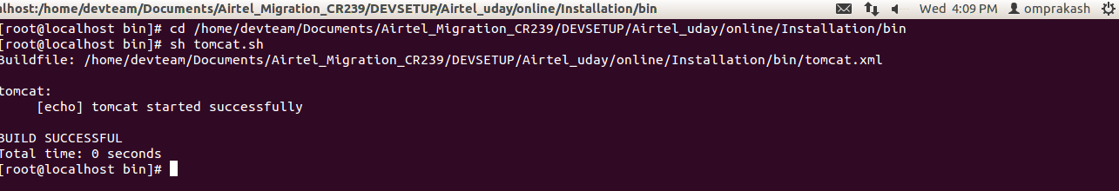

9.3 How to Down De-dupe Application Services for any Down Time Approval
- Stop ActiveMQ and Prime360 Engine Services form Prime360AdminUI.
- Stop the Tomcat Server.

9.4 How to UP The De-dupe Application Server after any Down Time Activity Done
- Start the Tomcat Server.
- Start All the Posidex De-dupe Services.

9.5 How to Access Active MQ Admin console?
- Open the Any Web browser
- Enter the URL to access the Active MQ admin console.

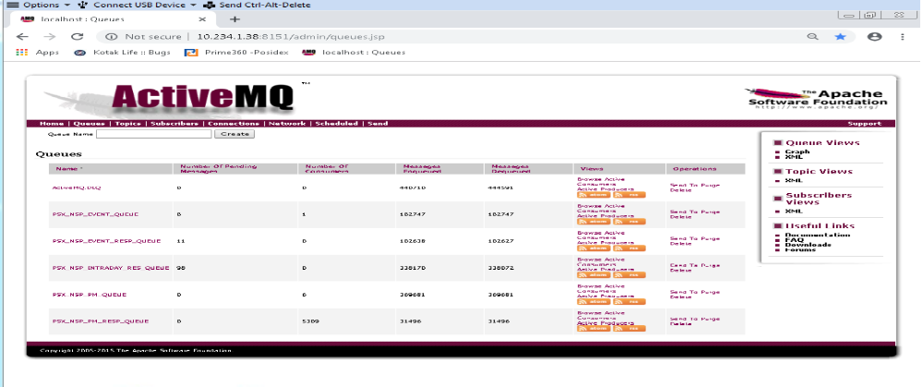

9.6 System Level Issues

9.6.1. Too many open files at the system level in Linux environment
Increased the number of open files by increasing the uLimit value at the system level and had to be performed under root level.

9.6.2. Application failed to start up due to invalid file permissions
Files were to be copied at the same user level as that our user had to assign 777 permission for the files residing in Installation and software folders.

9.6.3. Engine unable to start up with memory allocation of more than 1.5Gb
Firstly we had to confirm if Java 64 bit is installed or not and if so we need to check if Java Path has been set to 64 bit version which was not there and to change the same

9.6.4.Unable to access our application's URL
Port numbers used by our application were restricted and had to request the client to grant access of the same.

9.7 DataBase Level Issues

9.7.1. Temporary table space issue
Allocated Temporary table space at the database level was not sufficient with respect to the data so requested the client to increase the same with respect to the data

9.7.2. Session time out.
Had to increase the session time out value in SQL.*.net for our schema this was a temporary solution and later deployed a patch handling the closed connections.

9.7.3. The Network Adapter could not establish the connection.
Whenever you see a Network Adapter could not establish the connection, you have either
The wrong SQL Developer URL or you have a basic SQL*Net connectivity issue! This error is most likely caused by one of these factors:

- You are using the wrong URL
- The wrong port number or IP address (or DNS host name) was used
- The listener is not configured properly

10)Services Using in Dedupe:

10.1)Intraday Service:

10.1.1)How to start:
- before starting intraday service we have to start Activemq service,for starting intraday service. Go to installation path(D:/KotakLife_dec/Prime360v1.1/IntradayEodProcess).In this path you will have a jar file and need to execute the jar by using below command.
- java -jar Kotak_intraday_eod.jar

10.1.2)Purpose:
- In this service we are getting the updated data from Life Asia to view(vw_dedupe_client).
- we are listening on this view and fetching the data by using the time stamp and the same updating in Prime360 accumulator.
- by using this service we will get the updated information in matching.

10.1.3)Process Flow:
- Intraday service will listen on vw_dedupe_client view on every 5 seconds , here in fetch query in where condition we are giving system time stamp with minus of 15 seconds to system timestamp.so when ever data comes into view we will fetch that data and we will insert the same data into psx_nsp_intraday table.
- After fetching the data from view we are updating the timestamp as SystemTimestamp in ThreadFiredTime table.As we are listening continously on view we will fetch the records only having time stamp gretaer than of Timestamp of ThreadFiredTime.
- Then for those records service will build the activemq message and sends to prime360 engine.
- Engine process the request and stored it in accumulator.
- When the web service request is sent, the updated data will come for matching.
- Note:There exists 4 timestamps in view as Timestamp1, Timestamp2, Timestamp3 and Timestamp4 and for suppose if there exists 4 records with same clientId in view means we will fetch only one record among the 4 which is having max timestamp we will take only that record.

10.2)Restfull Webservice:

- Installed below tomcat path.
D:\KotakLife_Dec142018\apache-tomcat-9.0.19
- this service is given for online and offline matches.
- we have given Restful web service with Json format
- this webservice is hybrid web service and we will get the matching response with in 30 seconds
- if the response time is more than 30 seconds we are giving default response as “Resources Busy please call the getResponse after 10 seconds”.
- In the web service request Request Id,Profile Id and DOB is mandatory fields.

10.2.1)Sample JSON request:
{
"Request": {
"RequestInfo": {
"CreationDate": "2016-06-21T15:15:26+05:30",
"CreationTime": "2016-06-21T15:15:26+05:30",
"RequestorToken": "52191101",
"SourceInfoName": "tablet",
"Source": "",
"TransactionId": "9e59098a45f549e894",
"userName": "Kancharla Bharath",
"device_uuid": "UNIQUE_DEVICE_ID_287CHBE873JB",
"lastSyncDate": "2016-06-21T15:15:26+05:30",
"userEmail": "dummy@kotak.com"
},
"RequestPayload": {
"Transactions": [
{
"TransactionData": {
"RequestNo": "303191217",
"ProfileID": "77",
"ClientID":"303191218",
"FirstName":"AARAV SOFTWARE",
"MiddleName":"",
"LastName":"",
"MotherName":"bhavani",
"FatherName":"ramchandra",
"DOB":"1812-05-28",
"Pan":"CDPVS1140G",
"Gender":"M",
"PassportNo":"145256895695" ,
"VoterId":"684687468787",
"Aadhaar":"111110000222",
"DrivingLicence": "698563214756",
"RationCardNo":"323213213424",
"DOC":"2019-02-06",
"GSTIN":"",
"CKYCNO":"",
"CRNNO":"",
"Mobile":"",
"Address": [
{
"AddressType":"OFFICE",
"Address": "21 street 5587 assured off add 3",
"City":"",
"State": "",
"Country":"",
"Pincode":"110085"
},
{
"AddressType":"PERMANENT",
"Address":"101 Akshay Appt Andheri ",
"City":"Amritsar" ,
"State":"telangana",
"Country":"",
"Pincode":"110051"
},
{
"AddressType":"RESIDENCE",
"Address":"",
"City":"",
"State":"",
"Country":"",
"Pincode":""
},
{
"AddressType":"TEMPORARY",
"Address":"",
"City":"" ,
"State":"" ,
"Country":"",
"Pincode":""
}
],
"Contact": [
{
"PhoneType":"OFFICE",
"Phone": ""
},
{
"PhoneType":"PERMANENT",
"Phone":"24541250"
},
{
"PhoneType": "RESIDENCE",
"Phone":""
},
{
"PhoneType":"TEMPORARY",
"Phone":""
}
],
"Email": [
{
"EmailType":"OFFICE",
"EmailID": ""
},
{
"EmailType":"PERMANENT",
"EmailID":"nandhitha@YAHOO.COM"
},
{
"EmailType":"RESIDENCE",
"EmailID":""
},
{
"EmailType":"TEMPORARY",
"EmailID":""
}
]
}
}
]
},
"Type": "P"
}
}
- Synchronous webservice request from ESB, Response will be no of matches along with the matched information and authentic count.
- The webservice inserts the request information into the request input table.
- The Webservice simultaneously build the activemq message and places in the prime360queue.
- Prime360 engine service consumes the request.
- After processing, the service will place the results into the psx_nsp_request_results table.
- Also Prime360Engine sends the response queue.
- Webservice application listens on response queue and receives the response data from the psx_nsp_request_results table.

10.2.2)Corporate and Personal Matches:
- here client is providing base data with corporate and personal clients.
- we are differentiating the corporate and personal clients in flag3 column in posidex base tables
- in web service request we are having a field “Type”,
1)if we give the Type as “C” then it will give only Corporate matches.
2)if we give the Type as “P” then it will give only Personal matches.

10.2.3)Authentic Matches(For Branch and Genie requests):
- here we are getting online requests from multiple source systems those are
1)BRANCH
2)GINIE
3)IONE
- Branch and Genie requests are coming under authentic.
- when the branch and genie request got authentic match then the same updating in the psx_nsp_request table authentic_flag column.
- we have separated the scales to two types in Prime360AdminUI.
1)Authentic rules
2)Suggestive rules
- when respective scale is satisfy those matches will update in the results table with respective scale type.
- whenever the matched data is single authentic then the response will display with single record
- whenever the matched data is single authentic match and multiple or single suggestive match ,the response will be produces only single authentic record.
- whenever the matched data is multiple authentic , the response will be the zero match count.
- whenever the matched data is only suggestive , the response will be the zero match count.

10.2.4)Merge Client Id Status:
- merge_client_id_status is one of the flag which is declared in rules
- the records which are getting updated with “Y” value those records will not participate in matching.
- this flag value is get update in intraday process.

10.2.5)Self Match:
- in webservice request we are having a field “ClientID”
- if you provide the clientId in this field , that clientId related record will not participate in dedupe matching.

10.3)Prime360 Admin UI:
- we will provide a separate detailed document for this service.
- in this service we will do all configurations related to Initial data process, Profiles,Rules and scales creation.
- For login to the application use below URL:
http://IP:port/Prime360AdminUI/
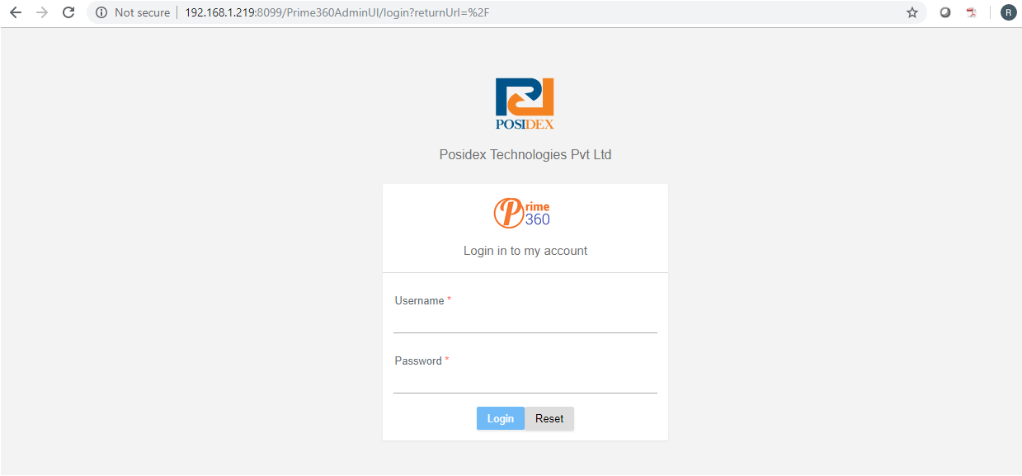
Important menus for configurations
1)Start/Stop services
2)Profiles
3)Logging
4)Message posting

10.3.1)Start/Stop services:
- by using this menu we can start and stop the activemq and prime360 engine services.
- below screen will show the start stop services screen.
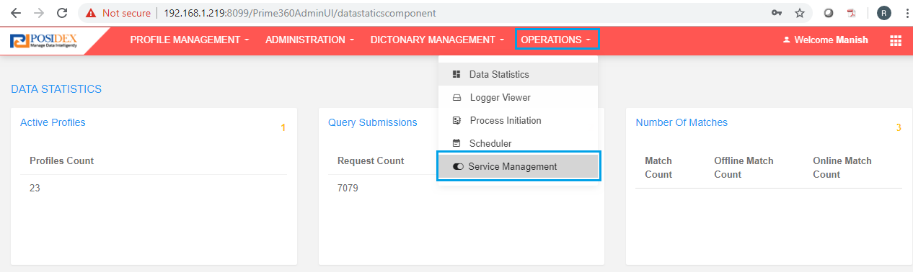
- after click on service management below screen will display

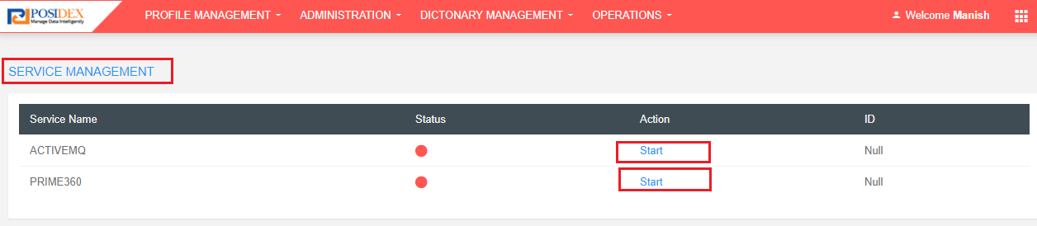
- here we have two services ActiveMq and Prime360 engine ,for starting we have to click on start button , Activemq service should start first then start the Prime360.
- after click on start button status will change to green color and action changed from start to stop and session id's will display.

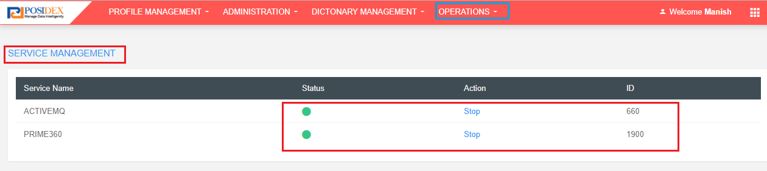

10.3.2)Profiles:
- by using this menu we can create the profile and configure the rules and scales.
- after creation of rules we have to approve the profile with another user.
- below screen display's the profiles menu.
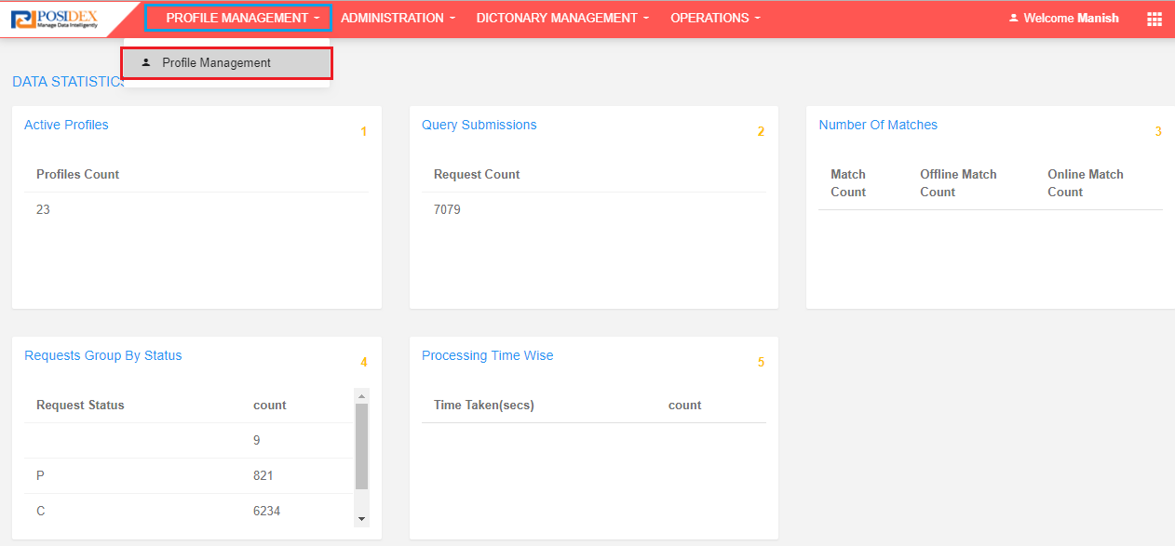
- after click on menu below screen will display.
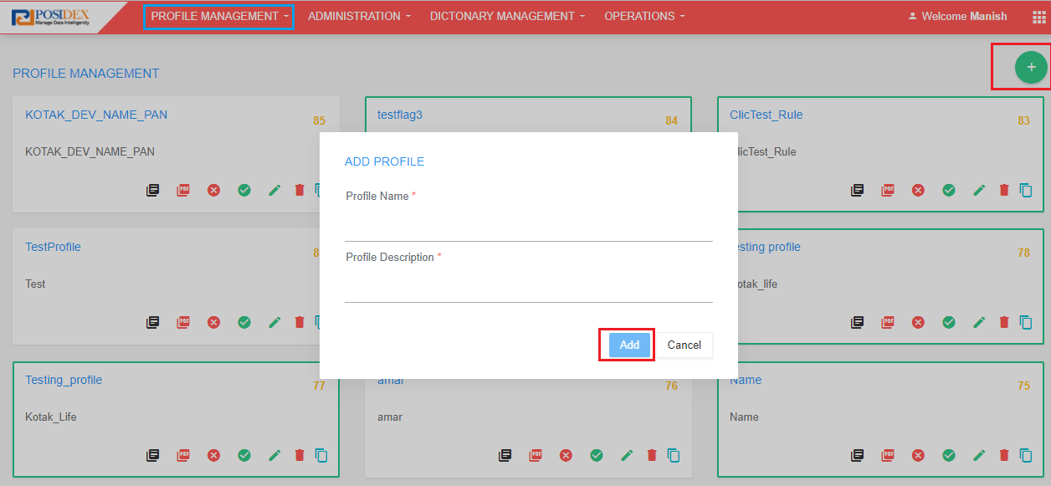
- here for new profile we have to click om plus(+) icon then add profile popup will come then fill the name and description then click on add button.
- one profile will created and we need to add the rules for that profile.

10.3.3)Logging:
- in this menu prime360 engine dedupe related logs will display , if any error is came or not getting response , we can check the same from logs screen.
- below screen shows the logs.
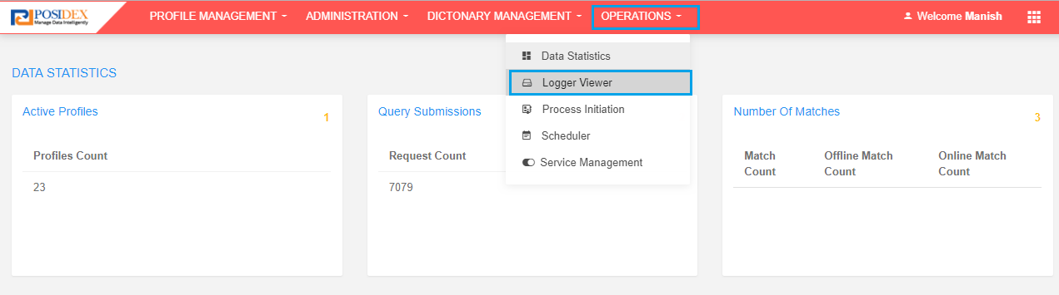
- after click on Logger service menu below screen will daisplay
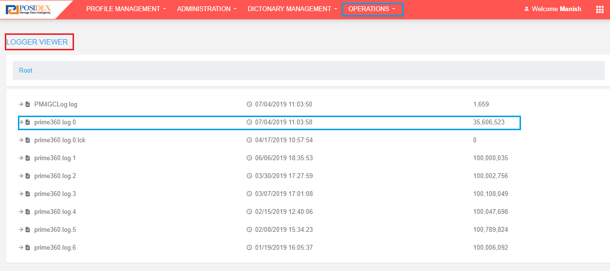
- here the page will load with all log files we have to select the log file then the text will display ,
- below screen displays the log text.
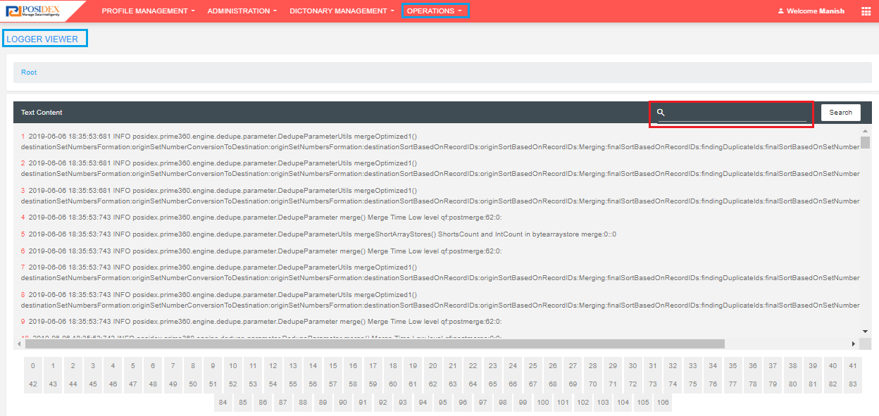
- we have a search box for searching particular text.

10.3.4)Message Posting:
- this service is useful for doing initial data process

10.3.4.1)Initial Process:
- client will provide the updated data in VW_DEDUPE_CLIENT view.
- by using below query insert the base data into posidex table (psx_nsp_blk_trg)
- after successful insertion update the total data with single psx_batch_id.
update psx_nsp_blk_trg set psx_batch_id='';
- now we need to post the message to prime360engine from adminUI.
- look into below screenshots for posting initial process message.
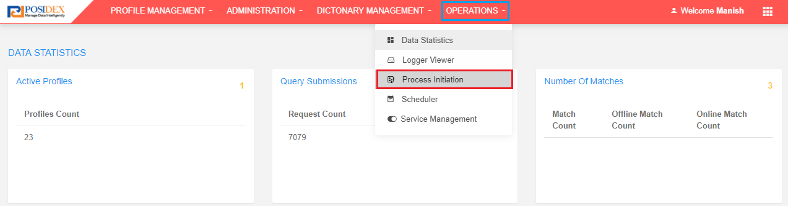

- after click on Process Initiation button below screen will display.
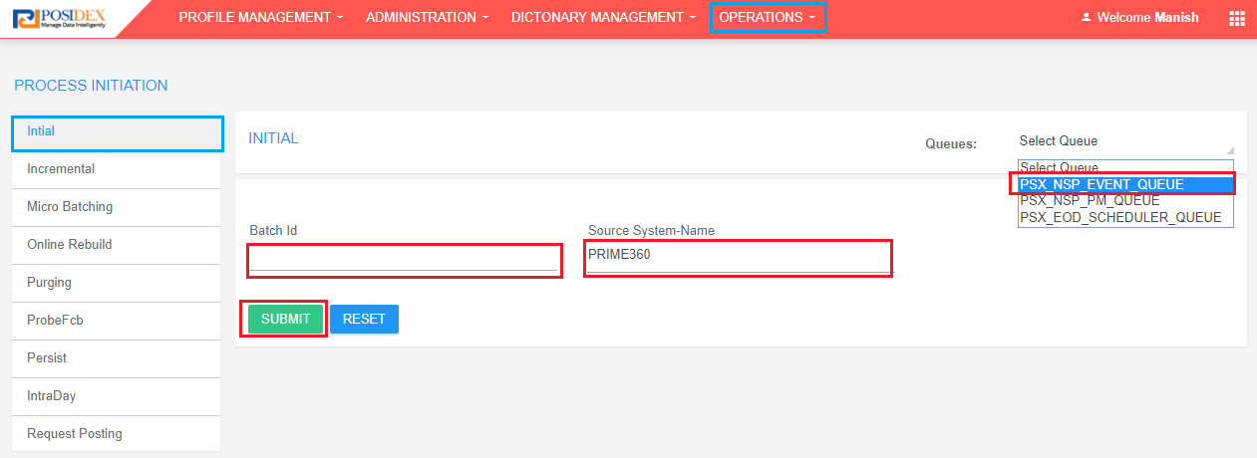
- here fill the batch_id which is updated in the psx_nsp_blk_trg table and select source system name as Prime360 and select queue name psx_nsp_event_queue then click on submit button.
- initial objects creation message will sent to activemq queue and prime360 service consumes that queue and start the objects creation process.

10.3.4.2)Prob FCB:
- in this menu we can extract the particular client record object information from initial object cache bean.
- by posting the message to prime360 engine we can create prob fcb file.
- below screen tells how to post the prob fcb message.
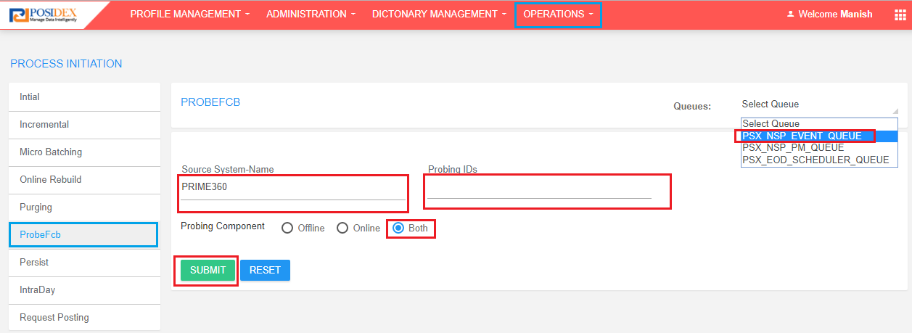
- from left side menu we have to select the ProbFcb option and select the source system name , probing id's(psx id from our psx_nsp_blk_trg table),psx_nsp_event_queue queue and select the probing component as both (here offline and online components will generate) then click on submit button.
- two files will generate(offline and online) and placed in installation path.

Note: for more information on AdminUi configuration refer prime360Admin Ui document which is shared including this doc.

11)Maker/Checker UI service:

11.1) Installation Directory:
D:\KotakLife_Dec142018\apache-tomcat-9.0.19_crms

11.2) How to Stop Tomcat Server:
Logon to Dedupe Application Server
Go to “D:\KotakLife_Dec142018\apache-tomcat-9.0.19_crms/bin” and
Run the following command to start tomcat server. shutdown.bat

11.3) How to Start Tomcat Server:
Logon to Dedupe Application Server
Go to “D:\KotakLife_Dec142018\apache-tomcat-9.0.19_crms/bin” and
Run the following command to start tomcat server. startup.bat

11.4) Log file location:
D:\KotakLife_Dec142018\logs\crms

11.5) Browser Compatibility:
Internet Explorer V9+

There are two primary users to perform maker checker operation for KLI.
1)Maker User
2)Checker User

11.6) Maker:
In generally users are landing to maker screen through IONE interface, even we can open maker screen by entering below URL by supported IE9 browser.
http://IP:port/crms/?PID=<proposal>&USERID=<UserName>&Role=M
If all the given information is valid than below screen will open as landing screen for Maker.
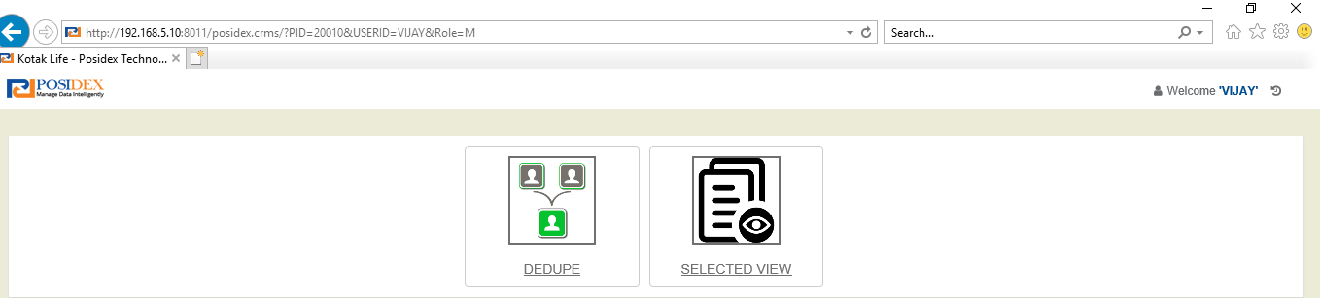
Screen-1:

11.6.1) Maker URL Validation:
From above URL we supposed to enter PID, USERID and Role
Here PID is nothing-but Proposal Number which is in KOTAK_DEDUPE_DATA_MAPPING_V view.
USERID is given by Kotak, that we are maintaining in PSX_NSP_KOTAK_USER table. If Kotak wants to be add any new USER that need to be add in this table. While loading Maker or checker page it will look into this table whether user is existed or not.
Role is static value which can be either M or C. M for Maker C for Checker.
If anything missed in the URL or not available in database than below screen will return as default error page.

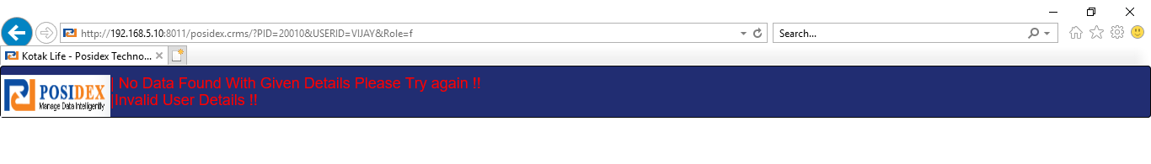
Screen-2

11.6.2) Proposal Number:
KOTAK_DEDUPE_DATA_MAPPING_V view given by kotak. In this view each proposal number associated with corresponding Life Assured Id, Proposed Id, Joint Life Assured Id while loading Maker page All these displayed in dropdown selection.

11.6.3) User Id:
PSX_NSP_KOTAK_USER Table having user data, here user may be Maker or Checker, There is no specific role for user. Any user can act like Maker or Checker.
Note: While performing Maker and Checker operation Maker cannot be checker. That means same user cannot perform maker and checker activity on same Policy number.
From screen-1, If we click on DEDUPE icon it will open maker operation screen. There we can select any one client from dropdown.
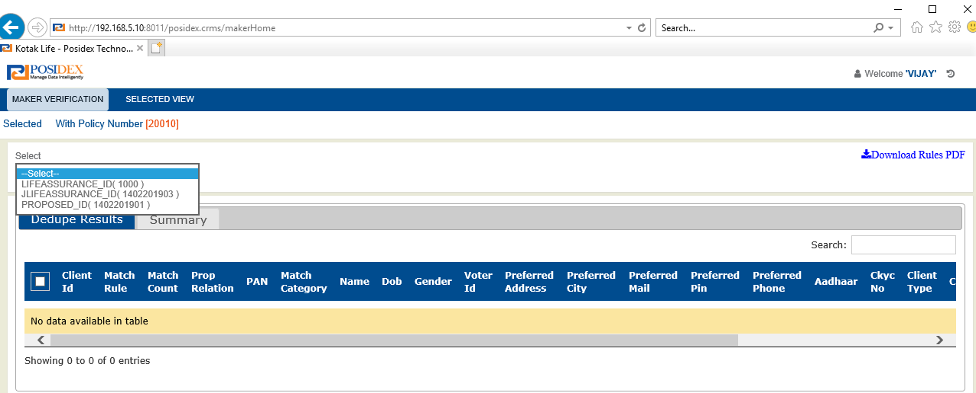

From above screen dropdown populated with three clients i.e, Proposed, Life Assured, Joint Life Assured.
These all 3 are associated with given Proposal from URL.

11.6.4) Dropdown Selection Validation:
Case 1: If Proposed and Life Assured same than Proposed Id displaying as default.
Case 2: If Joint Life Assured and Proposed ID same than Proposed Id displaying as default.

11.6.4.1) VW_DEDUPLE_CLIENT:
This view given by Kotak, here all updated customer data is available in this view. And each client associated with any one of this clients (Proposed id, life Assured, Joint Life Assured) from dropdown.
When we select any client from dropdown, for that associated customer data is rendered in the current screen to perform dedupe.

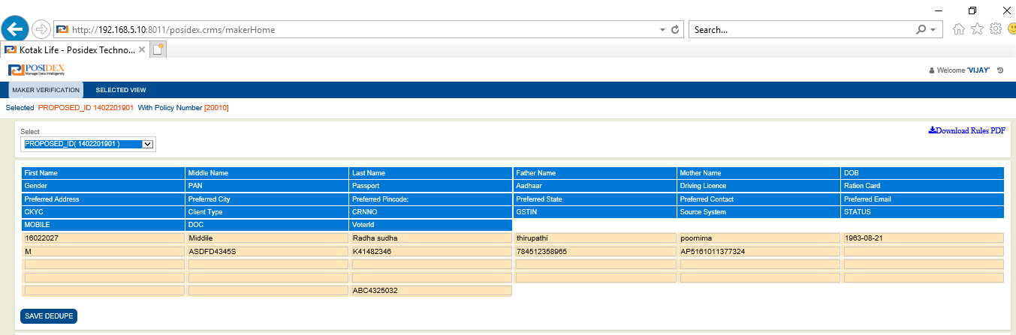

11.6.4.2) Dedupe Client Validation:
Case 1: For fresh dedupe data will be rendered based on client selection from dropdown.
Case 2: If already Dedupe performed than new button <<GetData>> available to load with same selection.
Case 3: In dedupe screen we are displaying only preferred address information instead of showing Permanent, Office address separately.
This will be based on Addresstype column from VW_DEDUPE_CLIENT view, if Address Type flag is “B” than Office address information showing as preferred address in UI.
If flag is “P” Permanent address information showing as preferred address information.
ADDRESSTYPE | PREFERRED ADDRESS
P | PERMANENT ADDRES
B | OFFICE ADDRES

11.6.4.3) Validation Message After Client Selection:
If Only dedupe performed but no action taken, then message will displaying as Dedupe already performed!!
If Maker action completed, then flash message will be displaying as Action Pending at Checker!!
If Checker action also completed, then flash message will be displaying as Action completed at checker!!
Action | Message
Only Dedupe performed not taken any action | Dedupe Already completed !!
Merge Operation completed from maker | Checker approve status is under process, Please kindly go for next action.
Checker operation completed | Case has already been approved by checker.
No data available with selected client. | No data available with this selection

After successful landing the screen we can perform save and dedupe.

11.6.5) Save And Dedupe:
When user click on save and dedupe button Dedupe process will start. Request data will be inserted into PSX_NSP_REQUEST table with generated unique PSX_ID, and inserting SOURCE column as “GUI” with status column “P”.
After that request posted to ActiveMQ PSX_NSP_PM_QUEUE, from there engine will start matching process.
Engine will return the response and result will be updated in the PSX_NSP_REQUEST_RESULTS
When request posted by GUI and request status became C, then trigger will be fired on PSX_NSP_REQUEST table and PSX_NSP_REQUEST_RESULTS inserted into PSX_NSP_REQUEST_RESULTS_CRMS.
Now all the Input and target details will be available in PSX_NSP_REQUEST_RESULTS_CRMS table. For further Maker and Checker operations all the updates will be done in this table.

11.6.5.1) Save And Dedupe Validation:
Case-1: If engine process will take too long time I.e., more than 30 sec, than system throws message as “Resources are busy please try after some time!!”.
Case-2: If ActiveMQ is down, then system throws “Problem with ActiveMQ”.
Case-3: If Profile Id is not correct than system throws “No Matches found due to wrong profile id”.
Profile id configured D:\KotakLife_Dec142018\apache-tomcat-9.0.19_crms\webapps\crms\WEB-INF\classes\ WSResources.properties file with key PSX_NSP_PROFILE_ID.
Case-4: Matching process will be done based on client type P or C. This will be available in VW_DEDUPE_CLIENT view, CLIENT_TYPE column and same available in dedupe screen client type field. Based on the client type, matches will be found.
Case-5: Matching process will be done based on Merge status column N or Y in the table <<table name>>. Only merge status column as “N” records are participating in dedupe matching. When Merge status “Y”, this will not be projected as matching clients for any case.
Case-6: After posting the request, request details will be inserted in to PSX_NSP_REQUEST table with status “P”.
Once engine process completed status column updated with “C”. When it will become “C” trigger will be fired on PSX_NSP_REQUEST table with source GUI. than PSX_NSP_REQUEST_RESULTS will be inserted into PSX_NSP_REQUEST_RESULTS_CRMS table.
Case-7: From the results grid first record is INPUT record which is highlighted with orange color. and below are the matching clients.
Case-8: In result grid DOC field is populated for only corporate client.

11.6.6) Merge:
After completing of matching process, results will be rendered in result grid. From this grid, maker can perform merge operation by selecting any number of matching clients and single retain with source (Input) selection. Source is mandatory selection while doing merge. When user click on MERGE Button System will give confirmation box as Are you sure want to verify, if user want to continue than go for “ok”. If cancel page remain same.
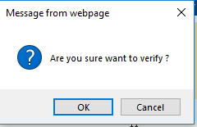

11.6.6.1) Merge Validation:
Case-1: While doing merge operation source selection is mandatory, if not alert will throw.
Case-2: One Retain selection is mandatory, if not alert will throw.
Case-3: Selected Target DOB, Pin-code, Gender for corporate client DOC should match with the INPUT.
If any one of the selected target not matched with the mentioned fields, system will throw an alert as below.
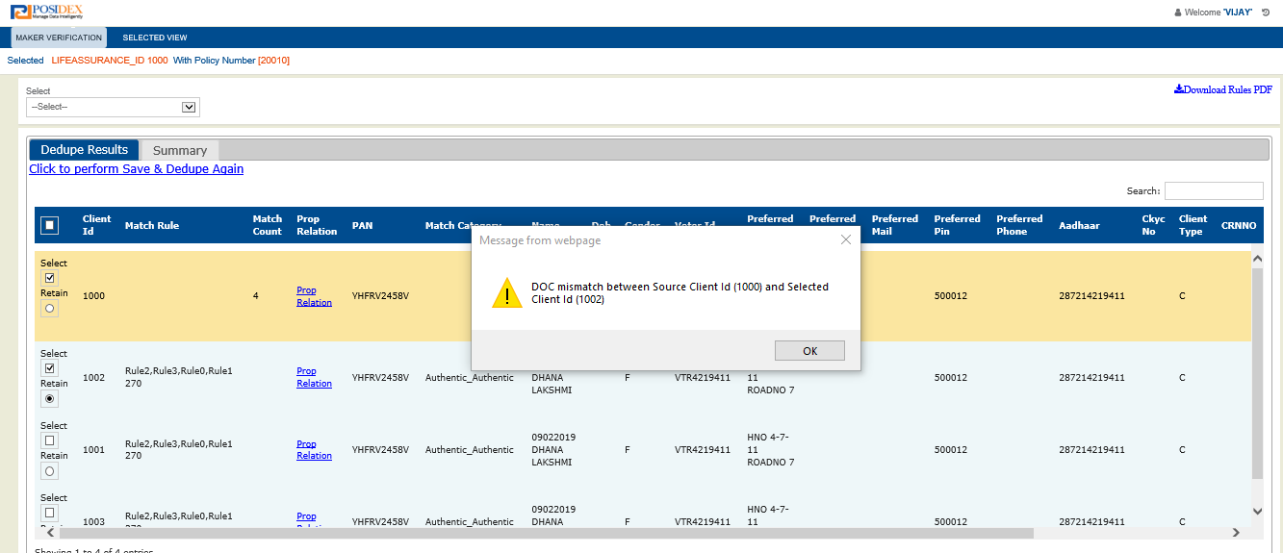
Validation alert will through accordingly for DOB, DOC, Gender, Pin-code validation. If all validation
get satisfied than system will throw below alert.
“Client merging information save successfully!”
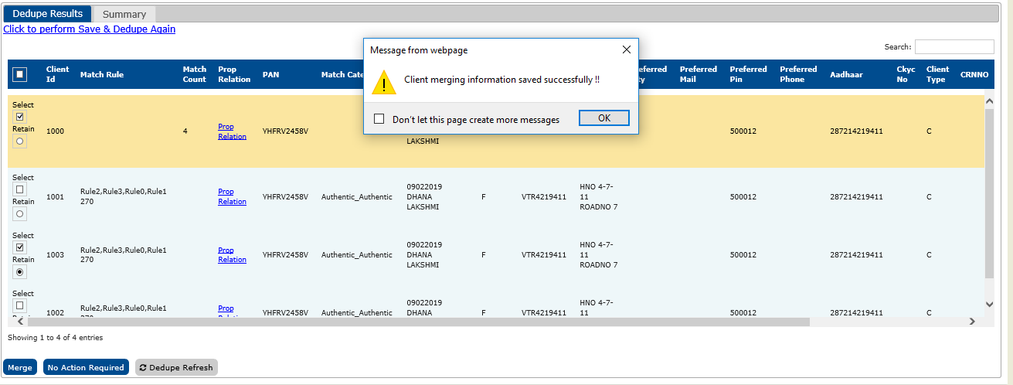

11.6.6.2) Merge Database Updates:
When user done merge operation the changes will be updated in PSX_NSP_REQUEST_RESULT_CRMS table accordingly.
VERIFIED
SELECTED
RETAIN
COMMENTS
MAKER_VERI_TS
ACTIVITY_COMPLETED
MAKER_DECISION
Below are the columns update with corresponding values.
Action | VERIFIED | SELECTED | RETAIN | COMMENTS | MAKER_VERI_TS | MAKER_DECISION | ACTIVITY_COMPLETED
Source(Checkbox) selection | Y | Y | null | Merged | SYSTIMESTAMP | Merged | Maker
Target (checkbox)selection | Y | Y | null | Merged | SYSTIMESTAMP | Merged | Maker
Retain(Radio button) | Y | Y | T | Merged | SYSTIMESTAMP | Merged | Maker

11.6.6.3) Merge Summary:
Summary will display last update action information against user selection.
After completing the merge operation user will get success alert. Immediate after that summary tab will open with merge information.
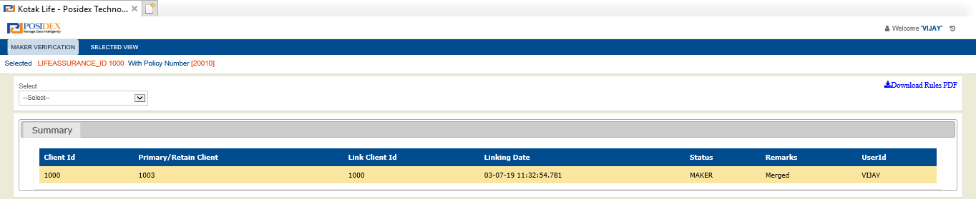
From the above table, Comments showing as Remarks ,Activity completed showing as Status,Source client as Client ID,Retain -“T” Crms_client_id as Primary/Retain client, Selected -“Y” crms_client_id as Merge_client_id.

11.6.6.4) Kindly Perform Action For Pending Clients:
After opening the Summary user will get alert for Kindly perform action for pending clients.
If Policy number having 3 clients (Life Assured, Joint Life Assured, Proposal) and we done merge only for one client than system will throw alert as Kindly perform verification for(Life Assured ID, Joint Life Assured ID).remaining two client ids.
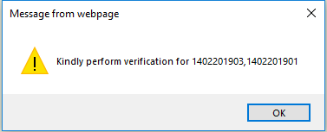

11.6.7) No Action Required:
User can take no action required decision on dedupe results. When user don't want to merge any client user will go for no action required action.

11.6.7.1) No Action Required Validation:
Case-1: User can perform no action required with selection or without selection also. Only Input record will update.

11.6.7.2) No Action Required Database Updates:
Below are the columns will update in PSX_NSP_REQUEST_RESULTS_CRMS table.
Action | VERIFIED | SELECTED | COMMENTS | MAKER_VERI_TS | ACTIVITY_COMPLETED
Source(Checkbox) selection | Y | Y | No action required | SYSTIMESTAMP | Maker

11.6.7.3) Kindly Perform Action for Pending Clients:
Same as merge operation.

11.6.7.4) No Action Required Summary:
No action required summary will open immediate after completing the merge operation.
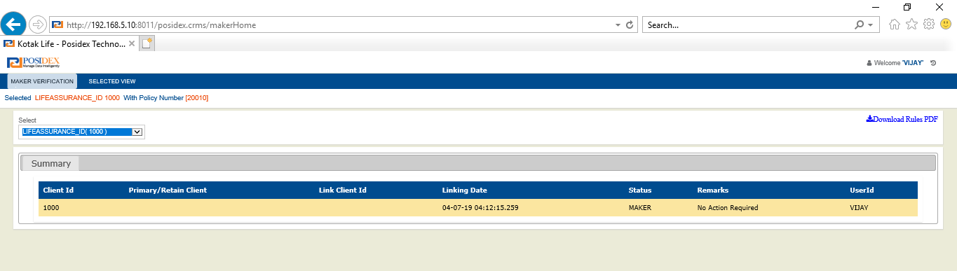

11.6.8) Dedupe Refresh:
When user clicks on Dedupe Refresh button all the selection gets cleared. It is nothing but resetting the form.

11.6.9) Selected View:
From maker screen we have two main menu tabs in that one is Selected view.
When user clicks on selected view it will load with same dropdown values as maker screen. When user submit the selection, selected result will be rendered in below data table.
In Selected view, only selected client information available to against the selected client.
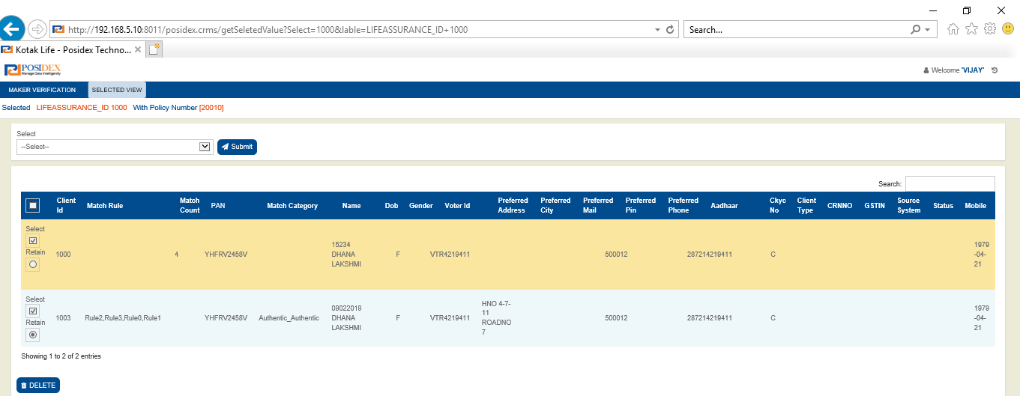
From selected view user can perform only delete operation.

11.6.9.1) Delete:
After submitting the dropdown, result will be rendered in result grid. There user can take decision for delete. If user submit delete button than all the selection of that client gets deleted.

11.6.9.2) Delete Action Database Updates:
Below are the columns will update in PSX_NSP_REQUEST_RESULTS_CRMS table.
Action | VERIFIED | SELECTED | RETAIN | COMMENTS | MAKER_VERI_TS | MAKER_DECISION | ACTIVITY_COMPLETED
Delete button | N | N | null | Deleted | null | null | Maker

The deleted records are available in maker screen. From maker screen if user select any client first that client will be verified in PSX_NSP_REQUEST_RESULT_CRMS whether Verified value is N or not if it is “N” GetData button will display in maker.

11.7) CHECKER:
Checker is another user ,Checker will perform action on top of the maker decision that can be Approve or Reject.
There are two activities that can be performed by checker.
- Approve
- Reject
In generally users are landing to Checker screen through IONE interface, Even we can open checker screen by entering below URL by supported IE9 browser.
http://IP:port/crms/?PID=<proposal>&USERID=<UserName>&Role=M
If all the given information is valid than below screen will open as landing screen for checker.
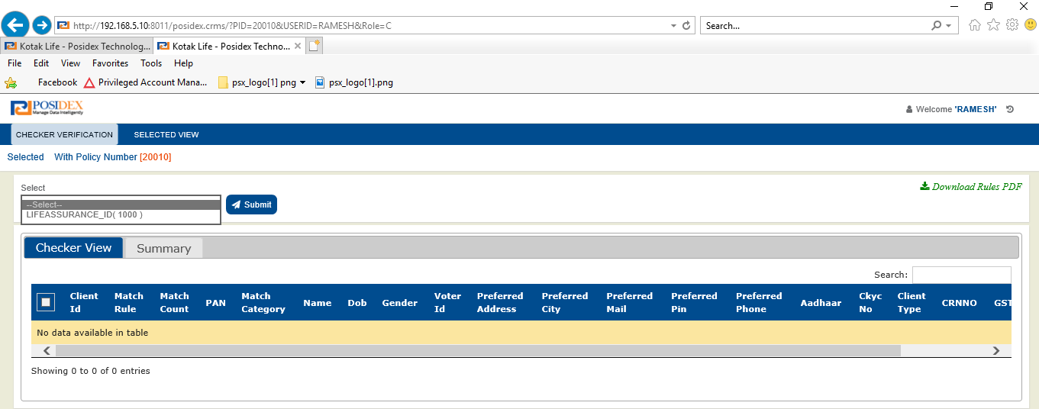

11.7.1) Checker URL validation:
URL validation as similar as Maker URL validation, USERID, PID should be existed in corresponding views. Role should be “C”.
If anything went wrong, default error page will return as shown below.

After landing into Checker screen, user should select any one client and submit the dropdown.
If any maker verified cases are matched with selected client in PSX_NSP_REQUEST_RESULTS_CRMS table that all maker verified records will be displayed in result grid to perform checker operation.
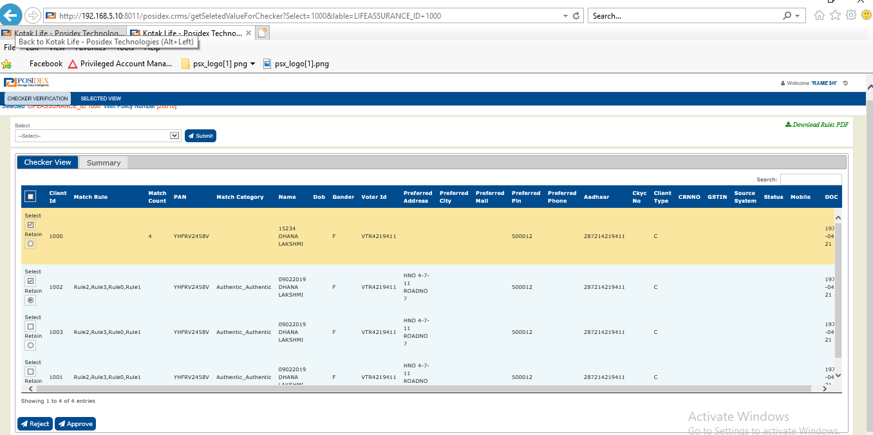

11.7.2) Checker Dropdown Selection Validation:
Checker dropdown will display only maker verified clients. That is based on the VERIFIED column. If maker done merge on some client that client VERIFIED column will update to “Y”. Only Verified -”Y” that clients will be available in dropdown.

11.8) Approve:
After completing merge operation from maker, checker can take decision to approve it. When user clicks on approve button. It will return confirmation box as below, If user select Ok than All the merge information will forward to Life Asia Webservice. The Life Asia request is not done by single request.
If User select cancel from confirm box page remain same.
Request is separated into two parts Request header and request body. Request header is common for all requests, Request body will be different based on the merge selection.
Request will be framed in below xml format:

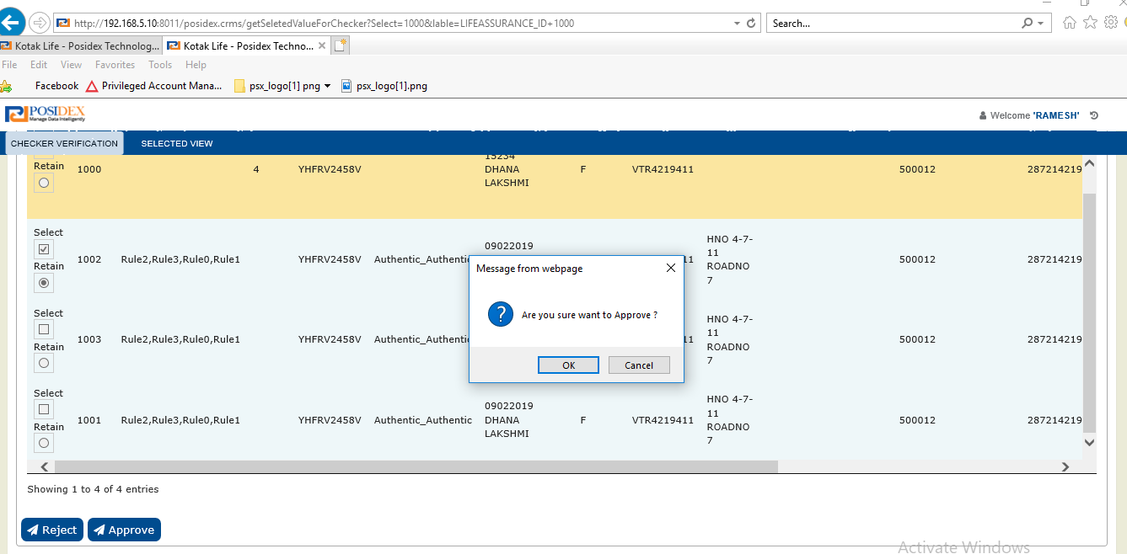
When we click on ok button from confirmation box. The Life Asia Request Information will be inserted in to KLI_ASIA_REQ_DATA_TBL table.

11.8.1) LA Request Format:
<soapenv:Envelope xmlns:soapenv="http://schemas.xmlsoap.org/soap/envelope/" xmlns:kli="http://KLI.ESB.LA.ClientMerge.Schemas.ClientMerge_ESB_Req">
<soapenv:Header/>
<soapenv:Body>
<kli:ClientMergeESBRequest>
<Header>
<Source>?</Source>
<Destination>?</Destination>
<TransactionDT>?</TransactionDT>
<TransactionType>?</TransactionType>
</Header>
<Data>
<Action>?</Action>
<PolicyNumber>?</PolicyNumber>
<MergeClientNumber>?</MergeClientNumber>
<RetainedClientNumber>?</RetainedClientNumber>
<SourceClientNumber>?</SourceClientNumber>
</Data>
</kli:ClientMergeESBRequest>
</soapenv:Body>
</soapenv:Envelope>

11.8.2)Life Asia Request Scenarios :
 | CLIENT | Radio button/Retain | Check box/Selection | Life Asia Hit
Case 1 |  |  |  | 1hit
 | SOURCE | RETAIN | MERGED | <source>Source Client ID</Source>  <retain>Source Client ID</retain>  <Merge>Target 2 Client ID</Merge>
 | TARGET 1
 | TARGET 2 |  | MERGED
Case 2 |  |  |  | 2 hits
 | SOURCE | RETAIN | MERGED | <source>Source Client ID</Source>  <retain>Source Client ID</retain>  <Merge>Target 1 Client ID</Merge>
 | TARGET 1 |  | MERGED
 | TARGET 2 |  | MERGED | <source>Source Client ID</Source>  <retain>Source Client ID</retain>  <Merge>Target 2 Client ID</Merge>
Case 3 |  |  |  | 1 hit
 | SOURCE |  |  | <source>Source Client ID</Source>  <retain> Target 1 Client ID</retain>  <Merge>Target 2 Client ID</Merge>
 | TARGET 1 | RETAIN | MERGED
 | TARGET 2 |  | MERGED
Case 4 |  |  |  | 1 hit
 | SOURCE |  |  | <source>Source Client ID</Source>  <retain> Target 1 Client ID</retain>  <Merge> Source Client ID</Merge>
 | TARGET 1 | RETAIN | MERGED
 | TARGET 2

For above all requests Request header is same.
<Header>
<Source>IONE</Source>
<Destination>LA</Destination>
<TransactionDT>SYS TIMESTAMP</TransactionDT>
<TransactionType>LAClientMerge</TransactionType>
</Header>

When request submitted to Life Asia, Request will be validated and return response with merge status.
When Life Asia return success flag than that client record VERFIFIED column updated with “C” in PSX_NSP_REQUEST_RESULTS_CRMS table.
After successful merge, if user will try same case from Checker than user will get message as Case already been approved. If user will try same case from Maker screen ,user will get RETRIGGER button.

11.8.3) Life Asia Validation:
Case-1: When user click on Approve button request will hit to Life Asia, If Life Asia taking too long time than system will throw alert message as “Life Asia timed out”.
Case-2: If is there any Network error Or URL issue than system will give alert as “LA web service host not reachable”.
Case-3: Life Asia Response Other than success, LA returns error codes for failure cases that will be generated by Life Asia. That we can found in Our KLI_ASIA_REQ_DATA_TBL table.
Case-4: For each LA request, response will be inserted into KLI_ASIA_REQ_DATA_TBL table.

11.8.4) Database update:
Action | VERIFIED | SELECTED | RETAIN | COMMENTS | CHECKER_VERI_TS | CHECKER_DECISION | ACTIVITY_COMPLETED
For Approve | C | Y | null | Approved | SYSTIMESTAMP | Merged | Checker

11.8.4) Approve Summary:
After approving, based on LA response summary will be populated. Summary will open with corresponding request and LA response status.
Summary before approve:
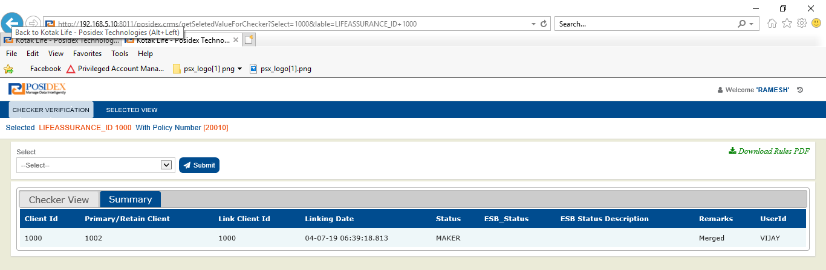

After submitting request, Summary will be updated as below.
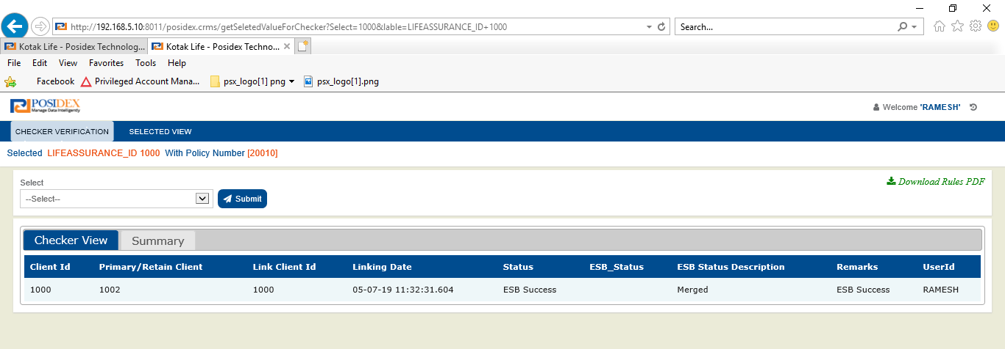
If LA merge success than status will be ESB Success. Along with merge details all required information will updated as mentioned above.

11.9) Reject:
Reject is another activity for Checker, when user select client and submit, corresponding merge details will be rendered in result grid.
For that selected client, checker can take decision for reject also. When user clicks on reject button system will throw confirm box As “Are you sure want to reject!” the case.
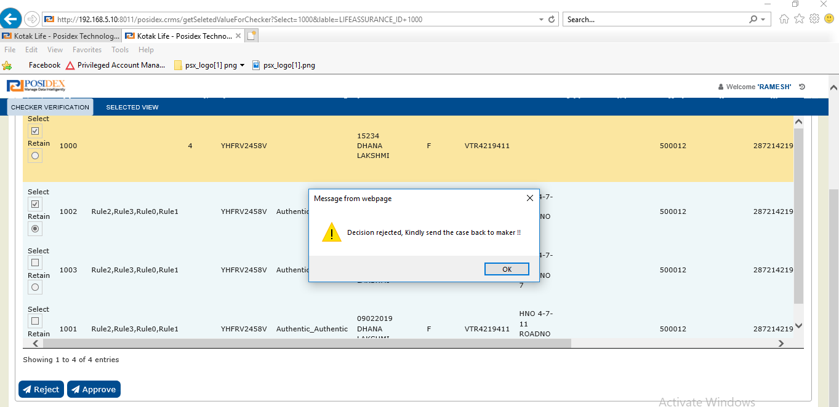
If user selected Ok than case will rejected and return alert as “Decision rejected Kindly send the case back to maker” .

11.9.1) Database updates:
When user perform Reject operation PSX_NSP_REQUEST_RESULTS_CRMS table will update as below.
Action | VERIFIED | SELECTED | RETAIN | COMMENTS | CHECKER_VERI_TS | MAKER_DECISION | CHECKER_DECISION | ACTIVITY_COMPLETED
REJECT | N | No change | null | Rejected | SYSTIMESTAMP | No change | Reject | Checker

When user perform Reject operation, case will be moved to Maker again.
In maker, user can able to see Get Data button by the same policy and client selection with same merge client selection.
From there Maker can change the selection or maker can perform Re Dedupe operation.

11.9.2) Reject Summary:
Summary will display as per the reject decision.

11.8) Override Case:
Override button will enable in Checker screen for LA failure cases (Already merged cases).
For LA already merged case we cannot send approve action again. For that cases we need to perform override action.
When user perform Override operation than that case PSX_NSP_REQUEST_RESULTS_CRMS table updated with verified -C.

12.1) Override Database updates:
When user perform Overridden operation PSX_NSP_REQUEST_RESULTS_CRMS table will update as below.
Action | VERIFIED | SELECTED | RETAIN | COMMENTS | CHECKER_VERI_TS | MAKER_DECISION | CHECKER_DECISION | ACTIVITY_COMPLETED
REJECT | C | No change | null | Overridden | SYSTIMESTAMP | No change | Overridden | Checker

11.9) Re-Trigger:
Re-Trigger button will enable in maker screen that to only for approved (Verified -C) cases.
When User submit selection from maker screen case will be validate at backend and display the Re-Trigger button.
When user submit Re-trigger on selected client, internally SP_RETRIGGER_FROM_UW procedure will be executed, and the client will be removed from PSX_NSP_REQUEST_RESULT_CRMS table.

