VISVESVARAYA TECHNOLOGICAL UNIVERSITY
“JNANA SANGAMA”, BELAGAVI-590018

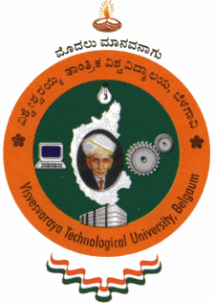

2025 - 26

Report on: pedagogy
“Digital Design and Computer Organization”
Submitted in partial fulfilment of the requirements for the Third Semester degree of Bachelor of Engineering in Information Science Engineering of Visvesvaraya Technological University, Belagavi

BACHELOR OF ENGINEERING
IN
INFORMATION SCIENCE AND ENGINEERING

Submitted by
USN Name 1
USN Name 2
USN Name 3
USN Name 4

Under the guidance of
Prof. Harshitha M
Assistant Professor


DEPARTMENT OF INFORMATION SCIENCE AND ENGINEERING
VIDYA VIKAS INSTITUTE OF ENGINEERING AND TECHNOLOGY
MYSURU – 570028

