Pedagogy REPORT
Title of the Experiment
Design Verilog program to implement types of De-Multiplexer 4:1 and 8:1
Course
Digital Design and Computer Organization Pedagogy Activity
Objective
To design, implement, and simulate 4:1 and 8:1 Demultiplexer circuits using Verilog HDL, and to verify their functionality through simulation and waveform analysis.

Tools and Software Used
- Verilog HDL for hardware description
- Icarus Verilog for compilation and simulation
- GTKWave for waveform visualization and signal analysis
GTKWave is used to observe the timing behavior of input and output signals and to validate the correctness of the demultiplexer operation.

Prepared a detailed report on the executed program, including:
- Source code
- Explanation of the logic
- Output obtained
- Observations or conclusions

1. 4:1 Demultiplexer
Aim
To design and simulate a 4:1 Demultiplexer using Verilog HDL and verify its functionality using a testbench.

Introduction
A demultiplexer (DEMUX) is a combinational logic circuit that takes one input signal and routes it to one of several output lines based on the values of select inputs.
In a 4:1 demultiplexer, one input is routed to one of four outputs using two select lines.

Source Code:
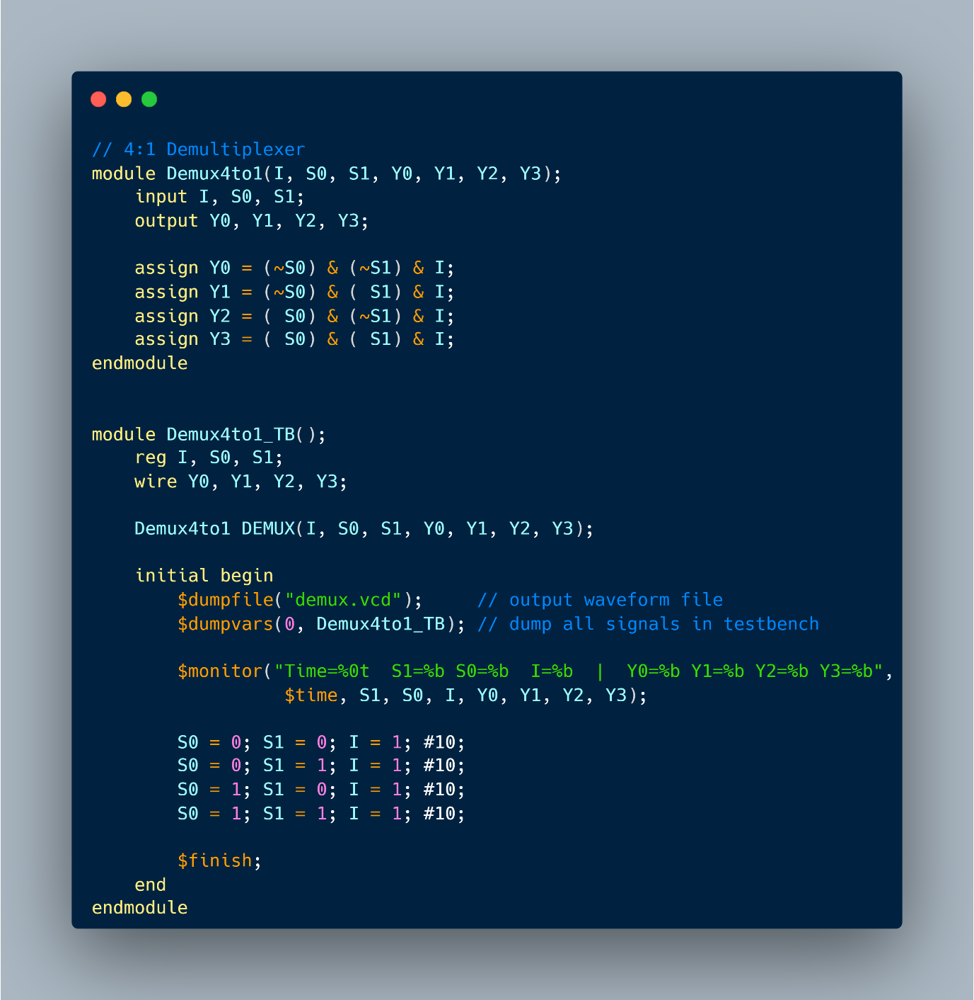
Logic Explanation
Inputs
- I – Data input
- S0, S1 – Select lines
Outputs
- Y0, Y1, Y2, Y3
Each output corresponds to one unique combination of select lines.

Truth Table Logic
S1 | S0 | Active Output
0 | 0 | Y0 = I
0 | 1 | Y1 = I
1 | 0 | Y2 = I
1 | 1 | Y3 = I
Only one output is active at a time, while others remain 0.

Boolean Logic Used
Each output is enabled only when its select condition is satisfied.
Y0 = (~S0) & (~S1) & I;
Y1 = (~S0) & ( S1) & I;
Y2 = ( S0) & (~S1) & I;
Y3 = ( S0) & ( S1) & I;
- ~S0 or ~S1 ensures the select line is LOW
- & I ensures output depends on the input
- Logical AND ensures exclusive activation
This implementation is purely combinational and does not require clocks or memory elements.

Testbench Explanation
The testbench:
- Generates all possible combinations of select lines
- Keeps input I = 1
- Observes which output becomes HIGH
The $monitor statement prints signal values for each time step, allowing verification of correct routing.

Output:
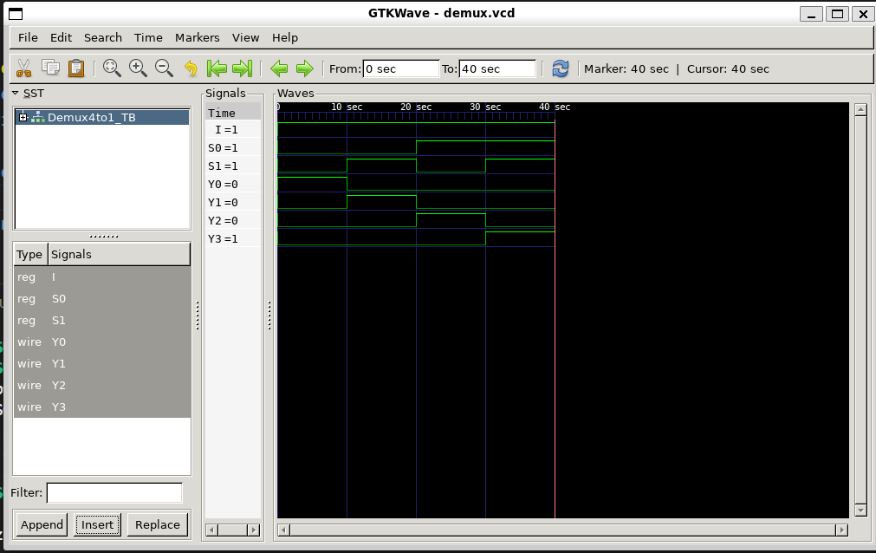

Observations / Conclusions (4:1 DEMUX)
- For each select combination, only one output is HIGH
- All other outputs remain LOW
- The demultiplexer correctly routes the input to the selected output
- The design is free from race conditions and glitches
- Simulation results match the theoretical truth table

2. 8:1 Demultiplexer
Aim
To design and simulate an 8:1 Demultiplexer using Verilog HDL and verify its operation through simulation.

Introduction
An 8:1 demultiplexer routes a single input signal to one of eight outputs using three select lines.
It is an extension of the 4:1 demultiplexer and demonstrates scalable digital logic design.

Source Code:
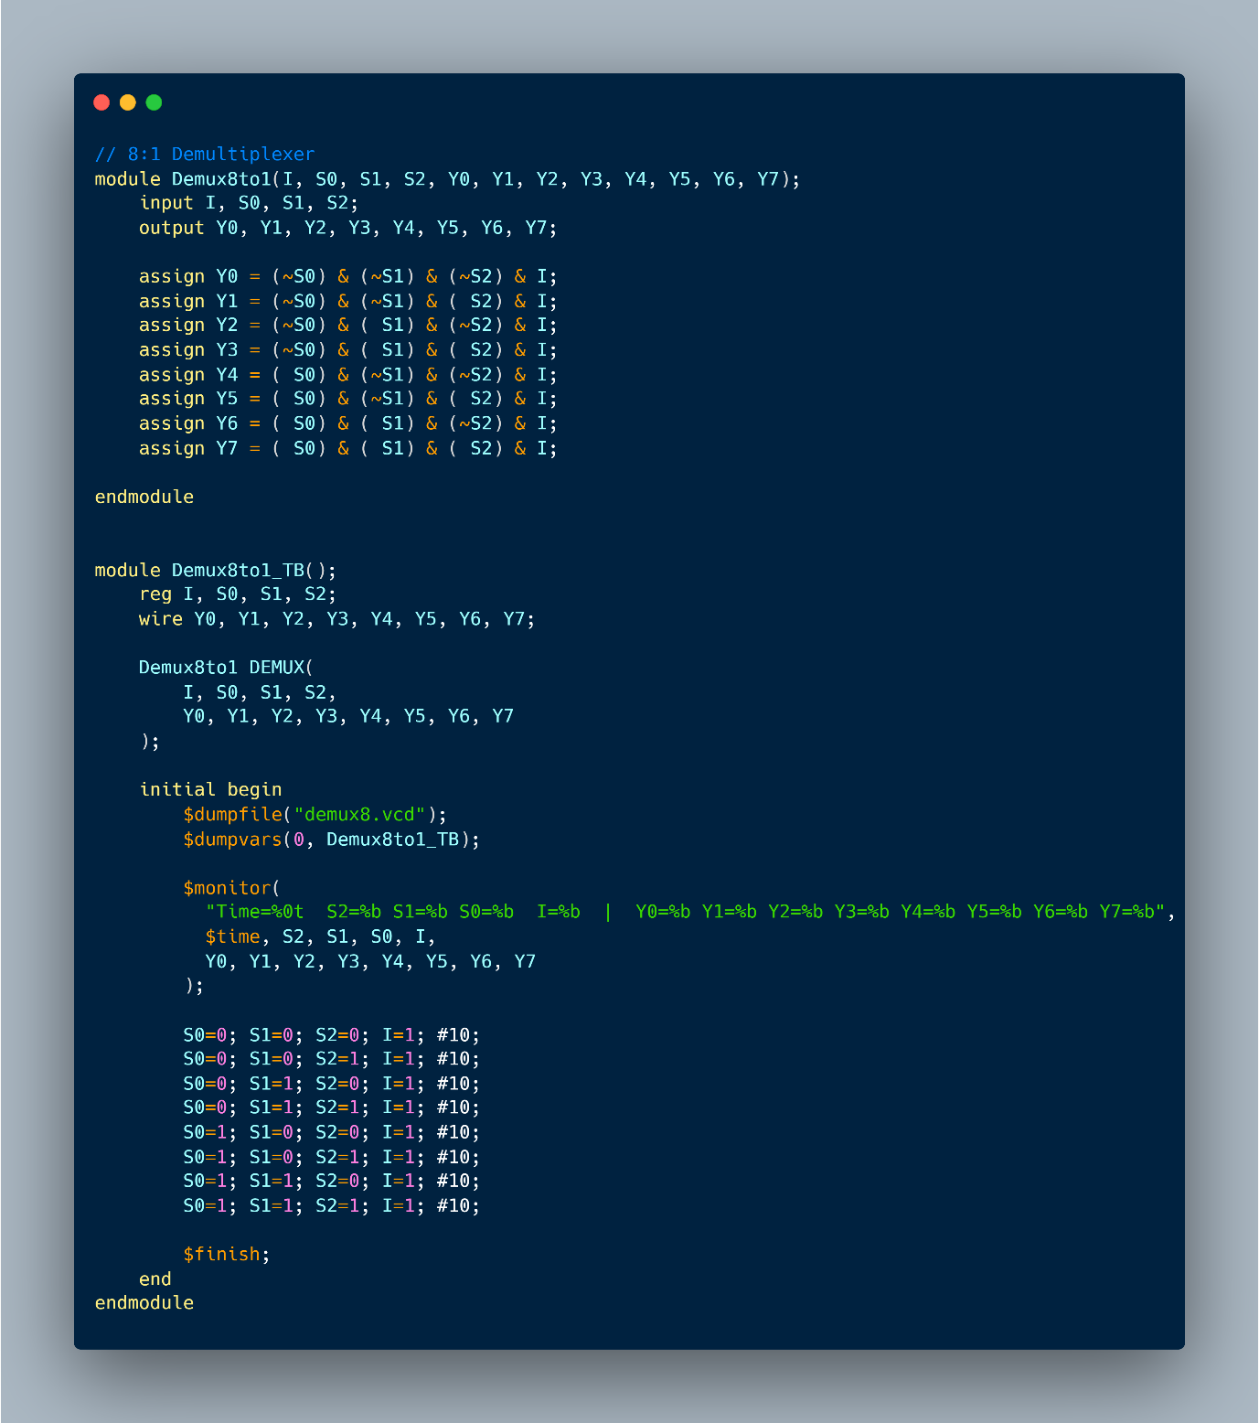

Logic Explanation
Inputs
- I – Data input
- S0, S1, S2 – Select lines
Outputs
- Y0 to Y7
Each output corresponds to one unique 3-bit select combination.

Truth Table Logic
S2 | S1 | S0 | Active Output
0 | 0 | 0 | Y0
0 | 0 | 1 | Y1
0 | 1 | 0 | Y2
0 | 1 | 1 | Y3
1 | 0 | 0 | Y4
1 | 0 | 1 | Y5
1 | 1 | 0 | Y6
1 | 1 | 1 | Y7

Boolean Logic Used
Each output is activated by a unique AND combination of select lines and the input.
Y0 = (~S0) & (~S1) & (~S2) & I;
Y1 = (~S0) & (~S1) & ( S2) & I;
Y2 = (~S0) & ( S1) & (~S2) & I;
Y3 = (~S0) & ( S1) & ( S2) & I;
Y4 = ( S0) & (~S1) & (~S2) & I;
Y5 = ( S0) & (~S1) & ( S2) & I;
Y6 = ( S0) & ( S1) & (~S2) & I;
Y7 = ( S0) & ( S1) & ( S2) & I;
Each output:
- Is mutually exclusive
- Depends strictly on select lines
- Acts as a decoded AND gate

Testbench Explanation
The testbench:
- Cycles through all 8 combinations of select inputs
- Keeps I = 1 to observe output behavior
- Verifies one-hot output behavior

Output:
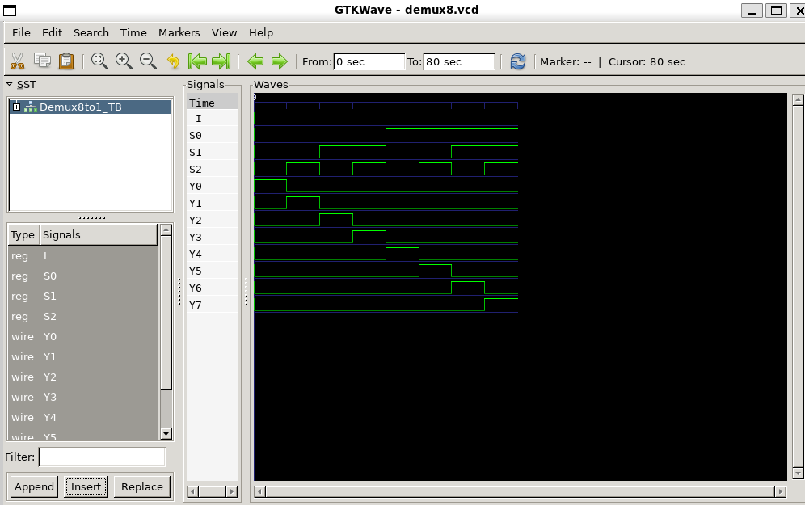

Observations / Conclusions (8:1 DEMUX)
- Exactly one output is HIGH for each select combination
- No overlap or multiple outputs active
- Output transitions are clean and deterministic
- Logic scales correctly from 4:1 to 8:1
- Simulation confirms theoretical expectations

