TicTacToe Game
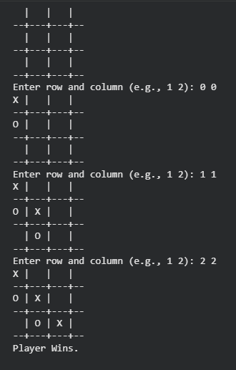

Vacuum Cleaner
