Project 2: 5-Stage Pipeline + Hazards (stall/flush/forward)

Pre- Flight Knowledge
Abstract
Starting from the working Project 1 single-cycle CPU and assembler, the CPU is upgraded to a classic 5-stage pipeline (IF/ID/EX/MEM/WB) while preserving identical ISA behavior and architectural results. Correct hazard handling is implemented: (1) EX/MEM and MEM/WB forwarding to the EX stage, (2) a one-cycle load-use stall with bubble insertion, and (3) control-hazard flushing when a taken BEQ/JAL is resolved in EX. Correctness is demonstrated using hazard-focused programs that write a PASS signature to memory and with waveforms annotated to show stalls, forwards, and flushes.
Project Aim
Build a pipelined CPU that runs the exact same 32-bit Toy ISA as Project 1 and produces the same final register and memory state for the same program. The ISA and assembler do not change; only the microarchitecture changes (pipeline + hazards).
Architectural vs Microarchitectural State
Architectural state refers to the visible state of the processor defined by the ISA. This includes the register file contents, memory contents, and program counter values that determine the program’s externally observable behavior. If two implementations produce the same architectural state for the same program, they are architecturally equivalent.
Microarchitectural state refers to internal implementation details used to achieve performance. Examples include pipeline registers, forwarding paths, stall signals, and flush logic. These structures are not visible to software but influence how instructions flow through the processor.
Pipeline hazards are therefore a microarchitectural problem, because they arise from overlapping instruction execution. However, correctness is judged architecturally, meaning that despite stalls, forwarding, or flushing, the final register and memory state must match the ISA specification.
Design and Architecture
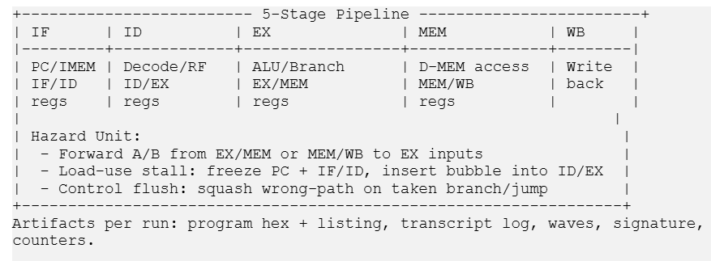

An instruction is fetched in IF by reading ROM at the current PC, while PC normally advances by +4. The fetched instruction and PC+4 are latched into the IF/ID pipeline register. In ID, the instruction is decoded (using the same control_decode from Project 1) and the register file is read, producing rs1_val and rs2_val; these values and control bits are latched into ID/EX. In EX, the ALU runs using either rs2_val or an immediate depending on alu_src_imm, and BEQ/JAL decisions are resolved; EX also selects forwarded operands if needed. Results plus store data and control bits are latched into EX/MEM. In MEM, the data memory is accessed for loads/stores (same dmem behavior as Project 1), and results are latched into MEM/WB. In WB, the final writeback value (ALU result, load data, or PC+4 for JAL) is written to the regfile if reg_we is asserted. Pipeline registers carry data (operand values, ALU results, memory data), destination register (rd), and control bits (reg_we/mem_rd/mem_we/wb selects/branch/jump).

End-to-end success procedure
- Keep the exact same Toy ISA spec and assembler from Project 1 (32-bit, PC+4, same opcodes and field mapping).
- Refactor cpu_top into a 5-stage pipeline using IF/ID, ID/EX, EX/MEM, MEM/WB pipeline registers.
- Implement forwarding into EX inputs from EX/MEM and MEM/WB.
- Implement load-use stall: freeze PC and IF/ID for one cycle, and inject a bubble into ID/EX (control bits forced to 0).
- Implement control flush: if BEQ/JAL is taken in EX, redirect PC and squash wrong-path instructions so they do not commit.
- Run hazard programs end-to-end (assemble → simulate → HALT) and check a PASS signature written to memory address 0x00F0.
- Save artifacts per run: command.txt, transcript.log, waves.vcd, signature.txt, program.hex.
A signature provides an objective, repeatable correctness check across many runs. Waveforms can look plausible while still hiding subtle state corruption (wrong forwarding priority, wrong stall boundary, wrong flush timing). A signature forces the CPU to produce the correct architectural end-state deterministically.
Instruction Flow Through Pipeline
An instruction progresses through five stages of the pipeline.
Cycle 1 – IF stage:
The program counter provides the instruction address to the instruction memory. The fetched instruction and PC are stored in the IF/ID pipeline register.
Cycle 2 – ID stage:
The instruction is decoded, source registers are read from the register file, and immediate values are generated. Control signals are also produced during this stage and stored in the ID/EX pipeline register.
Cycle 3 – EX stage:
The ALU performs arithmetic operations or calculates branch targets and memory addresses. Forwarding may override operand values to resolve RAW dependencies.
Cycle 4 – MEM stage:
If the instruction is a load or store, the data memory is accessed. Otherwise the ALU result simply passes through this stage.
Cycle 5 – WB stage:
The result (either ALU result or memory read value) is written back to the register file.
After the pipeline is filled, one instruction completes every cycle.

Module 0 — Pipeline plan + interface spec
Project 2 workspace copied from Project 1, repeatable build/run entrypoint for pipelined top, and a one-page pipeline spec + hazard checklist.
Pipelining changes the microarchitecture while keeping ISA behavior fixed. If the baseline already has an ISA/decode/memory bug, the pipeline debug becomes ambiguous because failures may come from old issues rather than hazards. A known-good Project 1 baseline ensures any new failures are pipeline/hazard related and makes debug deterministic.
Pipeline spec
EX must receive stable operands and all decisions needed for execution: rs1_val, rs2_val, imm_ext, off_ext_bytes, rs1/rs2/rd, and all relevant control bits (reg_we, mem_rd, mem_we, wb selects, branch/jump, alu_op, alu_src_imm). This ensures EX is completely driven by the ID/EX register and prevents timing issues from reusing regfile read outputs from the wrong cycle.
Hazard checklist
- ALU→ALU RAW: solved by forwarding
- ALU→store RAW: solved by forwarding store_data (forward into store write data path)
- Load-use: requires stall + bubble
- Load→store: usually needs stall (or careful forwarding if store-data comes from WB later)
- Branch uses reg (BEQ compares): solved by forwarding into EX comparator (same as ALU operands)
- Taken branch/jump: solved by flush (squash wrong-path instructions)

RTL interface verification step:
Before writing the pipelined top module, the exact port interfaces of Project 1 building blocks (pc, rom, regfile, alu, control_decode, dmem) were verified directly from the RTL headers. This prevents common integration errors (wrong reset polarity, wrong PC update interface, wrong regfile write port naming) and ensures Project 2 reuses Project 1 modules without functional changes.
Module 1 — Pipeline Register Scaffold
Objective
The goal of this step is to refactor the single-cycle CPU top module into a pipelined structure while preserving the same functional behavior. Instead of executing all operations in one cycle, the CPU is divided into five pipeline stages: IF, ID, EX, MEM, and WB. Each stage communicates with the next stage through pipeline registers that store both instruction data and control signals.
Pipeline register structures
Four pipeline registers are defined:
Register | Purpose
IF/ID | Transfers fetched instruction and PC from instruction fetch to decode
ID/EX | Transfers decoded operands and control signals to execution
EX/MEM | Transfers ALU results and memory control signals
MEM/WB | Transfers memory data or ALU results to writeback
Each register contains both data fields and control fields so that instructions carry their associated control signals through the pipeline.
PC Enable Mechanism
In the pipelined processor, the program counter must support an enable input so that instruction fetch can be paused during stalls. When a load-use hazard occurs, the PC enable signal is deasserted so the PC holds its value for one cycle. This prevents the pipeline from fetching a new instruction while the hazard is being resolved.
In the single-cycle CPU from Project 1 the PC advanced every cycle automatically, but in the pipelined design it must be conditionally updated.
Pipeline Register Behavior During Stalls
When a stall occurs due to a load-use hazard, the following actions occur:
• PC is frozen (pc_en = 0)
• IF/ID pipeline register is held constant
• ID/EX pipeline register is converted into a bubble
A bubble is created by forcing the control signals in ID/EX to zero so that the instruction behaves like a NOP. This ensures that no incorrect register or memory updates occur while the pipeline resolves the dependency.
Reset behavior
All pipeline registers are reset to zero during reset:
if (!rst_n)
pipeline_reg <= '0;
This ensures that when the processor starts executing, the pipeline contains no partially executed instructions.
Pipeline register update
Pipeline registers update on every positive clock edge:
always_ff @(posedge clk)
This guarantees synchronous propagation of instruction data and control signals between stages.
Temporary unused signal warnings
During early pipeline scaffolding, some registers such as if_id_q, id_ex_q, ex_mem_q, and mem_wb_q may not yet be connected to downstream logic. This causes Verilator to detect unused signals. The warnings are temporarily suppressed using:
/* verilator lint_off UNUSEDSIGNAL */
...
/* verilator lint_on UNUSEDSIGNAL */
These directives will be removed once the stages are fully connected.

Pipeline scaffold compilation
The pipeline scaffold was compiled using Verilator to verify that the new pipeline register structures integrate correctly with the existing Project-1 modules. Successful compilation confirms that the pipelined top module, testbench, and build system are correctly configured before implementing decode, execution, and hazard logic.
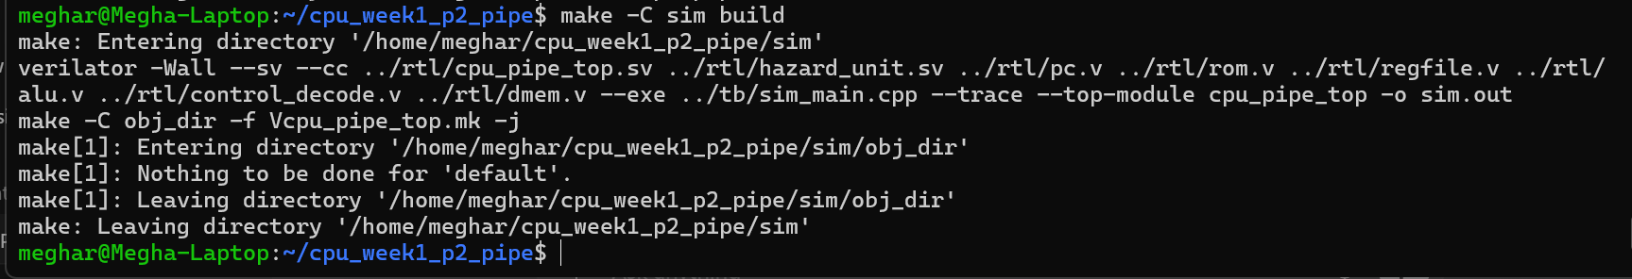
Control signals generated during instruction decode must travel along with the instruction data. If control signals become misaligned with the instruction they belong to, incorrect operations such as unintended memory writes or incorrect register updates could occur. Therefore, control bits are latched into the pipeline registers together with the instruction operands.
Pipeline Register Scaffold
The first step of the pipelined CPU implementation is to introduce the pipeline register structures that separate the five execution stages. The top-level CPU module is refactored so that instruction flow proceeds through four pipeline registers: IF/ID, ID/EX, EX/MEM, and MEM/WB.
The IF stage fetches instructions from the instruction memory using the program counter. The fetched instruction, along with PC+4, is stored in the IF/ID pipeline register. This register serves as the interface between instruction fetch and instruction decode.
The ID/EX pipeline register is responsible for transferring decoded operands and control signals from the decode stage to the execution stage. It stores register operand values, destination register identifiers, immediate values, and control signals generated by the decode logic.
The EX/MEM pipeline register holds the results of the ALU operation as well as memory control signals required for load and store instructions. This register transfers execution results to the memory stage.
The MEM/WB pipeline register holds the values that will eventually be written back to the register file. This includes either ALU results, memory read data, or PC+4 for jump instructions.
Each pipeline register stores both instruction data and control bits so that instructions carry their control information as they progress through the pipeline.
Verification of Pipeline Register Integration
After defining the pipeline register structures, the pipelined top module was compiled using Verilator. Successful compilation confirms that the new pipeline register definitions integrate correctly with the existing modules reused from Project 1.
At this stage the pipeline registers are present but some signals are not yet connected to later stages. This can produce temporary unused-signal warnings during compilation. These warnings are suppressed using Verilator lint directives until the remaining pipeline stages are implemented.
Importance of Control Signal Propagation
Control signals generated in the instruction decode stage must travel alongside the instruction data through the pipeline. If control signals become misaligned with their corresponding instruction data, incorrect behavior can occur such as unintended memory writes or incorrect register updates. To prevent this issue, control signals are latched into the pipeline registers together with the instruction operands.
Module 1 Status at This Checkpoint
At this checkpoint, the top-level CPU has been refactored into a pipelined structure with four pipeline register definitions: IF/ID, ID/EX, EX/MEM, and MEM/WB. The IF stage is functional and continuously fetches instructions from ROM using the program counter. The IF/ID pipeline register captures the fetched instruction and PC+4 on each clock cycle.
The remaining pipeline stages are currently represented as placeholder pipeline registers initialized to zero. This establishes the structural skeleton of the pipelined CPU while preserving a clean compilation flow. Later modules will populate these registers with decoded operands, control signals, ALU results, memory data, and writeback values.
At this stage, the design goal is structural correctness rather than full execution functionality.
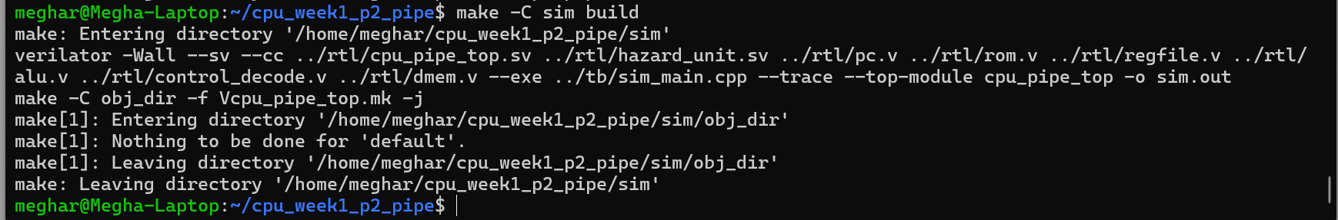
Waveform Verification of Pipeline Stage Progression
To verify correct propagation of instructions through the pipeline stages, a short simulation was executed using the demo_arith.s program. The waveform shows the fetched instruction appearing first in the instruction fetch stage and then propagating sequentially through the pipeline registers IF/ID, ID/EX, EX/MEM, and MEM/WB. Each instruction advances by one stage per clock cycle after the pipeline fills, confirming that the pipeline registers correctly transfer both instruction data and control signals between stages.

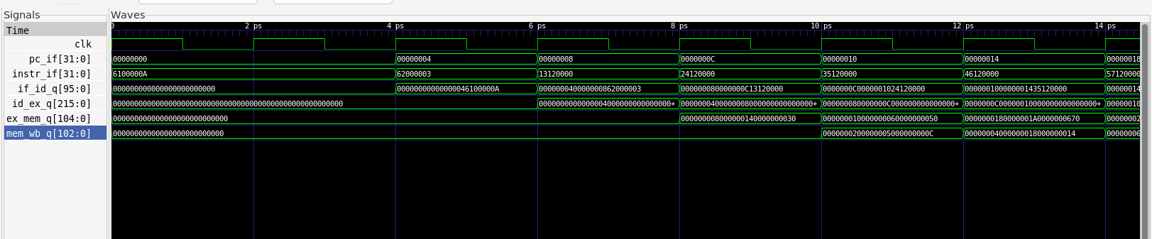
The instruction fetched in instr_if is captured by the IF/ID register and then propagates through ID/EX, EX/MEM, and MEM/WB in subsequent cycles. This confirms that the pipeline registers correctly implement stage-to-stage instruction flow.
Module 2 — Execution, Memory, and Writeback Path
The execution stage was implemented by connecting the ID/EX pipeline register outputs to the Project 1 ALU. Operand A is taken from rs1_val, while operand B is selected between rs2_val and imm_ext using the alu_src_imm control signal. The ALU result is stored in the EX/MEM pipeline register together with the store-data operand and memory/writeback control bits.
The MEM stage reuses the Project 1 data memory module. The effective address computed by the ALU is used as the memory address, and store instructions write the store_data value carried by EX/MEM. Load results are read combinationally from the memory output.
The MEM/WB pipeline register stores the ALU result, memory read data, and PC+4 so that the writeback stage can select the correct register-file write value. At this checkpoint, the processor contains a complete five-stage datapath, although hazard resolution mechanisms such as forwarding, stalling, and flushing are not yet enabled.
Execution Result Timing
The EX/MEM pipeline register holds the result produced by the ALU during the EX stage. This value becomes available one cycle before the value written back to the register file.
The MEM/WB register holds the value that will be written back during the WB stage. Because this stage occurs later in the pipeline, the MEM/WB value is older than the EX/MEM value.
This timing difference is important when implementing forwarding logic.
Branch and jump computation
Branch and jump target calculation were added in the EX stage using the same target computation rule from Project 1: pc_plus4 + off_ext_bytes. The branch/jump decision signals are computed in EX but are not yet used to redirect the PC. These signals will be applied later during the control-hazard flush stage.
Branch and jump instructions are resolved in the EX stage. The branch condition is evaluated using the ALU zero flag, and the target PC is computed using the branch offset. If a branch or jump is taken, the pipeline must flush the incorrectly fetched instruction(s) that follow.
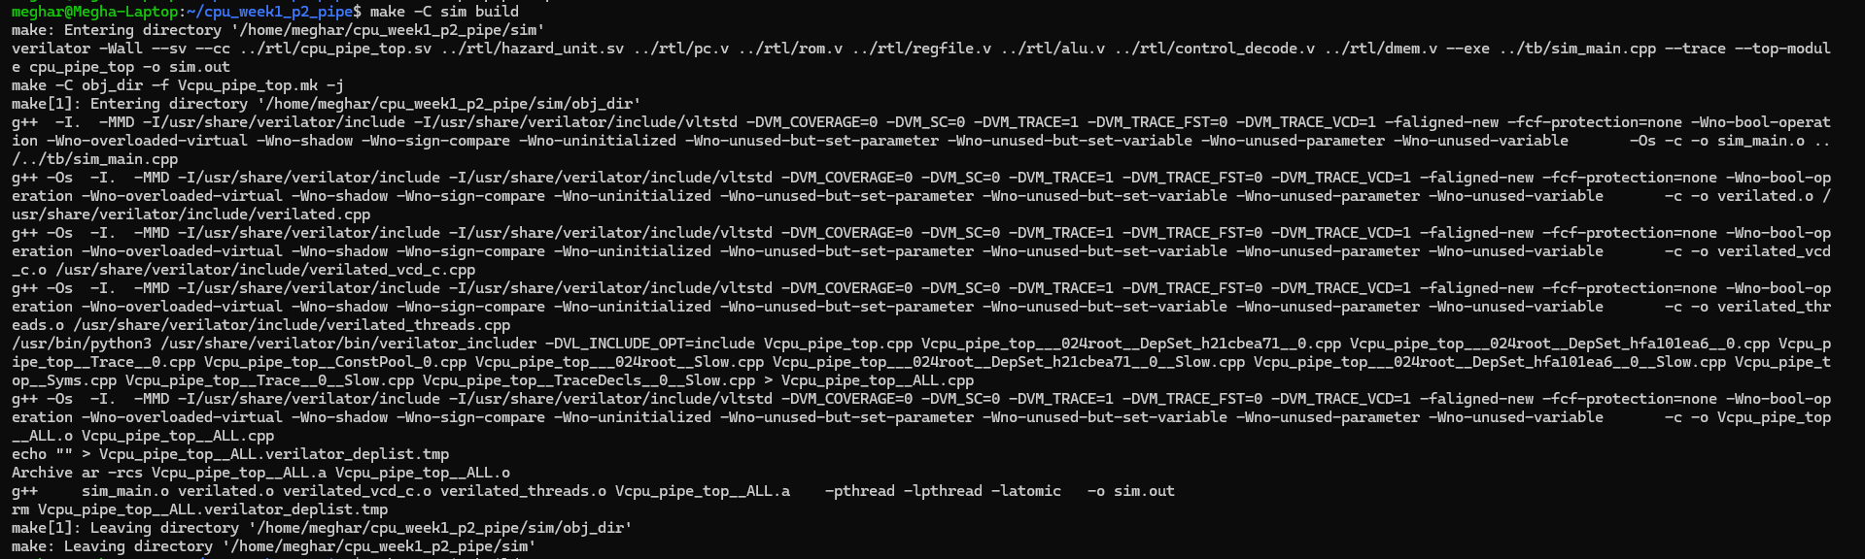
The waveform verifies correct datapath operation across the execution, memory, and writeback stages. The instruction fetched in the IF stage propagates through the pipeline registers while operand values are supplied to the ALU in the EX stage. The ALU produces the result (alu_y), which is transferred through the EX/MEM and MEM/WB pipeline registers before being written back. This confirms correct integration of execution and memory datapaths in the pipelined
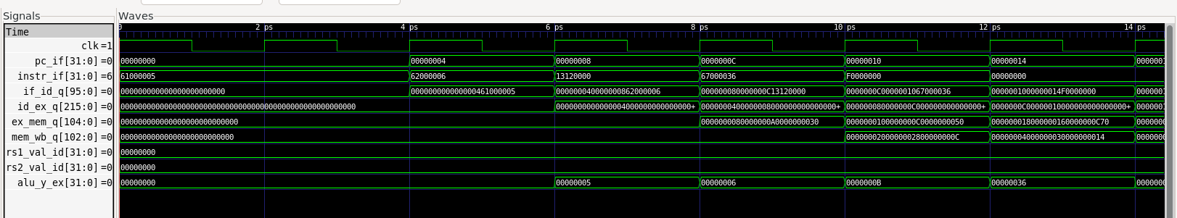
Module 3 — Forwarding Network
The next hazard-handling mechanism implemented is operand forwarding. In a pipelined processor, arithmetic results may be needed by following instructions before they are written back to the register file. To avoid unnecessary stalls, the processor forwards results directly from later pipeline stages back to the EX stage inputs.
A forwarding unit compares the source registers in the ID/EX pipeline register against the destination registers in EX/MEM and MEM/WB. If a match is detected and the later-stage instruction will write a register, the EX operand mux selects the forwarded value instead of the original register-file output.
Forwarding must prioritize EX/MEM over MEM/WB because EX/MEM contains the newer value in program order. The forwarding logic is also reused for branch comparisons in EX and for the store-data path so that store instructions can write the most recent operand value even if it has not yet reached the register file.
At this checkpoint, arithmetic RAW hazards can be resolved without stalling. Load-use hazards and control-hazard flushing are not yet implemented and remain the next stages of the project.
Forwarding Priority
Forwarding must prioritize the EX/MEM stage over MEM/WB because the EX/MEM stage contains the most recent result in program order.
If both stages match the source register of the instruction in the EX stage, the value from EX/MEM is selected because it represents the newer instruction res
Forwarding Network Integration
The forwarding unit was integrated to resolve arithmetic RAW dependencies without stalling the pipeline. The forwarding logic compares the source register identifiers in the ID/EX pipeline register against the destination registers in EX/MEM and MEM/WB. If a match is found and the later-stage instruction writes a register, the EX operand mux selects the forwarded result instead of the original register-file output.
Forwarding must prioritize EX/MEM over MEM/WB because EX/MEM contains the most recent value in program order. This priority is implemented directly in the forwarding select logic.
The forwarding muxes are applied to both ALU operand inputs and to the store-data path. This ensures that store instructions can also receive the newest register value even if it has not yet been written back to the register file.
At this checkpoint, arithmetic RAW hazards can be resolved without stalling. Load-use hazards and control-hazard flushing remain to be implemented in the next modules.
Limitation of Forwarding
Forwarding resolves many RAW dependencies but cannot solve load-use hazards. In a load instruction, the data becomes available only after the MEM stage. If the following instruction needs that value in the EX stage, the value arrives one cycle too late.
Therefore the pipeline must insert a stall cycle and bubble to delay the dependent instruction until the load data becomes available.
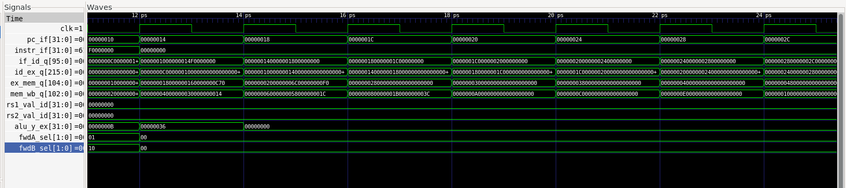

Module 4 — Load-Use Stall + Bubble Insertion
Objective
The objective of this module is to correctly detect and resolve load-use hazards that cannot be handled by forwarding. A load-use hazard occurs when an instruction immediately following a load instruction depends on the value being loaded from memory.
Why forwarding cannot solve load-use
Forwarding resolves many RAW hazards by bypassing results from later pipeline stages back to the EX stage. However, for a load instruction, the required data is only available after the MEM stage. If the next instruction needs that value in EX, the data arrives one cycle too late. Therefore, a one-cycle stall must be inserted.
Load-use detection rule
A load-use hazard is detected when the instruction currently in the ID/EX pipeline register is a load (mem_rd = 1) and its destination register matches either source register of the instruction currently in IF/ID.
Stall behavior
When a load-use hazard is detected:
- the program counter is frozen (pc_en = 0)
- the IF/ID pipeline register is held constant
- the ID/EX pipeline register is converted into a bubble by forcing it to zero
This inserts exactly one cycle of delay while allowing older instructions already in the pipeline to continue normally.
Waveform Verification
The waveform confirms correct handling of the load-use hazard. During the stall cycle, the program counter remains unchanged, the IF/ID register holds the same instruction for one extra cycle, and the ID/EX register is cleared to zero, indicating insertion of a bubble. After the stall cycle, the dependent instruction advances normally through the pipeline.
This verifies that the processor resolves load-use hazards correctly without allowing an instruction to consume invalid data.
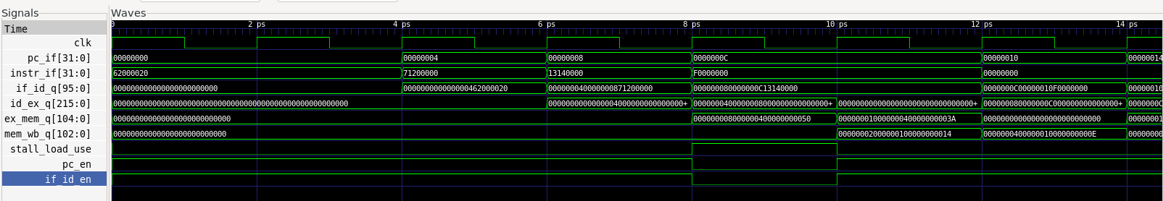
Module 5 — Control Hazard Flush
Objective
The objective of this module is to correctly handle control hazards caused by taken branches or jumps. When a branch or jump is resolved in the EX stage as taken, the instruction(s) fetched after it belong to the wrong path and must be prevented from committing.
Branch/jump resolution stage
Branches and jumps are resolved in the EX stage. The branch condition is evaluated using the ALU zero flag, and the target PC is computed using the same rule as Project 1: pc_plus4 + off_ext_bytes.
Flush behavior
When a taken branch or jump is detected:
- the next PC is redirected to the target address
- the IF/ID pipeline register is squashed to zero
- the ID/EX pipeline register is bubbled
This removes the wrong-path instruction from the pipeline and prevents incorrect architectural updates.
Why flushing is necessary
Without flushing, an incorrectly fetched instruction on the wrong path could continue through the pipeline and perform register writes or memory writes that do not belong to the correct control-flow path. Flushing ensures that only instructions from the correct path are allowed to commit.
Waveform Verification
The waveform confirms correct control-hazard handling. When the branch is resolved as taken in the EX stage, the flush_ex signal is asserted, the PC is redirected to the branch target, and the wrong-path instruction present in the IF/ID register is squashed. At the same time, the ID/EX register is cleared to zero, inserting a bubble. After the flush, instruction fetch resumes from the correct target address.
This verifies that taken branches do not allow wrong-path instructions to commit.
