UI/UX DESIGN ANALYSIS REPORT- TELEGRAM

OBJECTIVE
To design a modern, user-friendly messaging app interface inspired by Telegram that provides fast communication, simple navigation, secure messaging, and an intuitiver user experience.
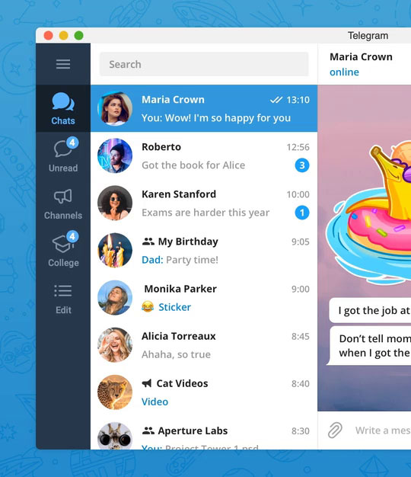
INTRODUCTION
Telegram is a cloud- simplicity & focuses on improving the user experience through intuitive navigation, modern visuals, and accessible interactions while preserving Telegram's core functionality and clean design.

NAVIGATION STRUCTURE
Telegram's navigation structure is designed with a bottom navigation bar, allowing users to easily access Chats, Contacts, Calls, Settings, and Search, while providing a simple, intuitive, and seamless messaging experience.
FEATURES
- Fast and secure cloud-based messaging with multi-device access.
- End-to-end encrypted Secret Chats for enhanced privacy.
- Create large groups, channels, and communities for communication.
- Share photos, videos, documents, and files up to 2 GB each.
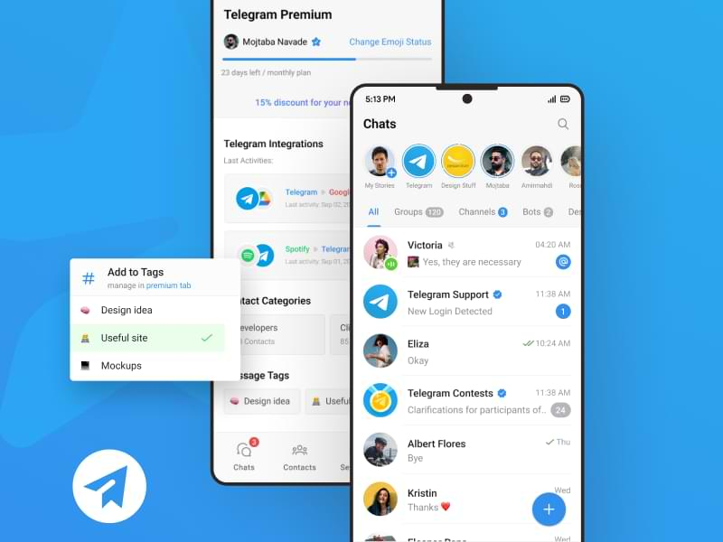
ANALYSIS

The navigation requires very few steps to access important features, reducing user effort and making the application easy to learn.
COLOUR SCHEME
- Primary Blue: Telegram mainly uses a bright blue to represent communication, trust, and connectivity.
- White Background: A clean white background provides a simple, minimal, and easy-to-read interface.
- Gray Tones: Light and dark gray shades are used for chat bubbles, icons, and text to create contrast and improve readability.

ANALYSIS
1) Blue builds trust: The primary blue color creates a sense of trust, reliability, and communication.
2) White keeps it clean: The white background gives the interface a simple, modern, and uncluttered look.
3) Gray improves readability: Gray shades help separate content, highlight important elements, and make text easier to read.
TYPOGRAPHY
Telegram uses a clean, modern, and easy-to-read sans-serif font for a smooth user experience.
FEATURES
- Clear Readability: Text is easy to read on all screen sizes.
- Simple Font Style: Uses a clean sans-serif font for a modern look.
- Consistent Hierarchy: Different font sizes highlight titles, messages, and labels.
- Good Spacing: Proper spacing between Letters and lines improves Readability.
ANALYSIS
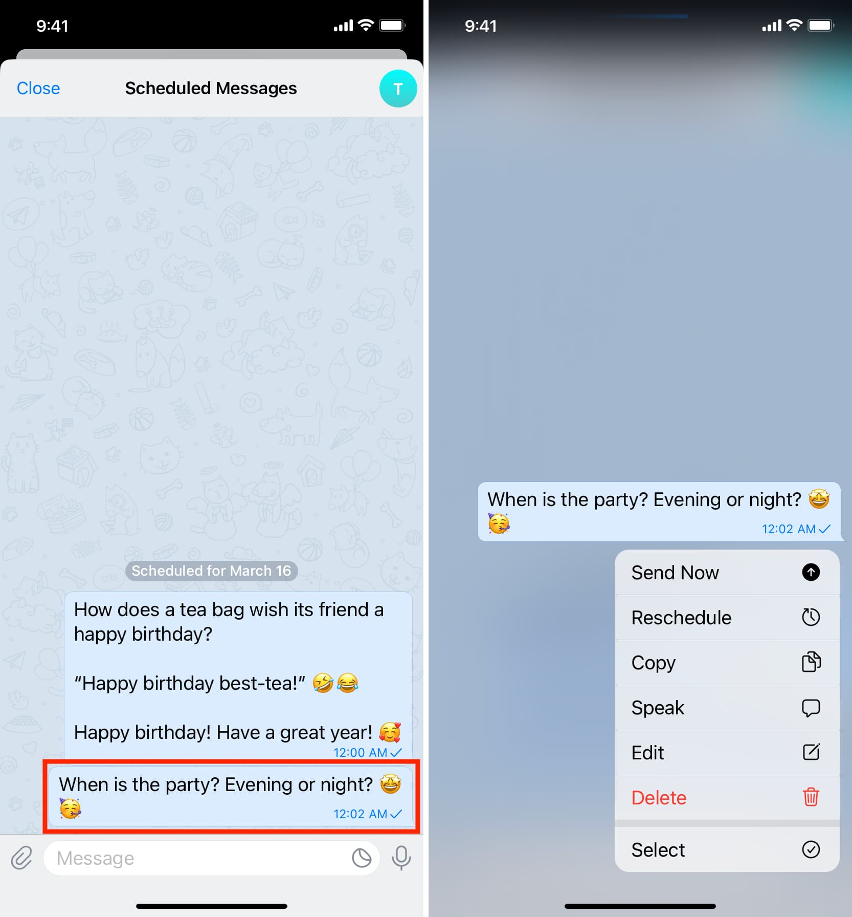
Easy to Read: Telegram's clean and consistent typography makes messages and navigation clear, improving the overall user experience.
USER FLOW
Open Telegram
|
Sign in / Log in
|
View Chat List
|
Select A Chat
|
Type A Message
|
Send Message
|
Receive Reply

ANALYSIS
Telegram's user flow is easy to follow, allowing users to quickly open the app, access chats, and send messages with minimal steps.
UI ELEMENTS IDENTIFIED
UI Element | Purpose
Search Bar | Helps users quickly find chats, contacts, and messages.
Chat List | Displays all conversations in one place.
Message Input Box | Allows users to type and send messages.
Send Button | Sends the typed message instantly.
Attachment Icon | Lets users share photos, videos, files, and documents.
Voice Message Button | Records and sends voice messages.
Bottom Navigation Bar | Provides quick access to Chats, Calls, Contacts, and Settings.
Profile Picture | Helps users identify contacts and groups easily.
UX FEATURES
- Users can quickly move between chats, calls, and settings.
- Messages are sent and received instantly.
- Chats and media are synced across all devices.
- Secret Chats and privacy settings keep conversations secure.
- The interface is clean, responsive, and easy to use.
- Users can send photos, videos, documents, and other files effortlessly.
STRENGTHS
- Easy for users to understand and use.
- Messages and media are delivered quickly.
- Users can access chats and features with minimal effort.
- Offers Secret Chats and privacy controls.
- Chats are available on multiple devices through cloud storage.
- Supports text, voice, video calls, groups, channels, and file sharing.
WEAKNESSES
- New users may feel confused by the large number of options.
- Privacy and notification settings can be difficult to find.
- They work only on the device where they are created.
- Finding useful public channels is not always easy.
- Some screens contain many buttons and menu options.
- Managing notifications for many chats and groups can be confusing.
UI VS UX OBSERVATION
UI (User Interface) | UX (User Experience)
Clean and modern design | Easy and smooth to use
Blue and white color scheme | Fast messaging experience
Clear icons and buttons | Simple navigation between features
Easy-to-read typography | Quick access to chats and contacts
Well-organized layout | Secure and reliable communication
SUGGESTIONS FOR IMPROVEMENT
- Make privacy settings easier to understand.
- Simplify the interface for new users.
- Improve channel and group search for easier discovery.
- Reduce spam messages in public groups and channels.
- Make notification settings easier to manage.
- Add better guides or tips for first-time users.
LEARNING OUTCOMES
Learned how a clean and simple interface improves user experience,Understood the importance of easy navigation in mobile apps.Observed how color, typography, and icons create a consistent design.Learned how UI elements help users complete tasks quickly.Understood the role of privacy and security features in UX design.Identified Telegram's strengths, weaknesses, and areas for improvement to create better user-centered designs.
CONCLUSION
Telegram has a clean, modern, and user-friendly interface.The app provides fast, secure, and smooth communication.Its simple navigation makes it easy for users to access features.The consistent color scheme, typography, and UI elements improve usability.Although some advanced features can be confusing for new users, the overall user experience is effective and reliable.Telegram is a well-designed messaging app that successfully balances functionality, usability, and visual appeal.

