Algorithm_comparision

SudhaRani

4/30/2020

#packages required

library(ggplot2)  
library(microbenchmark)

#test string

source("C:/Users/udai/Documents/Master_thesis_sudha/HybridPackage/R/HybridPackage.R")

## Loading required package: stringi

test <- "abacabacabadaca"  
y1 <- RLE_compressor(test)  
y2 <- lz77_compressor(test)  
y3 <- Hybrid_compressor(test)

## Including Plots

You can also embed plots, for example:

#compression Ratio  
alldata1 <- data.frame (algo = c("RLE", "lz77", "HybridPackage"),ratio = c(length(y1), length(y2), length(y3) / length(test)))  
ggplot(alldata1, aes(x = algo, fill = algo, y = ratio))+geom_bar(color = "white", stat = "identity")+xlab("") + ylab("Compressed ratio (less is better)")

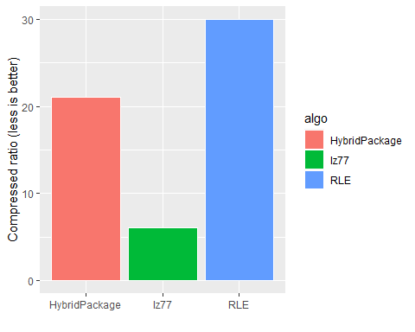

#decompression speed  
bm <- microbenchmark(RLE_decompressor(y1),lz77_decompressor(y2),Hybrid_decompressor(y3),times = 1000)  
  
alldata1$decompression <- summary(bm)$median  
ggplot(alldata1, aes(x = algo, fill = algo, y = decompression))+geom_bar(color = "white", stat = "identity")+xlab("") + ylab("Decompression time (less is better)")

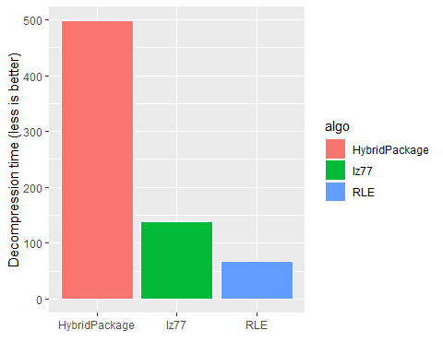

#compression speed  
bm2 <- microbenchmark(RLE_compressor(test),lz77_compressor(test),Hybrid_compressor(test),times = 20)  
  
alldata1$compression <- summary(bm2)$median  
ggplot(alldata1, aes(x = algo, fill = algo, y = compression))+geom_bar(color = "white", stat = "identity")+xlab("") + ylab("Compression time (less is better)")

