DAY 1
Introduction to Cloud Computing
Module 1: Introduction to Cloud Computing | Azure DevOps Training

Learning Objectives
After this session, students will be able to:
• Define cloud computing and explain why businesses adopt it
• List and explain the 5 essential characteristics of cloud computing (NIST)
• Understand the 3 cloud service models: IaaS, PaaS, SaaS
• Identify the cloud deployment models: Public, Private, Hybrid
• Explain what virtualization is and how it enables cloud computing
• Understand the advantages of cloud computing and CapEx vs OpEx

1. What is Cloud Computing?
Cloud computing is the delivery of computing services — servers, storage, databases, networking, software, analytics, and intelligence — over the internet (“the cloud”) to offer faster innovation, flexible resources, and economies of scale. You typically pay only for the cloud services you use.

Simple Definition: Renting IT resources over the internet instead of buying and maintaining your own hardware.

Analogy: Owning a generator vs. plugging into the electricity grid. You don’t build a power plant — you pay for what you use.
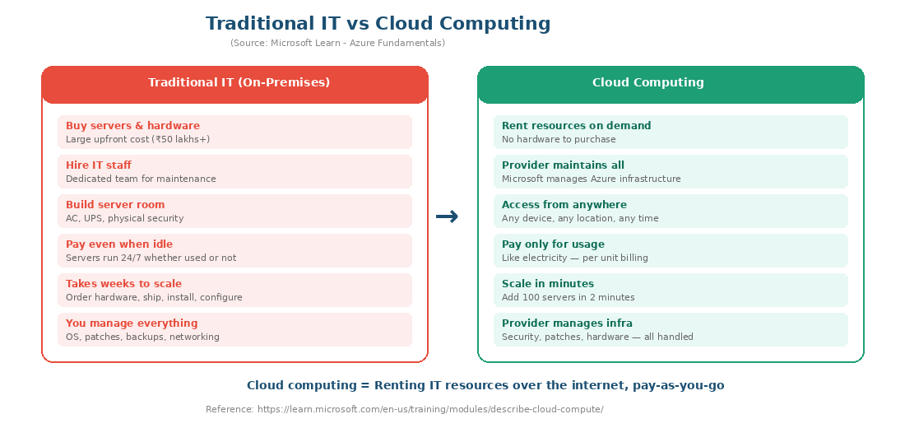
Source: Based on Microsoft Learn - Describe Cloud Computing
Official Microsoft Reference: https://learn.microsoft.com/en-us/training/modules/describe-cloud-compute/

1.1 Why Cloud Computing?
• No need to buy expensive hardware upfront (eliminates capital expenditure)
• No need to hire large IT teams for hardware maintenance
• Access resources from anywhere in the world on any device
• Scale up or down based on demand within minutes
• Pay only for what you use — like an electricity bill
• Built-in security, backup, and disaster recovery

Real-World Example: A startup can launch a web app on Azure without buying a single server. If the app goes viral, Azure auto-scales to handle millions of users. If traffic drops, they pay less. No hardware wasted.

2. Five Essential Characteristics of Cloud Computing
These characteristics are defined by NIST (National Institute of Standards and Technology) in SP 800-145 and are the industry standard for identifying true cloud computing services.
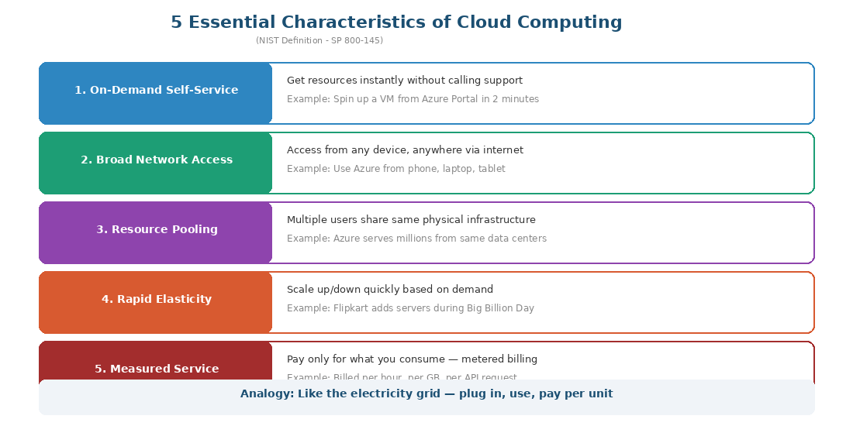
Source: NIST SP 800-145 - The NIST Definition of Cloud Computing
Characteristic | What It Means | Example
On-Demand Self-Service | Provision resources instantly without human intervention from provider | Create a VM from Azure Portal in 2 minutes without calling Microsoft
Broad Network Access | Accessible from any device over the internet | Access Azure from phone, laptop, tablet — anywhere in the world
Resource Pooling | Provider’s resources are shared across multiple customers using multi-tenancy | Azure’s data centers serve millions of customers from the same physical servers
Rapid Elasticity | Scale up or down quickly and automatically based on demand | Flipkart adds 100 servers during Big Billion Day sale, removes them after
Measured Service | Usage is monitored, controlled, and billed — pay per unit consumed | Billed per VM-hour, per GB stored, per API request made

3. Types of Cloud Computing (Service Models)
The three service models define how much the cloud provider manages for you vs. how much you manage yourself. This is one of the most important concepts in cloud computing.
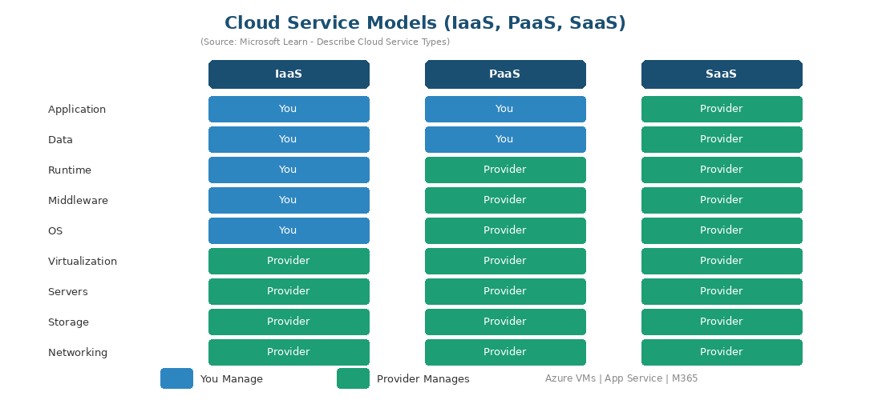
Source: Based on Microsoft Learn - Describe Cloud Service Types
Official Microsoft Reference: https://learn.microsoft.com/en-us/training/modules/describe-cloud-service-types/

3.1 IaaS — Infrastructure as a Service
Provider gives you: Virtual Machines, Storage, Networking
You manage: Operating System, Runtime, Middleware, Applications, Data
Azure Example: Azure Virtual Machines, Azure Virtual Network
Analogy: Renting an empty house — you get walls, electricity, plumbing. You bring furniture and appliances.

3.2 PaaS — Platform as a Service
Provider gives you: Everything except your application code and data
You manage: Only your Application and Data
Azure Example: Azure App Service, Azure SQL Database
Analogy: Renting a furnished apartment — kitchen, furniture, utilities ready. Just move in.

3.3 SaaS — Software as a Service
Provider gives you: Complete, fully managed software
You manage: Nothing — just use the software
Azure Example: Microsoft 365, Microsoft Teams, Dynamics 365
Analogy: Staying in a hotel — everything is done for you. Just walk in and use it.

Key Rule: As you move from IaaS → PaaS → SaaS, your responsibility decreases and the provider’s responsibility increases.

4. Types of Cloud Implementation Models
Deployment models define WHERE your cloud infrastructure lives and WHO can access it. Your syllabus refers to these as “cloud implementation models.”
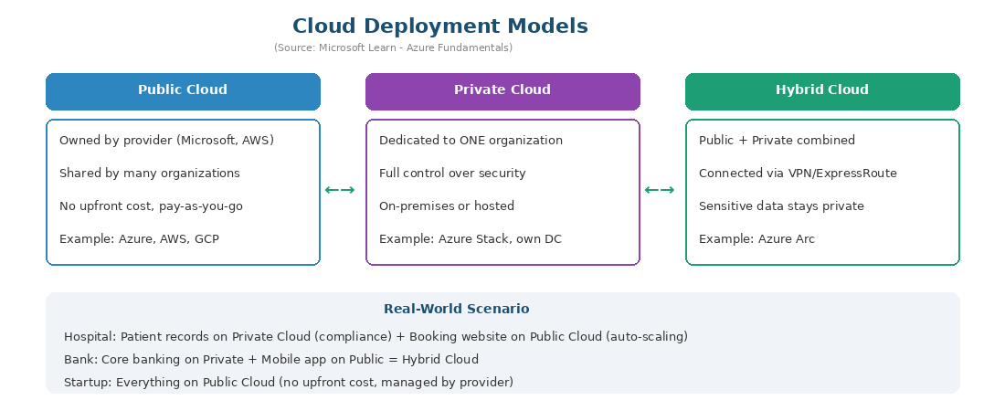
Source: Based on Microsoft Learn - Define Cloud Models
Official Microsoft Reference: https://learn.microsoft.com/en-us/training/modules/describe-cloud-compute/5-define-cloud-models
Model | What It Is | Best For | Example
Public Cloud | Shared infrastructure, owned by provider, accessed over internet | Startups, web apps, testing, variable workloads | Azure, AWS, GCP. Scenario: Zomato auto-scales during peak hours
Private Cloud | Dedicated to ONE organization, full control over security | Banks, hospitals, government, defense | Azure Stack. Scenario: SBI keeps financial data in own data center
Hybrid Cloud | Public + Private combined, connected via secure VPN | Large enterprises with compliance + scalability needs | Azure Arc. Scenario: Hospital records private + booking site public
Community Cloud | Shared by organizations with common requirements | Government agencies, healthcare consortiums | NIC cloud for Indian govt departments

5. Advantages of Cloud Computing
Your syllabus specifically lists cloud advantages as a required topic. Here are the six key advantages with real-world examples:
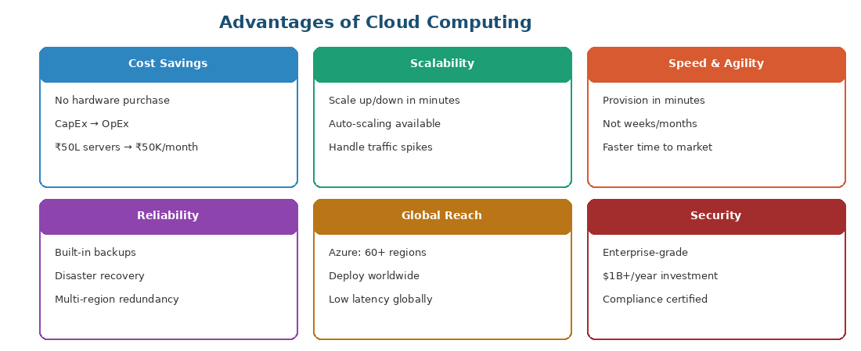

5.1 CapEx vs OpEx
 | CapEx (Traditional IT) | OpEx (Cloud)
Full Form | Capital Expenditure | Operational Expenditure
What | Buy servers, hardware upfront | Pay monthly subscription
Cost | Large one-time investment (₹50+ lakhs) | Small recurring payments (₹50K/month)
Risk | Hardware depreciates over 3-5 years | Cancel anytime, no depreciation
Analogy | Buying a car | Using Ola/Uber

6. Virtualization
Virtualization is the technology that allows you to create multiple virtual machines (VMs) from a single physical server using software called a Hypervisor. This is the foundational technology that makes cloud computing possible.
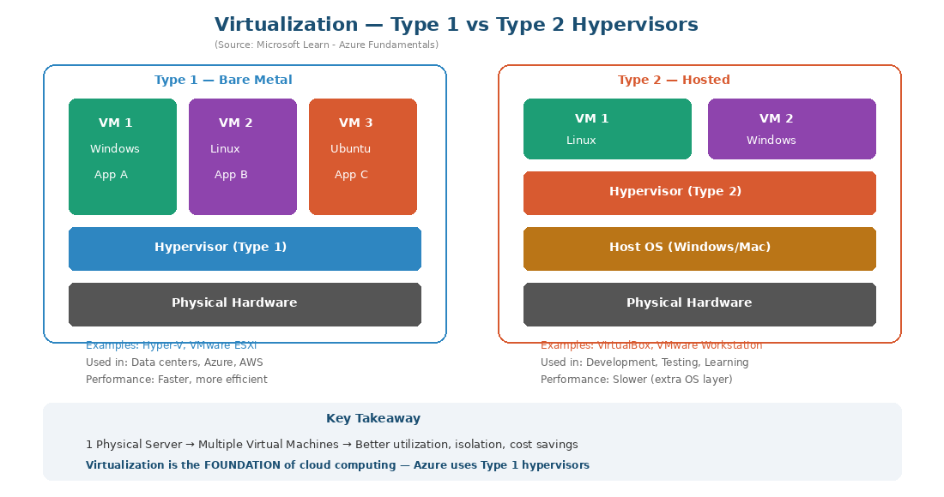
Source: Based on Microsoft Learn - Azure Fundamentals

6.1 What is a Virtual Machine?
A VM is a software-based emulation of a physical computer. It has its own OS, CPU allocation, memory, and storage — but shares the underlying physical hardware with other VMs through the hypervisor.

6.2 Types of Hypervisors
 | Type 1 (Bare-Metal) | Type 2 (Hosted)
Runs On | Directly on physical hardware | On top of existing OS (Windows/Mac)
Performance | Faster, more efficient | Slower (extra OS layer overhead)
Used For | Data centers, production, cloud providers | Development, testing, learning
Examples | Microsoft Hyper-V, VMware ESXi | VirtualBox, VMware Workstation

6.3 Types of Virtualization
• Server Virtualization — Multiple VMs on one physical server (most common)
• Storage Virtualization — Pooling physical storage into one logical unit
• Network Virtualization — Combining network resources into one virtual network (Azure VNet)
• Desktop Virtualization — Hosting desktops on a central server (Azure Virtual Desktop)
• Application Virtualization — Running apps in isolated environments (Containers, Docker)

6.4 Benefits of Virtualization
• Better hardware utilization — One server runs 10-20 VMs instead of sitting idle
• Cost savings — Fewer physical servers needed, lower electricity and cooling costs
• Isolation — Each VM is independent; if one crashes, others are unaffected
• Easy backup — Snapshots save the entire state of a VM instantly
• Fast provisioning — Create a new VM in minutes instead of buying/installing hardware

Key Connection: Virtualization is the FOUNDATION of cloud computing. Azure, AWS, and GCP all use Type 1 hypervisors to divide their massive physical infrastructure into virtual resources that customers rent on-demand.

7. Microsoft Learn References
Use these official Microsoft links to access original diagrams and documentation. Show these in class or download images for slides:

Cloud Computing Fundamentals:
Describe Cloud Computing: https://learn.microsoft.com/en-us/training/modules/describe-cloud-compute/
Benefits of Cloud Computing: https://learn.microsoft.com/en-us/training/modules/describe-benefits-use-cloud-services/
Define Cloud Models: https://learn.microsoft.com/en-us/training/modules/describe-cloud-compute/5-define-cloud-models

Service Models:
Describe Cloud Service Types: https://learn.microsoft.com/en-us/training/modules/describe-cloud-service-types/
What are IaaS, PaaS, SaaS?: https://azure.microsoft.com/en-us/resources/cloud-computing-dictionary/what-are-iaas-paas-and-saas/
Shared Responsibility Model: https://learn.microsoft.com/en-us/azure/security/fundamentals/shared-responsibility

Azure Fundamentals (AZ-900 Path):
AZ-900 Learning Path: https://learn.microsoft.com/en-us/training/paths/microsoft-azure-fundamentals-describe-cloud-concepts/
Azure Architecture Center: https://learn.microsoft.com/en-us/azure/architecture/
Azure Global Infrastructure: https://azure.microsoft.com/en-us/explore/global-infrastructure/

How to get Microsoft’s official images:
1. Open any Microsoft Learn link above in your browser
2. Right-click on the diagram or image you want
3. Select ‘Save image as...’ to download the PNG
4. Insert into your PowerPoint slides or Word documents
Tip: Microsoft Learn images are free to use for educational and training purposes.

8. Quick Q&A Reference
Q1: What is cloud computing?
Delivery of computing services (servers, storage, databases, networking, software) over the internet on a pay-as-you-go basis.

Q2: What is the electricity grid analogy?
Just like you plug into the grid and pay per unit instead of building a power plant — in cloud, you rent computing power and pay for usage.

Q3: Name the 5 characteristics of cloud computing.
On-demand self-service, Broad network access, Resource pooling, Rapid elasticity, Measured service.

Q4: What is the difference between IaaS, PaaS, and SaaS?
IaaS = you manage OS and above. PaaS = you manage only app and data. SaaS = provider manages everything. From IaaS to SaaS, your responsibility decreases.

Q5: Give one Azure example for each service model.
IaaS = Azure Virtual Machines. PaaS = Azure App Service. SaaS = Microsoft 365.

Q6: What is a hypervisor?
Software that creates and manages virtual machines by allocating physical resources (CPU, RAM, storage) to each VM.

Q7: What is the difference between Type 1 and Type 2 hypervisors?
Type 1 runs directly on hardware (used in data centers, e.g. Hyper-V). Type 2 runs on top of an OS (used for testing, e.g. VirtualBox).

Q8: What is hybrid cloud? Give an example.
Combines public + private cloud. Example: Hospital keeps patient records on private cloud, runs booking website on Azure public cloud.

Q9: What is CapEx vs OpEx?
CapEx = large upfront cost (buying servers). OpEx = small monthly payments (cloud subscriptions). Cloud shifts IT spending from CapEx to OpEx.

Q10: How is virtualization related to cloud computing?
Virtualization is the foundation of cloud computing. Cloud providers use Type 1 hypervisors to divide massive physical infrastructure into virtual resources that customers rent on-demand.

9. Homework
1. Create a free Azure account at https://portal.azure.com
2. Login to the Azure Portal and explore the dashboard
3. Click on “All services” and note down 5 services you recognize
4. Read: https://learn.microsoft.com/en-us/training/modules/describe-cloud-compute/

Next Class Preview
Day 2: Cloud Service Models deep dive (IaaS, PaaS, SaaS with real-world scenarios), Deployment Models with Indian industry examples, and CapEx vs OpEx.

