Square of Matrix Implementation

**Methodology:** Square of a matix is computed using a recursive approach of dividing the matrix into blocks and perform multiplication among the individual small blocks to compute the overall squared matrix. Following approach maintains a additional array where the result of multiplication is being stored.

|  |
| --- |
| A corresponds to array1 B corresponds array2  spawn MultA(C11,A11,B11,n/2);  spawn MultA(C12,A11,B12,n/2);  spawn MultA(C22,A21,B12,n/2);  spawn MultA(C21,A21,B11,n/2);  sync;  sync;  spawn  spawn MultA(C21,A22,B21,n/2);  spawn MultA(C22,A22,B22,n/2);  spawnMultA(C12,A12,B22,n/2);  spawn MultA(C11,A12,B21,n/2);  sync; |

**Cilk View Report :**

|  |  |  |  |  |  |  |  |  |  |  |  |  |  |  |  |
| --- | --- | --- | --- | --- | --- | --- | --- | --- | --- | --- | --- | --- | --- | --- | --- |
| |  |  |  |  |  | | --- | --- | --- | --- | --- | | # of Matrix Elements | Duration (ms) | Overall Parallelism | Parrallelism in Parallel region | Speed Up in Parallel Region | | 128 | 180 | 9.33  9.02(burdened) | 15.99  15.05(burdened) | 2 processors: 1.80 - 2.00  4 processors: 2.99 - 4.00  8 processors: 4.47 - 8.00  16 processors: 5.94 - 15.99  32 processors: 7.11 - 15.99  64 processors: 7.88 - 15.99  128 processors: 8.34 - 15.99  256 processors: 8.59 - 15.99 | | 4096 | 636130 | 2297.53  2270.56  (burdened) | 16368.10  15090.75  (burdened) | 2 processors: 1.90 - 2.00  4 processors: 3.80 - 4.00  8 processors: 7.60 - 8.00  16 processors: 15.20 - 16.00  32 processors: 30.40 - 32.00  64 processors: 60.80 - 64.00  128 processors: 121.60 - 128.00  256 processors: 243.20 - 256.00 | |

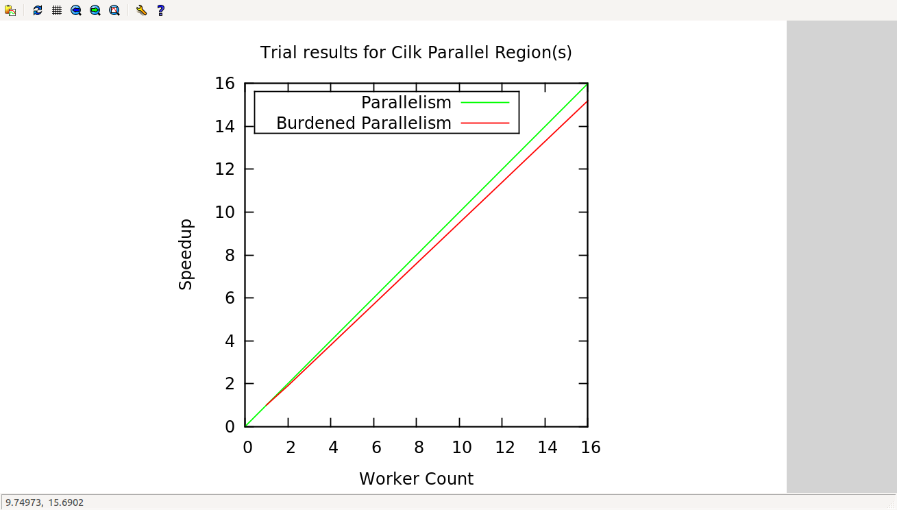

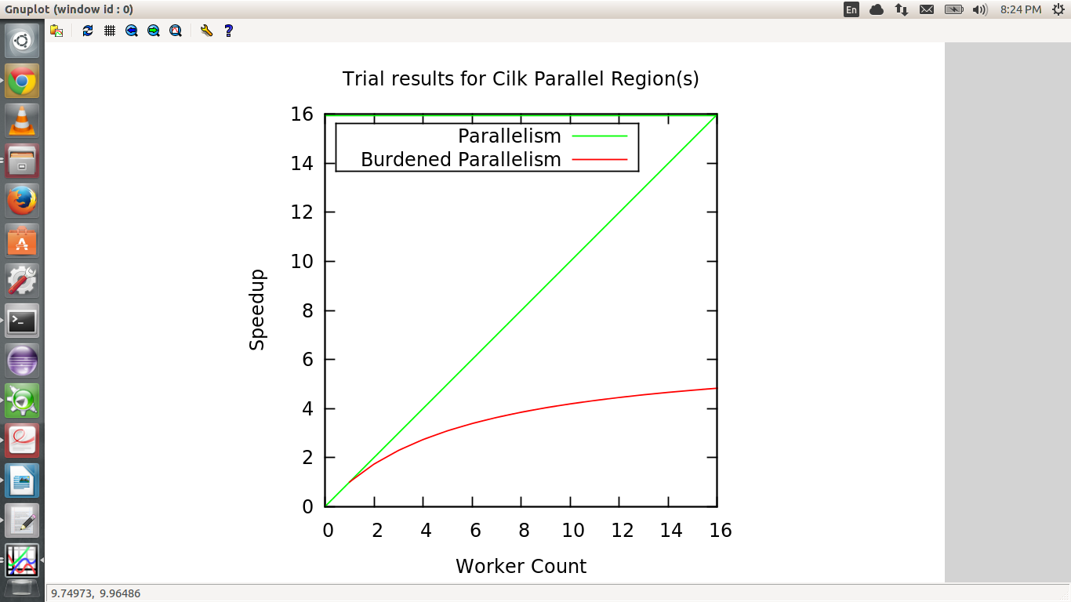

**Cilk Screen Report :**

|  |
| --- |
| sudhar@ubuntu:~/assignments/ConcurrentProgramming/Assignment1$ cilkscreen ./mat 512  Cilkscreen Race Detector V2.0.0, Build 3566  155680 No errors found by Cilkscreen |