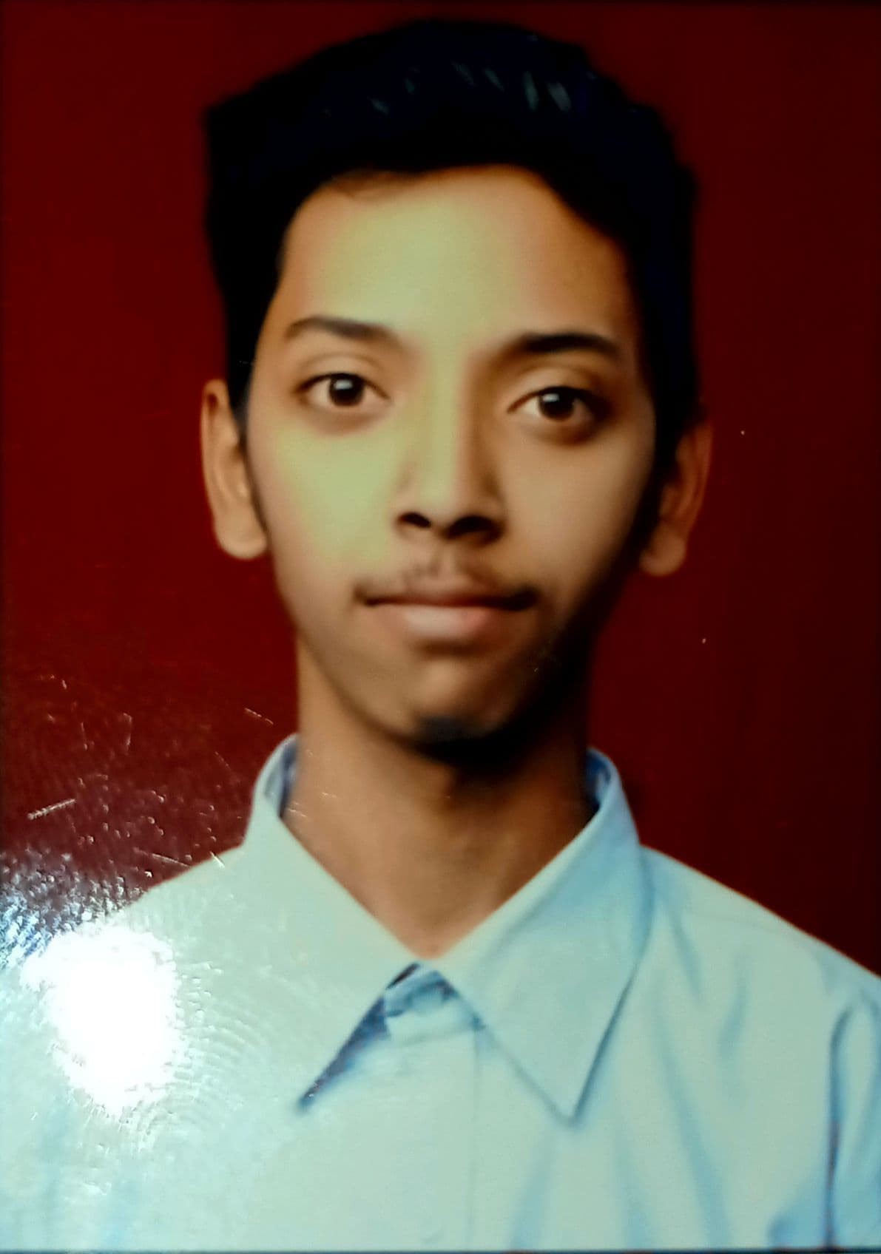CURRICULUM VITAE

.

Sudharm Jadhav

E-mail: sudharmjadhav2004@gmail.com

Address: Sambhaji Nagar, Colony no.7, Alandi Road, Bhosari, Pune -411039

Contact: 9307119586/9850839182

.

# CAREER OBJECTIVE: -

I am looking for a career, which offers me constant challenges to work with people, new problems, excellent advancement opportunities and value addition in a progressive concern.

# ACADEMIC QUALIFICATIONS: -

|  |  |  |  |  |  |
| --- | --- | --- | --- | --- | --- |
|  | **Name of passed exam** | **Name of institute/college** | **University** | **Percentage** | **Passing Year** |
| 1) | HSC | Abhishek Arts, Science and Commerce college | Maharashtra State Board | 80.31% | 2021 |
| 2) | SSC | Gayatri English medium school | Central Board of Secondary Education | 96.20% | 2019 |
| 3 | BBA-CA | MIT arts, commerce and science college | Savitribai Phule university | ------------- | appearing |

COMPUTER KNOWLEDGE: -

MS-OFFICE: (Word, Excel, office, Power point)

C Programming

Algorithms and Data Structures

Photo editing in canvas

# STRENGTH: -

1. Good Communication
2. Versatile
3. Presentation Skills
4. Quick learner
5. Positive Attitude
6. Willing to Work in under pressure

# HOBBIES:-

1. Reading Novels
2. Community Involvement
3. Travel
4. Coding
5. Cycling
6. yoga

# DETAILS OF ACADEMIC PARTICIPATIONS:-

1)Participated as Technical supporter in Jagruti Manch program arranged for girls.

2)Participated in interschool chess championship.

3)Participated in speech competition in school.

4)Participated in yoga championship.

# PERSONAL DETAILS:-

|  |  |
| --- | --- |
| Full Name | : Sudharm Sunil Jadhav |
| Father Name | : Sunil Jadhav |
| Permanent Address | : Sambhaji Nagar, Colony no.7, Alandi Road, Bhosari, Pune |
| Date of Birth | : 25-March-2004 |
| Gender | : Male |
| Marital status | : Unmarried |
| Nationality | : Indian |
| Language | : Marathi, English, Hindi |

# DECLARATION: -

I hereby declare that the above written particulars are true to the best of my knowledge and belief.

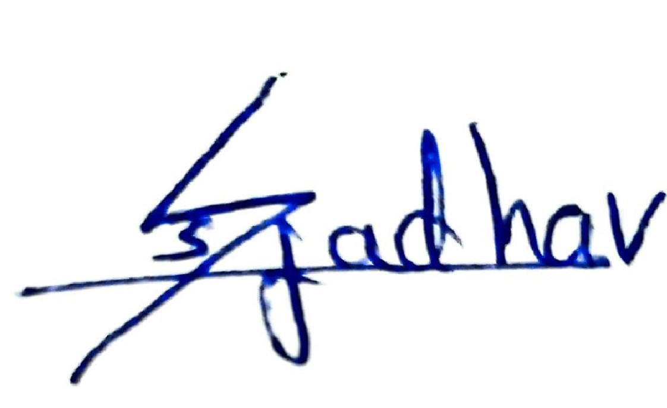

DATE-31/12/2021

PLACE-Bhosari, Pune