**Quizathon**

**Table of Contents**

* **Introduction**
* **System Requirements**
* **Technical Requirement**
  + **Backend**
  + **Database**
  + **Frontend**
* **Advantages**
* **UI Walkthrough**
* **Work Breakdown**

**Introduction**

Quizathon is a open source web site which will enable user to both be an Author or Test-taker to enhance his skills in the field of his interest. The website gives the user two kinds of work around to either select a particular field or random questions from different fields for attending the quiz.

The level of difficulty will be increased as the points increase. The global Highscore will be viewed for all users. The user can create an account for either an author or test-taker. After choosing the roles, They can login and start working on their way around.

The User can view his Last game score and his High Score when logged in. The user can attend the quiz any number of times. The question will be randomly viewed to the user based on the level he is in.

The Authors can add new questions and mention there categories and answers. The Authors cannot attend the exams and restricted only to add and view questions.

**System Requirement:**

Developer Requirements:

* + - Windows, Mac os or Linux.
    - Any modern Processor.
    - Node Js.
    - Node Package Manager or Bower.
    - Command Prompt.
    - Sublime Text Editor or any comfortable Text Editor.
    - Any Javascript enabled browser.
    - AWS or Heroku for Deployment.
    - Github repository.

User Requirements:

* + - Internet connection.
    - Any Javascript enabled browser.

**Technical Requirement**

**Backend:**

The Website backend is being developed in Express JS and other Node plugins. The Node js helps in easy request and response using Rest Webservices. Installing instructions for Node Js and NPM can be found online, Since for different OS and architecture it has different ways of installation.

Once the NPM is installed we can install plugins like ‘Mysql, Express Js, Angular Js, Express session’ and much more based on the requirement. The Node Js provides easy access to plugins using the keyword ‘require’ to import the plugins into the project where ever it is necessary.

**Database:**

The Database Management System can be either SQL or NO-SQL database. But we are developing and deploying the project using My-SQL database, Due to its Advantages, Stability, Security and its ergonomics.

Other possible databases are SqlServer, MongoDB, Redis DB, Postgres DB etc.

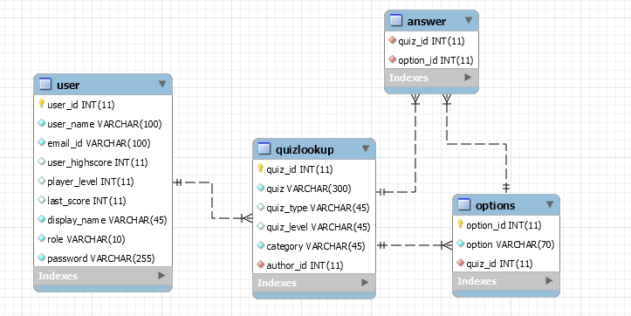

**Frontend:**

The Frontend of the project will be comprising of many modern technologies like Jquery, Angular Js, Bootstrap etc. The Angular Js version one is being used in the project which provides the power of creating ‘Single Page Applications’ with ‘two way binding’.

Bootstrap is used to provide an expensive look for the viewer. And It provides a greater advantage of viewing in any sized device and wrap the contents of the webpage based on the viewport. Also Bootstrap also provides number of ice breaking Javascript and css features inbuilt.

**Advantages:**

* + - * Easy to Deploy
      * Easy maintenance
      * Needs very low memory than java or Ruby
      * Browser side compilation for frontend
      * Fully works on AJAX.
      * Single Page Application
      * Cost Effective
      * Security
      * Faster Response time
      * Connection pooling
      * Works in a Single thread

**UI WalkThrough**

**Registration Page:**

The Registration page asks for the complete details of the user. The user need to specify the role for which he is creating an account. Below are the details that need to filled while creating the account.

* + - User Name
    - Email Id
    - Phone Number
    - User Display Name
    - User Role

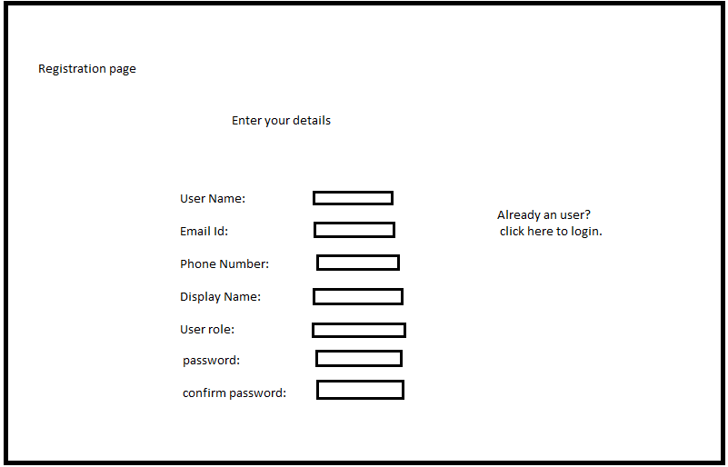

**Login Page:**

The Login Page allows the user to login with the credentials. If the user already registered he will be redirected to homepage.

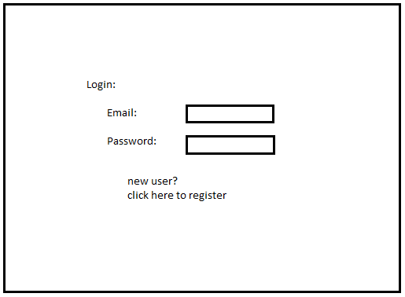

**Home Page:**

The home page will show the details of user and some menus for user selection.

**Test taker Screen:**

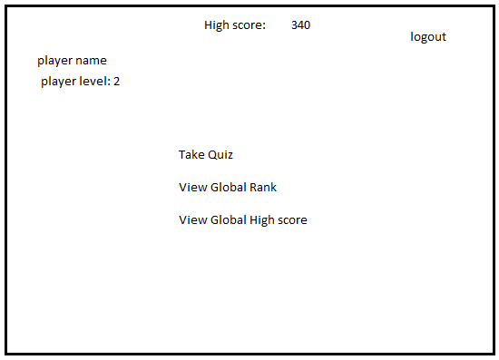

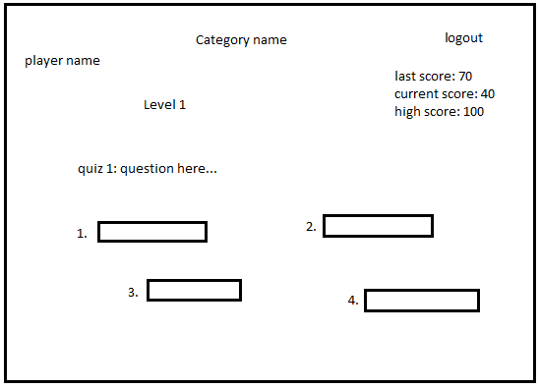

**Author screen:**

