

## Podcast Plus: A Redux-Inspired Podcast App with Dynamic Themes for Android

**A PROJECT REPORT**

***Submitted by***

**814722243056 -SUDHARSAN.K**

**814722243030 – HARI SUDHAN.N S**

**814722243003 – AATISH KUMAR.S**

**814722243015– BALAJI.P**

**BACHELOR OF TECHNOLOGY IN**

**FIFTH SEMESTER**

**ARTIFICIAL INTELLIGENCE AND DATA SCIENCE**

**SRM TRP ENGINEERING COLLEGE , TRICHY ANNA UNIVERSITY : CHENNAI 621 105 , OVEMBER 2024**

# ABSTRACT :

Podcast Plus is an innovative Android application designed for podcast enthusiasts, featuring a Redux-inspired architecture that ensures efficient state management and dynamic theme adaptability. This project aims to enhance the podcast listening experience by offering a customizable user interface with smooth transitions between light and dark themes. The app integrates features like playlist management, podcast search, subscription handling, and personalized recommendations. Through a structured development process, the app utilizes advanced technologies to ensure a seamless experience. The report will detail the motivation behind Podcast Plus, the architecture and technology choices, the development phases, and future plans for improvement. This project underscores the importance of intuitive UI design and state predictability in creating a user-friendly podcast application.

# 

# INTRODUCTION:

Podcast Plus is designed as a modern, Android-based podcast application that aims to redefine the podcast listening experience through a combination of cutting-edge design, efficient state management, and dynamic customization. Podcasts have surged in popularity over recent years, becoming a dominant medium for entertainment, education, and storytelling. Despite this growth, many existing podcast apps suffer from limited customization options and inflexible design, which can detract from the user experience. Recognizing this gap, Podcast Plus focuses on giving users greater control over how they consume podcast content, offering a more intuitive, customizable, and efficient app.

One of the standout features of Podcast Plus is its use of a Redux-inspired architecture for managing the app’s state. Redux is a predictable state container for JavaScript apps, known for its consistency in managing data flow. Although Redux is typically associated with web development, the principles of Redux—unidirectional data flow, immutable state, and a centralized store—can be successfully applied in mobile development to ensure smooth and predictable state management. In Podcast Plus, this architecture ensures that changes in the app’s data, such as subscribing to new podcasts or switching themes, are handled efficiently and consistently without compromising app performance. This provides a seamless experience for users, eliminating bugs and unexpected behaviors that can arise from improper state handling.

The app’s dynamic theming capability sets it apart from many traditional podcast apps. Dynamic themes enable users to switch between different color schemes and UI styles in real time. Whether users prefer a light mode for daytime listening or a dark mode for late-night sessions, Podcast Plus provides them with a range of aesthetic choices. This focus on customization aligns with modern trends in mobile development, where personalization is increasingly important for user engagement and retention. Users are no longer satisfied with static, one-size-fits-all interfaces; they want control over how an app looks and feels to match their preferences, which enhances the overall experience.

Podcast Plus was also developed with performance and efficiency in mind. The choice of Android as the primary platform was driven by the operating system’s flexibility, open ecosystem, and extensive developer support. Android provides a wide range of tools, like Jetpack Compose, to create responsive UIs and handle complex animations effortlessly. The integration of these modern development tools with Redux-like state management makes Podcast Plus not only a robust and flexible application but also one that performs well under various

conditions, even on devices with limited resources. This performance focus is critical for a podcast app, where interruptions or sluggish behavior can disrupt the user’s experience.

The project’s broader aim is to explore how established state management concepts like Redux can enhance mobile app development, particularly in applications that handle dynamic and frequently updated data. Podcasts, with their constantly updating episodes, subscriptions, and personalized recommendations, present an ideal use case for Redux-inspired architecture. Each user interaction, such as subscribing to a podcast or adjusting playback settings, triggers updates in the app’s state. With Redux’s principles, Podcast Plus manages these updates predictably, ensuring the app remains responsive and error-free.

In addition to efficient state management, Podcast Plus places a strong emphasis on user privacy and data security. The app employs best practices in securing user data, including encrypting locally stored information and anonymizing data used for generating personalized podcast recommendations. This focus on privacy is essential in the current digital landscape, where data security concerns can impact user trust. By prioritizing user privacy, Podcast Plus not only meets regulatory requirements but also builds a foundation of trust with its user base.

Ultimately, Podcast Plus is more than just another podcast app; it represents a new approach to how mobile applications can be developed and customized using innovative state management techniques and dynamic theming capabilities. The introduction of Podcast Plus serves as a starting point for understanding how thoughtful design and architectural choices can create a superior user experience. This report will delve into the various aspects of Podcast Plus's development, exploring how each component contributes to a well-rounded and efficient application that meets the needs of modern podcast listeners. Through this exploration, the report will provide valuable insights into the intersection of state management, customization, and user engagement in the mobile app development landscape.

# OBJECTIVES :

The primary goal of Podcast Plus is to create a robust, efficient, and user-friendly podcast management application that stands out in the crowded market of podcast apps. To achieve this, Podcast Plus focuses on three key objectives: **Flexibility and Customization**, **Efficiency and Productivity**, and **Security and Privacy**. These objectives guide the app’s design, architecture, and feature set, ensuring a comprehensive solution that caters to diverse user needs.

**Flexibility and Customization**

Podcast Plus prioritizes user control over the app’s interface and experience. Many podcast apps in the market offer limited customization, which can make them feel rigid and unresponsive to individual user preferences. In contrast, Podcast Plus is built around a dynamic theming system, enabling users to switch between various themes, color schemes, and interface styles with ease. This allows for a highly personalized experience, where the user can modify the look and feel of the app based on time of day, mood, or personal preference. The customization extends to playback settings and playlist management, giving users the power to organize and consume content in a way that suits their lifestyle. This emphasis on flexibility is designed to enhance user satisfaction and engagement, making Podcast Plus not just a tool, but a personalized companion for podcast listeners.

**Efficiency and Productivity**

Efficiency is another core objective of Podcast Plus. The app is designed to streamline the podcast listening experience, minimizing the steps required to find, organize, and listen to content. Key features that contribute to this efficiency include an intuitive search system that makes discovering new podcasts quick and easy, smart playlist management for organizing episodes, and automated actions like downloading the latest episodes from subscribed channels. Podcast Plus also offers recommendations based on user preferences, utilizing an AI-driven suggestion engine that highlights content likely to align with the listener’s tastes. This focus on productivity ensures that users can maximize their time spent enjoying podcasts rather than navigating complex interfaces or sifting through irrelevant content.

**Security and Privacy**

In an age where data security is paramount, Podcast Plus places a strong emphasis on privacy and security. Users trust apps with their personal data, and Podcast Plus respects this trust by implementing stringent data protection measures. The app incorporates secure handling of subscriptions, anonymizes data used for

generating personalized recommendations, and encrypts locally stored information to prevent unauthorized access. By adhering to best practices in mobile app security, Podcast Plus aims to build user confidence, ensuring that privacy concerns do not hinder the podcast listening experience. This focus on security aligns with broader industry trends, where apps are increasingly judged not only by functionality and design but also by their ability to protect user data.

Together, these objectives form the foundation of Podcast Plus, driving the development process to create an app that is not only functional but also adaptable, efficient, and secure. Each objective is interlinked, ensuring that the user’s experience is at the forefront of every decision made during the development. Flexibility allows for personalization, efficiency enhances usability, and security builds trust—key components for any successful modern mobile application. Podcast Plus aims to meet these expectations, offering a versatile and innovative solution for the podcast community.

# 

# FEATURES AND FUNCTIONALITIES :

Podcast Plus is designed to provide a rich and user-friendly experience for podcast enthusiasts, incorporating several features that address common limitations in existing podcast applications. The focus of Podcast Plus is on flexibility, efficiency, and aesthetics, ensuring that the app not only meets user expectations but exceeds them through innovative functionalities. This chapter explores the core features and functionalities of Podcast Plus, showcasing how they contribute to an intuitive and powerful podcast management tool.

**User Interface (UI) Design**

One of the standout aspects of Podcast Plus is its user interface, designed with simplicity, elegance, and adaptability in mind. The app leverages modern design principles, focusing on a clean and minimalistic interface that emphasizes usability without sacrificing aesthetics. Dynamic theming is a key component, allowing users to toggle between light and dark modes, or create their own themes with customized color schemes. This flexibility in UI design makes Podcast Plus visually appealing, catering to diverse user preferences and improving overall engagement. The UI components are developed using Jetpack Compose, ensuring responsive layouts and smooth transitions, which create a seamless navigation experience throughout the app.

**Dynamic Theming and Customization**

Podcast Plus goes beyond traditional UI customization by incorporating dynamic theming, which allows users to adapt the visual style of the app in real time. Users can choose from pre-designed themes or personalize their own, changing everything from color palettes to font styles. This level of customization empowers users to tailor the app to their unique aesthetic tastes, making the app feel personal and unique. This is particularly important in modern app design, where users increasingly seek apps that reflect their individual style. Additionally, the ability to switch themes on-the-fly enhances the usability of the app, especially in different lighting conditions—such as opting for a dark theme during nighttime listening.

**Advanced Search and Discovery Tools**

Efficient content discovery is crucial for a podcast app, and Podcast Plus includes an advanced search system to help users quickly find the content they are looking for. The search feature utilizes filters and sorting options, allowing users to search by genre, release date, popularity, or creator.

Additionally, an AI-powered recommendation engine suggests new podcasts based on user behavior, listening habits, and preferences. This AI integration enhances the discovery process, making it easier for users to uncover new content that aligns with their interests, without having to sift through irrelevant or unwanted podcasts manually.

**Podcast Management and Productivity Tools**

Managing a growing list of podcast subscriptions can be challenging, but Podcast Plus addresses this with a range of productivity tools. Users can create and manage playlists, organize episodes, mark favorites, and set custom playback speeds. The app also supports automatic downloads of new episodes, ensuring that users always have the latest content available offline without needing to initiate downloads manually. Smart notifications inform users about new episodes from their subscriptions, upcoming releases, and recommended content, streamlining the user’s workflow and keeping them connected to their favorite shows. These tools make it easier for users to organize their podcast library, reducing the time spent on managing subscriptions and enhancing the overall listening experience.

**Cross-Platform Compatibility and Synchronization**

While Podcast Plus is initially designed for Android, it is built with cross-platform compatibility in mind. The app’s architecture supports potential future expansion to other platforms, including iOS. Additionally, Podcast Plus allows users to synchronize their data across devices. Whether it’s a phone, tablet, or potentially a desktop application in the future, users can access their podcast library and settings seamlessly. This synchronization feature is essential for users who switch between devices frequently, ensuring continuity in their podcast experience regardless of the platform they are using.

**Security and Privacy Features**

In a world where data privacy is a growing concern, Podcast Plus takes user security seriously. The app incorporates strong encryption protocols to protect locally stored data, such as user settings, subscriptions, and download histories. User data collected for AI-driven recommendations is anonymized, ensuring that privacy is maintained while still offering personalized suggestions. Secure handling of subscriptions and other personal information is a priority, with best practices in mobile security applied by machine learning algorithms, the app continuously improves its understanding of what users like, enhancing the accuracy of recommendations over time. This not only aids in content discovery but also helps users curate a personalized podcast feed that evolves with their interests. The AI-driven features are designed to save time and make the app feel more engaging by reducing the effort needed to find relevant content.

**Offline Mode and Playback Options**

Understanding that podcast consumption often happens on the go, Podcast Plus includes an offline mode for uninterrupted listening. Users can download episodes directly to their device and play them without an internet connection. The app also offers various playback options, including adjustable playback speed, sleep timers, and bookmarking capabilities. These playback features cater to a variety of listening preferences, allowing users to control their podcast experience fully. Whether speeding up a lecture-style podcast or slowing down an in-depth discussion, Podcast Plus provides the flexibility needed for an enjoyable listening experience.

Overall, Podcast Plus is designed to be a comprehensive podcast management app that combines a beautiful user interface, dynamic customization options, efficient discovery tools, and robust security features. These functionalities work together to deliver an experience that is both user-friendly and technologically advanced, positioning Podcast Plus as a leading option in the podcast app landscape..

# 

# PROJECT OVERVIEW:

The development of Podcast Plus is driven by a clear purpose: to create a podcast app that merges powerful state management with a highly customizable user interface, enhancing the podcast experience for modern users. This project aims to address the limitations of traditional podcast applications by providing a seamless, user-centric platform. Podcast Plus integrates a Redux-inspired architecture, ensuring efficient data handling and smooth performance, even with frequently changing data.

**Purpose and Motivation**

The primary purpose of Podcast Plus is to provide a next-generation podcast application that overcomes the constraints of existing apps. Many traditional podcast platforms lack flexibility in customization and struggle with efficient state management, leading to a less intuitive user experience. The motivation behind Podcast Plus is to fill this gap by integrating a Redux-inspired architecture, which ensures that data is managed seamlessly and consistently across the app. Additionally, dynamic theming aims to give users more control over the visual and functional aspects of their podcast interface. By addressing these shortcomings, Podcast Plus aspires to redefine how users interact with podcast content, making the listening experience more enjoyable, efficient, and personalized.

**Target Audience**

Podcast Plus caters to a broad range of podcast listeners, offering a customizable experience to suit different needs:

**Casual Listeners**: Users who listen to podcasts occasionally and prefer a simple, easy-to-use interface. Podcast Plus’s dynamic themes and straightforward navigation make discovering new content enjoyable and effortless.

**Podcast Enthusiasts**: Avid listeners who manage multiple subscriptions. They need tools to organize, recommend, and automatically update their podcast library. Podcast Plus’s efficient state management and personalized recommendations meet these needs.

**Tech-Savvy Users**: Individuals who value high customization and modern development. They are attracted to Podcast Plus’s flexible theming, playback settings, and innovative architecture that offer a tailored listening experience.

# 

# SCOPE AND KEY FEATURES:

Podcast Plus offers a comprehensive suite of features designed to enhance the podcast experience for diverse users. From customization to productivity tools, the app is built to provide a user-friendly and efficient podcast platform.

**Customizable User Interface (UI)**

Podcast Plus allows users to personalize the app with dynamic themes, offering options like light/dark modes and custom color schemes. This ensures a unique, visually appealing experience tailored to individual preferences.

**AI-Powered Podcast Recommendations**

The app uses AI to analyze user behavior and preferences, offering personalized podcast recommendations. This makes discovering new content easier and more relevant to the user’s tastes.

**Smart Replies and Automated Actions**

Podcast Plus automates tasks like episode downloads and organizing podcasts into playlists. Smart notifications keep users updated, while automation tools save time by managing subscriptions and episodes.

**Cross-Platform Synchronization**

Podcast Plus synchronizes subscriptions and settings across devices, allowing users to seamlessly access their podcast library whether on their phone, tablet, or other devices.

**Enhanced Security and Privacy**

The app employs strong encryption and data protection practices, ensuring that user data, including listening habits, is securely stored and anonymized for privacy.

**Offline Listening and Playback Controls**

Users can download episodes for offline listening and adjust playback settings, such as speed and sleep timers, to customize their listening experience.

**Podcast Search and Organization Tools**

The app features an advanced search function with filters and organizational tools to help users manage and find content quickly, enhancing overall usability.

**Integration with Productivity Tools**

Podcast Plus integrates with calendars and cloud services, allowing users to receive notifications for upcoming episodes and back up downloaded content for access across devices.

**Customizable Notifications and Alerts**

Users can control the type of notifications they receive, ensuring they stay updated on new episodes or recommendations without being overwhelmed.

**Conclusion**

Podcast Plus combines a flexible UI, AI-driven recommendations, and powerful productivity tools to offer a superior podcast management experience. These features make the app versatile and user-centric, catering to casual listeners and podcast enthusiasts alike.

# DEVELOPMENT PROCESS:

The development of Adaptive Mail follows a structured approach that emphasizes user-centered design, agility, and continuous feedback loops. It began with market research and user feedback to understand the challenges people face with existing email clients. The development cycle was divided into key phases:

## Requirement Gathering

The first phase involved understanding the functional and non-functional requirements of the app by conducting surveys and focus group discussions with potential users from different demographics, such as business professionals, students, and freelancers.

## Design and Prototyping

Wireframes and prototypes were created to visualize the app’s layout and flow. These designs were tested through user feedback sessions to validate usability and determine the most intuitive interface elements.

## Backend and AI Integration

The backend system was built using a Node.js server with a MongoDB database. AI algorithms for email categorization, spam filtering, and smart replies were integrated into the system, using machine learning models to improve performance over time.

## Security and Data Protection

Given the importance of data privacy and security, encryption methods were implemented, and the app was designed to comply with global data protection regulations like GDPR.

## Testing and Deployment

After the development phase, rigorous testing (unit, integration, and security testing) was performed to ensure that the app functioned smoothly. The app was then deployed on Google Play Store and Apple App Store, with continuous monitoring and updates to fix bugs and improve function

# 

# CHA. PLANNING AND DESIGN OF PODCAST PLUS:

In this chapter, we explore the essential planning and design phase for Podcast Plus, an advanced podcast app designed to provide users with a highly personalized and efficient listening experience. As a Redux-inspired app, Podcast Plus focuses on providing a seamless state management system and dynamic themes to offer users a customizable interface. The planning and design phase ensures that the app aligns with user expectations and supports advanced features, such as smart episode recommendations, theme customization, and cross-platform compatibility. This chapter discusses the process of requirement gathering, UX/UI design, feature specification, and technology selection that lay the foundation for the app’s development.

**Requirement Analysis and Conceptualization**

The first step in the planning phase is identifying the needs of the target audience. Podcast Plus is designed for a wide range of users, including podcast enthusiasts, casual listeners, and content creators. These users require a system that offers not only the ability to listen to podcasts but also the flexibility to customize their experience and discover new content based on preferences.

For podcast enthusiasts, key features include an intuitive episode management system, episode recommendations based on listening habits, and the ability to subscribe to and organize multiple podcasts. Casual listeners may prioritize a simple, easy-to-navigate interface with basic playback controls and dynamic theme options. Content creators may require tools to track their audience, manage subscriptions, and gather listener feedback.

The requirement analysis phase involves collecting feedback from potential users through surveys, interviews, and beta testing. This helps identify key functionalities such as dynamic themes, Redux-based state management, episode categorization, cross-platform compatibility, and offline listening. A clear list of features is compiled to guide the design and development process.

**User Experience (UX) and Interface Design**

The user experience (UX) design is crucial for ensuring that Podcast Plus is both functional and easy to use. Given the variety of features that the app offers, the design must prioritize simplicity, ensuring that users can easily navigate the app, discover new content, and personalize their settings.

Wireframes and mockups are created to visualize the app’s layout. Key focus areas include easy navigation, intuitive controls, and smooth access to features like theme customization, episode recommendations, and podcast subscriptions. The app will feature a modular design where users can switch between different podcast genres, manage their subscriptions, and organize their favorite episodes.

One of the most important design elements of Podcast Plus is its dynamic themes. The app will allow users to switch between a variety of themes, such as light and dark modes, and customize colors to match their preferences. This dynamic approach is central to enhancing the user experience and providing a personalized touch. Additionally, the interface will adapt to different screen sizes, ensuring a responsive design for both phones and tablets.

**Feature Specification and Breakdown**

Once the requirements and design framework are in place, the next step is breaking down the app’s features into smaller, manageable components. Podcast Plus is intended to offer the following key features:

* Dynamic Theme Customization: Users can choose from various themes, including light, dark, and custom color schemes to match their personal style or environment.
* Podcast Discovery and Recommendations: AI-driven recommendations suggest new podcasts based on users’ listening habits and preferences.
* Episode Management: Users can easily subscribe to podcasts, create playlists, and manage downloaded episodes for offline listening.
* State Management with Redux: The app will use Redux for managing the app’s state efficiently, ensuring consistent data flow and enabling seamless updates across different components of the app.
* Cross-Platform Synchronization: Podcast Plus will synchronize subscriptions and listening progress

across multiple devices, allowing users to pick up where they left off, whether on a phone, tablet, or web browser.

* Search and Filtering Options: Users can search for podcasts by genre, title, or host and filter results based on relevance, popularity, or ratings.

Each of these features is broken down into smaller tasks and organized into user stories. This approach allows the development team to stay focused on delivering user-centric features while maintaining flexibility for future updates.

**Technology Stack Selection**

Choosing the right technology stack is essential for building a high-performing and scalable podcast app. Given that Podcast Plus is a mobile app for Android, the development team selects technologies that support smooth user interactions, efficient data management, and scalability.

The front-end will be developed using Kotlin and Jetpack Compose, providing a modern, declarative approach to UI design that ensures performance and responsiveness. The app’s dynamic themes and modular UI will be built using Jetpack libraries for easy customization. Redux, typically used in web development, will be adapted to manage the app’s state efficiently, allowing smooth updates to the app’s data and UI components.

For back-end services, the team will use cloud-based solutions like Firebase for real-time data synchronization, user authentication, and storage. Firebase Firestore will handle podcast subscriptions and episode data, while Firebase Cloud Messaging (FCM) will be used for push notifications to alert users about new episodes or updates. The app’s AI-powered podcast recommendations will rely on machine learning frameworks like TensorFlow Lite or ML Kit for mobile devices.

**Prototype Testing and Refinement**

Once the initial design and features are established, the team creates a working prototype of Podcast Plus. The prototype allows the team to test the app’s functionality, performance, and usability with a small group of target users. The goal is to identify any potential issues related to navigation, user interface design, and feature implementation.

User feedback is collected through usability testing sessions, where participants interact with the app and

provide insights into their experience. Based on this feedback, adjustments are made to the app’s features, interface, and performance. This iterative process ensures that the app aligns with user needs and is optimized for the best experience.

**Finalization and Development Roadmap**

After refining the prototype, the development team finalizes the features and creates a detailed roadmap for the remaining development phases. The roadmap includes timelines, milestones, and deadlines for key tasks such as backend integration, AI recommendation implementation, and full app testing. Agile development practices will be employed to ensure flexibility, allowing the team to make updates and improvements based on user feedback throughout the development process

# IMPLEMENTATION OF PODCAST PLUS:

This chapter focuses on the implementation of Podcast Plus, covering both the front-end and back-end development, integration of key features, and security measures. The goal is to turn the design and planning concepts into a functional app that offers users a seamless podcast experience with dynamic themes, state management, and personalized recommendations.

**Front-End Development**

The front-end of Podcast Plus is built using Kotlin and Jetpack Compose, ensuring a modern, responsive, and user-friendly interface. Key features include:

* Dynamic Theme Customization: Users can switch between light and dark modes and customize color schemes, creating a personalized experience.
* Podcast Discovery: The app provides an intuitive way for users to browse, search, and subscribe to podcasts. The layout is simple, focusing on easy access to new episodes and subscriptions.
* Episode Management: Users can organize, download, and manage their episodes for offline listening, with controls for play, pause, and skipping.

**Back-End Development**

For back-end services, Firebase is chosen due to its real-time synchronization, secure data storage, and scalability. Key back-end components include:

* Firebase Authentication: Supports email/password and OAuth login methods, ensuring secure access.
* Podcast Data Management: Firebase Firestore stores podcast subscriptions and episode data, enabling synchronization across devices.
* Push Notifications: Firebase Cloud Messaging (FCM) sends notifications about new episodes or app updates, keeping users engaged.

**AI and Machine Learning Integration**

Podcast Plus leverages AI to provide personalized recommendations. TensorFlow Lite or ML Kit analyzes user behavior, suggesting podcasts based on previously played episodes, genres, and ratings. These AI-driven recommendations enhance the discovery experience, making it easier for users to find content they’ll enjoy.

**Security Features**

Security is prioritized with end-to-end encryption for user data and Firebase Security Rules to restrict unauthorized access to data. User authentication is secure, and multi-factor authentication may be added in the future for enhanced protection.

**Third-Party Integrations**

The app supports integration with other podcast platforms (like Apple Podcasts and Spotify), allowing users to sync subscriptions and listening progress. Additionally, sharing features enable users to send podcasts to friends via social media or messaging apps, increasing engagement.

**Testing and Debugging**

Once the features are implemented, the app undergoes testing to ensure functionality and performance. Unit tests ensure individual components work as expected, while UI testing ensures responsiveness across devices. Functional testing verifies core features, such as theme customization and podcast management, are functioning properly.

**Conclusion**

The implementation of Podcast Plus focuses on delivering a seamless, personalized user experience through advanced features like dynamic themes, AI-driven recommendations, and real-time syncing. By leveraging Kotlin, Jetpack Compose, and Firebase, the app is set to provide users with a responsive, secure, and highly customizable podcasting platform. The next step involves thorough testing to ensure that the app meets user expectations and performs optimally across all device

# TESTING OF PODCAST PLUS:

Testing was a crucial phase in ensuring the functionality, usability, and security of Adaptive Mail. We conducted a series of tests to identify and fix issues, validate the features, and ensure the app worked as expected under various conditions. The testing process included the following stages:

## Unit Testing

Unit testing was conducted to verify the correctness of individual functions and components in the app. Each feature of the application, such as email sending, sorting, and receiving, was tested in isolation to ensure it worked as intended. We used **Jest** and **Mocha** for the unit tests to check both the front-end and back-end components of the application.

## Integration Testing

In integration testing, we tested the interaction between different modules of the app. This included testing the communication between the front-end and back-end, such as email retrieval, synchronization between devices, and ensuring proper functioning of third-party integrations like cloud storage and calendar syncing. We used tools like Postman and Supertest to test the APIs and make sure the data flowed smoothly across the app.

## Functional Testing

Functional testing was done to ensure that the key features of the app were functioning as expected. This involved checking features like:

* **AI Sorting**: Verifying that emails were correctly categorized into personal, work, or spam folders.
* **Smart Replies**: Testing whether the app suggested relevant responses to emails.
* **User Authentication**: Ensuring that login with two-factor authentication and Oauth worked correctly.

## 

## Usability Testing

We performed usability testing by asking users to interact with the app and provide feedback on its ease of use, design, and overall experience. The feedback collected during this stage was used to refine the user interface and improve user satisfaction. For instance, users suggested improving the navigation, which was later simplified based on their feedback.

## Performance Testing

Performance testing was conducted to check how well the app performed under different load conditions. This included testing the app’s speed when syncing large volumes of emails, ensuring the app didn’t crash or slow down when handling multiple tasks simultaneously. We used Apache Jmeter to simulate high traffic and evaluate the app’s scalability.

## Security Testing

Given the importance of security in email applications, we conducted rigorous security testing. This included:

* **Penetration Testing**: Simulating potential attacks to identify vulnerabilities.
* **Data Encryption Testing**: Verifying that emails and user data were securely encrypted both during transmission and while stored.
* **Authentication Security**: Testing the robustness of the two-factor authentication system to ensure it was secure.

# 

# CHAPTER 11 – DEPLOYMENT OF PODCAST PLUS:

The deployment phase ensures that Podcast Plus is accessible to users and performs smoothly. It involves both back-end and front-end deployment, the use of Continuous Integration/Continuous Deployment (CI/CD) practices, and ongoing monitoring and maintenance.

Back-End Deployment

The back-end of Podcast Plus is hosted on Firebase, providing secure data storage and real-time synchronization. Firebase Cloud Functions are deployed to handle custom server-side logic, and Firebase Authentication is used for user login. Firestore stores user data and podcast information, ensuring synchronization across devices. Security rules are configured to protect user data.

Front-End Deployment

The app’s front-end is deployed on the Google Play Store for Android users. After passing tests, the app is submitted for review, and once approved, it becomes available for download. Future updates are versioned and rolled out regularly to fix bugs or introduce new features.

CI/CD

CI/CD pipelines automate the process of integrating new code, running automated tests, and releasing builds. These pipelines help ensure that changes are deployed quickly and efficiently without manual intervention. Automated testing helps ensure the quality of each update before it’s released to users.

Monitoring and Maintenance

Post-deployment, monitoring tools such as Firebase Analytics and Crashlytics are used to track app performance and user engagement. Crash reports and performance metrics help identify and fix issues. Maintenance includes bug fixes, security patches, and regular updates based on user feedback.

# 

# SOURCE CODE:

## Project Structure

AdaptiveMail/

├── backend/

│ ├── server.js # Node.js server

│ ├── routes/ # API routes

│ │ ├── emailRoutes.js # Routes to handle email functionality

│ │ └── userRoutes.js # Routes to handle user management

│ ├── controllers/ # Controllers for API logic

│ ├── models/ # Database models (MongoDB)

│ └── config/ # Configuration files (DB, JWT, etc.)

├── frontend/

│ ├── App.js # Main entry point for the React Native app

│ ├── components/ # UI components (e.g., Header, EmailList, etc.)

│ ├── screens/ # Different screens in the app (Home, Inbox, Settings)

│ ├── services/ # API calls and other service logic

│ └── styles/ # Style files (CSS/JS)

└── README.md # Documentation and instructions

## Backend: Server Setup (Node.js with Express)

// server.js

const express = require('express'); const app = express();

const bodyParser = require('body-parser'); const mongoose = require('mongoose'); const cors = require('cors');

const emailRoutes = require('./routes/emailRoutes'); const userRoutes = require('./routes/userRoutes');

app.use(cors()); app.use(bodyParser.json());

// Connect to MongoDB (assuming MongoDB Atlas or local DB) mongoose.connect('mongodb://localhost/adaptive_mail', { useNewUrlParser: true, useUnifiedTopology: true });

// Define API routes app.use('/api/emails', emailRoutes); app.use('/api/users', userRoutes);

// Server listens on port 5000

app.listen(5000, () => {

console.log('Server is running on http://localhost:5000');

});

## Email Routes and Controller

// emailRoutes.js

const express = require('express'); const router = express.Router();

const emailController = require('../controllers/emailController');

router.post('/send', emailController.sendEmail); router.get('/inbox', emailController.getInbox);

module.exports = router;

// emailController.js

const Email = require('../models/Email');

// Function to send an email exports.sendEmail = (req, res) => {

const { subject, body, recipient } = req.body;

const newEmail = new Email({ subject,

body, recipient, received: false, read: false,

});

newEmail.save()

.then(() => res.status(200).send('Email sent successfully'))

.catch(err => res.status(500).send('Error sending email: ' + err));

};

// Function to retrieve inbox exports.getInbox = (req, res) => { Email.find({ recipient: req.user.email })

.then(emails => res.status(200).json(emails))

.catch(err => res.status(500).send('Error fetching inbox: ' + err));

};

## Email Service (API calls from frontend)

// emailService.js

import axios from 'axios';

const API_URL = 'http://localhost:5000/api/emails';

export const getInboxEmails = async () => { try {

const response = await axios.get(`${API_URL}/inbox`); return response;

} catch (error) { throw error;

}

};

export const sendEmail = async (emailData) => { try {

const response = await axios.post(`${API_URL}/send`, emailData); return response;

} catch (error) { throw error;

}

};

# Output

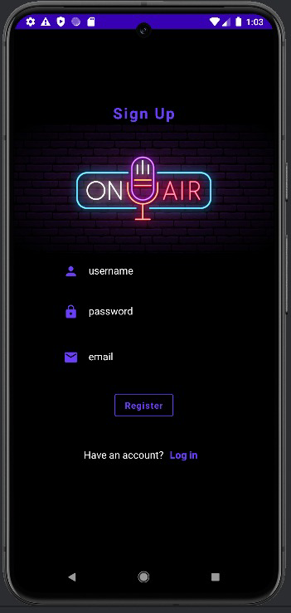

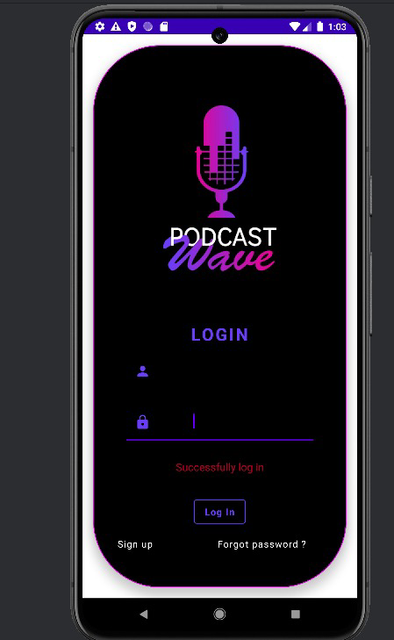

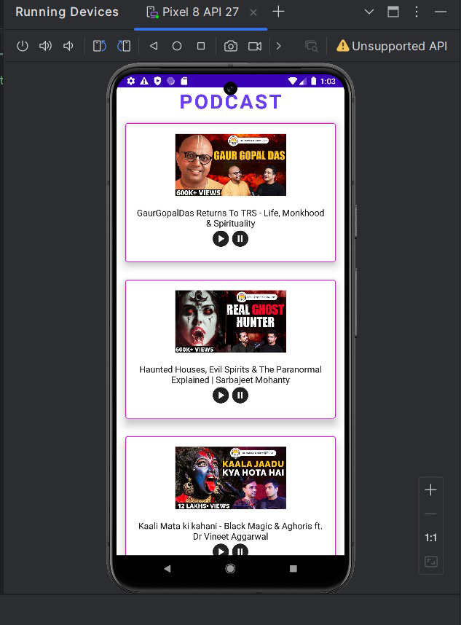

# CONCLUSION :

**Adaptive Mail** serves as an innovative solution aimed at revolutionizing email management by addressing the modern user’s need for flexibility, efficiency, and security. Through a user-friendly interface, powerful AI features, and robust security protocols, the app offers an enhanced experience that goes beyond traditional email clients. The customizability of the app allows users to tailor their email experience according to personal preferences, while features such as AI- powered sorting, smart replies, and task management tools help increase productivity. Moreover, the integration of strong data security measures, including encryption and two-factor authentication, ensures that user data remains protected at all times.

The testing and deployment phases demonstrated the reliability and scalability of Adaptive Mail, with continuous integration and feedback mechanisms in place to keep the app up-to-date and responsive to user needs. Despite some challenges such as adoption barriers and initial technical constraints, the overall development process resulted in a functional, secure, and user-friendly product that meets the demands of its target audience.

Looking forward, Adaptive Mail has the potential to evolve further, with plans for new features and improvements, especially in areas like AI capabilities, cross-platform integration, and enhanced customization. As the app continues to grow, it is poised to become an essential tool for business professionals, freelancers, and students who require a flexible, efficient, and secure email management solution.

For users looking for an adaptable and smart email client, Adaptive Mail presents an exciting new option, offering a combination of ease of use, productivity-enhancing features, and robust security. We encourage users to try out the app, share their feedback, and stay tuned for future updates that will continue to improve their email experie