PRIYADARSHINI ENGINEERING COLLEGE, VANIYAMBADI – 635 751


(Approved b y AIC TE, New Delhi and Affiliated to Anna University, C hennai)

DEPARTMENT O F COMPUTER SCIENCE AND ENGINEERING

VISION OF THE DEPARTM ENT

TO IMBIBE COMPUTER SCIENCE SKILLS TO MEET THE GROWING TECHNOLOGIC AL NEEDS OF SOFTWARE INDUS TRY FOCUSING SPECIF ICALLY RURAL BAS ED POPULATION.

M ISSION OF THE D EPARTM ENT

TO PROVIDE S TUDENTS AND FAC ULTY WITH AN OPEN ENVIRONMENT THAT FOSTERS P ROFESSIONAL AND P ERSONAL GROW TH.
TO OFFER LIBERAL HIGH QUALITY COMPU TER SCIENCE EDUCATION.

MOTIVATING STUDEN TS TO DO INTERDISCIPLINARY RES EARCH IN THE FIELD OF ENGINEERING AND TECHNOLOGY.

PROGRAMME EDUCATIONAL OBJECTIVES (PEOs)

PEO 1: Co re Co mpetence

Graduates will be comp etent to design, develop and solve Engineering prob lems and shall have expertise in programming tools.
PEO 2: B readth

Graduates will acquire the skills required to be emplo yed in National, International and Government Or ganizations.
PEO 3: Lifelong Learning

Graduates will be equipp ed with the skills to pursue higher education and be expert in their profession adopting lifelong learning.
PEO 4: Professionalis m

Graduates will have the ability to present and p ractice team based p rojects with professional ethics and s ocial responsibility.
PROGRAM OUTCOMES (POs)

PO1 : Engineering Kno wledge

An ability to apply knowled ge o f computing, mathematics, science and engineering fundamentals appropriate to the discipline.
PO2 : Problem Analysis

An ability to analyze a problem, identify and formulate the computing requ irements appropriate to its solution.
PO3 : Design and Development of Solutions

An ability to design, implement and evaluate a co mputer-based s ystem, process, component or pro gram to meet desired needs with appropriate consideration for public health, safety, cultural, societal and environmental considerations.
PO4 : Investigation of Complex Proble ms

An ability to design and conduct experiments, as well as to analyze and interpret data.

PO5 : Modern Tool Usage

An ability to use current techniques, skills and modern tools necessary for computing practice.

PO6 : Engineer and Society

An ability to analyze the local and global impact o f computing on individuals, organizations and society.

PO7 : Environment and S ustainability

Knowledge o f contemporary issues.

PO8 : Ethics

An understanding of professional, ethical, legal, security and social issues and responsibilities.

PO9 : Individual and Teamwo rk

An ability to function effectively individually and with teams, including diverse and multidisciplinary activities to acco mplish a common goal.
PO10 : Co mmunication

An ability to communicate effectively with a range of audiences.

PO11 : Lifelong Learning

Reco gnition of the need for lifelong learning and an ability to engage in continuing pro fessional development.
PO12 : Project Manage ment and Finance

An understanding of engineering and management principles and apply these to one’s own work, as a member and leader in a team to manage project
CS8381 DATA STRUCTURES LABORATORY

OBJECTIVES

• To implement linear and non-linear data structures

• To understand the different operations of search trees

• To implement graph traversal algorithms

• To get familiarized to sorting and searching algorithms

OUTCOMES:

At the end of the course, the students will be able

1. Write functions to implement linear and non-linear data structure operations

2. Suggest appropriate linear / non-linear data structure operations for solving a given problem

3. Appropriately use the linear / non-linear data structure operations for a given problem

4. Apply appropriate hash functions that result in a collision free scenario for data storage and retrieval
1 (a). STACK USING ARRAY

#include<stdio.h>
#define max 20
int opt, a[20],i,top=0,n;
int main()
{
void create(),push(),pop(),disp();
int wish;
do
{
printf("\nMENU");
printf("\n1.Create\n2.Push\n3.pop\n4.Display\n5.Exit\n");
printf("\nEnter your option");
scanf("%d",&opt);
switch(opt)
{
case 1:create();break;
case 2:push();break;
case 3:pop();break;
case 4:disp();break;
}
printf("\nDo u want to continue(1/0):");
scanf("%d",&wish);
}while(wish==1);}
void create()
{
printf("\n Enter the limit of stack");
scanf("%d",&n);if(n<max)
{
printf("\nEnter the items");
for(i=0;i<n;i++)
scanf("%d",&a[i]);
top=n-1;
}
else
printf("\nUnable to create the stack");
}
void push()
{
int x;
if(top<max){
printf("\nEnter the element to be pushed:");
scanf("%d",&x);
top=top+1;
a[top]=x;
n=top;
}
else
printf("\n Stack is full");
}
void pop()
{
if(top<0)
printf("\n Stack is empty");
else
{
printf("\nThe element popped is %d",a[top]);
top=top-1;
n=top;
}}
void disp()
{
if(top<0)
printf("\n Stack is empty");
else
{
printf("\n The elements in the stack are:");
for(i=top;i>=0;i--)
printf("\n%d",a[i]);
}
}

OUTPUT:

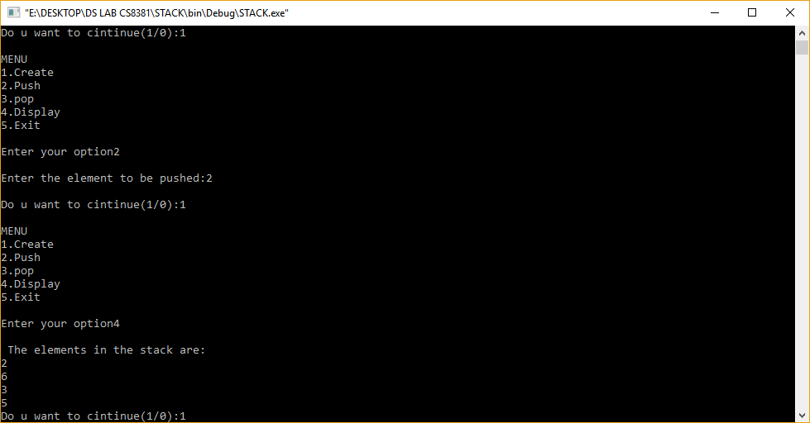

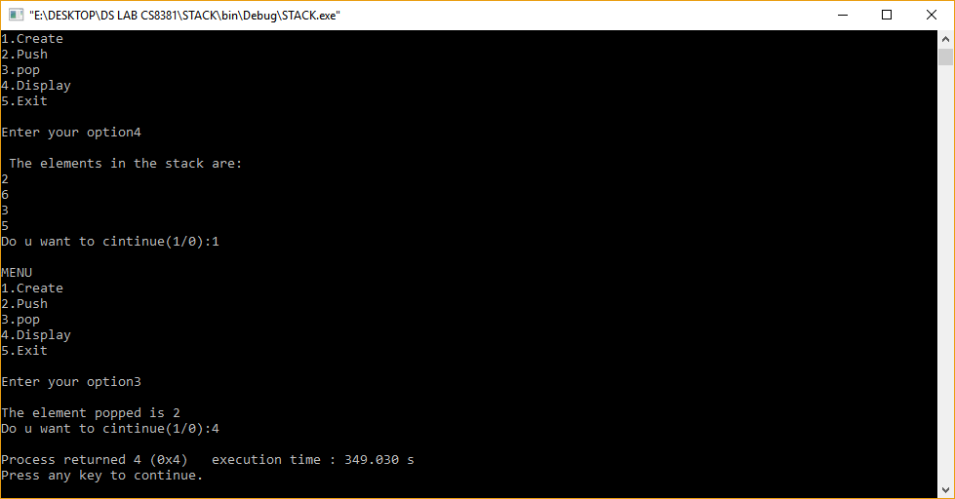

1 (b). QUEUE USING ARRAY

#include<stdio.h>
#include<stdlib.h>
#define SIZE 5
int front = - 1;
int rear = - 1;
int q[SIZE];
void insert( );
void del( );
void display( );
void main( )
{
int choice;
do
{
printf("\t Menu");
printf("\n 1. Insert");
printf("\n 2. Delete");
printf("\n 3. Display ");
printf("\n 4.Exit");
printf("\n Enter Your Choice:");
scanf("%d", &choice);
switch(choice)
{
case 1:
insert( ); display( ); break;
case 2:
del( ); display( ); break;
case 3:display( );
break;
case 4:
printf("End of Program....!!!!");
exit(0);
}}while(choice != 4);}
void insert( )
{
int no;
printf("\n Enter No.:");
scanf("%d", &no);
if(rear < SIZE - 1)
{
q[++rear]=no;
if(front == -1)
front=0;// front=front+1;
}
else
{
printf("\n Queue overflow");
}}
void del( )
{
if(front == - 1)
{
printf("\n Queue Underflow");
return;
}
else
{
printf("\n Deleted Item:-->%d\n", q[front]);
}
if(front == rear)
{
front = - 1;
rear = - 1;
}
else
{front = front + 1;
}}
void display( )
{
int i;
if( front == - 1)
{
printf("\nQueue is empty....");
return;
}
}

OUTPUT:

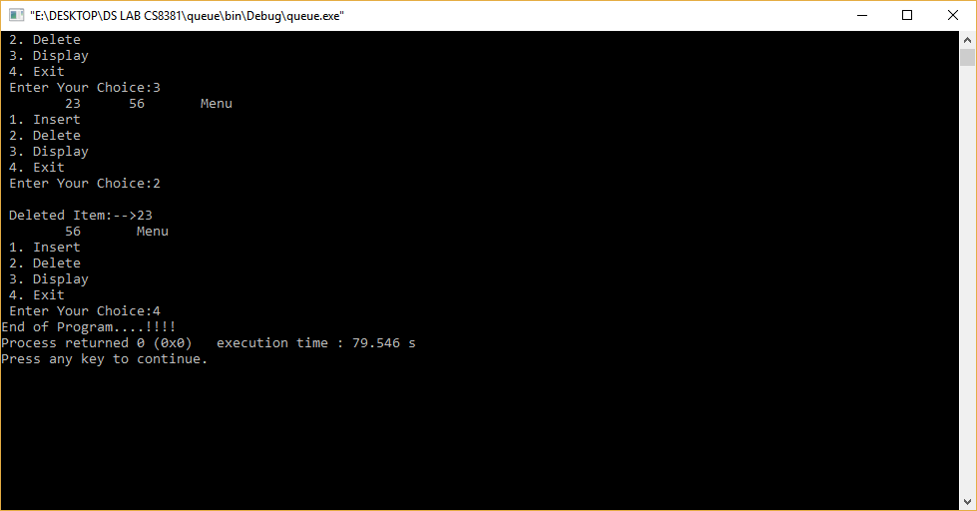

3 (a).STACK USING LINKED LIST

#include<stdio.h>
#include<malloc.h>
struct node
{
int data;
struct node *next;
}*top,*new1,*first;
int main()
{
int wish,opt;
void create(),push(),pop(),view();
do
{
printf("Stack using linked list menu");
printf("\n1.Create\n2.Push\n3.Pop\n4.View\n5.Exit\n");
printf("\nEnter your option(1,2,3,4,5):");
scanf("%d",&wish);
switch(wish)
{
case 1: create(); break;
case 2: push(); break;
case 3: pop(); break;
case 4: view(); break;
}
printf("\nDo you wnat to continue(0/1):");
scanf("%d",&opt);
}while(opt==1);
}
void create()
{
int ch;
top=(struct node*)malloc(sizeof(struct node));
top->next=NULL;
do
{
printf("Enter the data:\n");
scanf("%d",&top->data);
printf("Do you want to insert another(1/0)\n");
scanf("%d",&ch);
if(ch==1)
{
new1=(struct node*)malloc(sizeof(struct node));
new1->next=top;
top=new1;
first=top;
}
else
break;
}while(ch==1);
}
void push()
{
top=first;
new1=(struct node*)malloc(sizeof(struct node));
printf("Enter the element to be pushed:");
scanf("%d",&new1->data);
new1->next=top;
top=new1;
first=top;
}
void pop()
{
top=first;
if(top==NULL)
printf("\n Stack is empty");
else
{
printf("\nThe element popped out from stack is %d",top->data);
top=top->next;
first=top;
}}
void view()
{
printf("\nStack contents\n");
while(top->next!=NULL)
{printf("%d->",top->data);
top=top->next;}
printf("%d\n",top->data);
}

OUTPUT:

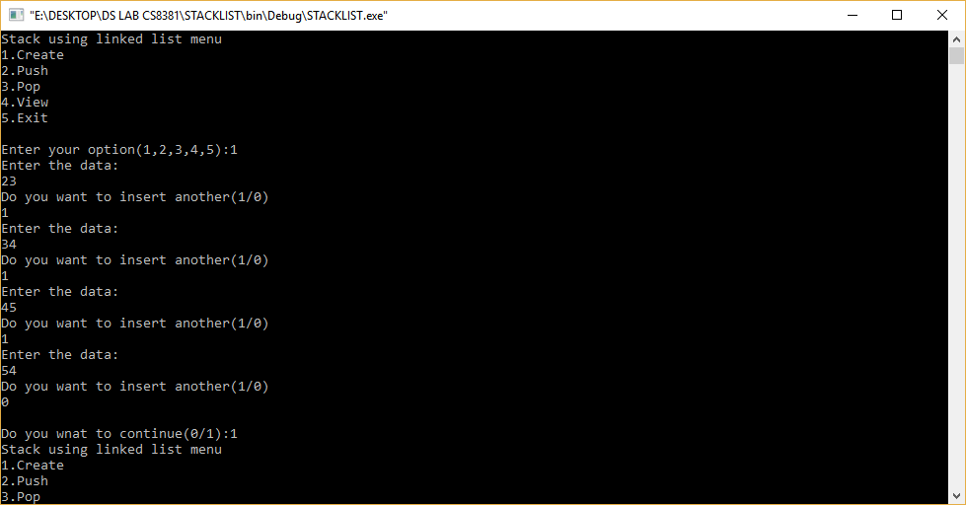

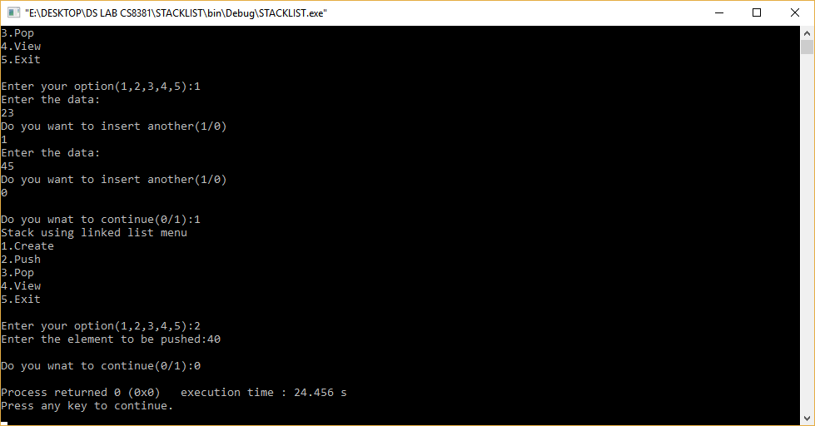

3 (b).QUEUE USING LINKED LIST

#include<stdio.h>
struct node
{
int info;
struct node *link;
}*front = NULL, *rear = NULL;
void insert();
void delet();
void display();
int item;
void main()
{
int ch;
do
{
printf("\n\n1.\tEnqueue\n2.\tDequeue\n3.\tDisplay\n4.\tExit\n");
printf("\nEnter your choice: ");
scanf("%d", &ch);
switch(ch)
{
case 1:
insert();
break;
case 2:
delet();
break;
case 3:
display();
break;
case 4:
exit(0);
default:
printf("\n\nInvalid choice. Please try again...\n");
}
} while(1);
getch();
}
void insert()
{
printf("\n\nEnter ITEM: ");
scanf("%d", &item);
if(rear == NULL)
{
rear = (struct node *)malloc(sizeof(struct node));
rear->info = item;
rear->link = NULL;
front = rear;
}
else{
rear->link = (struct node *)malloc(sizeof(struct node));
rear = rear->link;
rear->info = item;
rear->link = NULL;
}}
void delet(){
struct node *ptr;
if(front == NULL)
printf("\n\nQueue is empty.\n");
else{
ptr = front;
item = front->info;
front = front->link;
free(ptr);
printf("\nItem deleted: %d\n", item);
if(front == NULL)
rear = NULL;
}}
void display()
{
struct node *ptr = front;
if(rear == NULL)
printf("\n\nQueue is empty.\n");
else
{
printf("\n\n");
while(ptr != NULL)
{
printf("%d\t",ptr->info);
ptr = ptr->link;
}}}

OUTPUT:

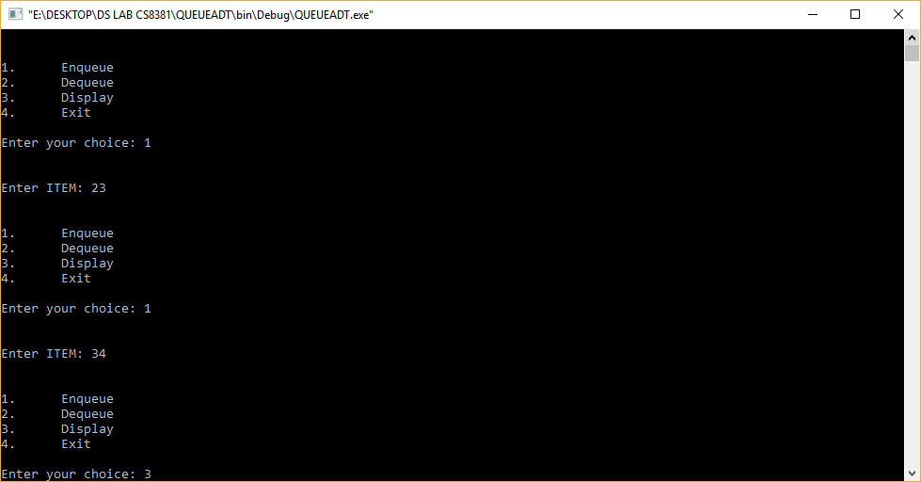

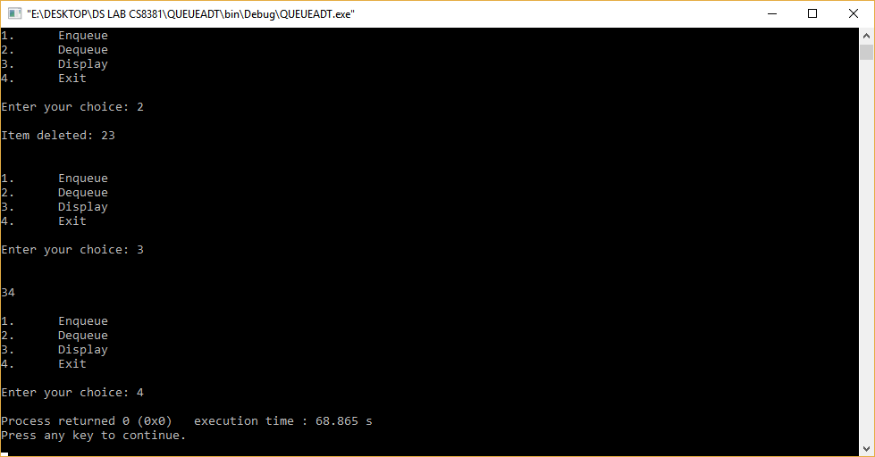

3 (c). POLYNOMIAL LINKED LIST

#include<stdio.h>
main()
{
int a[10], b[10], c[10],m,n,k,k1,i,j,x;
printf("\n\tPolynomial Addition\n");
printf("\t===================\n");
printf("\n\tEnter the no. of terms of the polynomial:");
scanf("%d", &m);
printf("\n\tEnter the degrees and coefficients:");
for (i=0;i<2*m;i++)
scanf("%d", &a[i]);
printf("\n\tFirst polynomial is:");
k1=0;
if(a[k1+1]==1)
printf("x^%d", a[k1]);
else
printf("%dx^%d", a[k1+1],a[k1]);
k1+=2;
while (k1<i)
{
printf("+%dx^%d", a[k1+1],a[k1]);
k1+=2;
}
printf("\n\n\n\tEnter the no. of terms of 2nd polynomial:");
scanf("%d", &n);
printf("\n\tEnter the degrees and co-efficients:");
for(j=0;j<2*n;j++)
scanf("%d", &b[j]);
printf("\n\tSecond polynomial is:");
k1=0;
if(b[k1+1]==1)
printf("x^%d", b[k1]);
else
printf("%dx^%d",b[k1+1],b[k1]);
k1+=2;
while (k1<2*n)
{
printf("+%dx^%d", b[k1+1],b[k1]);
k1+=2;
}
i=0;
j=0;
k=0;
while (m>0 && n>0)
{
if (a[i]==b[j])
{
c[k+1]=a[i+1]+b[j+1];
c[k]=a[i];
m--;
n--;
i+=2;
j+=2;
}
else if (a[i]>b[j])
{
c[k+1]=a[i+1];
c[k]=a[i];
m--;
i+=2;
}
else
{
c[k+1]=b[j+1];
c[k]=b[j];
n--;
j+=2;
}
k+=2;
}
while (m>0)
{
c[k+1]=a[i+1];
c[k]=a[i];
k+=2;
i+=2;
m--;
}
while (n>0)
{
c[k+1]=b[j+1];
c[k]=b[j];
k+=2;
j+=2;
n--;
}
printf("\n\n\n\n\tSum of the two polynomials is:");
k1=0;
if (c[k1+1]==1)
printf("x^%d", c[k1]);
else
printf("%dx^%d", c[k1+1],c[k1]);
k1+=2;
while (k1<k)
{
if (c[k1+1]==1)
printf("+x^%d", c[k1]);
else
printf("+%dx^%d", c[k1+1], c[k1]);
k1+=2;
}
return 0;
}

OUTPUT:

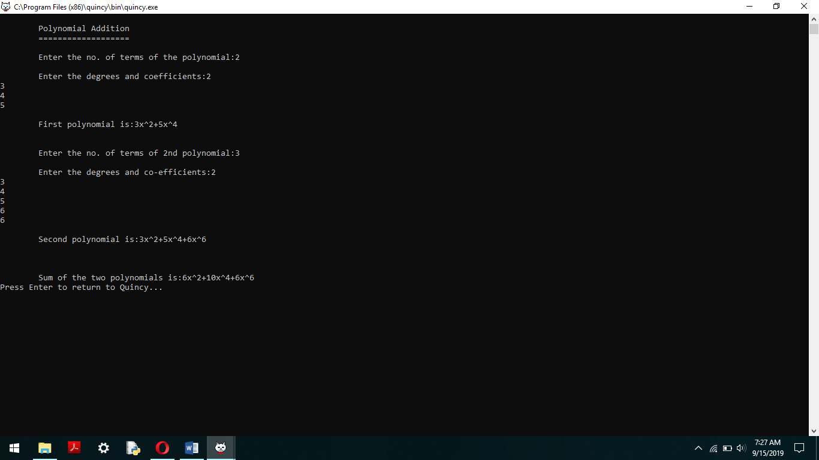

4 (a). POLYNOMIAL

#include<stdio.h>
int main()
{
int a[10],b[10],c[10],m,n,k,k1,i,j,x;
printf("\n\tPolynomial Addition\n");
printf("\t===================\n");
printf("\n\tEnter the no. of terms of the polynomial:");
scanf("%d", &m);
printf("\n\tEnter the degrees and coefficients:");
for (i=0;i<2*m;i++)
scanf("%d", &a[i]);
printf("\n\tFirst polynomial is:");
k1=0;
if(a[k1+1]==1)
printf("x^%d", a[k1]);
else
printf("%d x^%d", a[k1+1],a[k1]);
k1+=2;
while (k1<i)
{
printf("+%d x^%d", a[k1+1],a[k1]);
k1+=2;
}
printf("\n\n\n\tEnter the no. of terms of 2nd polynomial:");
scanf("%d", &n);
printf("\n\tEnter the degrees and co-efficients:");
for(j=0;j<2*n;j++)
scanf("%d", &b[j]);
printf("\n\tSecond polynomial is:");
k1=0;
if(b[k1+1]==1)
printf("x^%d", b[k1]);
else
printf("%d x^%d",b[k1+1],b[k1]);
k1+=2;
while (k1<2*n)
{
printf("+%d x^%d", b[k1+1],b[k1]);
k1+=2;
}
i=0;
j=0;
k=0;
while (m>0 && n>0)
{
if (a[i]==b[j])
{
c[k+1]=a[i+1]+b[j+1];
c[k]=a[i];
m--;
n--;
i+=2;
j+=2;
}
else if (a[i]>b[j])
{
c[k+1]=a[i+1];
c[k]=a[i];
m--;
i+=2;
}
else
{
c[k+1]=b[j+1];
c[k]=b[j];
n--;
j+=2;
}
k+=2;
}
while (m>0)
{
c[k+1]=a[i+1];
c[k]=a[i];
k+=2;
i+=2;
m--;
}
while (n>0)
{
c[k+1]=b[j+1];
c[k]=b[j];
k+=2;
j+=2;
n--;
}
printf("\n\n\n\n\tSum of the two polynomials is:");
k1=0;
if (c[k1+1]==1)
printf("x^%d", c[k1]);
else
printf("%d x^%d", c[k1+1],c[k1]);
k1+=2;
while (k1<k)
{
if (c[k1+1]==1)
printf("+x^%d", c[k1]);
else
printf("+%d x^%d", c[k1+1], c[k1]);
k1+=2;
}
return 0;}

OUTPUT:

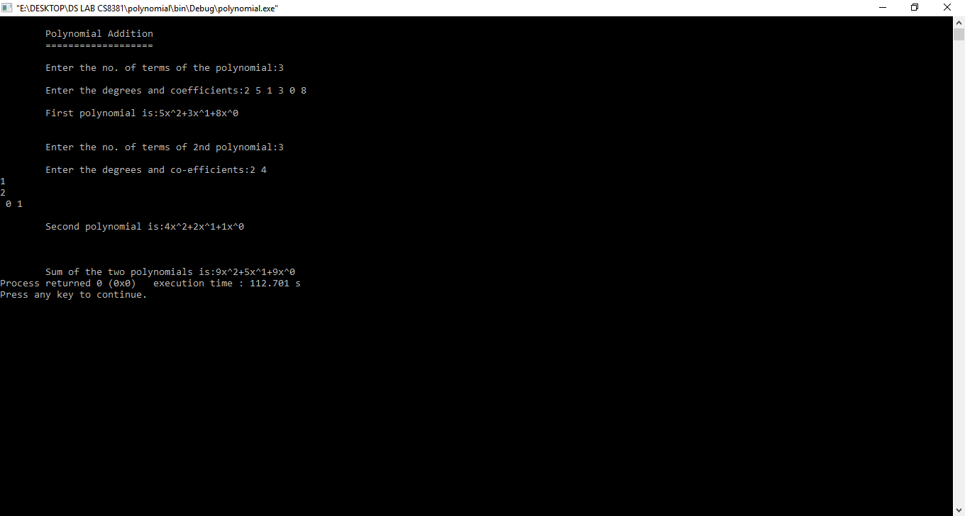

4 (b). INFIX TO POSTFIX CONVERSION

#include<stdio.h>
char stack[20];
int top = -1;
void push(char x)
{
stack[++top] = x;
}
char pop()
{
if(top == -1)
return -1;
else
return stack[top--];
}
int priority(char x)
{
if(x == '(')
return 0;
if(x == '+' || x == '-')
return 1;
if(x == '*' || x == '/')
return 2;
}
int main()
{
char exp[20];
char *e, x;
printf("Enter the expression :: ");
scanf("%s",exp);
e = exp;
while(*e != '\0')
{
if(isalnum(*e))
printf("%c",*e);
else if(*e == '(')
push(*e);
else if(*e == ')')
{
while((x = pop()) != '(')
printf("%c", x);
}
else
{
while(priority(stack[top]) >= priority(*e))
printf("%c",pop());
push(*e);
}
e++;
}
while(top != -1)
{
printf("%c",pop());
}
}

OUTPUT:

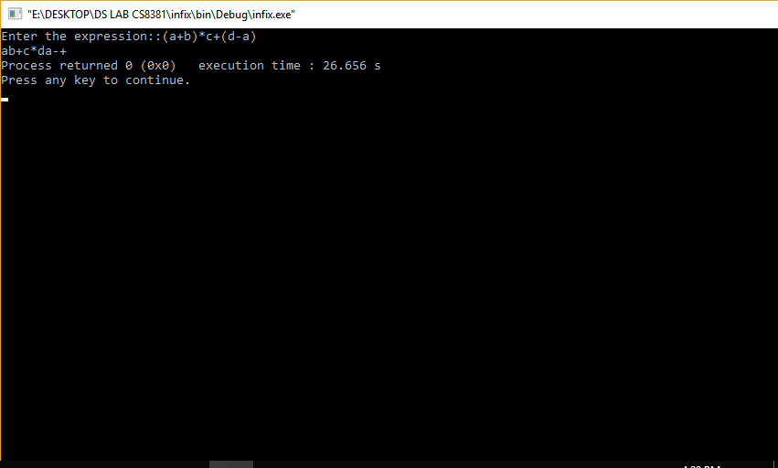

5. BINARY TREE AND OPERATIONS

#include<stdio.h>
#include<stdlib.h>
struct bin_tree {
int data;
struct bin_tree * right, * left;
};
typedef struct bin_tree node;
void insert(node ** tree, int val)
{
node *temp = NULL;
if(!(*tree))
{
temp = (node *)malloc(sizeof(node)
temp->left = temp->right = NULL;
temp->data = val;
*tree = temp;
return;
}
if(val < (*tree)->data)
{
insert(&(*tree)->left, val);
}
else if(val > (*tree)->data)
{
insert(&(*tree)->right, val);
}
}
void print_preorder(node * tree)
{
if (tree)
{
printf("%d\n",tree->data);
print_preorder(tree->left);
print_preorder(tree->right);
} }
void print_inorder(node * tree)
{
if (tree)
{
print_inorder(tree->left);
printf("%d\n",tree->data);
print_inorder(tree->right);
} }
void print_postorder(node * tree)
{
if (tree)
{
print_postorder(tree->left);
print_postorder(tree->right);
printf("%d\n",tree->data);
} }
void deltree(node * tree)
{
if (tree)
{
deltree(tree->left);
deltree(tree->right);
free(tree);
} }
node* search(node ** tree, int val)
{
if(!(*tree))
{
return NULL;
}
if(val < (*tree)->data)
{
search(&((*tree)->left), val);
}
else if(val > (*tree)->data)
{
search(&((*tree)->right), val);
}
else if(val == (*tree)->data)
{
return *tree;
} }
int main()
{
node *root;
node *tmp;
root = NULL;
insert(&root, 9);
insert(&root, 4);
insert(&root, 15);
insert(&root, 6);
insert(&root, 12);
insert(&root, 17);
insert(&root, 2);
printf("pre Order Display\n");
print_preorder(root);
printf("In Order Display\n");
print_inorder(root);
printf("Post Order Display\n");
print_postorder(root);
tmp = search(&root, 4);
if (tmp)
{
printf("Searched node=%d\n", tmp->data);
}
Else
{
printf("Data Not found in tree.\n");
}deltree(root); }

OUTPUT:

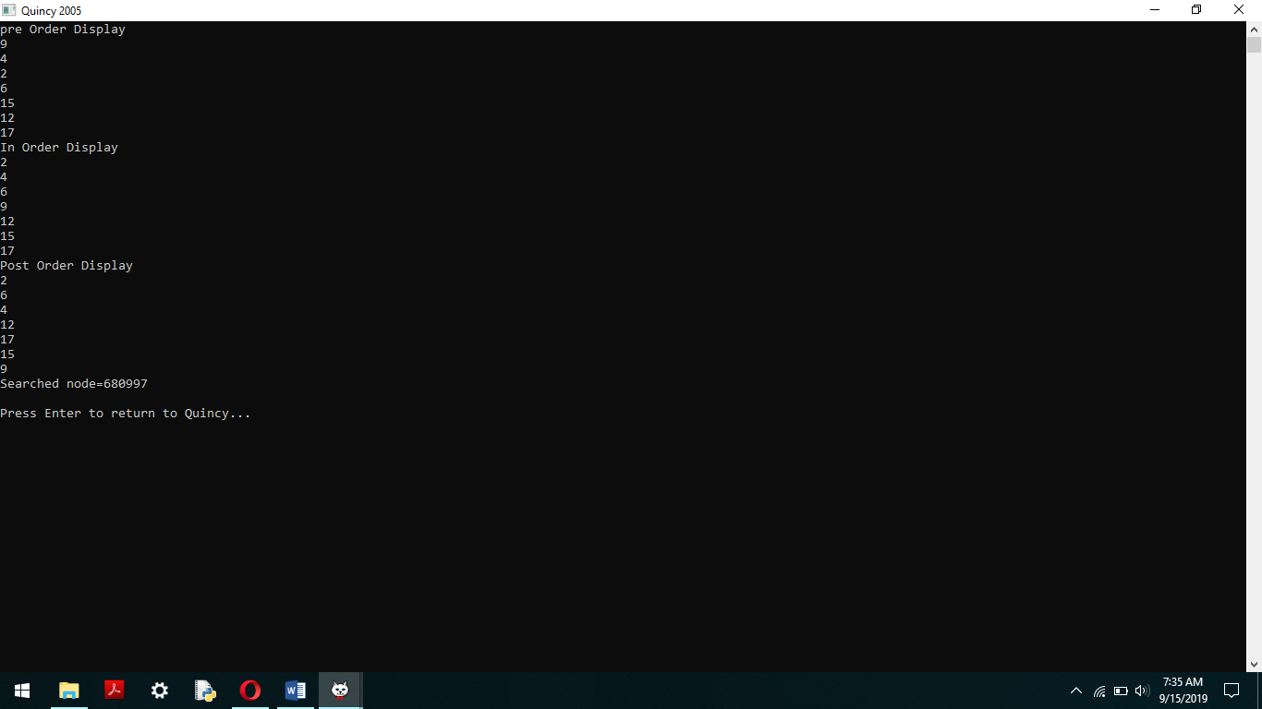

6. BINARY SEARCH TREE
#include<stdio.h>
#include<stdlib.h>
typedef struct BST
{
int data;
struct BST *left;
struct BST *right;
}node;
node *create();
void insert(node *,node *);
void preorder(node *);
int main()
{char ch;
node *root=NULL,*temp;
do
{
temp=create();
if(root==NULL)
root=temp;
else
insert(root,temp);
printf("Do you want to enter more(y/n)?");
getchar();
scanf("%c",&ch);
}while(ch=='y'|ch=='Y');
printf("nPreorder Traversal: ");
preorder(root);
return 0;
}
node *create()
{
node *temp;
printf("Enter data:");
temp=(node*)malloc(sizeof(node));
scanf("%d",&temp->data);
temp->left=temp->right=NULL;
return temp;
}
void insert(node *root,node *temp)
{
if(temp->data<root->data)
{
if(root->left!=NULL)
insert(root->left,temp);
else
root->left=temp;
}
if(temp->data>root->data)
{
if(root->right!=NULL)
insert(root->right,temp);
else
root->right=temp;
}}
void preorder(node *root)
{
if(root!=NULL)
{
printf("%d ",root->data);
preorder(root->left);
preorder(root->right);
}
}

OUTPUT:
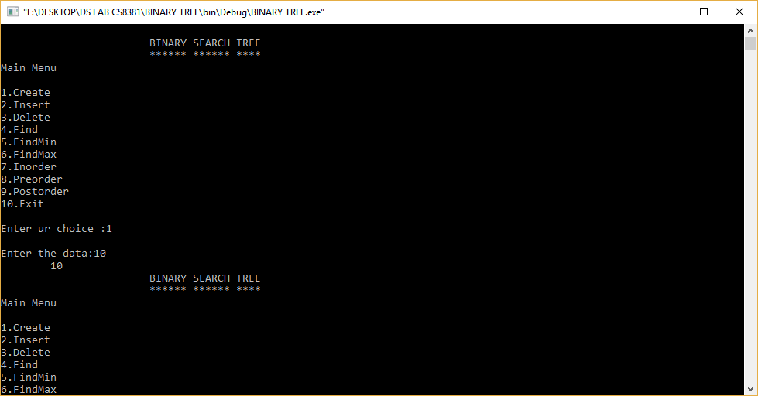
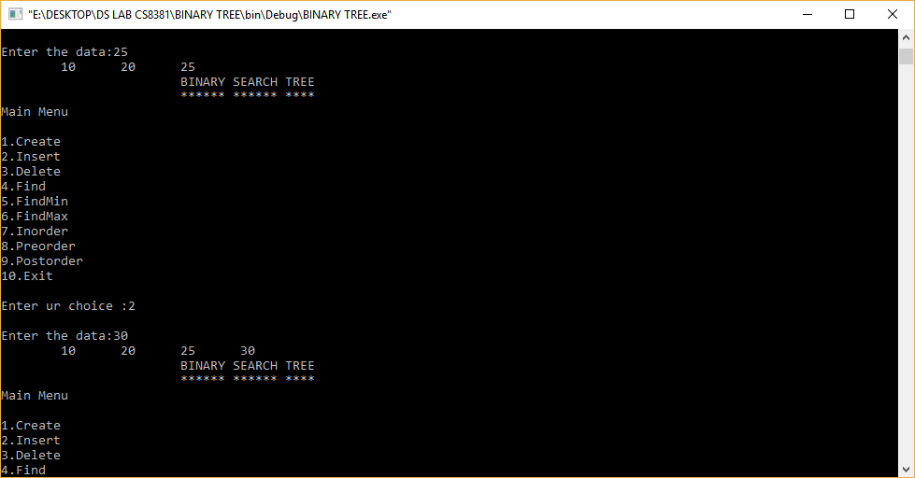
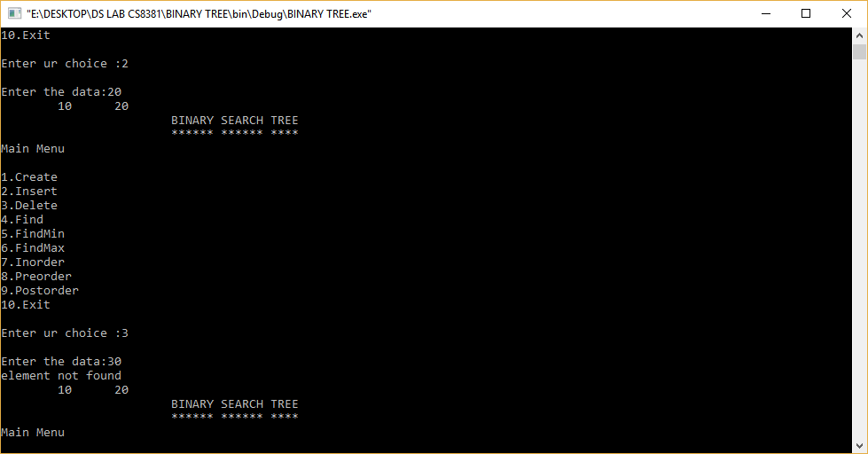

7. AVL TREE

#include<stdio.h>
typedef struct node
{
int data;
struct node *left,*right;
int ht;
}node;
node *insert(node *,int);
node *Delete(node *,int);
void preorder(node *);
void inorder(node *);
int height( node *);
node *rotateright(node *);
node *rotateleft(node *);
node *RR(node *);
node *LL(node *);
node *LR(node *);
node *RL(node *);
int BF(node *);
int main()
{
node *root=NULL;
int x,n,i,op;
do
{
printf("\n1)Create:");
printf("\n2)Insert:");
printf("\n3)Delete:");
printf("\n4)Print:");
printf("\n5)Quit:");
printf("\n\nEnter Your Choice:");
scanf("%d",&op);
switch(op)
{
case 1: printf("\nEnter no. of elements:");
scanf("%d",&n);
printf("\nEnter tree data:");
root=NULL;
for(i=0;i<n;i++)
{
scanf("%d",&x);
root=insert(root,x);
}
break;
case 2: printf("\nEnter a data:");
scanf("%d",&x);
root=insert(root,x);
break;
case 3: printf("\nEnter a data:");
scanf("%d",&x);
root=Delete(root,x);
break;
case 4: printf("\nPreorder sequence:\n");
preorder(root);
printf("\n\nInorder sequence:\n");
inorder(root);
printf("\n");
break;
}
}while(op!=5);
return 0;
}
node * insert(node *T,int x)
{
if(T==NULL)
{
T=(node*)malloc(sizeof(node));
T->data=x;
T->left=NULL;
T->right=NULL;
}
else
if(x > T->data) // insert in right subtree
{
T->right=insert(T->right,x);
if(BF(T)==-2)
if(x>T->right->data)
T=RR(T);
else
T=RL(T);
}
else
if(x<T->data)
{
T->left=insert(T->left,x);
if(BF(T)==2)
if(x < T->left->data)
T=LL(T);
else
T=LR(T);
}
T->ht=height(T);
return(T);
}
node * Delete(node *T,int x)
{
node *p;
if(T==NULL)
{
return NULL;
}
else
if(x > T->data) // insert in right subtree
{
T->right=Delete(T->right,x);
if(BF(T)==2)
if(BF(T->left)>=0)
T=LL(T);
else
T=LR(T);
}
else
if(x<T->data)
{
T->left=Delete(T->left,x);
if(BF(T)==-2) //Rebalance during windup
if(BF(T->right)<=0)
T=RR(T);
else
T=RL(T);
}
else
{
//data to be deleted is found
if(T->right!=NULL)
{ //dete its inorder succesor
p=T->right;
while(p->left!= NULL)
p=p->left;
T->data=p->data;
T->right=Delete(T->right,p->data);
if(BF(T)==2)//Rebalance during windup
if(BF(T->left)>=0)
T=LL(T);
else
T=LR(T);
}
else
return(T->left);
}
T->ht=height(T);
return(T);
}
int height(node *T)
{
int lh,rh;
if(T==NULL)
return(0);
if(T->left==NULL)
lh=0;
else
lh=1+T->left->ht;
if(T->right==NULL)
rh=0;
else
rh=1+T->right->ht;
if(lh>rh)
return(lh);
return(rh);
}
node * rotateright(node *x)
{
node *y;
y=x->left;
x->left=y->right;
y->right=x;
x->ht=height(x);
y->ht=height(y);
return(y);
}
node * rotateleft(node *x)
{
node *y;
y=x->right;
x->right=y->left;
y->left=x;
x->ht=height(x);
y->ht=height(y);
return(y);
}
node * RR(node *T)
{
T=rotateleft(T);
return(T);
}
node * LL(node *T)
{
T=rotateright(T);
return(T);
}
node * LR(node *T)
{
T->left=rotateleft(T->left);
T=rotateright(T);
return(T);
}
node * RL(node *T)
{
T->right=rotateright(T->right);
T=rotateleft(T);
return(T);
}
int BF(node *T)
{
int lh,rh;
if(T==NULL)
return(0);
if(T->left==NULL)
lh=0;
else
lh=1+T->left->ht;
if(T->right==NULL)
rh=0;
else
rh=1+T->right->ht;
return(lh-rh);
}
void preorder(node *T)
{
if(T!=NULL)
{
printf("%d(Bf=%d)",T->data,BF(T));
preorder(T->left);
preorder(T->right);
}
}
void inorder(node *T)
{
if(T!=NULL)
{
inorder(T->left);
printf("%d(Bf=%d)",T->data,BF(T));
inorder(T->right);
}
}

OUTPUT:

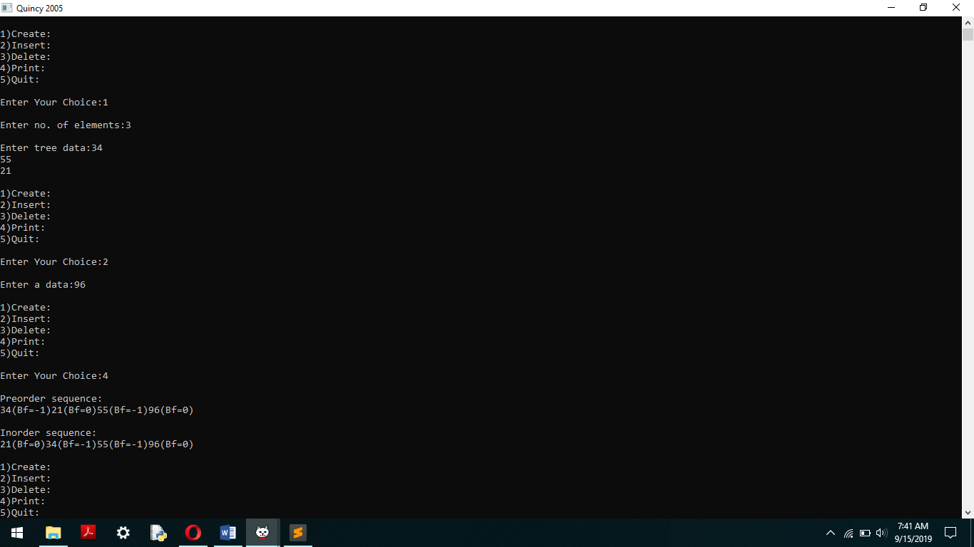

8. HEAPS USING PRIORITY QUEUE

#include<stdio.h>
#include<math.h>
#define MAX 100
void swap(int*, int*);
void display(int[],int);
void insert(int[],int,int,int);
int del_hi_priori(int[],int,int);
int main()
{
int lb,choice,num,n,a[MAX],data,s;
choice = 0;
n=0; //Represents number of nodes in the queue
lb=0; //Lower bound of the array is initialized to 0
while(choice != 4)
{
printf(".....MAIN MENU.....\n");
printf("\n1.Insert.\n");
printf("2.Delete.\n");
printf("3.Display.\n");
printf("4.Quit.\n");
printf("\nEnter your choice : ");
scanf("%d",&choice);
switch(choice)
{
case 1:
printf("Enter data to be inserted : ");
scanf("%d",&data);
insert(a,n,data,lb);
n++;
break;
case 2:
s=del_hi_priori(a,n+1,lb);
if(s!=0)
printf("The deleted value is : %d",s);
if(n>0)
n--;
break;
case 3:
printf("\n");
display(a,n);
break;
case 4:
return 0;
default:
printf("Invalid choice\n");
}
printf("\n\n");
}
return 0;
}

//-------INSERT-------
void insert(int a[],int heapsize,int data,int lb)
{
int i,p;
int parent(int);
if(heapsize==MAX)
{
printf("Queue Is Full!!n");
return;
}
i=lb+heapsize;
a[i]=data;
while(i>lb&&a[p=parent(i)]<a[i])
{
swap(&a[p],&a[i]);
i=p;
}
}

//-------DELETE-------
int del_hi_priori(int a[],int heapsize,int lb)
{
int data,i,l,r,max_child,t;
int left(int);
int right(int);
if(heapsize==1)
{
printf("Queue Is Empty!!\n");
return 0;
}
t=a[lb];
swap(&a[lb],&a[heapsize-1]);
i=lb;
heapsize--;
while(1)
{
if((l=left(i))>=heapsize)
break;
if((r=right(i))>=heapsize)
max_child=l;
else
max_child=(a[l]>a[r])?l:r;
if(a[i]>=a[max_child])
break;
swap(&a[i],&a[max_child]);
i=max_child;
}
return t;
}

//Returns Parent Index
int parent(int i)
{
float p;
p=((float)i/2.0)-1.0;
return ceil(p);
}

//Return Leftchild Index
int left(int i)
{
return 2*i+1;
}

//Return Rightchild Index
int right(int i)
{
return 2*i+2;
}

//-------DISPLAY-------
void display(int a[],int n)
{
int i;
if(n==0)
{
printf("Queue Is Empty!!\n");
return;
}
for(i=0;i<n;i++)
printf("%d ",a[i]);
printf("\n");
}

//-------SWAP-------
void swap(int*p,int*q)
{
int temp;
temp=*p;
*p=*q;
*q=temp; }
OUTPUT
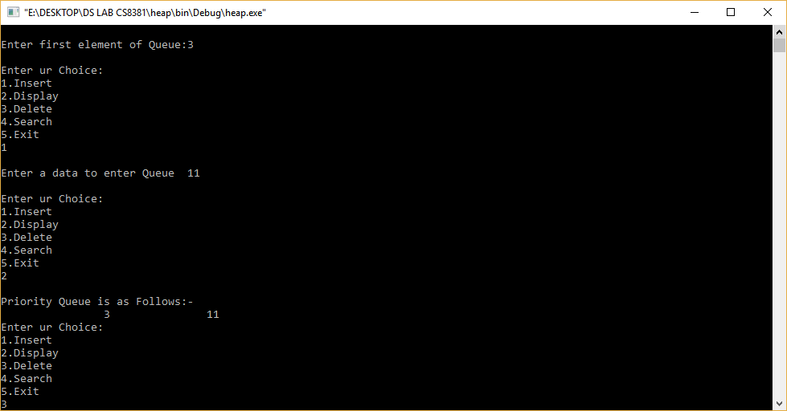

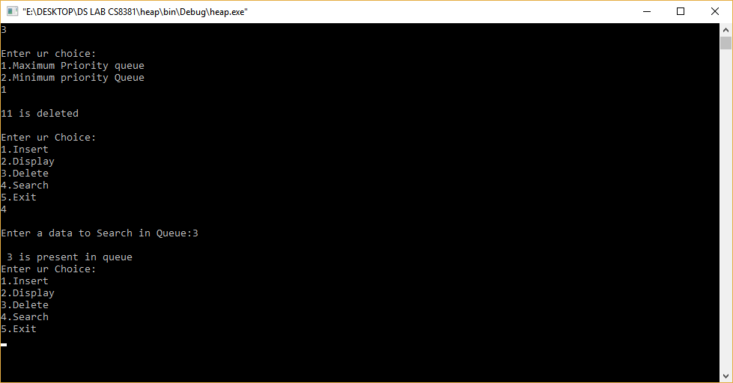

2. ARRAY IMPLEMENTATION OF LIST ADT
#include<stdio.h>
#include<conio.h>
#define MAX 10
void create();
void insert();
void deletion();
void search();
void display();
int a,b[20], n, p, e, f, i, pos;
void main()
{
clrscr();
int ch; char g='y'; do
{
printf("\n main Menu");
printf("\n 1.Create \n 2.Delete \n 3.Search \n 4.Insert \n 5.Display\n 6.Exit\n");
printf("\n Enter your Choice"); scanf("%d", &ch);
switch(ch)
{
case 1: create();
break;
case 2:deletion();
break;
case 3: search();
break;
case 4: insert();
break;
case 5: display();
break;
case 6: exit();
break;
default:
printf("\n Enter the correct choice:");
}
printf("\n Do u want to continue:::");
scanf("\n%c", &g);
}
while(g=='y'||g=='Y');
getch();
}
void create()
{
printf("\n Enter the number of nodes");
scanf("%d", &n);
for(i=0;i<n;i++)
{
printf("\n Enter the Element:",i+1);
scanf("%d", &b[i]);
}
}
void deletion()
{
printf("\n Enter the position u want to delete::");
scanf("%d", &pos);
if(pos>=n)
{
printf("\n Invalid Location::");
}
else
{
for(i=pos+1;i<n;i++)
{
b[i-1]=b[i];
}
n--;
}
printf("\n The Elements after deletion");
for(i=0;i<n;i++)
{
printf("\t%d", b[i]);

}
}
void search()
{
printf("\n Enter the Element to be searched:"); scanf("%d", &e);
for(i=0;i<n;i++)
{
if(b[i]==e)
{
printf("Value is in the %d Position", i);
}}}
void insert()
{
printf("\n Enter the position u need to insert::"); scanf("%d", &pos);
if(pos>=n)
{
printf("\n invalid Location::");
} else
{
for(i=MAX-1;i>=pos-1;i--)
{
b[i+1]=b[i];
}
printf("\n Enter the element to insert::\n");
scanf("%d",&p);
b[pos]=p;
n++;
}
printf("\n The list after insertion::\n");
display();
}
void display()
{
printf("\n The Elements of The list ADT are:");
for(i=0;i<n;i++)
{
printf("\n\n%d", b[i]);
}}

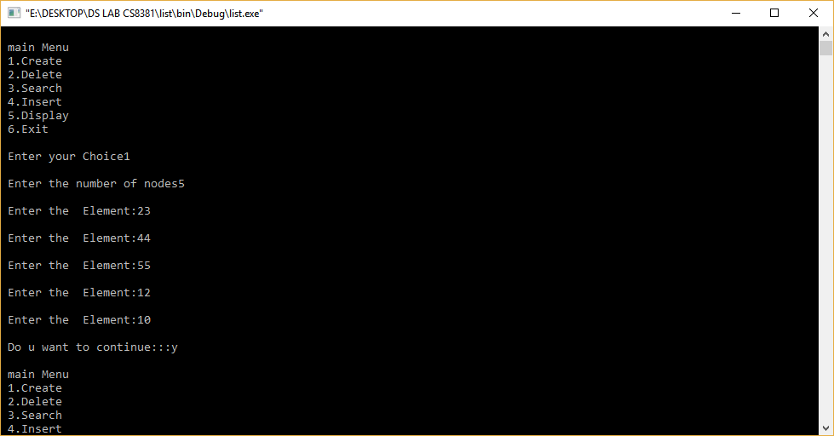
OUTPUT
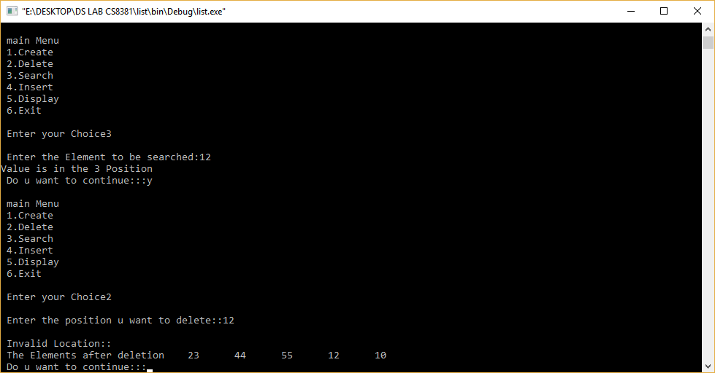

9 (a). GRAPH REPRESENTATION

#include <stdio.h>
#include <stdlib.h>
void main()
{ int option;
do
{printf("\n A Program to represent a Graph by using an ");
printf("Adjacency Matrix method \n ");
printf("\n 1. Directed Graph ");
printf("\n 2. Un-Directed Graph ");
printf("\n 3. Exit ");
printf("\n\n Select a proper option : ");
scanf("%d", &option);
switch(option)
{
case 1 : dir_graph();
break;
case 2 : undir_graph();
break;
case 3 : exit(0);
} // switch
}while(1);
}
int dir_graph()
{
int adj_mat[50][50];
int n;
int in_deg, out_deg, i, j;
printf("\n How Many Vertices ? : ");
scanf("%d", &n);
read_graph(adj_mat, n);
printf("\n Vertex \t In_Degree \t Out_Degree \t Total_Degree ");
for (i = 1; i <= n ; i++ )
{
in_deg = out_deg = 0;
for ( j = 1 ; j <= n ; j++ )
{
if ( adj_mat[j][i] == 1 )
in_deg++;}
for ( j = 1 ; j <= n ; j++ )
if (adj_mat[i][j] == 1 )
out_deg++;
printf("\n\n%5d\t\t\t%d\t\t%d\t\t%d\n\n",i,in_deg,out_deg,in_deg+out_deg);
}return;}
int undir_graph()
{
int adj_mat[50][50];
int deg, i, j, n;
printf("\n How Many Vertices ? : ");
scanf("%d", &n);
read_graph(adj_mat, n);
printf("\n Vertex \t Degree ");
for ( i = 1 ; i <= n ; i++ )
{
deg = 0;
for ( j = 1 ; j <= n ; j++ )
if ( adj_mat[i][j] == 1)
deg++;
printf("\n\n %5d \t\t %d\n\n", i, deg);
}
return;}
int read_graph ( int adj_mat[50][50], int n )
{
int i, j;
char reply;
for ( i = 1 ; i <= n ; i++ )
{
for ( j = 1 ; j <= n ; j++ )
{
if ( i == j )

{
adj_mat[i][j] = 0;
continue;
}
printf("\n Vertices %d & %d are Adjacent ? (Y/N) :",i,j);
scanf("%c", &reply);
if ( reply == 'y' || reply == 'Y' )
adj_mat[i][j] = 1;
else
adj_mat[i][j] = 0;
}}
return;}

OUTPUT
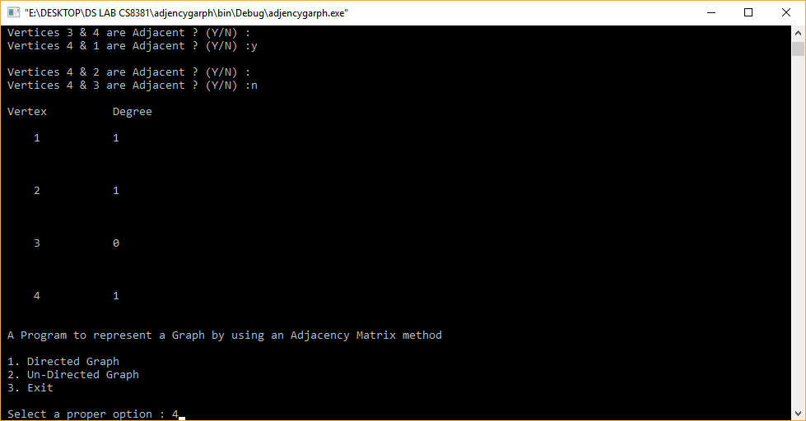

9 (b). BFS AND DFS GRAPH TRAVERSAL

include<stdio.h>
int q[20],top=-1,front=-1,rear=-1,a[20][20],vis[20],stack[20];
int delete();
void add(int item); void bfs(int s,int n); void dfs(int s,int n); void push(int item); int pop();
void main()
{
int n,i,s,ch,j;
char c,dummy;
printf("ENTER THE NUMBER VERTICES ");
scanf("%d",&n);
for(i=1;i<=n;i++)
{
for(j=1;j<=n;j++)
{
printf("ENTER 1 IF %d HAS A NODE WITH %d ELSE 0 ",i,j);
scanf("%d",&a[i][j]);
}
}
printf("THE ADJACENCY MATRIX IS\n");
for(i=1;i<=n;i++)
{
for(j=1;j<=n;j++)
{
printf(" %d",a[i][j]);
}
printf("\n");
}
do
{ for(i=1;i<=n;i++) vis[i]=0;
printf("\nMENU");
printf("\n1.B.F.S");
printf("\n2.D.F.S");
printf("\nENTER YOUR CHOICE");

scanf("%d",&ch);
printf("ENTER THE SOURCE VERTEX :");
scanf("%d",&s);
switch(ch)
{
case 1:bfs(s,n);
break;
case 2: dfs(s,n);
break;
}
printf("DO U WANT TO CONTINUE(Y/N) ? ");
scanf("%c",&dummy);
scanf("%c",&c);
}while((c=='y')||(c=='Y'));
}
//**************BFS(breadth-first search) code**************//
void bfs(int s,int n)
{
int p,i; add(s); vis[s]=1; p=delete(); if(p!=0)
printf(" %d",p);
while(p!=0)
{ for(i=1;i<=n;i++) if((a[p][i]!=0)&&(vis[i]==0))
{ add(i); vis[i]=1;
} p=delete(); if(p!=0)
printf(" %d ",p);
}
for(i=1;i<=n;i++)
if(vis[i]==0) bfs(i,n);
}
void add(int item)
{ if(rear==19)
printf("QUEUE FULL");
else
{
if(rear==-1)
{ q[++rear]=item; front++;
} else q[++rear]=item;
}
}
int delete()
{
int k; if((front>rear)||(front==-1))
return(0);
else
{ k=q[front++]; return(k);
}
}
//***************DFS(depth-first search) code******************//
void dfs(int s,int n)
{
int i,k;
push(s);
vis[s]=1;
k=pop();
if(k!=0)
printf(" %d ",k);
while(k!=0)
{ for(i=1;i<=n;i++)
if((a[k][i]!=0)&&(vis[i]==0))
{push(i);
vis[i]=1;
} k=pop();
if(k!=0)
printf(" %d ",k);
}
for(i=1;i<=n;i++)
if(vis[i]==0) dfs(i,n);
}
void push(int item)
{
if(top==19)

printf("Stack overflow ");
else stack[++top]=item;
}
int pop()
{
int k; if(top==-1) return(0); else
{
k=stack[top--];
return(k);
}
}

OUTPUT
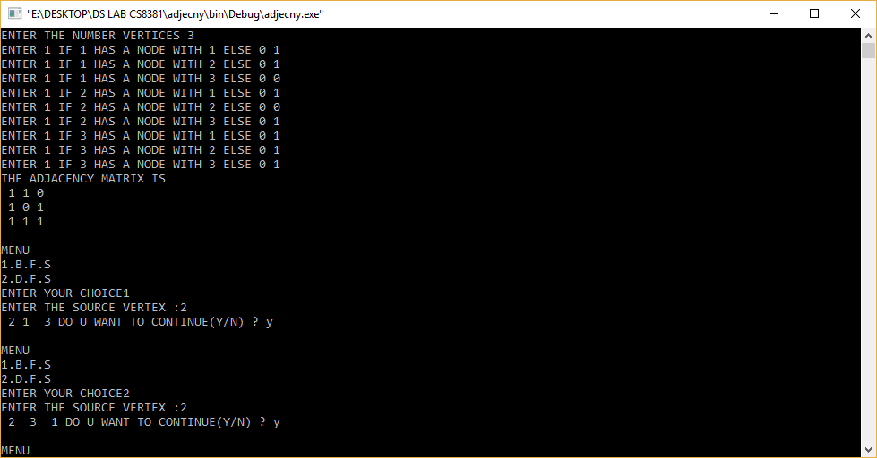

10. APPLICATION OF GRAPH-DIJKSTRA’S SHORTEST PATH

#include<stdio.h>
#include<conio.h>
#define INFINITY 9999
#define MAX 10
void dijkstra(int G[MAX][MAX],int n,int startnode);
int main()
{
int G[MAX][MAX],i,j,n,u;
printf("Enter no. of vertices:");
scanf("%d",&n);
printf("\nEnter the adjacency matrix:\n");
for(i=0;i<n;i++)
for(j=0;j<n;j++)
scanf("%d",&G[i][j]);
printf("\nEnter the starting node:");
scanf("%d",&u);
dijkstra(G,n,u);
return 0;
}
void dijkstra(int G[MAX][MAX],int n,int startnode)
{
int cost[MAX][MAX],distance[MAX],pred[MAX];
int visited[MAX],count,mindistance,nextnode,i,j;
for(i=0;i<n;i++)
for(j=0;j<n;j++)
if(G[i][j]==0)
cost[i][j]=INFINITY;
else
cost[i][j]=G[i][j];
for(i=0;i<n;i++)
{
distance[i]=cost[startnode][i];
pred[i]=startnode;
visited[i]=0;
}
distance[startnode]=0;
visited[startnode]=1;
count=1;
while(count<n-1)
{
mindistance=INFINITY;
for(i=0;i<n;i++)
if(distance[i]<mindistance&&!visited[i])
{
mindistance=distance[i];
nextnode=i;
}
visited[nextnode]=1;
for(i=0;i<n;i++)
if(!visited[i])
if(mindistance+cost[nextnode][i]<distance[i])
{
distance[i]=mindistance+cost[nextnode][i];
pred[i]=nextnode;
}
count++;
}
for(i=0;i<n;i++)
if(i!=startnode)
{
printf("\nDistance of node%d=%d",i,distance[i]);
printf("\nPath=%d",i);
j=i;
do
{
j=pred[j];
printf("<-%d",j);
}while(j!=startnode);
}}

Output:
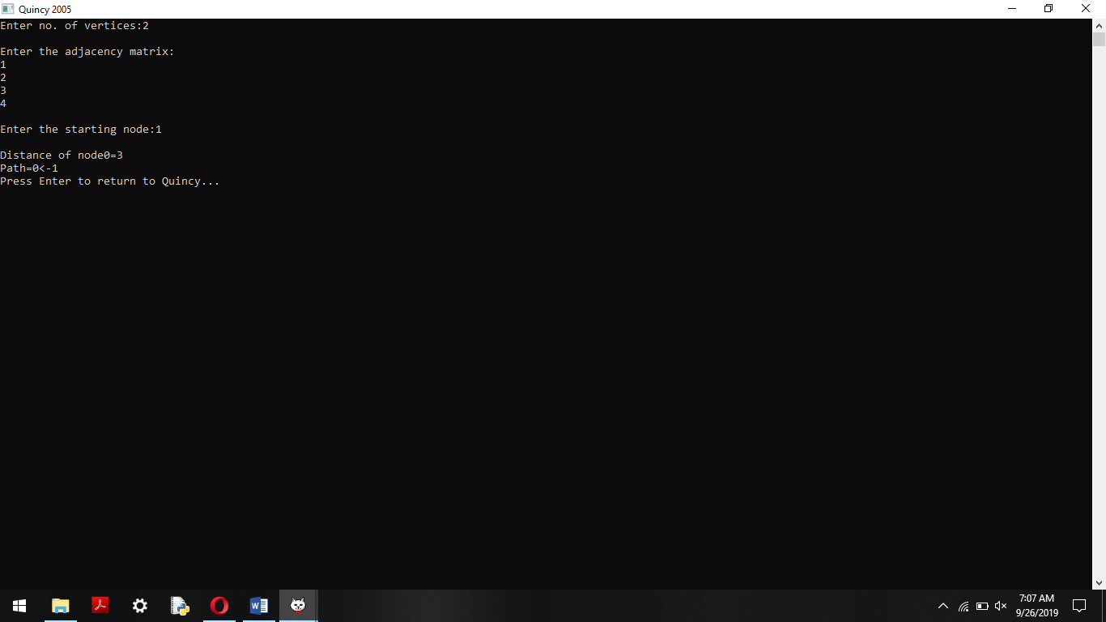

11 (a).IMPLEMENTATION OF SEARCHING-LINEAR SEARCH AND BINARY SEARCH

#include <stdio.h>
void sequential_search(int array[], int size, int n)
{
int i;
for (i = 0; i < size; i++)
{
if (array[i] == n)
{
printf("%d found at location %d.\n", n, i+1);
break;
}
}
if (i == size)
printf("Not found! %d is not present in the list.\n", n);
}
void binary_search(int array[], int size, int n)
{
int i, first, last, middle;
first = 0;
last = size - 1;
middle = (first+last) / 2;
while (first <= last) {
if (array[middle] < n)
first = middle + 1;
else if (array[middle] == n) {
printf("%d found at location %d.\n", n, middle+1);
break;
}
else
last = middle - 1;
middle = (first + last) / 2;
}
if ( first > last )
printf("Not found! %d is not present in the list.\n", n);

}
int main()
{
int a[200], i, j, n, size; printf("Enter the size of the list:");
scanf("%d", &size);
printf("Enter %d Integers in ascending order\n", size);
for (i = 0; i < size; i++)
scanf("%d", &a[i]);
printf("Enter value to find\n"); scanf("%d", &n);
printf("Sequential search\n");
sequential_search(a, size, n);
printf("Binary search\n");
binary_search(a, size, n);
return 0;
}

OUTPUT
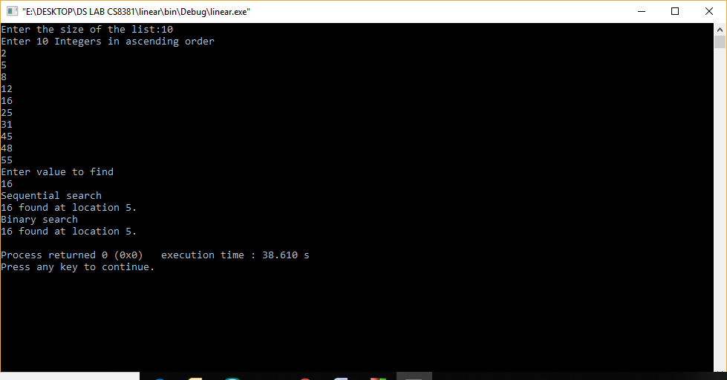

11 (b).BUBBLE SORT

#include<stdio.h>
#include<conio.h>
void main(){
int n, i, j, temp , a[100];
printf("Enter the total integers you want to enter (make it less than 100):\n");
scanf("%d",&n);
printf("Enter the %d integer array elements:\n",n);
for(i=0;i<n;i++){
scanf("%d",&a[i]);
}
for(i=0;i<n-1;i++){ for(j=0;j<n-i-1;j++){ if(a[j+1]<a[j]){
temp = a[j]; a[j] = a[j+1]; a[j+1] = temp;
}}}
printf("The sorted numbers are:"); for(i=0;i<n;i++){ printf("%3d",a[i]);
}getch();
}

OUTPUT:
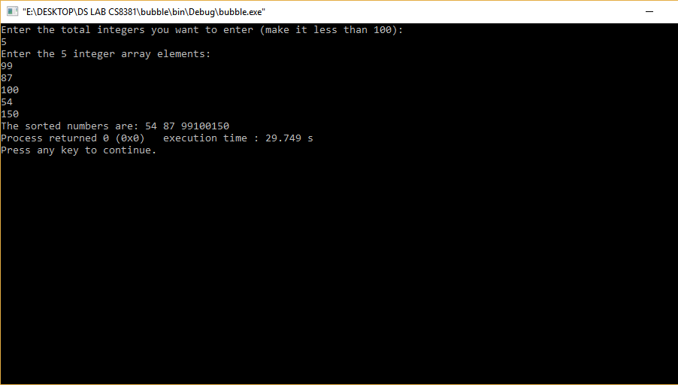

11 (b).MERGE SORT

#include<stdio.h>
#include<conio.h>
void merge(int [],int ,int ,int );
void part(int [],int ,int );
void main(){ int arr[30]; int i,size;
printf("\n\t------- Merge sorting method -------\n\n");
printf("Enter total no. of elements : "); scanf("%d",&size);
for(i=0; i<size; i++)
{
printf("Enter %d element : ",i+1);
scanf("%d",&arr[i]);
}
part(arr,0,size-1);
printf("\n\t------- Merge sorted elements -------\n\n");
for(i=0; i<size; i++)
printf("%d ",arr[i]);
getch();
}
void part(int arr[],int min,int max){
int mid;
if(min<max)
{
mid=(min+max)/2;
part(arr,min,mid);
part(arr,mid+1,max);
merge(arr,min,mid,max);}}
void merge(int arr[],int min,int mid,int max){
int tmp[30];
int i,j,k,m; j=min; m=mid+1;
for(i=min; j<=mid && m<=max ; i++)
{
if(arr[j]<=arr[m]){
tmp[i]=arr[j];
j++;}
else{
tmp[i]=arr[m];
m++;
}}
if(j>mid){
for(k=m; k<=max; k++)
{
tmp[i]=arr[k];
i++;
}}
else{
for(k=j; k<=mid; k++){
tmp[i]=arr[k];
i++;
}}
for(k=min; k<=max; k++)
arr[k]=tmp[k]; }

OUTPUT
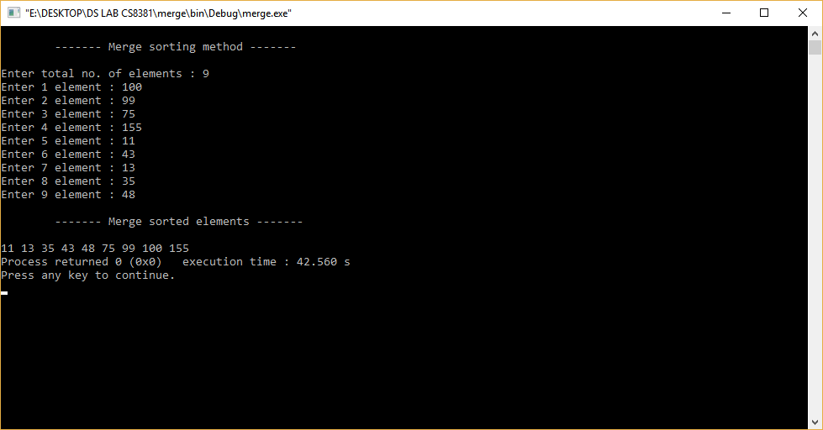

11 (b).QUICK SORT

#include<stdio.h>
#include<conio.h>
void qsort(int arr[20], int fst, int last);
void main()
{
int arr[30];
int i,size;
printf("Enter total no. of the elements : ");
scanf("%d",&size);
printf("Enter total %d elements : \n",size);
for(i=0; i<size; i++)
scanf("%d",&arr[i]);
qsort(arr,0,size-1);
printf("Quick sorted elements are as : \n");
for(i=0; i<size; i++)
printf("%d\t",arr[i]);
getch();}
void qsort(int arr[20], int fst, int last)
{
int i,j,pivot,tmp;
if(fst<last)
{
pivot=fst;
i=fst;
j=last;
while(i<j){
while(arr[i]<=arr[pivot] && i<last)
i++; while(arr[j]>arr[pivot]) j--;
if(i<j){ tmp=arr[i]; arr[i]=arr[j]; arr[j]=tmp;}} tmp=arr[pivot];
arr[pivot]=arr[j];
arr[j]=tmp; qsort(arr,fst,j-1); qsort(arr,j+1,last);
} }

OUTPUT
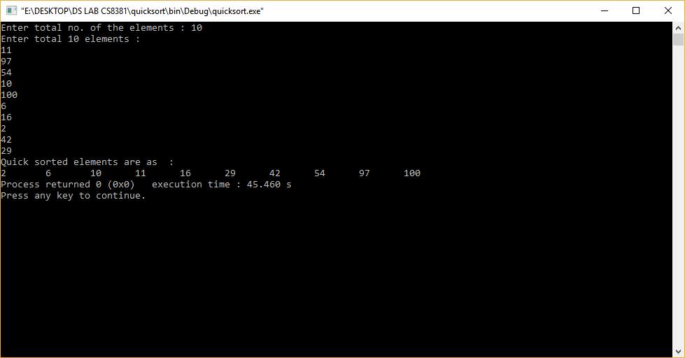

12. HASHING TECHNIQUES

#include<stdio.h>
#include<stdlib.h>
struct data
{
int key;
int value;
};
struct data *array;
int capacity = 10;
int size = 0;
int hashcode(int key)
{
return (key % capacity);
}
int get_prime(int n)
{
if(n%2==0)
{
n++;
}
for (; !if_prime(n); n += 2);
return n;
}
int if_prime(int n)
{
int i;
if ( n == 1 || n == 0)
{
return 0;
}
for (i = 2; i < n; i++)
{
if (n % i == 0)

{
return 0;}}
return 1;
}
void init_array()
{
int i;
capacity = get_prime(capacity);
array = (struct data*) malloc(capacity * sizeof(struct data));
for (i = 0; i < capacity; i++)
{
array[i].key = 0;
array[i].value = 0;
}}
void insert(int key)
{
int index = hashcode(key);
if (array[index].value == 0)
{
/* key not present, insert it */ array[index].key = key; array[index].value = 1;
size++;
printf("\n Key (%d) has been inserted \n", key);
}
else if(array[index].key == key)
{
printf("\n Key (%d) already present, hence updating its value \n", key);
array[index].value += 1;
}
else
{
printf("\n ELEMENT CANNOT BE INSERTED \n");
}}
void remove_element(int key)
{
int index = hashcode(key);

if(array[index].value == 0)
{
printf("\n This key does not exist \n");
}
else {
array[index].key = 0; array[index].value = 0; size--;
printf("\n Key (%d) has been removed \n", key);}}
void display()
{
int i;for (i = 0; i < capacity; i++)
{
if (array[i].value == 0)
{
printf("\n Array[%d] has no elements \n");
}
else
{
printf("\n array[%d] has elements -:\n key(%d) and value(%d) \t", i, array[i].key, array[i].value);
}}}
int size_of_hashtable()
{
return size;
}
void main()
{
int choice, key, value, n, c;
init_array();
do {
printf("\n Implementation of Hash Table in C \n\n");
printf("MENU-: \n1.Inserting item in the Hash Table" "\n2.Removing item from the Hash Table"
"\n3.Check the size of Hash Table" "\n4.Display a Hash Table" "\n\n Please enter your choice -:");
scanf("%d", &choice);
switch(choice)
{
case 1:
printf("Inserting element in Hash Table\n");
printf("Enter key -:\t");
scanf("%d", &key);
insert(key);
break;
case 2:
printf("Deleting in Hash Table \n Enter the key to delete-:");
scanf("%d", &key); remove_element(key); break;
case 3:
n = size_of_hashtable();
printf("Size of Hash Table is-:%d\n", n);
break;
case 4:
display();
break;
default:
printf("Wrong Input\n");}
printf("\n Do you want to continue-:(press 1 for yes)\t");
scanf("%d", &c);
}while(c == 1);
getch();}

OUTPUT

